
Learning Python - Sheet #1


Basic Maths – Variables – Input

1. Starting Python

Python is a programming language. It allows to make a computer do anything we want, as long as we know how to ask for it. Python comes with an IDE called IDLE which we’re going to use here.
To start it, find the IDLE icon on the desktop or in the application menu. It should look like this: 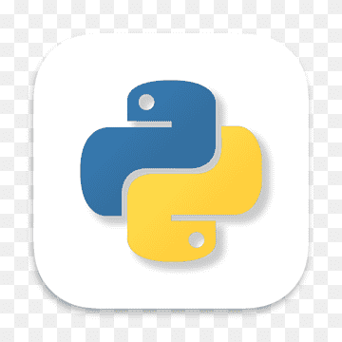

2. Basic Maths

When IDLE starts, you should see something like this:
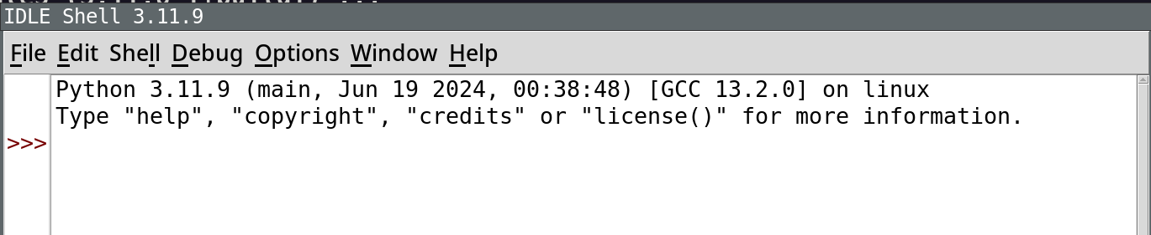

This is what we call a shell, or also a REPL (for read-eval-print loop).

You can type commands after the >>> and they will be executed immediately.

Try typing things like:

3+4
12 – 3
10*5
100/20
(10*5)+7


Have fun experimenting:
Try doing other operations. Can you trick the computer? Can you obtain surprising results? Do you understand everything that happens?

3. Variables

You can store results of your computations in variables. This is a nice way to put a name on something to reuse it later.

Try typing this:

a = 3+4
b = 12-3
c = a+b

What happens? What’s different?
Now try:

c

4. Input

To finish this session let’s see how the computer can read something from you:

name = input(“What’s your name?”)

And then:

“Hello, %s” % name

