
Learning Python - Sheet #4


Programs

So far we’ve seen how to type python instructions in IDLE Shell and get immediate results. But to write a program, we need to be able to group many of these instructions in a file so that we can run them whenever we want without having to type them every time.

1. New file

In IDLE Shell, click on the menu File and then on New File.
This opens a new window:
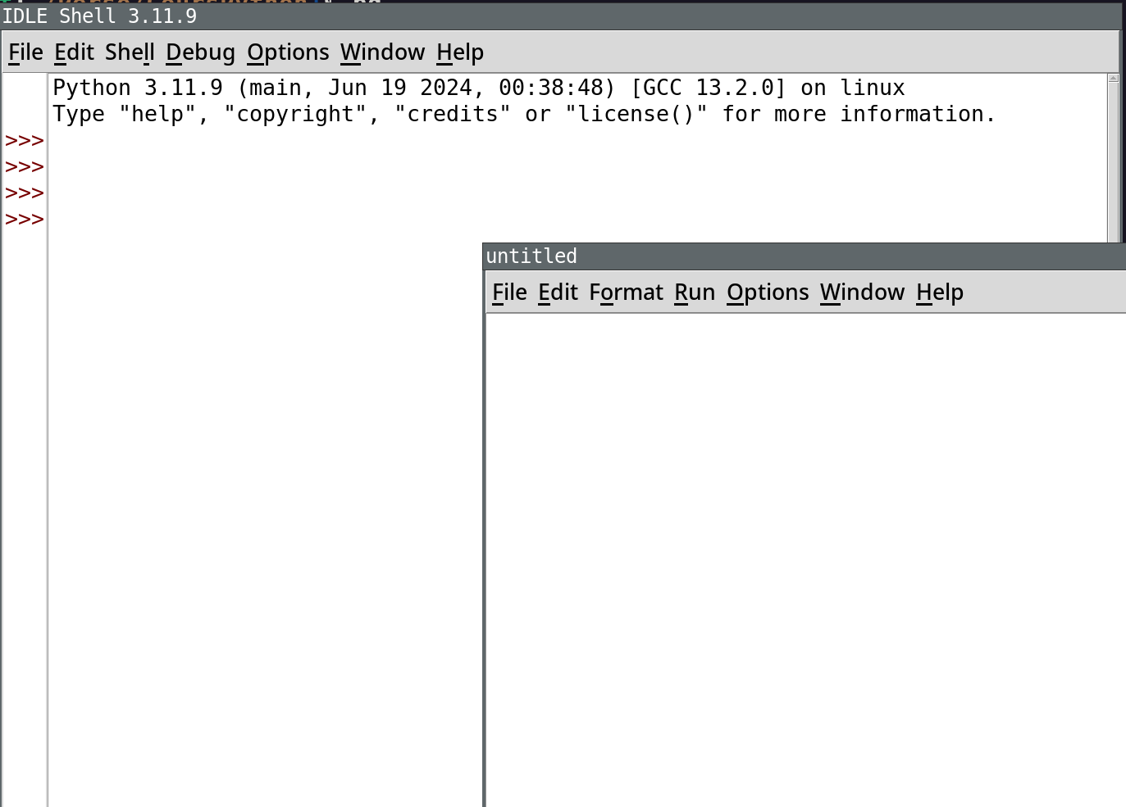

The new window is a text editor. It allows to type some text and save it in a file. Later, you can open this file to modify it.

Let’s type the following instructions, from previous sheet, in the file:

for i in range(5, 10):
print(i)

You can then click on the Run menu and then on Run Module. Note that another way to do this is to press F5, as shown in the menu.

A message box is displayed saying that the file is not saved. Before being able to run it, you need to save it a first time to give it a name.


It can be annoying to be asked every time if you want to save. To avoid this, you can go in Options > Configure IDLE > Shell/Ed > Editor Preferences > At Start or Run (F5) and check No Prompt.

Notice how the result of the execution of your program is visible in IDLE Shell.

2. Larger program

name = input("Hello, what's your name? ")
print("Nice to meet you %s" % name)
age = int(input("How old are you? "))

if age < 7:
print("You're a small child!")
elif age < 13:
print("You're a child!")
elif age < 20:
print("You're a teen!")

if age >= 18:
print("You're an adult!")


Pay attention:
Note that we use int when we read the age. This is because we want an integer, not a string.


Have fun experimenting:
Look at this program before playing with it. Can you guess what it will do? Try giving it various ages. Does it behave as you expected? What if you answer your age as text instead of a number? What if you remove int?
Try modifying the program to make it do new things.

