
Learning Python - Sheet #10


Spacewar #1

We’ll start creating a game that will take us more than one sheet. The first step will be to take control of a space ship.

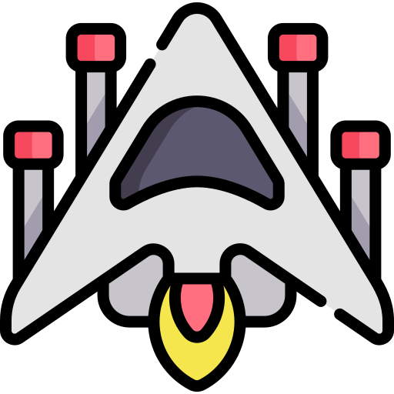
First, let’s download the picture of a space ship. Name it spaceship.png. For example, you can use this one:
https://www.flaticon.com/free-icon/spaceship_1985789

Then, in a new file (call it spacewar.py), type the following.
Note that there’s a lot of code reused from the previous sheet, so you can copy it instead of re-typing everything.

import pygame

pygame.init()
screen = pygame.display.set_mode((800, 600))
clock = pygame.time.Clock()
running = True
spaceship = pygame.image.load('spaceship.png')
# Our spaceship points up, make it point right.
spaceship = pygame.transform.rotate(spaceship, -90)
spaceship = pygame.transform.scale(spaceship, (64, 64))
x, y = 0, 0

MIN_X, MIN_Y = 0, 0
MAX_X = screen.get_width() - spaceship.get_width()
MAX_Y = screen.get_height() - spaceship.get_height()

def handle_events():
global running
for event in pygame.event.get():
if event.type == pygame.QUIT:
running = False

def move_spaceship():
global x, y
pressed = pygame.key.get_pressed()
if pressed[pygame.K_UP]:
y -= 10
if pressed[pygame.K_DOWN]:
y += 10
if pressed[pygame.K_LEFT]:
x -= 10
if pressed[pygame.K_RIGHT]:
x += 10
if x < 0:
x = 0
if x >= MAX_X:
x = MAX_X
if y < 0:
y = 0
if y >= MAX_Y:
y = MAX_Y

def draw():
screen.fill("black")
screen.blit(spaceship, (x, y))
pygame.display.flip()

while running:
handle_events()
move_spaceship()
draw()

clock.tick(60) # limits FPS to 60

pygame.quit()

