Controls System Lab 3 : Introduction to Simulink Colin Roskos

An introduction to Simulink through the Spring-Mass system problem.

This lab was successful to the introduction of Simulink and its interface with the Matlab CLI. The results are as expected, with the varying B-Value reducing the overshoot as it increases.

The representation of the model is as shown below, with its outputs listed on page 2, and the code defining the output at the end of this document.

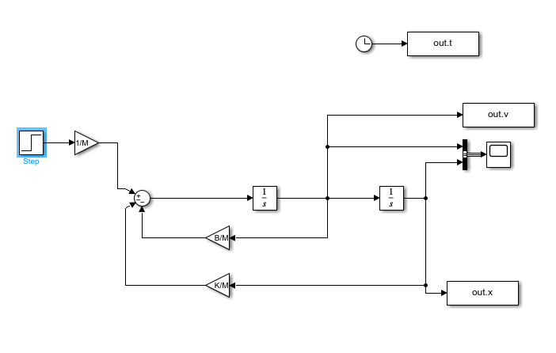

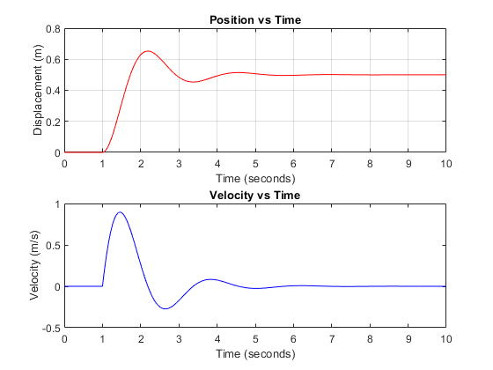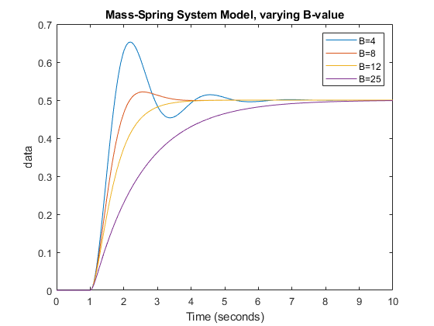

Code:

ex1_para.m

%% Parameters for Ex1

M=2;

B=4;

K=16;

ex1_plot.m

% This file is named ex1_plot.m.

% It plots the data produced by exl_model.mdl for

% several values of B. Execute exl_parameter.m first.

subplot(2,1,1);

plot(out.x, "red", DisplayName="Position"); grid;

ylabel("Displacement (m)");

title("Position vs Time");

subplot(2,1,2);

plot(out.v, "blue", DisplayName="Velocity");

ylabel("Velocity (m/s)");

title("Velocity vs Time");

ex2_plot.m

% This file is named ex2_plot.m.

% It plots the data produced by exl_model.mdx for

% several values of B. Execute exl_para.m first.

out = sim("ex1_model") % Has the same effect as clicking on

% Start on the toolbar.

plot(out.x, 'DisplayName', sprintf("B=%d", B)) % Plots the initial run with B=4

title("Mass-Spring System Model, varying B-value") % setting the figure title

hold on % Plots later results on the same axes % as the first.

B = 8; % New value of B; other parameter values % stay the same.

out = sim("ex1_model") % Rerun the simulation with new B value.

plot(out.x, 'DisplayName', sprintf("B=%d", B)) % Plots new x on original axes.

B = 12; out = sim("ex1_model"); plot(out.x, 'DisplayName', sprintf("B=%d", B))

B = 25; out = sim("ex1_model"); plot(out.x, 'DisplayName', sprintf("B=%d", B))

legend;

hold off