Ecological divergence of DNA methylation patterns at distinct spatial scales

H. De Kort**\***, B. Panis, D. Deforce, F. Van Nieuwerburgh, O. Honnay

**\* Correspondence to:** hanne.dekort@kuleuven.be

**Figures S1 - S7**

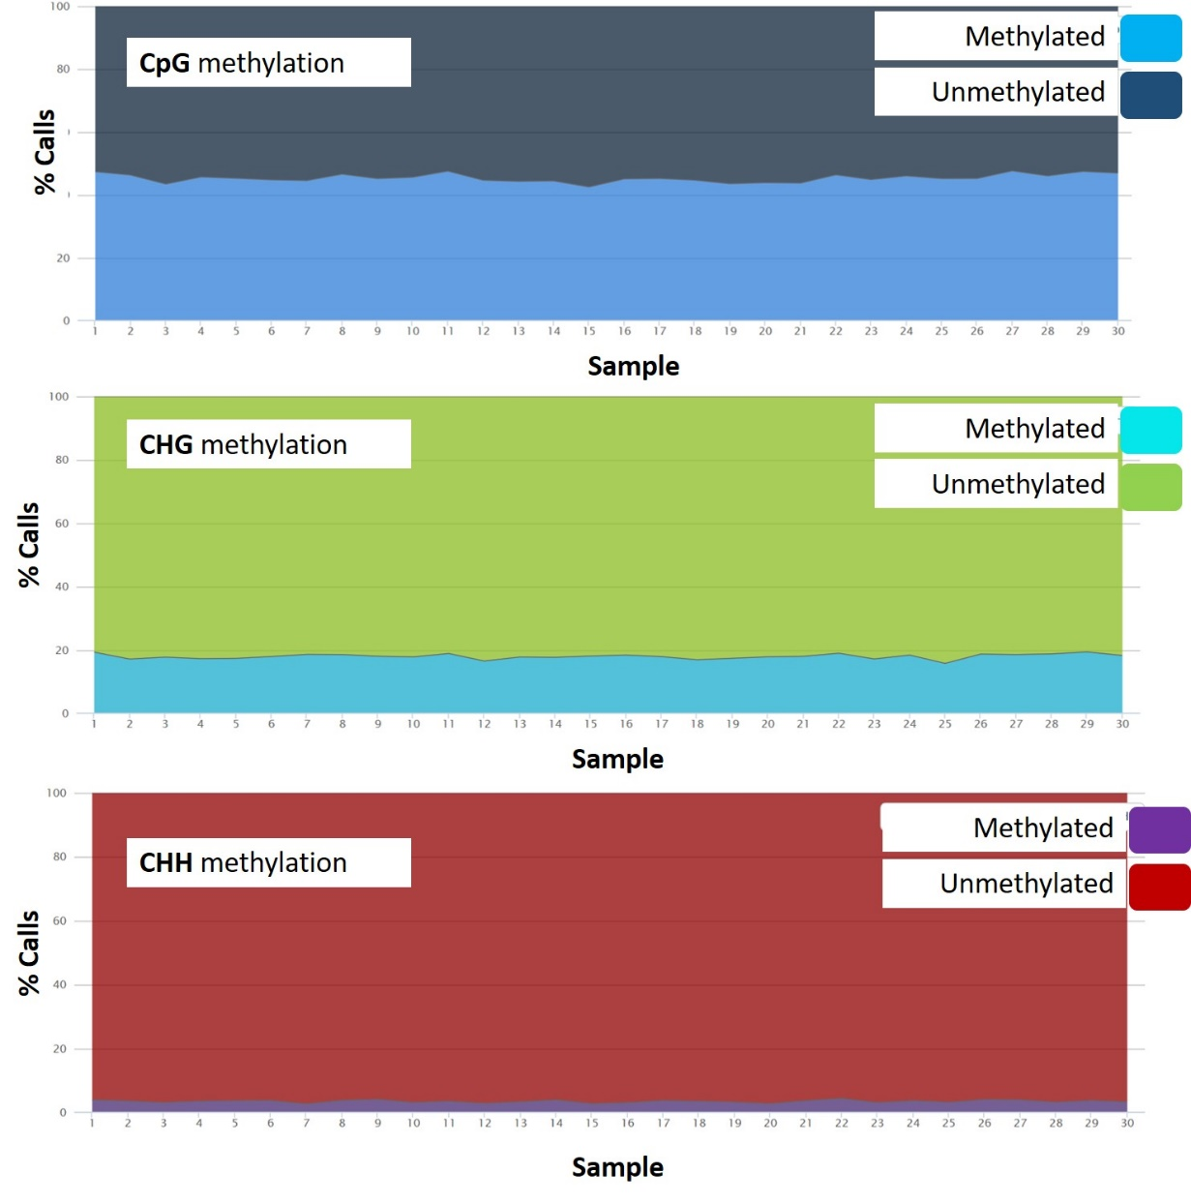

**Fig. S1**. Proportion of cytosines that were methylated across the genome, within each sample, and for each sequence context (CG, CHG and CHH, respectively).

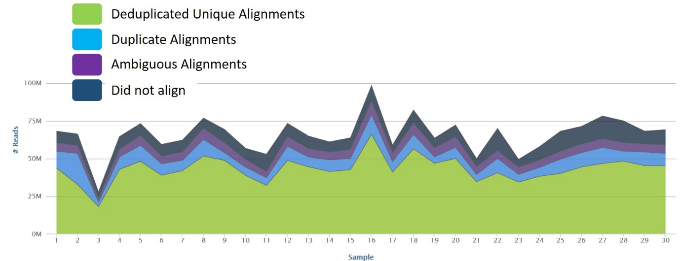

**Fig. S2.** Number of reads sequenced and aligned against the *F. vesca* genome in each sample.

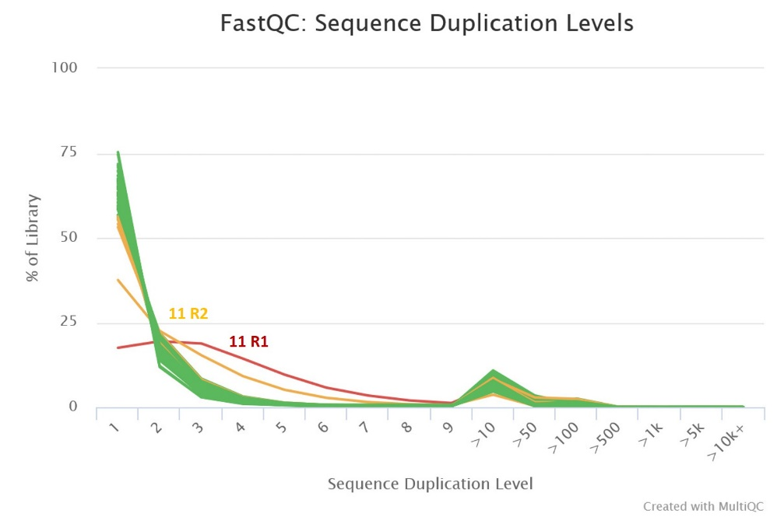

**Fig. S3**. Sequence duplication levels for each of the 30 individuals subjected to whole genome bisulfite sequencing. Individual 11 showed suspicious levels of duplication and was therefore removed from the data-analysis.

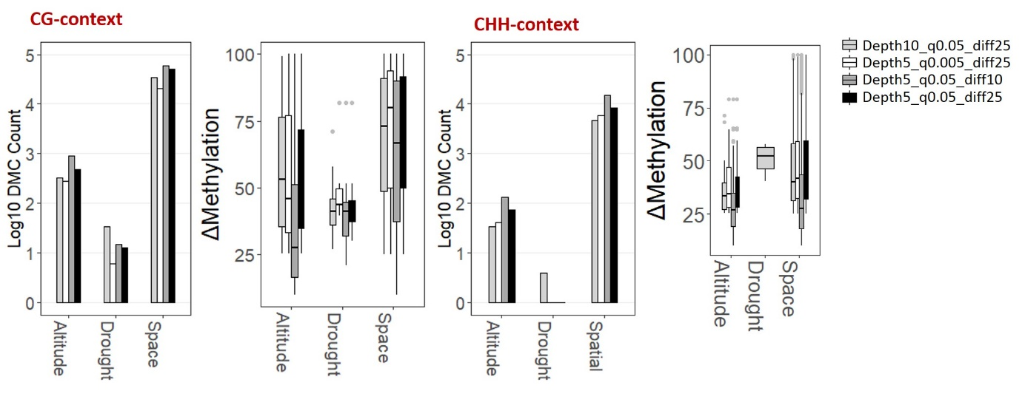

**Fig. S4.** Methylation patterns among the studied gradients (Altitude, Drought, Space) for all DMCs in CG and CHH context while considering **alternative DMC calling parameters**. The default parameters (used for downstream analyses) for significant DMCs are sequencing depth of at least 5, q-value < 0.05 and methylation difference of at least 25% (black bars).

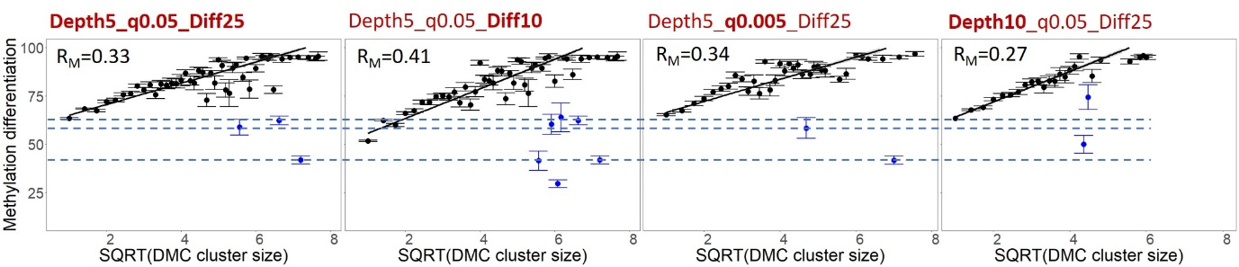

**Fig. S5.** Relation between methylation differentiation and cluster size compared between **alternative DMC calling parameters.** Blue colour represents DMC outliers that deviate from the modeled relationship between methylation differentiation and cluster size. Dashed lines indicate the overlap in outliers between alterantive DMC scenarios. Note that increasing sequencing depth decreases the probability of finding large DMC clusters (right panel), while decreasing the differentiation threshold (second pandel) increases the strength of the relation between metylation differentiation and cluster size. RM (marginal R) was obtained through running the mixed model [DMC differentiation ~ ClusterSize + 1 | Cluster_ID] and represents the amount of variance in methylation differenation that can be explained by cluster size while controlling for cluster ID.

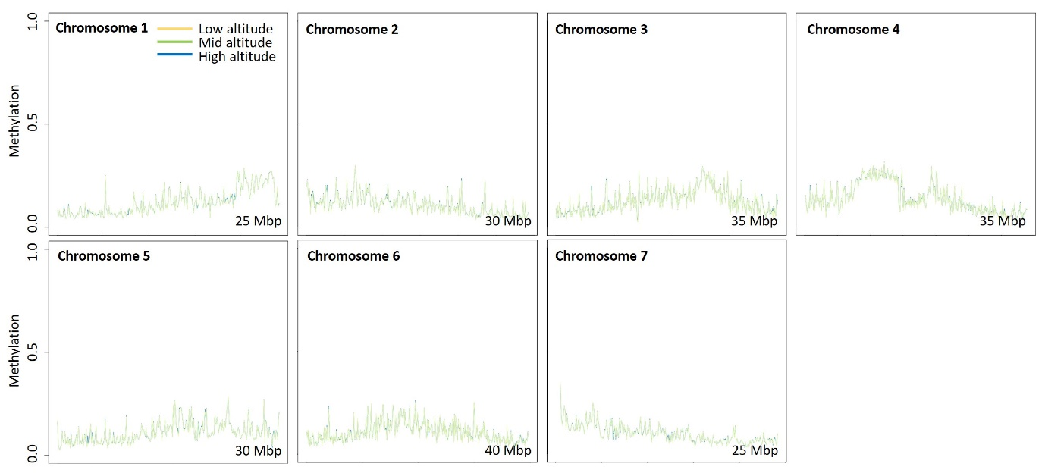

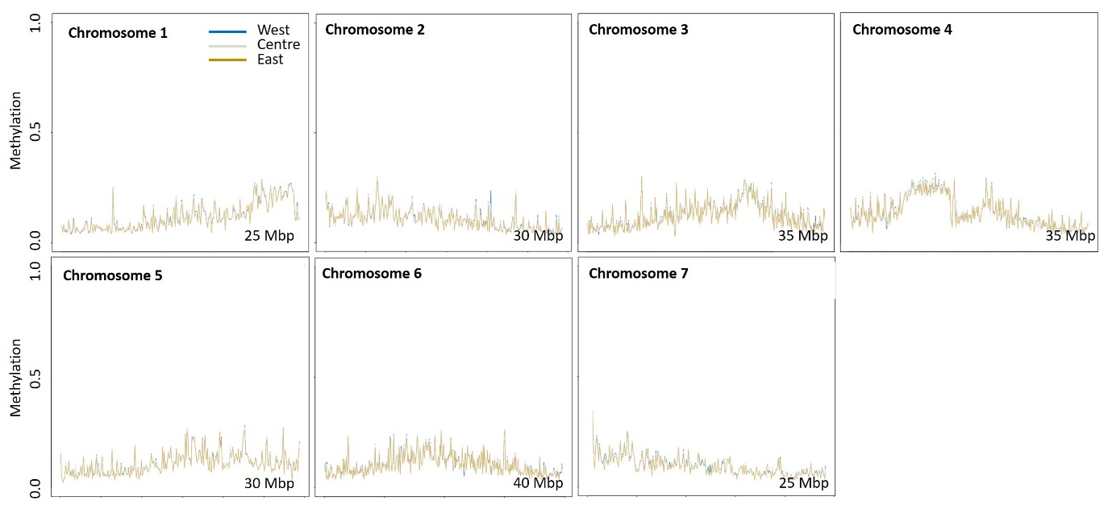

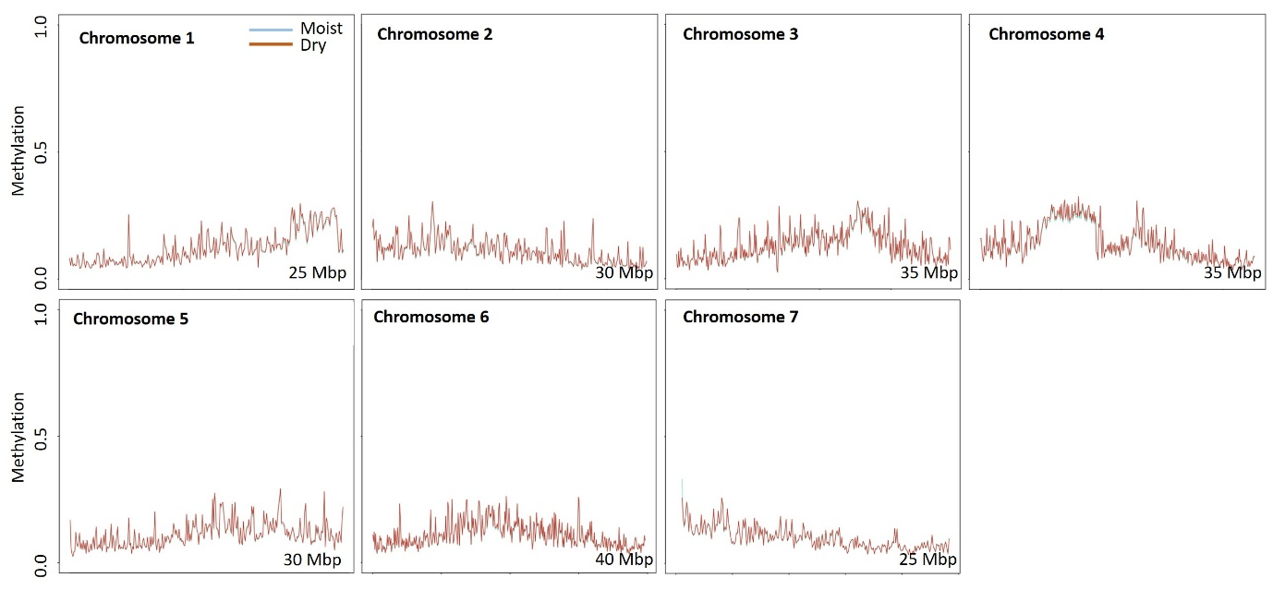

**Fig. S6.** Genome-wide methylation levels at small spatial scale (upper graphs), large spatial scale (central graphs), and between soil moisture treatments (lower graphs).

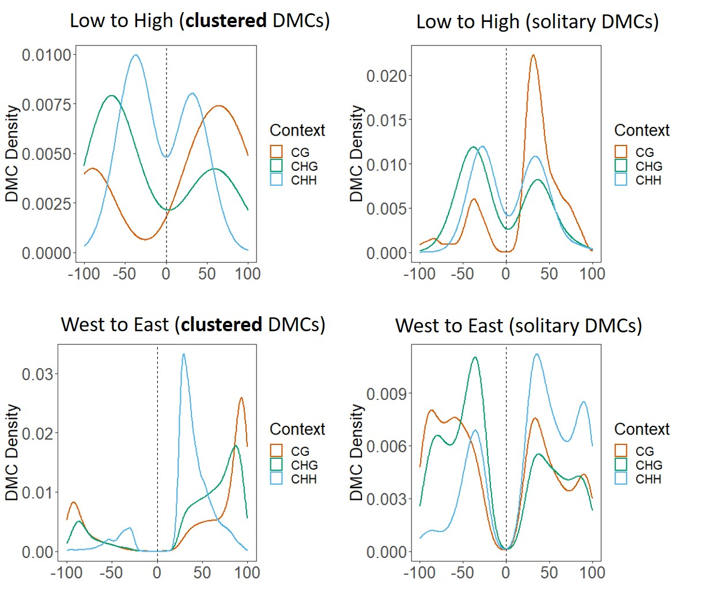

**Fig. S7**. DMC density plots showing the abundance of DMCs in different cytosine contexts and for clustered vs. solitary DMCs. Solitary DMCs (CG DMCs in particular) seem to play a dominant role at the fine altitudinal gradient while clustered DMCs (CHH and CG DMCs in particular) are more important at the large spatial scale.