**Colin Smith – X00175174**

**EX1.**

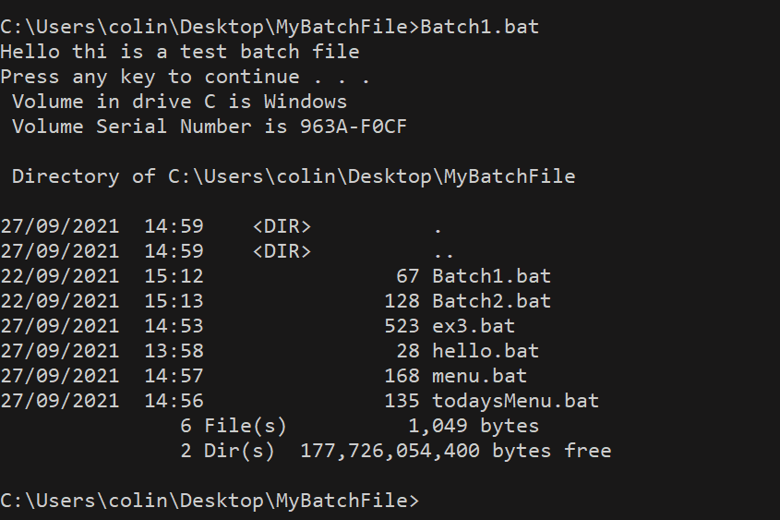

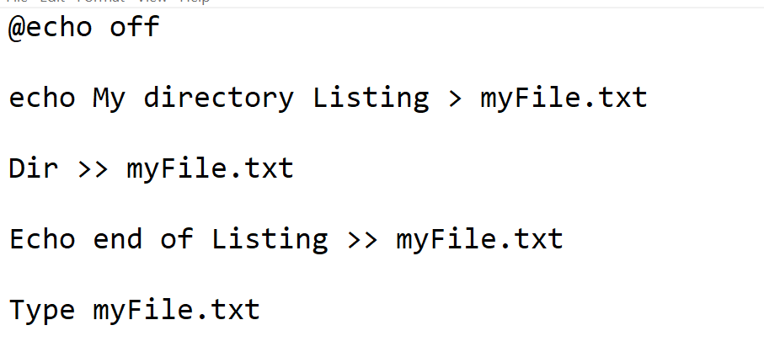

**EX2.**

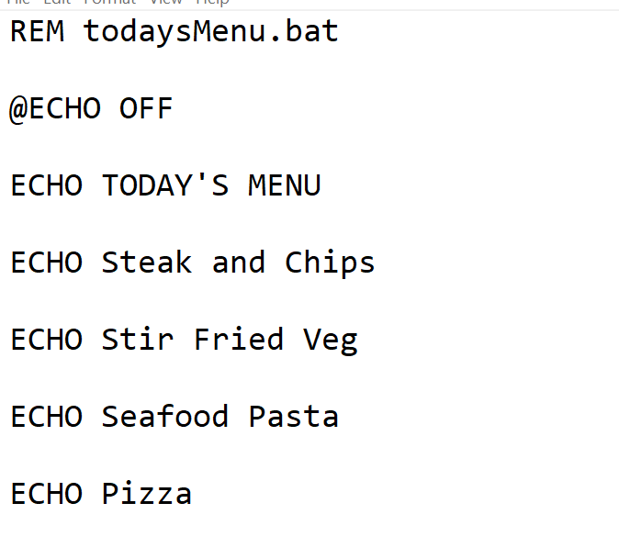

**EX3**

