

# Colin Smith X00175174

Instructions:

Create a MS Word document with the solutions of each exercise. Include your name and x-number.

# Exercise 1.

Create a text file (called employee) with the following information:

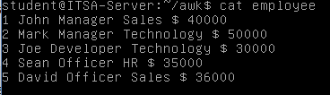

* 1. Try and then explain the outputs of the following AWK statements.

$ awk ‘BEGIN { FS = “ ” ;} {print $2;} ‘ employee – Finds and prints the 2nd column printing per line in each row

$ awk ‘{sum=sum+$6;} END{print “Total salary: ” sum;}’ employee – Adds the 6th row together into the variable sum which then adds up all the salaries the END just makes it so it prints only one line with the total salary at the end

$ awk ‘{sum=sum+$6; print “Total salary: ” sum;}’ employee – prints the total salary sum line per line adding the next salary onto the next line and printing it every time till the final salaries added

$ awk ‘{if($1 > 40000){ print $2” – “$6; }}’ employee - prints the column 2 and 6 of where row 6 is greater than 40000.

$ awk ‘$6>40000’ employee – prints the entire row of where row 6 is greater than 40000.

$ awk 'BEGIN {print "Name\tRole\tDepartment\tSalary";}

{print $2,"\t",$3,"\t",$4,"\t",$NF;}

END{print “End of Report \n--------------";}’ employee – Creates a table layout with the heading columns Role Department Salary with the columns 2 – 4 under the headings with an end of report finishing print.

* 1. Using the previous text file (employee) create an AWK statement to calculate:
     1. The average salary in this company



* + 1. The average salary for “Technology” department only



* + 1. The total salary paid in “Sales” department only



* + 1. Number of “Officer” employees

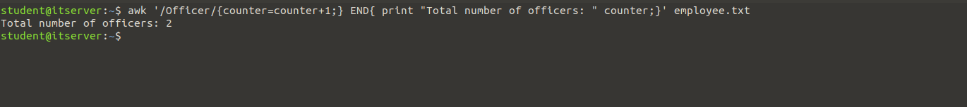



# Exercise 2.

Create the following script (called script2.sh) to process “/etc/passwd” file. Show execution of your

script (screenshot). Explain the output of the script.

## #!/bin/bash directory=$1 file=$2 path=$1/$2

**cat $path | awk ‘BEGIN{FS=“:”;}{print $1;}’ | sort**

*Script execution:*

## ./script2.sh /etc passwd

## Prints the directory followed by the files and is sorted in alphabetical order

Exercise 3.

Create AWK statements to do the following:

* Print the total number of kilobytes used by files with extension ‘sh’.



* Count the number of lines in a file.

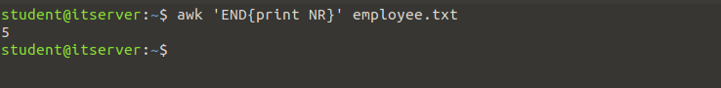

Exercise 4.

: