

Colin Smith – X00175174

# Instructions:

Create a MS Word document with the solutions of each exercise. Include your name and x-number.

# Exercise 1.

Provide **screenshots** of your AWK statements for question. You must also show your scripts/awk statements running (**screenshots**).

1. Create a text file called “Buses.txt” with the following content (*You can use VIM editor*):

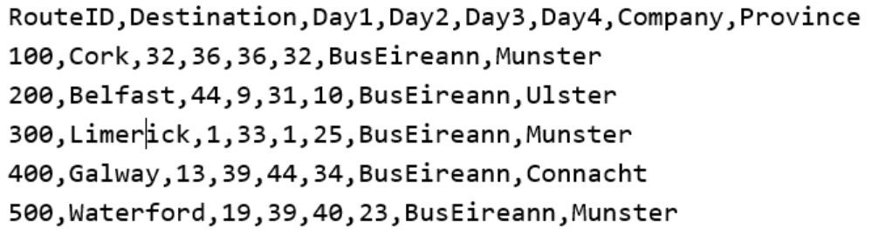

1. Write **AWK statements** that will calculate and display the following:
   1. The total number of customers traveling to “Connacht” over the four days.



* 1. List the destination name **and** total count of the routes having more than 20 people traveling on Day1.



* 1. Average number of travellers on the five Bus Eireann routes.



*Sample output*: **The average number of travellers per bus route over the four days is: 108.2**

* 1. The number of routes with more than 30 people traveling to “Munster” on day4.



ercise 2.

Create the following scripts (*a,b,c*). Provide screenshots of the scripts.

1. A Python script (helloFunction.py) with a function called “hello” which will accept a

parameter.

*Hint:*

def **hello** (parameter):

# Write the function code here

#

* within main part of the script call ***hello*** function using a parameter e.g.: hello ("World")

hello (“everybody”) hello (“John”)

## Sample Script Execution:

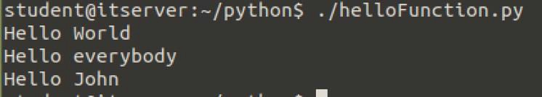

1. A Python script (fahrenheitToCelsius.py) with a function called “farenheit” which will accept a parameter and convert Celsius to Fahrenheit degrees.

*Formula*: Temp_in_Fahrenheit = (Temp_in_celsius * 9 / 5) + 32

*Hint:*

def **fahrenheit**(Temp_in_celsius):

# Write the function code here

#

* Within main part of the script calculate Fahrenheit temperatures from 0 to 50 Celsius degrees
* use a loop) and call the function in every loop iteration.

2



## Sample Script Execution:

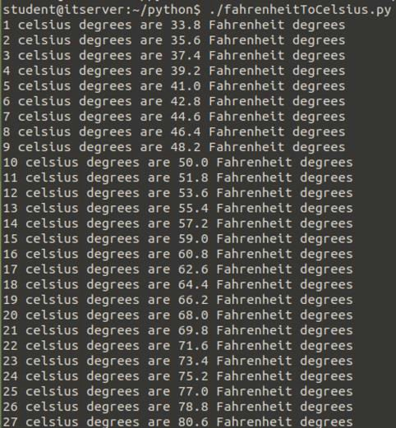

1. A script (*math_op.py*) with a function called "sum_op" which will accept two parameters (numbers). Use the **return** statement.

*Hint:*

def **sum_op**(number1,number2):

# Write the function code here return result

res = return_sum(4,5)

print(“Addition result: ” + str(res))

## Sample Script Execution:



3



# Exercise 3.

4