

Colin Smith – X00175174

# Instructions:

Create a MS Word document with the solutions of each exercise. Include your name and x-number.

# Exercise 1.

Sample String: ‘The script is not poor!’

Expected Output: ‘The script is very good!’

# Exercise 2.

* + Create a **Python function** which can create **and** print a **dictionary** where the keys are numbers between 1 and 20 (both included) **and** the values are square of keys.

## i.e.: 1:1, 2:4, 3:9, 4:16 …etc.

* + Show a screenshot of the function running

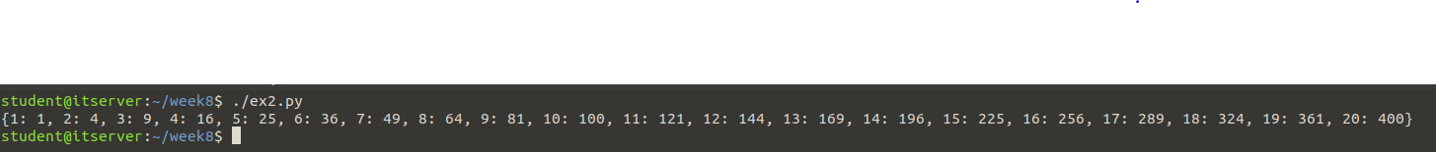



# Exercise 3.

* + Create a Python Script to find a phone number in a string.
  + The phone number pattern as follows:
    - an opening bracket,
    - two numbers,
    - a closing bracket,
    - a hyphen,
    - three numbers, o a hyphen, and o four numbers.

**Example**: (01)-444-2424

c

**NOTE**:.

*Example Output:*

Enter a valid phone number: (01)-444-2424

True

Enter a valid phone number: Test-string

False

# Exercise 4.

1. Using Regular expressions, write a **Python Script** that accepts a hyphen separated sequence of words as input and prints the words in a hyphen-separated sequence
2. after sorting them alphabetically.
3. Finally, replace the ‘-’ by ‘/’

*Sample Input* : green-red-yellow-black-white

*Expected Result* : black/green/red/white/yellow

:

# Exercise 5.:

* + Create a **Python Script** (***emailValidator.py***) to verify if a string (Input for the user) contains a valid email address using a ***regular expression***.
  + Assume simple email addresses [user1@domain.com](mailto:user1@domain.com) i.e ., not including the special characters such as .,_-

