Dusk Refiner

DESIGN DOCUMENT

By Iron5 for Pirate Software Game Jam

**Introduction 2**

Game Summary Pitch 2

Inspiration 2

Platform 2

Development Software 3

Genre 3

Target Audience 3

**Concept 3**

Gameplay overview 3

Theme Interpretation (Shadows and Alchemy) 3

Primary Mechanics 4

**Art 4**

**Audio 4**

**Game Experience 5**

UI 5

Controls 5

**Development Timeline 5**

## 

## **Introduction**

### **Game Summary Pitch**

Dusk Refiner is a 3d horror game about harvesting shadows from a procedurally generated maze and refining them into upgrades and tools.

### **Inspiration**

**Mike Klubnika**

The art direction, worldbuilding and feelings of player agency are inspired by the games of Mike Klubnika, specifically his unsorted horror series.

**Lethal Company**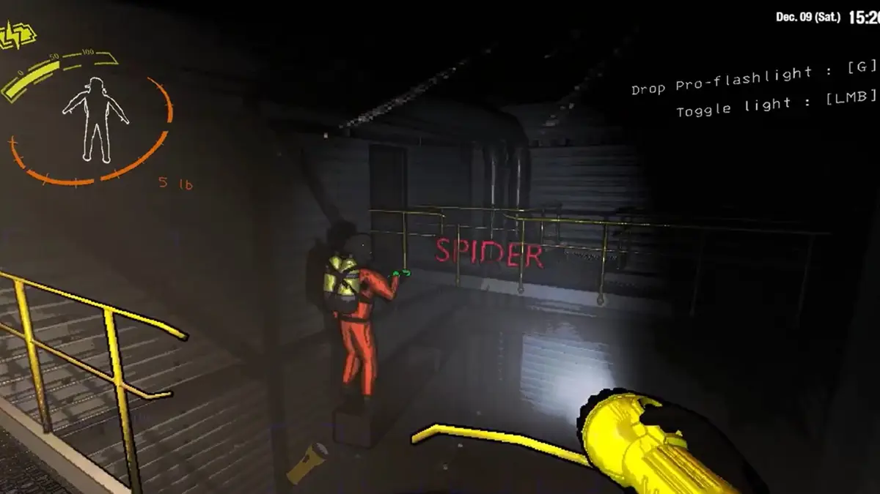

Lethal Company provides the main inspiration for the procedural mazes and the main gameplay loop. (But without the multiplayer because I’m not good enough for that yet)

### **Platform**

The game will be developed for general PC platforms (Windows, Mac, Linux) with potential for a VR port.

### **Development Software**

* Godot 4.2 (Main engine / coding environment)
* Blender (3D modeling)
* GIMP (Texture art / misc graphics)
* Audacity (Sound)

### **Genre**

Singleplayer, First-Person 3D, horror, dungeon crawler / roguelike

### **Target Audience**

The horror theme and lack of clear gameplay direction / instructions means this is marketed for experienced gamers who liked games like Iron Lung.

## **Concept**

### **Gameplay overview**

The player will enter a procedurally generated maze with a flashlight and hunt for “shadows” (negative light sources) and collect them to bring back to their alchemy table where they can refine the darkness into tools and upgrades.

### **Theme Interpretation (Shadows and Alchemy)**

**Shadows:** The player is searching through a dark maze to find persistent shadows which they then collect *dusk essence* from to refine.

**Alchemy:** The alchemy is with the player taking the *dusk essence* they collected and then refine down to create upgrades and tools.

### **Primary Mechanics**

**Collecting *Dusk Essence*:** This is the main gameplay loop. You walk around a maze with a flashlight looking for shadows and then collect them with your handheld refiner.

**Synthesizing Upgrades:** After you’ve collected an amount of Dusk Essence you’ll find your way back to the main base of operations which has an Alchemy Table which the player can use Dusk Essence to synthesize tools and upgrades with

**Monster(s):** There will be a monster (or multiple) traversing the maze. They’ll make obvious sound cues for you to track their movement around the maze. When they’re near you you’ll have to turn off your flashlight and stick to the sides of the maze so you don’t get caught.

## **Art**

The art direction is low poly models with pixelated textures. This art style seems achievable for a team of one person who doesn’t have the best art skills. This art style is also reminiscent of games like my inspirations which manage to create an eerie atmosphere with it.

## **Audio**

To create a scary and mysterious atmosphere instead of traditional background music there will just be miscellaneous ambience. Sounds of machinery and wind will be the main focus. In the safe room / main base there will be a radio playing music to create a warming atmosphere when out of the maze.

## **Game Experience**

### **UI**

The plan is for most of the UI to be diegetic. The exception is the menu and alchemy table which are pixelated with strong buttons, think minecraft UI.

### **Controls**

WASD - Movement

Mouse1 - Flashlight / Item

Mouse2 - Collect Dusk

E - Interact

## **Development Timeline**

**MINIMUM VIABLE PRODUCT**

| **#** | **Assignment** | **Type** | **Status** | **Notes** |
| --- | --- | --- | --- | --- |
| 1 | Design Document | Other | Finished |  |
| 2 | Player movement | Coding | Not started | Move single cells around and collide with walls |
| 3 | Maze Generation | Coding | Not started |  |
| 4 | Flashlight | Coding | Not started |  |
| 5 | Dusk Collection | Coding | Not started |  |
| 6 | Alchemy Table + Upgrades | Coding | Not started | Speed, Collection, Quiet Steps, Supersonic Hearing |
| 7 | Soundscapes | Audio | Not started |  |
| 8 | Monster | Coding | Not started |  |
| 9 | Monster Audio | Audio | Not started |  |
| 10 | Monster Model | Art | Not started |  |
| 11 | Collector Art | Art | Not started |  |
| 12 | Sound Effects | Audio | Not started |  |
| 13 | Alchemy Art | Art | Not started |  |
| 14 | Alchemy Menu Art | Art | Not started |  |
| 15 | Texture Art | Art | Not started |  |
| 16 | Main Menu | Art | Not started |  |

**BEYOND (if ahead of schedule / extra time)**

| Extra Monsters | Coding | Not started | Keep flashlight point at monster |
| --- | --- | --- | --- |
| Settings Menu | Coding | Not started | Volume slider, fullscreen toggle |