Plain Text Workflow

Dennis Tenen, Grant Wythoff

January 20, 2014

# Section 1

## Subsection 1.1

Lorem ipsum dolor sit amet, consectetur adipisicing elit, sed do eiusmod tempor incididunt ut labore et dolore magna aliqua. Ut enim ad minim veniam, quis nostrud exercitation ullamco laboris nisi ut aliquip ex ea commodo consequat.

Next paragraph should start like this. Do not indent.

## Subsection 1.2

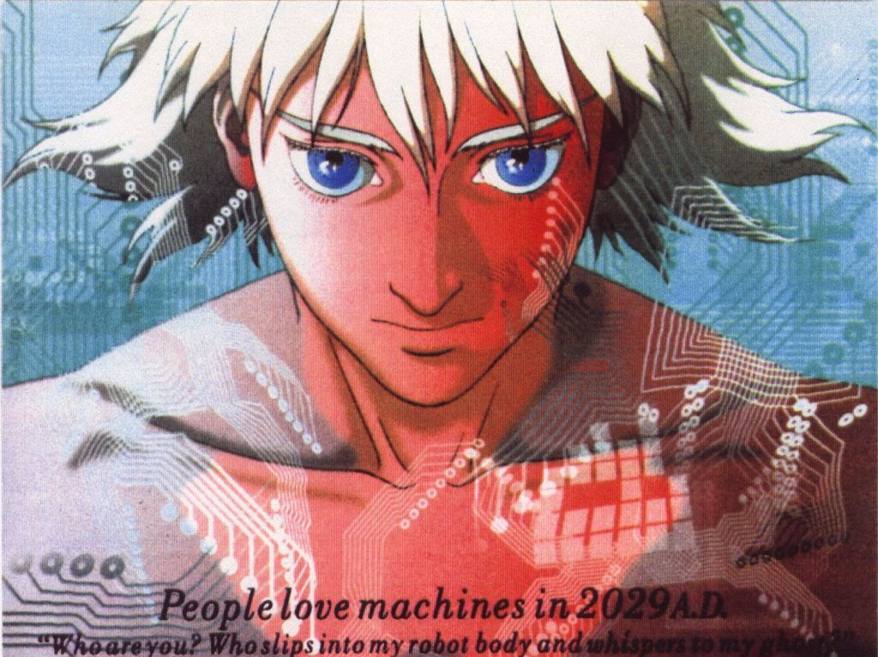

The ghost in question

Sed ut perspiciatis unde omnis iste natus error sit voluptatem accusantium doloremque laudantium, totam rem aperiam, eaque ipsa quae ab illo inventore veritatis et quasi architecto beatae vitae dicta sunt explicabo.

# Section 2

## Subsection 2.1

A sentence that needs a note.[1]

1. my first footnote! And a [link](https://www.eff.org/). YOu could just the same go to <www.eff.org> but is not working as it should.