### 

### 

**DSO 569 Final Project:**

**License Plate Reader Using CNN**

Prepared by: Colin Zhou

**Introduction**

In the evolving landscape of urban development, managing vehicular traffic and associated logistics remains a formidable challenge that cities globally continue to face. Traditional License Plate Recognition (LPR) technologies have played a crucial role in addressing these challenges; however, they frequently encounter issues such as variable plate formats, diverse lighting conditions, and different viewing angles. These challenges often result in high error rates and inefficiencies, underscoring the need for more advanced solutions. This report outlines a project that utilizes Convolutional Neural Networks (CNNs) to develop an enhanced LPR system, aimed at surpassing the capabilities of traditional methods.

The evolution of LPR technology has progressively transitioned from basic optical character recognition to more sophisticated machine learning approaches. Building on this technological advancement, our project employs CNNs, known for their robustness in handling visual data under varied conditions. By accurately identifying and interpreting license plates from vehicle images, this advanced technology aims to significantly improve traffic flow, law enforcement, and parking logistics, thus enhancing the efficiency of urban mobility.

The primary goal of this project is to enhance the accuracy and efficiency of LPR systems, thereby supporting traffic law enforcement, automating toll collections, and optimizing parking management. These enhancements are anticipated to reduce operational costs and improve daily commutes. This report will detail the project's preliminary stages, including the assembly and preprocessing of a substantial dataset, which is crucial for training the CNN model. It will also cover the early phases of model implementation, setting the stage for later discussions on system performance and potential business applications, ultimately aiming to provide significant advancements in LPR system functionality across various urban settings.

**Dataset and Image**

**Dataset Introduction**

The foundation of any deep learning project is the robustness and quality of its dataset. For the LPR system utilizing Convolutional Neural Networks, a high-quality dataset is paramount. The dataset for this project was sourced from Kaggle, specifically focusing on Belgian car license plates. Each alphanumeric character from 0-9 and A-Z is well-represented, with over 1,000 images for each category, excluding the letter "O" to avoid confusion with the number "0." The dataset is accompanied by well-annotated XML files for each image, which facilitates precise and efficient label extraction for training the model.

This dataset is particularly suited for tasks involving the classification or detection of license plates in image or video frames. Given the high quality of the images, a substantial computational effort is required, which has been taken into consideration in the system design to manage resource allocation effectively.

**Image Preprocessing**

The initial step in image preprocessing involved loading the images using Keras's image_dataset_from_directory function. To maintain uniformity and enhance computational efficiency, images were resized to 100x100 pixels, despite their original dimensions varying around 75x100. Following resizing, pixel values were normalized to a [0, 1] range. This normalization is crucial as it ensures that the input to the CNN maintains consistent dimensions, vital for optimal feature extraction by the model.

To account for real-world variations that the model might encounter, such as different angles, distances, and partial obstructions, data augmentation techniques were implemented. Techniques included rotation to help recognize plates from various angles, zoom to interpret plates at different scales, and width and height shifts to identify characters even when plates are partially obscured or off-center. Although horizontal flipping was considered, it was used sparingly due to the directional nature of text, which is rarely reversed in real-world scenarios. (See Appendix A)

**Validation Set Preparation**

The validation set, making up approximately 20% of the total dataset or about 7,000 images, was processed with normalization only, without augmentation. This approach ensures the model's performance during validation accurately reflects its ability to generalize to new, unmodified real-world data, rather than merely recalling features enhanced through augmentation.

The strategic integration of original and augmented data for training establishes a robust foundation for subsequent CNN model development. This comprehensive preparation ensures the model is equipped to perform with high accuracy under a variety of challenging real-world conditions.

**CNN Model Architecture**

The architecture of the Convolutional Neural Network designed for this project is tailored to efficiently classify license plate images, starting with a convolutional layer that utilizes 32 filters of size 3x3 to extract foundational features such as edges and textures from the input images. This is immediately followed by a 2x2 max pooling layer with a stride of 2, which serves to reduce the spatial dimensions of the feature maps, thereby decreasing both the computational complexity and the number of parameters within the network. To further mitigate the risk of overfitting, a dropout layer with a rate of 0.2 is integrated subsequent to the max pooling layer.

Building upon this initial configuration, the architecture repeats the sequence but with an enhanced convolutional layer that contains 64 filters of the same size. This layer allows the network to capture more complex features, essential for the nuanced task of license plate recognition. After the convolution and max pooling, another dropout layer is employed to continue regularization, ensuring that the model maintains generalization capabilities. Once the feature detection is sufficiently abstracted through these layers, the network transitions the data through a flattening process, converting the 2D feature maps into a 1D feature vector. This vector then feeds into a fully connected layer comprising 64 neurons, which performs high-level reasoning based on the extracted and processed features. To finalize the classification, the architecture includes an output layer with 35 neurons, corresponding to the classes represented in the one-hot-encoded labels of the dataset. (See Appendix B)

ReLU activation function is applied across all hidden layers to enable efficient learning without the hindrance of vanishing gradients, while the softmax activation function in the output layer calculates a probability distribution over the 35 classes, ensuring that each image is classified into one of the predefined categories. The model uses categorical cross-entropy as its loss function to optimize the classification process, which is particularly suited for scenarios involving multiple classes.

During the model's training phase, batches of 64 images were processed, which, given the dataset size of approximately 56,000 images, resulted in 888 steps per epoch. The training was set to continue for 10 epochs, resulting in validation accuracies that notably exceeded those of the training phase, coupled with lower validation losses. This discrepancy initially raised concerns regarding potential underfitting; however, further evaluation involving separate training sessions with only the original dataset and only the augmented dataset clarified that the model was effectively capturing the critical features from the original images and was capable of generalizing well to unseen normal images encountered in the validation set. This high level of accuracy on unseen images confirms the model's robustness and the efficacy of the architectural and training strategies employed in this deep learning project.

**Business Implications**

The deployment of the LPR system using CNN presents substantial opportunities for enhanced operational efficiency and improved revenue generation across various sectors. The system’s utility in urban traffic management, commercial logistics, and law enforcement underscores its versatile applications and potential economic impacts.

**Urban Traffic and Parking Management**

The deployment of the CNN-based LPR system in parking facilities presents a substantial opportunity for urban centers such as Los Angeles, where managing parking efficiency is critical due to high vehicle densities. By automating the vehicle entry and exit processes using LPR technology, shopping centers and public parking lots can significantly reduce the time customers spend waiting for parking verification. This automation not only enhances user experience but also ensures a higher accuracy in toll and fee collection, potentially increasing revenue. Moreover, the system's ability to collect and analyze data on parking usage patterns can help facility managers optimize space utilization, leading to a more efficient allocation of parking resources.

**Retail and Commercial Logistics**

In the retail and commercial sectors, the LPR system can be a pivotal tool for improving the efficiency of inventory management and supply chain operations. By implementing LPR at warehouse entry and exit points, businesses can streamline the tracking of shipments, reducing labor costs associated with manual check-ins and minimizing the risk of errors. This automation also enhances security protocols, enabling precise vehicle identification and preventing unauthorized access to sensitive areas, thereby safeguarding assets and reducing theft-related losses.

**Law Enforcement and Public Safety**

For law enforcement agencies, the LPR system offers a powerful resource for automated vehicle identification and monitoring, particularly in high traffic areas or at critical checkpoints. This capability supports traffic regulation efforts and can assist in the rapid identification of stolen or flagged vehicles. Integration with existing surveillance systems can further extend the utility of LPR technology by providing real-time alerts on suspicious vehicles, thus enhancing public safety and response times in emergency situations.

**Economic Impact and Scalability**

The economic benefits of integrating LPR systems extend beyond operational efficiencies. For instance, reducing manual labor in parking and logistics can directly decrease operational costs while increasing profit margins through more accurate billing and reduced leakage in revenue collections. However, the scalability of LPR systems and their integration into existing urban infrastructures pose challenges, including compatibility with different camera and software systems and the need for significant initial investment in technology. Addressing these challenges requires a detailed cost-benefit analysis to ensure that the long-term benefits justify the upfront costs.

By addressing these specific business implications, stakeholders can better understand the potential impact of LPR systems in various sectors and plan for their integration in a way that maximizes benefits while minimizing disruptions to existing operations.

**Conclusion**

The development and deployment of the LPR system utilizing CNN marks a significant milestone in leveraging machine learning for practical applications in traffic management and law enforcement. This project has demonstrated the efficacy of CNNs in accurately identifying and interpreting license plates from a variety of vehicle images, achieved through meticulous data preprocessing, strategic model design, and comprehensive training and validation processes. The adaptability and robustness of the CNN architecture have not only enabled the creation of a model that excels in controlled experimental settings but also shown promising results in real-world scenarios. The system's potential to enhance urban mobility, improve safety, and increase efficiency in parking management, law enforcement, and commercial logistics underscores the practical value of integrating advanced machine learning technologies into everyday urban operations.

Future work should focus on expanding the capabilities of the LPR system to adapt dynamically to new license plate formats and integrate seamlessly with other traffic and surveillance systems. Evaluating the economic impact through pilot implementations could provide tangible benchmarks for cost savings and efficiency gains, offering a clearer pathway for widespread adoption. Moreover, considerations regarding privacy and regulatory compliance are paramount as deployment scales up. Establishing guidelines and protocols to address these concerns will be crucial in ensuring that the deployment of such technologies aligns with legal standards and public expectations. As industries and public sectors continue to explore and expand the capabilities of AI-driven technologies, the insights and methodologies developed in this project lay a solid foundation for further innovations. These advancements are poised to enhance not only urban mobility but also the broader landscape of smart city technologies, making our cities safer and more efficient.

**Appendix A**

**Dataset link on kaggle:** [**License Plate Digits Classification Dataset (kaggle.com)**](https://www.kaggle.com/datasets/aladdinss/license-plate-digits-classification-dataset)

**Image samples**

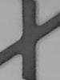

**Image before augmentation Image after augmentation**

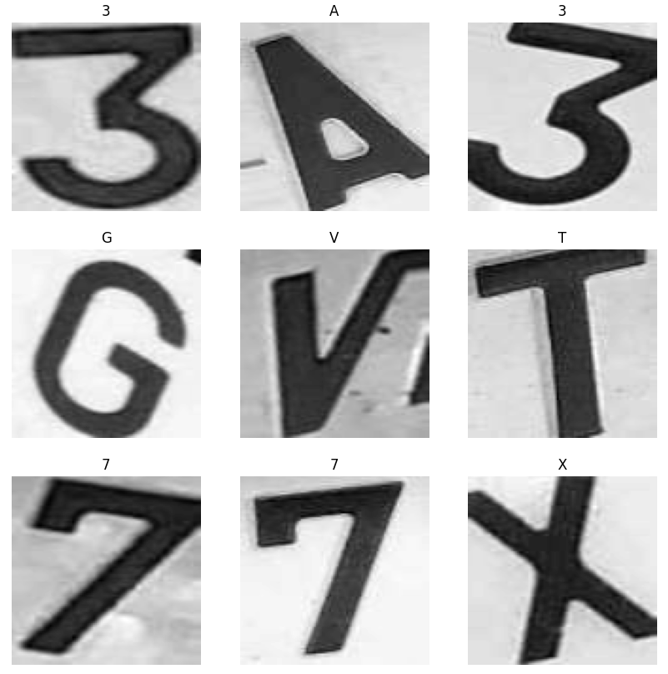 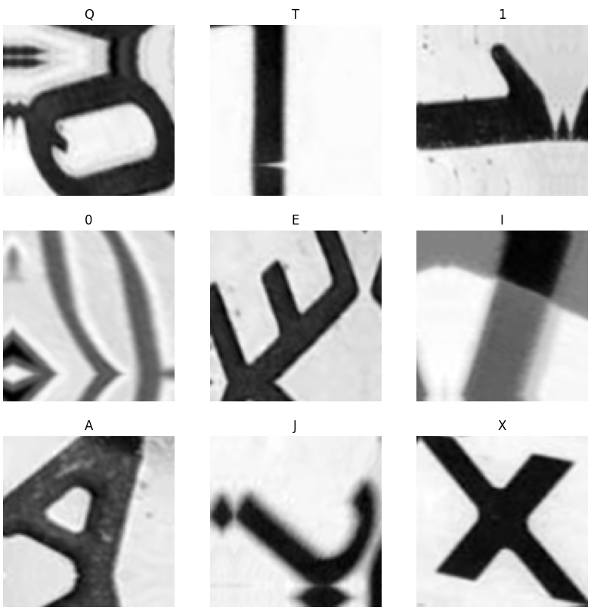

**Appendix B**

**CNN Model Architecture**

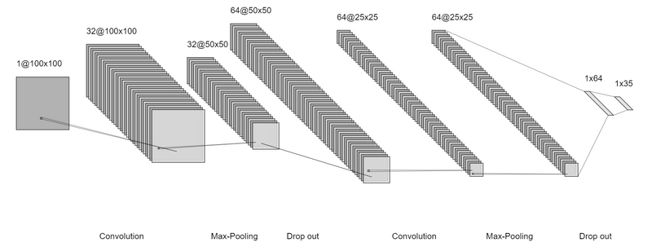

**CNN Model Summary Model Results**