

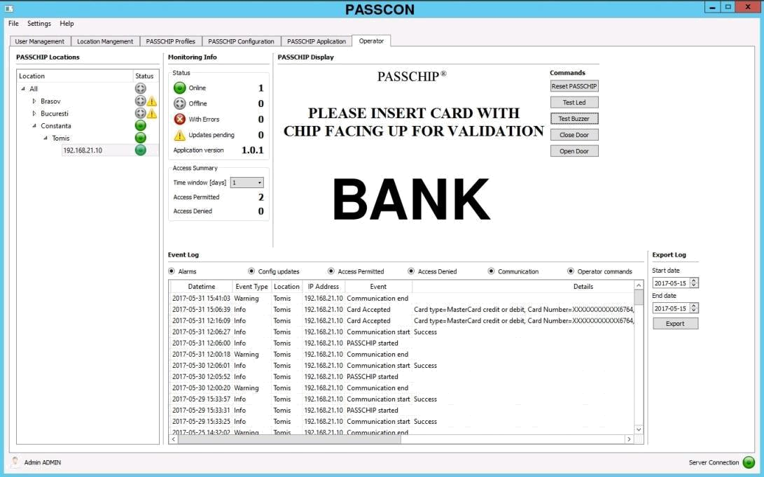

Functions

Client Server architecture
PASSCHIP monitoring
PASSCHIP configuration

PASSCHIP Centralized Log collection and management PASSCON user rights and management Email Alerts

CONIC DESIGN® --- PASSCHIP® | Printed in Romania
1 Piata Presei Libere, 1st District, 013888, Bucharest, Romania
Tel: 0040745342887, office@passchip.com |  | www.passchip.com

PASSCON®

Management Software

This product is the complete management solution for PASSCHIP ATM entry lobby/vestibule readers, integrating the real time monitoring with the provisioning and configuration functions.

It is mainly dedicated to large number of site installations.

It allows multiple level hierarchy classifications (eg. area, city, street and site). Provides a powerful yet intuitive interface to manage and monitor the PASSCHIP readers.


Benefits

Centralized management of PASSCHIP ATM entry lobby/vestibule

Easy configuration changes by using PASSCHIP Configuration Profiles

Remote firmware updates Summarized monitoring information

Different users can have different access rights

Secure communications between PASSCON Server and PASSSCHIP

Data subject to change without notice


Installation
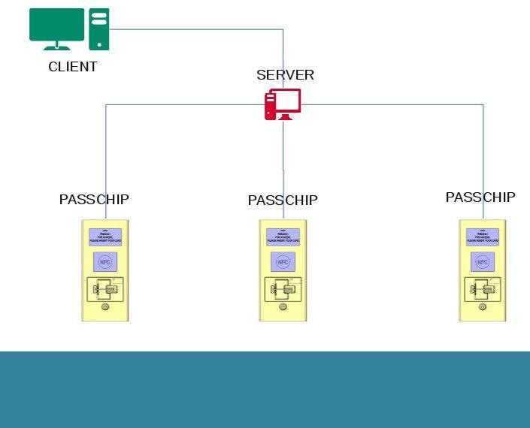

Licensing

Standard License 200 PASSCHIPs
Extra (incremental) package of 100 PASSCHIPs

CONIC DESIGN® --- PASSCHIP®
1 Piata Presei Libere, 1st District, 013888, Bucharest, Romania Tel: 0040745342887, office@passchip.com
ATM readers.


Technical Specifications

PASSCON Server Hardware Requirements
Communication | Ethernet 100Base-TX /
 | 1000Base-T
Memory | 4 GB
Processor | x64 Quad Core @2Ghz
Operating System | LINUX, Windows 7, Windows
 | 2008 Server, Windows 2012
 | Server
Storage | 250 GB
Display resolution | 1280x1024
Database Hardware Requirements
Storage | 10 MB / PASSCHIP / year
Type | Microsoft SQL, MySQL
Communication | Ethernet 100Base-TX /
 | 1000Base-T
Memory | 4 GB
Processor | x64 Quad Core @2Ghz
Client Hardware Requirements
Memory | 2 GB
Processor | x64 Dual Core
Communication | Ethernet 100Base-TX /
 | 1000Base-T
Operating System | Windows 7, Windows 8.1,
 | Windows 10

Printed in Romania Data subject to change without notice

www.passchip.com

