CENTRALIZED ADMINISTRATION SOFTWARE OF THE ID SMART ACCESS CHIP READERS FOR SELF SERVICE AREAS

PASSCON®

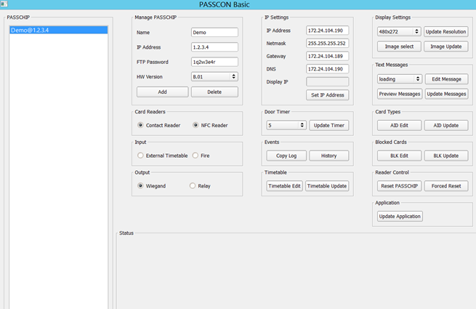
Basic

Main Functions

Complete IP control: Configuration, Administration, User Management, Monitoring and Recording

Centralized network upgrade of readers while running using an user friendly interface

Centralized access to internal PASSCHIP history resources, including sincronized time stamp

Centralized cards’ management, including BLACK LIST

Represents an advanced programming and configuration tool for PASSCHIP range of self service ID chip readers.

It provides an user friendly interface that simplifies the PASSCHIP control.

Offers a centralized Ethernet administration, using unique software functions for all the network; important savings are made in terms of time and specific resources of the security managers.

Facilitates PASSCHIP integration with CCTV, fire and intrusion detection through Wiegand, Ethernet and Serial interface.

Benefits

- Protection of customers during self-service procedures

- Protection of ATMs and banking assets against unauthorized usage

- Extremely reliable product with an excellent ROI rate

- Proven long life service

- May be integrated with third parties security software, including biometric applications

- May be linked and integrated with CCTV, fire and intrusion detection

- Excellent substitute to human guard patrol service

--- PASSCON® | Printed in Romania |  |  | Data subject to change without notice
1 Piata Presei Libere, 1st District, 013888, Bucharest, Romania
Tel: 0040745342887, Fax: 0040378104216, office@passchip.com |  | www.passchip.com

CENTRALIZED ADMINISTRATION SOFTWARE OF THE ID SMART ACCESS CHIP READERS FOR SELF SERVICE AREAS

Installation Technical Specifications

Configuration example of PASSCHIP with door module:
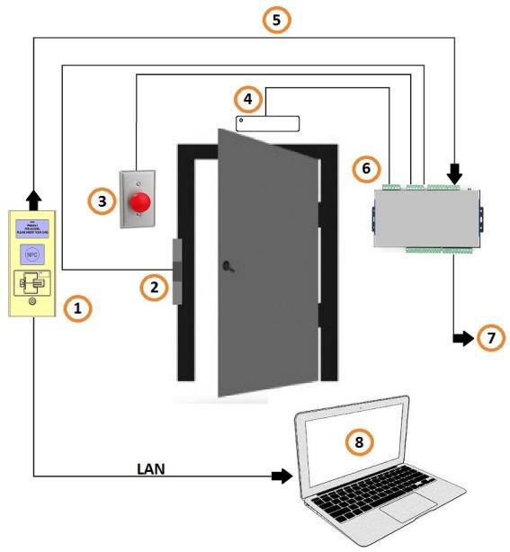

- = PASSCHIP;
- = Door lock;
- = Exit button;

- = Door magnetic sensor;
- = Communication between readers and control unit;

- = Control unit;

- = Wiegand communication to an external access control system;

- = PC with PASSCON Basic parameterization software via Ethernet

Ordering Information

- PASSCON BASIC: Administration platform software, unlimited number of panels, one user

- PASSCON GUI: Administration graphical software 0->100 panels, one simultaneous user

- GSSACDU: Upgrade option for GSSACD: 100->unlimited panels, one simultaneous user

- SMUS: Additional simultaneous user for GSSACD

Computer Requirements | Windows XP or higher
 | Intel CORE 2 or higher
 | 32 MB of RAM
 | 100 MB HDD free space
 | CD ROM player, keyboard and
 | mouse
PC Configuration | Max number of connected PC with
 | running PASSCON software: 1
 | with basic license, unlimited
 | according additional licensing
Panels Configuration | Max number of panels on
 | administration platform:
 | unlimited(limited functions)
 | Max number of panels on graphical
 | platform: 100, unlimited according
 | additional licensing
Users Configuration | Max number of simultaneous
 | users: 1, unlimited according
 | additional licensing
Communication with PASSCHIP | Ethernet
Transfer of parameterization | On line, during PASSCHIP
 | functioning
NTP | YES
Black list management | YES, online programable for
 | maximum 1 000 card profiles
Panels’ History Log access | YES, limited to 5MB, aprox.10 000
 | events with time stamp (panel’s
 | capacity)
Language | English

--- PASSCON® | Printed in Romania |  |  | Data subject to change without notice
1 Piata Presei Libere, 1st District, 013888, Bucharest, Romania
Tel: 0040745342887, Fax: 0040378104216, office@passchip.com |  | www.passchip.com

