**PASSCHIP**

**24/24 access by contact CHIP or contactless NFC**

**CONIC DESIGN PRODUCES THE WORLD’S FIRST BANK ID SMART ACCESS CHIP READER FOR SELF SERVICE AREAS.**



1

**PASSCHIP – SOLUTION OVERVIEW**

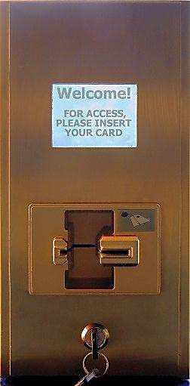

Specially designed for advanced 24h self banking zones or high security spaces: ATM lobbies, treasuries, boxes of values, etc.

**How it works and solution features**

* The customer uses its bank card in order to have an authorized entrance into the bank subsidiary or self service area
* The access selection is performed according to one or more selected criteria by the solution administrator such as: Name / Surname mentioned on the credit card **(BLACK LISTS may be implemented)**

Last four digits of the credit card number

Type of credit card (Visa, Visa Electron, Visa Business, Visa Gold, Maestro....) Card expiration date. BLACK LIST is possible

* Communication with users / card owners is ensured by text messages and pictures according to the chosen language
* The equipment can simultaneously display a text message in more languages
* The events history can be internally accessed and managed by the bank security administrator



2

**PASSCHIP – BENEFITS AND ADVANTAGES**



**BENEFITS FOR THE BUSINESS**

Improved customers protection and comfort during self-service procedures

Card reading by contact CHIP or contactless NFC

Reduced rate of incidents at ATMs and high security areas

Increased security level – higher protection of banking assets against unauthorized usage

Strong and stable access control platform

Ethernet instant history reports of access events Excellent Return of Investment rate

Reduced costs with guard patrol service, customer care and transportation

Proven long live service in any environment Increased Bank’s image

**ADVANTAGES OF PASSCHIP**

Access of programmable groups of users as

decided by system’s administrator;

Configuration to allow access for any credit card’s

owner depending of the bank’s own security policy

Equipment connectivity to any new or existing

access control platform using the most commonly

used data formats: WIEGAND and/or Ethernet IP

Solution integration with CCTV, fire and intrusion

detection through any security platform

Built in vandal proof concept, with a very strong stainless steel case with opening tamper and a specially protected LCD screen

Advanced graphical user interface through any written language

On line software upgrade

On line Black List

On line reports



3

**PASSCHIP – DIFFERENTIATORS**

* Passchip is the single worldwide control access solution for self banking, dedicated to CIP based cards; all the other control access solutions use the reading technology of magnetic cards
* **The advantages of reading the CIP based bank cards**:

The information extracted from CIP based cards is more difficult to clone

The information from CIP based cards is almost impossible to replicate illegally

CIP technology does not give reading errors

CIP technology cannot deteriorate in comparison to the magnetic band cards, which has a limited number of readings

The magnetic cards technology is closing to an end in Europe



4

**PASSCHIP – TECHNICAL OVERVIEW**

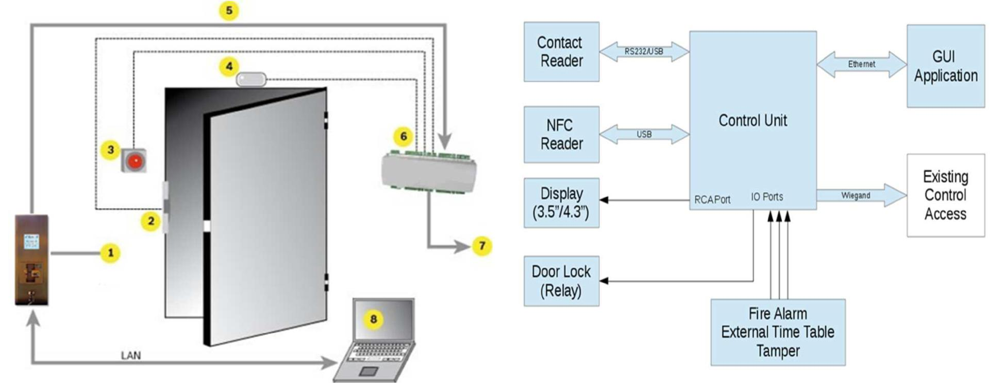

5

**ADMINISTRATION SOFTWARE**

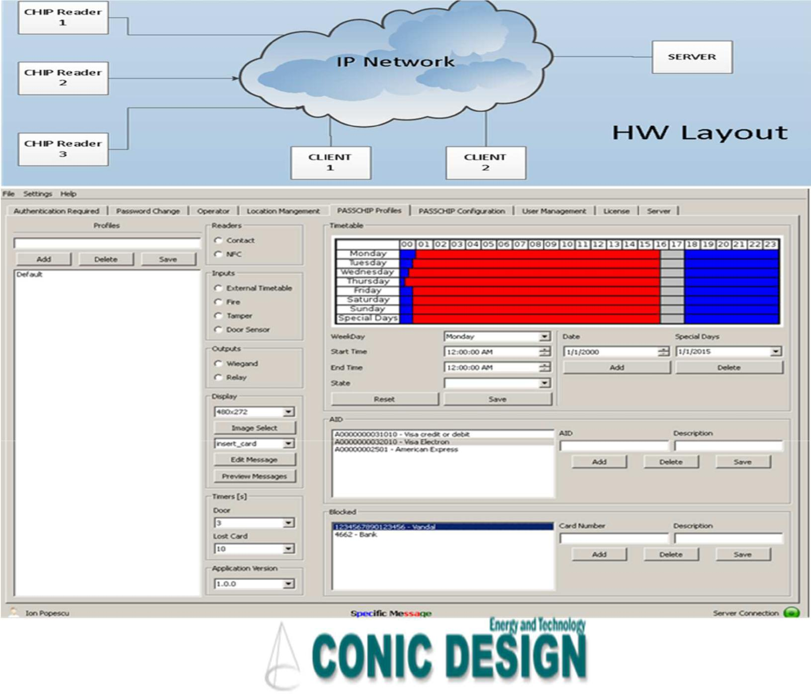

6