

**PASSCHIP®**

**LPR Reader**

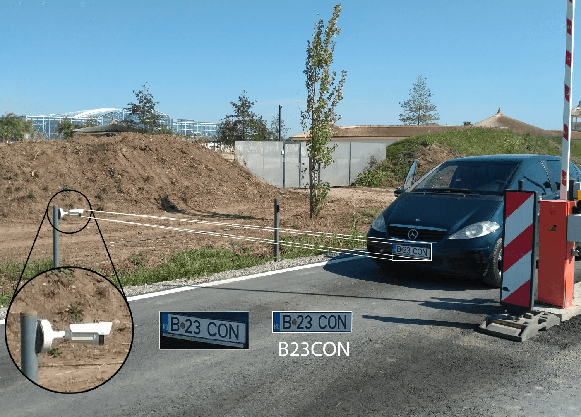

Our License Plate Reader offers automatic number plate reading combined with wiegand communication. The LPR reader transforms seamlessly integrated license plate reading into a wiegand card ID reader output. It includes all hardware and software required to integrate in standard access control systems, eliminating complex integration issues associated with alphanumeric license plates.

It can work in standalone mode or may be connected to any access control platform using the most commonly used data formats like RS232, Clock and Data or Wiegand with up to 64 bits of data.

It is standard delivered with a solid TCP/IP interface for fast and continuous communication with the centralized security center in order to be online updated by system’s administrator.

PASSCHIP LPR is specially designed for outdoor

installation in most severe environment conditions,

being the most suitable solution for installing

anywhere in the world with minimum maintenance

costs. It is vandal resistant.

|  |  |  |
| --- | --- | --- |
| Functions |  | Benefits |
|  |  |  |

Our License Plate Reader is an all-in-one system that embeds camera, projector and processing in a compact weatherproof housing. Management is simple using an embedded web browser interface, through the available Ethernet connection.

Accuracy of plate reading is very high due to the high resolution image sensor and advanced detection algorithm.

The LPR unit allows for simple set up and easy deployment. The embedded browser based interface is supplied for initial configuration and on-going management. The module provides plate detection and notification information.

The web browser interface also allows the integrator to configure the transmitted wiegand ID strings of the ALPR reader. Upon reading of the license plate the ALPR unit will refer to the database and transmit the corresponding wiegand ID using chosen wiegand format to the access control panel. If the wiegand ID is authorized then access is permitted.

The LPR reader is featured with an internal database that matches the license plate to a specific valid Wiegand card ID (i.e. the already existing card number of the person that drives the car). This matching can be done easily and from a remote location using the web browser interface.

|  |  |  |  |  |
| --- | --- | --- | --- | --- |
| CONIC DESIGN® --- PASSCHIP® | Printed in Romania | | | Data subject to change without notice |
| 1 Piata Presei Libere, 1st District, 013888, Bucharest, Romania |  |  |  |  |
| Tel: 0040745342887, office@passchip.com |  | [www.passchip.](http://www.passchip.)com |  |  |

|  |  |  |
| --- | --- | --- |
| Installation |  | Technical Specifications |
|  |  |  |

Observations

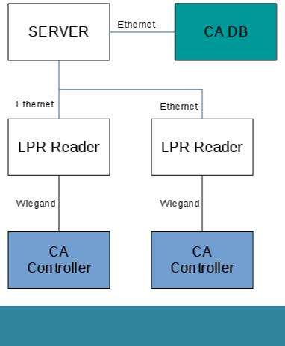

Server hardware specifications depend on the number of LPR Readers and their usage. License Plate - Card ID correspondences are provisioned directly in the server or extracted from CA Database (where possible) to avoid double provisioning.



Ordering Information

* CDLPR 100/1: LPR reader with Wiegand communication
* SLPR1: Server

|  |  |
| --- | --- |
| **LPR Reader** |  |
| Communication | Ethernet 100 Base- |
|  | TX/10Base-T RS232 up to |
|  | 115200 Bit/sec |
|  | Clock and Data |
|  | Wiegand up to 64 bit |
| Memory | Internal DRAM 1 GB |
|  | SD slot available 1xMMC |
|  | Real time clock with back-up |
|  | Li-Ion maintenance free |
|  | battery |
| Camera | 2MP 1080P, Optimized IR |
|  | 30m, 30fps WDR, Light |
|  | finder |
| Processor | ARM 64-bit, 1.2 GHz, Quad |
| Operating System | Linux OS |
| Software Upgrade | On line, during functioning |
| Power Supply | 85-264 VAC, 45-65 Hz |
|  | 12 VDC |
| Power Consumption | Max. 40 W |
| History Log capacity | Internal 5MB, aprox.10 000 |
|  | events with time stamp |
| Lens | Brushed stainless steel |
|  | vandal resistant |
| Max car Speed | 200 km/h |
| Response time | Max 2 sec |
| Construction | Aluminum vandal resistant |
|  | painted case |
| Agency Approvals | CE Conformity |
| and Standards |  |
| Ambient conditions | Operating Temp:-30 C +50 C |
|  | Storage Temp:-35 C +60 C |
|  | Humidity: 10-95% |
| Size of LPR Reader | 170 x 195 x 80 mm |
| (W x H x D) |  |
| Weight | 4 kg |
| Protection Class | IP67 |
| Reading distance | 3-10m |
| Black list | YES, online programmable |
|  | for maximum 1000 license |
|  | plates |
| PTZ | Digital PTZ |

|  |  |  |  |  |
| --- | --- | --- | --- | --- |
| CONIC DESIGN® --- PASSCHIP® | Printed in Romania | | | Data subject to change without notice |
| 1 Piata Presei Libere, 1st District, 013888, Bucharest, Romania |  |  |  |  |
| Tel: 0040745342887, office@passchip.com |  | [www.passchip.com](http://www.passchip.com) |  |  |