**CHIP READER**

A. Description

CHIP READER enables Banks to facilitate the access of customers to the 24Hours Self Service area, in a secured, automatic way. The system will be very flexible, allowing multiple possible configurations, will have its intuitive GUI administration software.

B. Hardware

The CHIP READER will have a main control unit which will be configured to work with a smart CHIP contact card reader, with a NFC card reader or both. Also the system will have input/output ports allowing to be interconnected with other access control systems. The magnetic stripe reading is not acceptable.

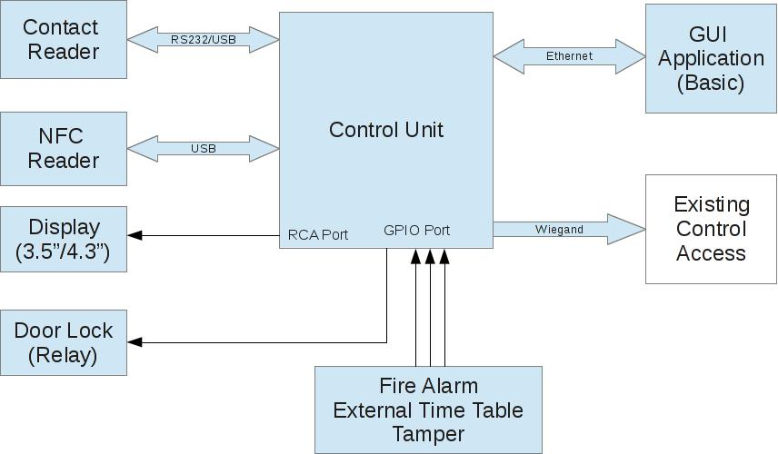

**Control Unit**: represents the core of the system. It will have IO ports which will permit controlling otheroutput devices like door lockers or to monitor outside sensors like Fire Alarm, External Time Table or Tamper.

The control will have serial communication ports such as RS232 or USB ports through which it will communicate with the card-reader units, video port for display and Ethernet port for interconnection with the GUI Application running on a PC with Windows OS.

**Contact Reader:** represents the unit through which the users are authenticated using a contact CHIPsmartcard.

**NFC Reader**: represents the unit through which the users are authenticated using a NFC card.

**Important note: Only bank smart cards will be accepted.**

**Display (3.5”or 4.3”)**: will be used for displaying text messages in order to signal some functional stages

of the CHIP READER system like “Loading”, ”Maintenance”, “Out of Service”, etc. or to interact with the users displaying messages like “Insert Card”, “Access Granted”, “Access Denied”, “Card Lost”.

**All text messages which will be shown on display will be configurable by the owner of the system**.

**Door Lock Output**: will represent the output contact through which the CHIP READER system activatesor not the door lock in order to permit or deny access to the 24Hours Self Service area.

The open time for door lockers will be selectable between 1 and 60 seconds.

**Fire Alarm, External Timetable and Tamper Inputs:** represent inputs for the CHIP READER system.

**Wiegand Interface**: represents the communication port through which the CHIP READER systeminterconnects with other existing access control systems (with Wiegand interface) in order to signal events.

**GUI software Application** will be a Windows based application which will have lots of functionalityconferring management and control functions to the whole system. The application will allow the declaration of multiple CHIP READER systems with different configurations, firmware updates, messages editing, background image update.

* + 1. **Insert Card:** this state will be the normal “waiting for a customer state”

Possible transitions:

* Maintenance – if Tamper is enabled and the tamper pin is open or an error is detected
* Insert card – if no card is detected
* Reading Card – if a Card has been inserted
* Card Accepted – if a CHIP/NFC enabled card has been authorized to enter
* Card Expired – if a CHIP/NFC enabled card has been not authorized due to expiration date
* Card Rejected – if a CHIP/NFC enabled card has been not authorized due to Blocked List
* Card not Read – if a CHIP/NFC enabled card has been not authorized due to missing banking application
  + 1. **Card Lost:** this state will be entered if the card has been left in the Contact reader longer than themaximum allowed period. This time period will be configured from GUI, between 1 and 60 seconds

**Offline:** this state will be entered when Fire is enabled and the fire input pin is open.

* 1. Server application

This application will run on a server and is responsible for controlling all readers and serving all requests from Client Application.

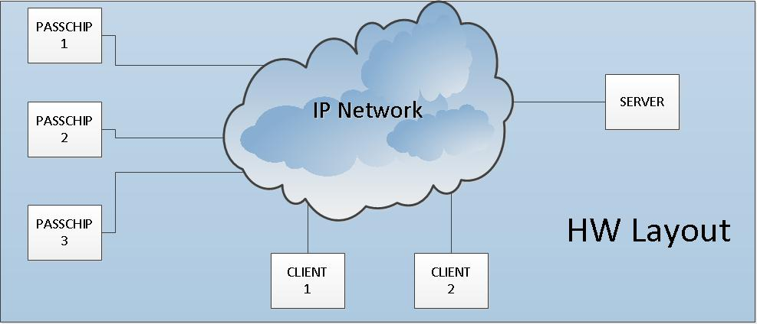

Functionality:

Logging

Monitoring

Statistics (Reports)

User management and configuration

CHIP readers’ management

Security in LAN environment will be made at port level with 802.1X authentication protocol.

All personal info about users will be hidden in logging histories, only full name and last 4 digits of each card will be saved.

The system will allow “black list’’ function for up to 1000 cards.

All persistent data will be stored using a SQL database.

**C1. Client application**

This application will run on user workstations and will be used for managing the entire system (both admin console and operator application).

Resets and shut downs through IP network will be possible.

**C2. External Interfaces**

1. The GUI application will have an outbound / inbound interface for interfacing with 3rd party Identity Management applications
2. User Roles – there will be 3 predefined roles:
   1. Operator – monitors the readers, has access to Event log data
   2. User admin – manages the users, passwords and roles
   3. Reader admin – manages the reader’s configuration data and the location tree
3. Audit logging – the audit data is accessible to external applications
4. Software environment – the operating system will be Linux, the database system will be MSSQL or MySql.
5. Reporting system – various reports will be based on log data and events

|  |  |  |  |  |  |
| --- | --- | --- | --- | --- | --- |
|  | Communication | Ethernet 100 Base-TX/10Base-T | | |  |
|  |  | RS232 up to 115200 Bit/sec | | |  |
|  |  | Wiegand up to 64 bit | |  |  |
|  |  |  |  |  |  |
|  | Memory | Internal DRAM 512 MB, record of | | |  |
|  |  | min 50 configurable ID banking | | |  |
|  |  | cards profiles according EMV or | | |  |
|  |  | non EMV standard, SD slot | | |  |
|  |  | available 1xMMC | |  |  |
|  |  | Real time clock with back-up Li-Ion | | |  |
|  |  | maintenance free battery | | |  |
|  |  |  |  |  |  |
|  | Reference Standards | ISO 7816 with T=0 and T=1, | | |  |
|  |  | EMVCo Level 1, ISO 7810, ISO | | |  |
|  |  | 7811, JIS X6301, JIS X6302I | | |  |
|  | Processor | 32-bit, 700 MHz |  |  |  |
|  | Operating System | Linux OS |  |  |  |
|  | Software Upgrade | On line, during functioning | | |  |
|  | Power Supply | 85-264 VAC, 45-65 Hz, Cold Start, | | |  |
|  |  |  |  |  |  |
|  | Power Consumption | Max. 11 W |  |  |  |
|  | History Log capacity | 5MB, aprox.10 000 events with time | | |  |
|  |  | stamp |  |  |  |
|  |  |  |  |  |  |
|  | Lifecycle | Min 125 000 functioning hours | | |  |
|  |  | Min 500 000 insertion cycles | | |  |
|  | Insertion Speed | 8-127 cm/sec |  |  |  |
|  |  |  |  |  |
|  | Card reading time | Max. 3 sec |  |  |  |
|  | Construction | Flush mount, Antiskimming, metal | | |  |
|  |  | bezel/mask, antivandal, UV filter for | | |  |
|  |  | LCD screen |  |  |  |
|  |  |  |  |  |  |
|  | Display | 3,5” or 4,2’’ TFT LCD | |  |  |
|  |  | Resolution 320x240 pixels | | |  |
|  |  | Contrast ratio 300:1, | | Brightness |  |
|  |  | min 300cd/sqm | Color QVGA 65 | |  |
|  |  | 000 colors |  |  |  |
|  | Ambient conditions | Operating Temp:-30 C | | +50 C |  |
|  |  | Storage Temp:-35 C +60 C | | |  |
|  |  | Humidity: 10-95% |  |  |  |
|  | Sound and interface | Multi-color LED and multi-tone | | |  |
|  |  | buzzer |  |  |  |
|  |  |  |  |  |  |
|  | Weight | Max 5.90 Kg |  |  |  |
|  |  |  |  |  |  |
|  | Protection Class | IP65 |  |  |  |
|  | Interaction with the user | Virtually any available known | | |  |
|  |  | written language and multitone | | |  |
|  |  | internal buzzer |  |  |  |
|  | Black list | YES, online programmable for | | |  |
|  |  | maximum 1 000 card profiles | | |  |
|  |  |  |  |  |  |