**THE WORLD’S FIRST BANK ID SMART ACCESS CHIP READER FOR SELF SERVICE AREAS**

**PASSCHIP®**

Functions

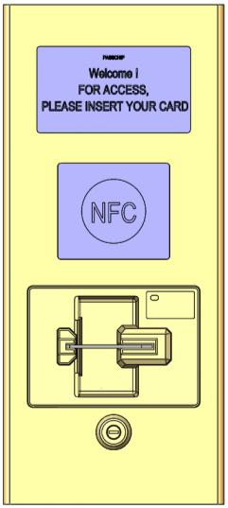

Banking automation filter against unauthorized access in the self-service zones or any other protected areas

Advanced design for integration in any classical or modern façade

Available optional slim-line installing pillar Compact dimensions with tamper-proof solid stainless steel case-brush finishing or painted Full color or monochrome LCD screen

Ready for virtually displaying any text language, pictograms and animation depending of the software customization

Visual and acoustic signals for interfacing with the user

Centralized network upgradable while running using an user friendly interface

Antiskimming and coin proof construction with mechanical shutter

This product is mainly dedicated to banks and financial institutions, with possibilities of usage in law enforcement agencies, telecom providers and other organizations for a secure and efficient access in sensitive areas using advanced contact chip and/or contactless NFC reader technology.

It can be connected to any access control platform using the most commonly used data formats like RS232, Clock and Data or Wiegand with up to 64 bits of data.

It is standard delivered with a solid TCP/IP interface for fast and continuous communication with the centralized security center in order to be online updated by system’s administrator.

PASSCHIP is specially designed for outdoor installation in most severe environment conditions, being the most suitable solution for installing anywhere in the world with minimum maintenance costs. It is built in vandal proof concept, with a very strong stainless steel case with opening tamper and a specially protected LCD screen or.



Benefits

* Protection of customers during self-service procedures
* Protection of ATMs and banking assets against unauthorized usage
* Extremely reliable product with an excellent ROI rate
* Proven long life service
* May be integrated in new or existing access control installations
* May be linked and integrated with CCTV, fire and intrusion detection through any integrated security platform
* Excellent substitute to human guard patrol service

|  |  |  |  |  |
| --- | --- | --- | --- | --- |
| --- PASSCHIP® | Printed in Romania | | | Data subject to change without notice |
| 1 Piata Presei Libere, 1st District, 013888, Bucharest, Romania |  |  |  |  |
| Tel: 0040745342887, Fax: 0040378104216, office@passchip.com |  | [www.passchip.com](http://www.passchip.eu/) |  |  |

**THE WORLD’S FIRST BANK ID SMART ACCESS CHIP READER FOR SELF SERVICE AREAS**



Installation

Configuration example of PASSCHIP with door module:

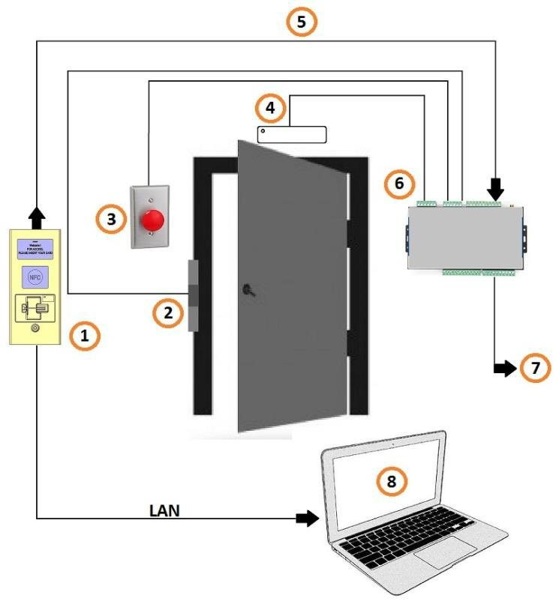

1. = PASSCHIP;
2. = Door lock;
3. = Exit button;
4. = Door magnetic sensor;
5. = Communication between readers and controller;
6. = Controller;
7. = Wiegand protocol to other access control system;
8. = PC with parameterization software via Ethernet(802.1X port authentication)



Ordering Information

* SACD 100/1: Outdoor stainless steel case Color LCD
* SACD 100/2: Outdoor flush mount Kit Color LCD
* SACD 200: Stainless Steel mounting column for SACD100/1 (Size W150 x H1300 x D150 mm)
* PASSCON Basic - Parameterization software
* PASSCON GUI - Client –Server administration software

Technical Specifications

|  |  |  |
| --- | --- | --- |
| Communication | Ethernet 100 Base-TX/10Base-T RS232 |  |
|  | up to 115200 Bit/sec |  |
|  | Clock and Data |  |
|  | Wiegand up to 64 bit |  |
| Memory | Internal DRAM 1 GB, record of min 50 |  |
|  |
|  | configurable ID banking cards profiles |  |
|  | according EMV or non EMV standard, |  |
|  | SD slot available 1xMMC |  |
|  | Real time clock with back-up Li-Ion |  |
|  | maintenance free battery |  |
|  |  |  |
| Reference Standards | ISO 7816 with T=0 and T=1, EMVCo Level 1, |  |
|  |
|  | ISO 7810, ISO 7811, JIS X6301, JIS X6302I, |  |
|  | contactless NFC |  |
| Processor | ARM 64-bit, 1.2 GHz, Quad |  |
|  |
| Operating System | Linux OS |  |
|  |
| Software Upgrade | On line, during functioning |  |
| Power Supply | 85-264 VAC, 45-65 Hz, Cold Start, |  |
|  |
|  |  |  |
| Power Consumption | Max. 30 W |  |
| History Log capacity | 5MB, aprox.10 000 events with time stamp |  |
|  |
|  |  |  |
| Lifecycle | Min 125 000 functioning hours |  |
|  |
|  | Min 500 000 insertion cycles |  |
| Insertion Speed | 8-127 cm/sec |  |
|  |
| Reading time | 1-3 sec |  |
|  |
| Construction | Applied mount in Stainless Steel case or Flush |  |
|  |
|  | mount in Aluminium painted case, Antiskimming, |  |
|  | metal bezel, antivandal, UV filter for LCD screen |  |
|  |  |  |
| Display | LCD: 4,3’’ 480x272 pixels Contrast ratio 300:1, |  |
|  |
|  | Brightness min 300cd/sqm Color min QVGA |  |
|  | 65 000 colors |  |
|  |  |  |
| Agency Approvals and Standards | CE Conformity |  |
|  |
| Ambient conditions | Operating Temp:-30 C +50 C |  |
|  |
|  | Storage Temp:-35 C +60 C |  |
|  | Humidity: 10-95% |  |
| Sound and interface | Multi-color LED and multi-tone buzzer |  |
|  |
|  |  |  |
| Size o f c ontr olle r (W x H x D) | 138 x 312 x 124 mm -Applied model |  |
|  |
|  | 170 x 195 x 80 mm -Flush mount |  |
|  |  |  |
| Weight | 3.90 Kg |  |
|  |
| Protection Class | IP65 for Applied model |  |
|  |
|  | IP50 for Flush mount |  |
| Interaction with the user | Virtually any available known written |  |
|  |
|  | language and multitone internal buzzer |  |
|  |  |  |
| Black list | YES, online programmable for maximum |  |
|  |
|  | 1 000 card profiles |  |
|  |  |  |
| NFC | OPTIONAL |  |
|  |
|  |  |  |

|  |  |  |  |  |
| --- | --- | --- | --- | --- |
| --- PASSCHIP® | Printed in Romania | | | Data subject to change without notice |
| 1 Piata Presei Libere, 1st District, 013888, Bucharest, Romania |  |  |  |  |
| Tel: 0040745342887, Fax: 0040378104216, office@passchip.com |  | [www.passchip.com](http://www.passchip.com) |  |  |