

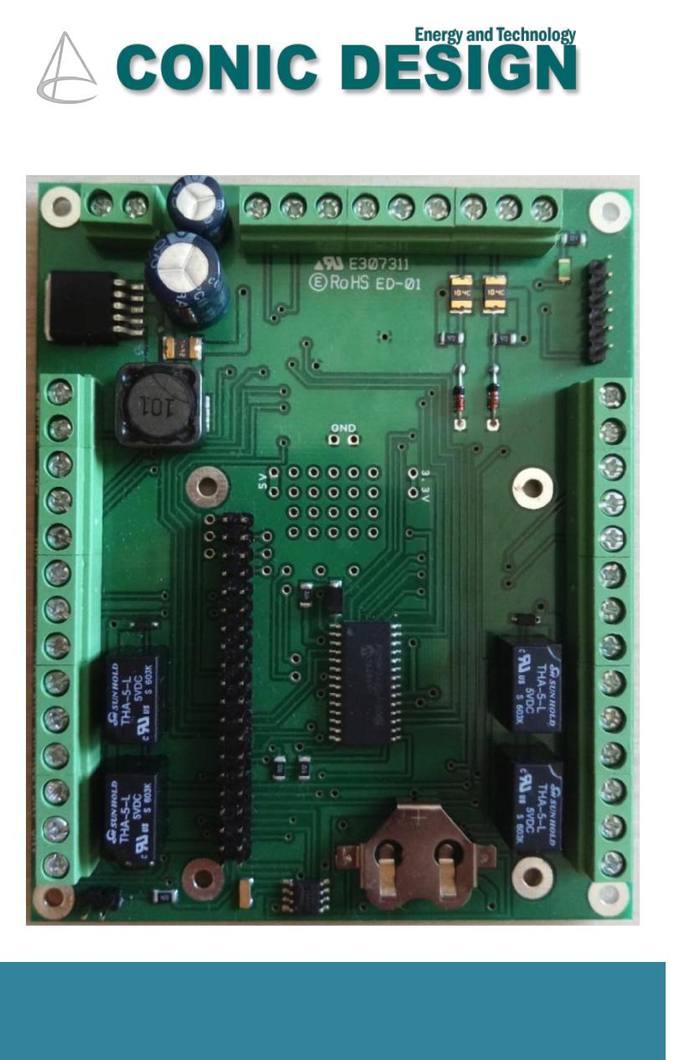

Functions

Automatic protection against unauthorized access in

sensitive zones or any other protected areas

Compact dimensions installed inside tamper-proof solid

metal case 12V power source

Ready in 2 doors or 4 doors variants

Each door may have 2 Wiegand card readers (1IN/1OUT) Dedicated powerful management software Centralized IP network upgradable while running using an user friendly interface

**PASSCHIP® Access Controller**

This product is a powerful networked door module giving the advantages of IP centralized control and event reporting.

It is mainly dedicated to large office buildings and industrial plants, with possibilities of usage in banks, commercial, law enforcement agencies, telecom and other organizations for secure and efficient access in sensitive areas.

May be used with any Wiegand format card readers with up to 64 bits of data.

It is standard delivered with a solid TCP/IP interface for fast and continuous communication with the administration software application.

PASSCHIP Access controller is specially designed for flexible installation in most severe environment conditions, being the most suitable solution for using anywhere in the world with minimum maintenance costs.



Benefits

Protection of people and assets

Extremely reliable product with an excellent ROI rate Proven long life service

May be integrated in new or existing access control installations

May be linked and direct integrated with PASSCHIP Intercom for an efficient door to door or door to dispatch center communication

Centralized integration with fire detection system for automatic door release

Excellent substitute to human guard patrol services

|  |  |  |  |  |
| --- | --- | --- | --- | --- |
| --- PASSCHIP® | Printed in Romania | | | Data subject to change without notice |
| 1 Piata Presei Libere, 1st District, 013888, Bucharest, Romania |  |  |  |  |
| Tel: 0040745342887, office@passchip.com |  | www.passchip.com |  |  |

|  |  |  |
| --- | --- | --- |
| Installation |  | Technical Specifications |
|  |  |  |

Observations

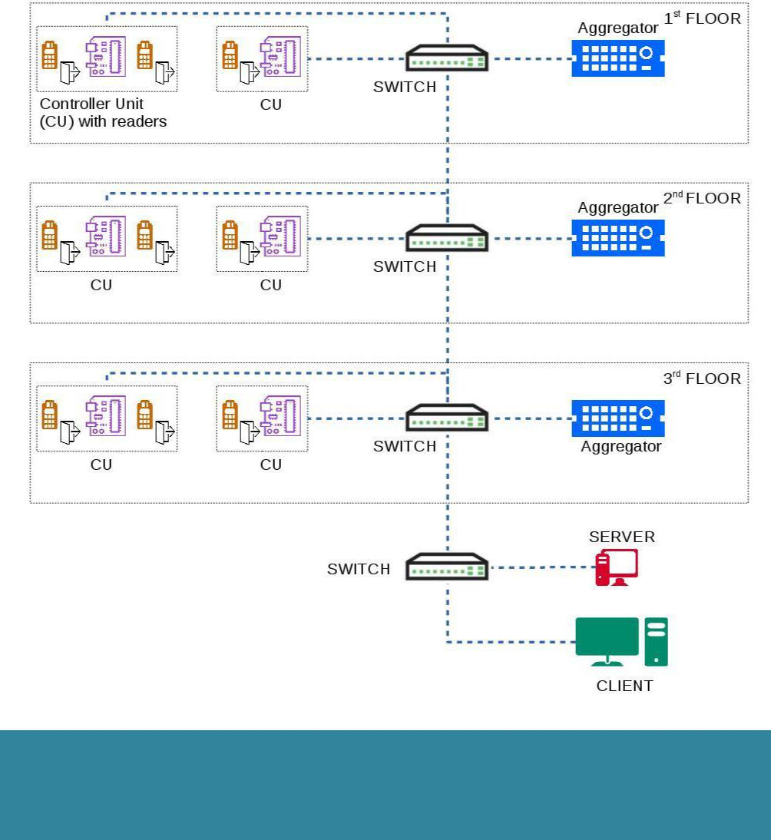

Each Aggregator handles monitoring and configuration for up to 20 Controllers. Server communicates directly with aggregators.

Any Wiegand Readers can be used, including PASSCHIP LPR Readers



Ordering Information

ACDM 100/2: Access control 2 door module

ACDM 100/4: Access control 4 door module

PASSCON Basic - Parameterization software

PASSCON GUI - Client –Server administration software

|  |  |
| --- | --- |
| **Control Unit** |  |
| Communication | Ethernet 100 Base- |
|  | TX/10Base-T |
|  | Wiegand up to 64 bit |
|  | between to card readers |
| Memory | Internal DRAM 1 GB |
|  | SD slot available 1xMMC |
|  | Real time clock with back-up |
|  | Li-Ion maintenance free |
|  | battery |
| Processor | ARM 64-bit, 1.2 GHz, Quad |
| Operating System | Linux OS |
| Software Upgrade | On line, during functioning |
| Power Supply | 12Vcc/3Ah |
| Power Consumption | Max. 30 W |
| Network | Up to 1000 Controllers/50 |
| configuration | Aggregators |
| Door configuration | Up to 4.000 Doors/8.000 |
|  | readers |
| Cards | Up to 100.000 |
| Areas | Up to 1.000 |
| Access Profiles | Up to 10.000 |
| Construction | Applied mount in metal case |
| Agency Approvals | CE Conformity |
| and Standards |  |
| Ambient conditions | Operating Temp:-30 C +50 C |
|  | Storage Temp:-35 C +60 C |
|  | Humidity: 10-95% |
| Size of panel | 138 x 312 x 124 mm -Applied |
| (W x H x D) | model |
| Weight | 3.90 Kg with power source |
| Protection Class | IP67 |
| **Aggregator** |  |
| Communication | Ethernet 100 Base- |
|  | TX/10Base-T |
| Memory | Internal DRAM 1 GB |
|  | SD slot available 1xMMC |
| Processor | ARM 64-bit, 1.2 GHz, Quad |
| Power Supply | 85-264 VAC, 45-65 Hz |
| Power Consumption | Max. 10 W |

|  |  |  |  |  |
| --- | --- | --- | --- | --- |
| --- PASSCHIP® | Printed in Romania | | | Data subject to change without notice |
| 1 Piata Presei Libere, 1st District, 013888, Bucharest, Romania |  |  |  |  |
| Tel: 0040745342887, office@passchip.com |  | www.passchip.com |  |  |