**PASSCHIP®**

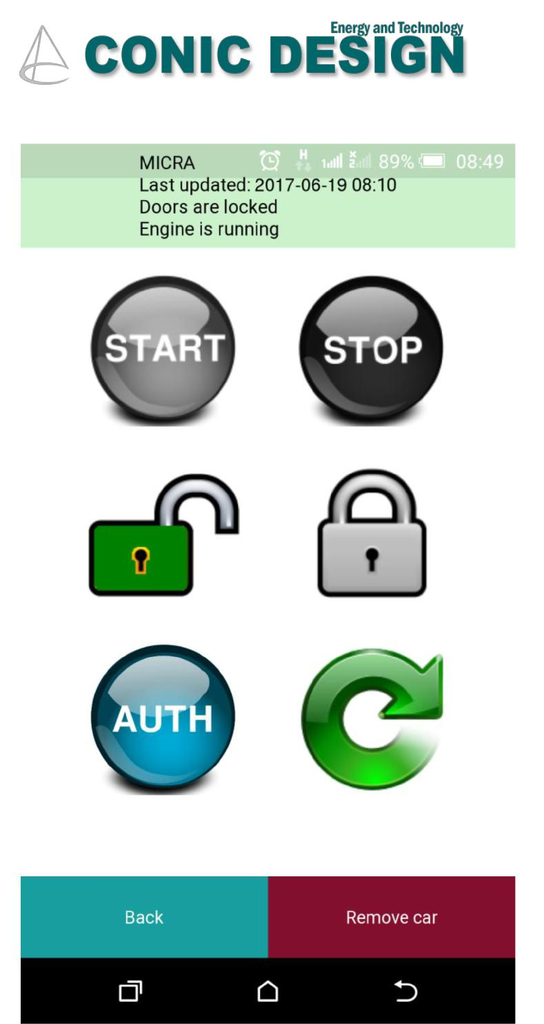**Automotive**

PASSCHIP Automotive is a mobile solution that replaces the need of using a physical car key. The Key is replaced by the smartphone app running on the customer’s phone or tablet that communicates with PASSCHIP - installed inside the cabin.

The smartphone app is using SMS (long distance) or Bluetooth (close distance) to communicate with PASSCHIP and to control the central locking system (Lock / Unlock), the Engine power on / power off and Authorize Engine start (Car board computer reads spare key chip hidden inside the dashboard).

PASSCHIP Automotive has 2 inputs and 5 outputs:

• Lock/Unlock central system – 2 digital outputs

• Engine can be started – digital input

• Engine running – digital input

• Start /Stop engine – 2 digital outputs

• Authorize Engine start – 1 digital outputs

The car engine can be stopped (STOP button active) only if the engine is running.

The car engine can be started (START button active) only if the engine is not running and the “Engine can be started” input is active – safety condition.

|  |  |  |
| --- | --- | --- |
| Functions |  | Benefits |
|  |  |  |

Start and Stop of engine – Main Module Doors Lock and Unlock – Main Module Authorize Engine start – Main Module WiFi AP – Optional Module Event Log – Optional Module

Key management is performed via Bluetooth and SMS – Main Module (no central server required)

Eliminates the need for multiple physical keys Increase number of virtual keys

Increase the number of possible users Mobile App

The keys are sent / received by Phone, SMS, WhatsApp, Facebook, etc. to users

Full management of users and cars Excellent schedule matrix

|  |  |  |  |  |
| --- | --- | --- | --- | --- |
| --- PASSCHIP® | Printed in Romania | | | Data subject to change without notice |
| 1 Piata Presei Libere, 1st District, 013888, Bucharest, Romania |  |  |  |  |
| Tel: 0040745342887, office@passchip.com |  | [www.passchip.com](http://www.passchip.com) |  |  |



Installation

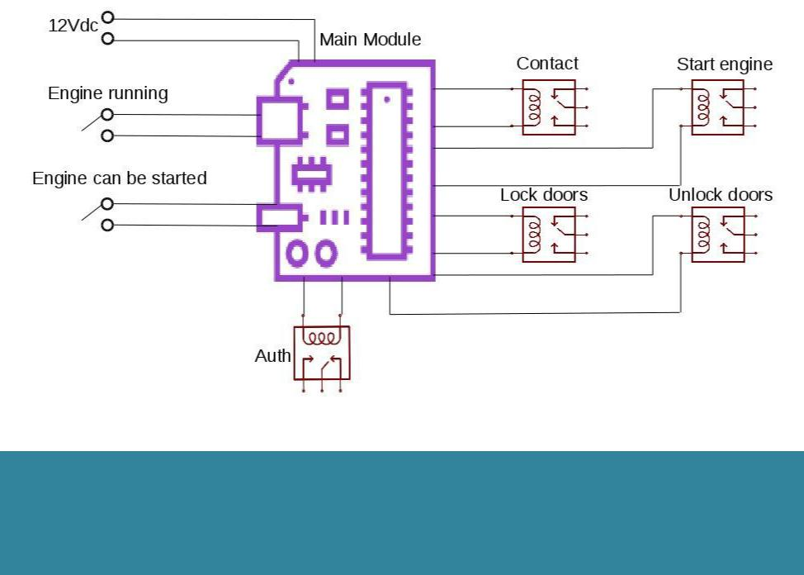

Use cases

Personal and family usage

Car Leasing

Car Sharing

Car Renting



Ordering Information

* MAPA 100/1: App for new cars - factory installing
* MAPA 100/2: App for existing cars - authorized service installing

Technical Specifications



|  |  |
| --- | --- |
| **Main Module** | **ALWAYS ON** |
| Communication | Bluetooth, SMS |
| Memory | 768 Bytes |
| Processor | 8Bit microcontroller |
| Software Upgrade | OFF line |
| Lifecycle | Unlimited |
| Max Keys stored | 64(4 Admin, 60 Users) |
| Power Supply | 12Vcc / max 20mA |
| Power Consumption | Max. 0.24 W |
| **Optional Module** | **ON only when Engine Running** |
| Communication | Wireless |
| Memory | Internal DRAM 1 GB |
|  | SD slot available 1xMMC |
|  | Real time clock with back-up Li- |
|  | Ion maintenance free battery |
| Processor | ARM 64-bit, 1.2 GHz, Quad |
| Operating System | Linux OS |
| Software Upgrade | ON line / OFF line |
| Power Supply | 12Vcc/ max 1A |
| Power Consumption | Max. 12 W |
| History Log capacity | 1.000.000 records |
| Lifecycle | Unlimited |
| Construction | Applied mount in PVC case |
| Optional in car | LCD: 4,3’’ 480x272 pixels |
| Display | Contrast ratio 300:1, Brightness |
|  | min 300cd/sqm Color min QVGA |
|  | 65 000 colors |
| **Agency Approvals** |  |
| **and Standards** |  |
| Ambient conditions | Operating Temp: -40 C +85C |
|  | Storage Temp: -50 C +85 C |
|  | Humidity: 10-95% |
| Sound and interface | Mobile App |
| Size of controller (W | 120 x 90 x 90 mm -Applied model |
| x H x D) |  |
| Weight | 0.4 Kg |
| Protection Class | IP65 for Applied model |
| Interaction with the | Mobile App in English |
| user |  |

|  |  |  |  |  |
| --- | --- | --- | --- | --- |
| --- PASSCHIP® | Printed in Romania | | | Data subject to change without notice |
| 1 Piata Presei Libere, 1st District, 013888, Bucharest, Romania |  |  |  |  |
| Tel: 0040745342887, office@passchip.com |  | [www.passchip.](http://www.passchip.)com |  |  |