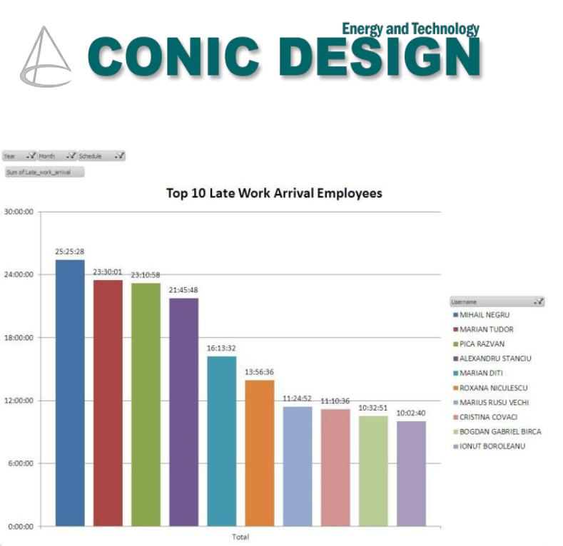

**PASSCHIP® TIME & Attendance**

Provides a powerful workforce management solution

Connects to any type of database

Connects to any type of access control system



Functions

Tracks working hours, absences and overtime Design work schedule

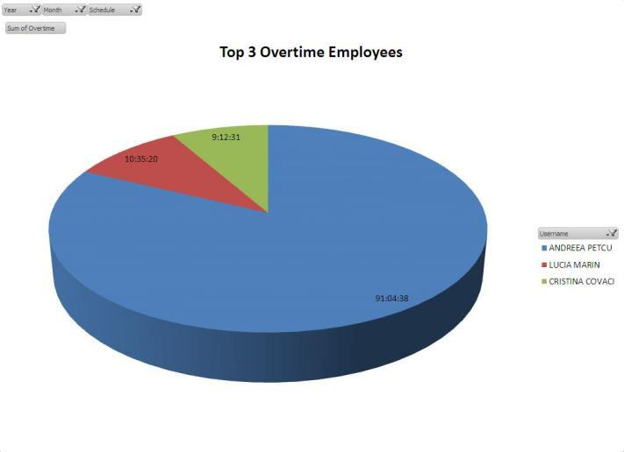

Incidents (sick leave, vacation, doctor, etc.)

Filter function employee

Gives a global view of the employee activity on the site. The reports are exported in .xls format and can be customized to the user’s needs



Benefits

Extremely reliable product with an excellent ROI rate Proven long life service

May be integrated with third parties security software, including biometric applications

Excellent substitute to human guard patrol services

|  |  |  |  |  |
| --- | --- | --- | --- | --- |
| CONIC DESIGN® --- PASSCHIP® | Printed in Romania | | | Data subject to change without notice |
| 1 Piata Presei Libere, 1st District, 013888, Bucharest, Romania |  |  |  |  |
| Tel: 0040745342887, office@passchip.com |  | [www.passchip.com](http://www.passchip.com) |  |  |

|  |  |  |  |  |  |  |  |  |  |  |
| --- | --- | --- | --- | --- | --- | --- | --- | --- | --- | --- |
|  | Installation |  |  |  | Technical Specifications | | | |  |  |
|  |  |  |  |  |  |  |  |  |  |  |
|  |  |  |  |  | **Server** |  |  |  |  |  |
|  |  |  |  |  |  |  |  |  |  |
|  |  |  |  |  | Operating System |  | Windows 7 or newer |  |  |  |
|  |  |  |  |  |  |  |  |  |
|  |  |  |  |  | Processor |  | Dual Core or more |  |  |  |
|  |  |  |  |  |  |  |  |  |
|  |  |  |  |  | RAM |  | 2GB or more |  |  |  |
|  |  |  |  |  |  |  |  |  |
|  |  |  |  |  | Storage |  | 1 GB HDD free space |  |  |  |
|  |  |  |  |  |  |  |  |  |
|  |  |  |  |  | Configured panels |  | Unlimited |  |  |  |
|  |  |  |  |  |  |  |  |  |
|  |  |  |  |  | Configured |  | Unlimited |  |  |  |
|  |  |  |  |  |  |  |  |  |
|  |  |  |  |  | employees |  |  |  |  |  |
|  |  |  |  |  | Communication |  | IP |  |  |  |
|  |  |  |  |  |  |  |  |  |
|  |  |  |  |  | Transfer of |  | On line, during system |  |  |  |
|  |  |  |  |  |  |  |  |  |
|  |  |  |  |  | parameterization |  | functioning |  |  |  |

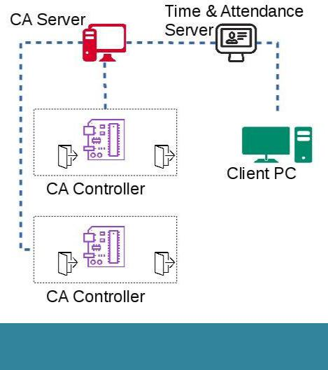

Observations

PASSCHIP Time & Attendance works out of the box with

PASSCHIP Access Control systems and SQL database but

can be customized to interface virtually any Access Control

system and any database type



Ordering Information

* CONTA100: License for 1 T&A connection

|  |  |  |  |  |
| --- | --- | --- | --- | --- |
| CONIC DESIGN® --- PASSCHIP® | Printed in Romania | | | Data subject to change without notice |
| 1 Piata Presei Libere, 1st District, 013888, Bucharest, Romania |  |  |  |  |
| Tel: 0040745342887, office@passchip.com |  | [www.passchip.com](http://www.passchip.com) |  |  |