**PASSCHIP**

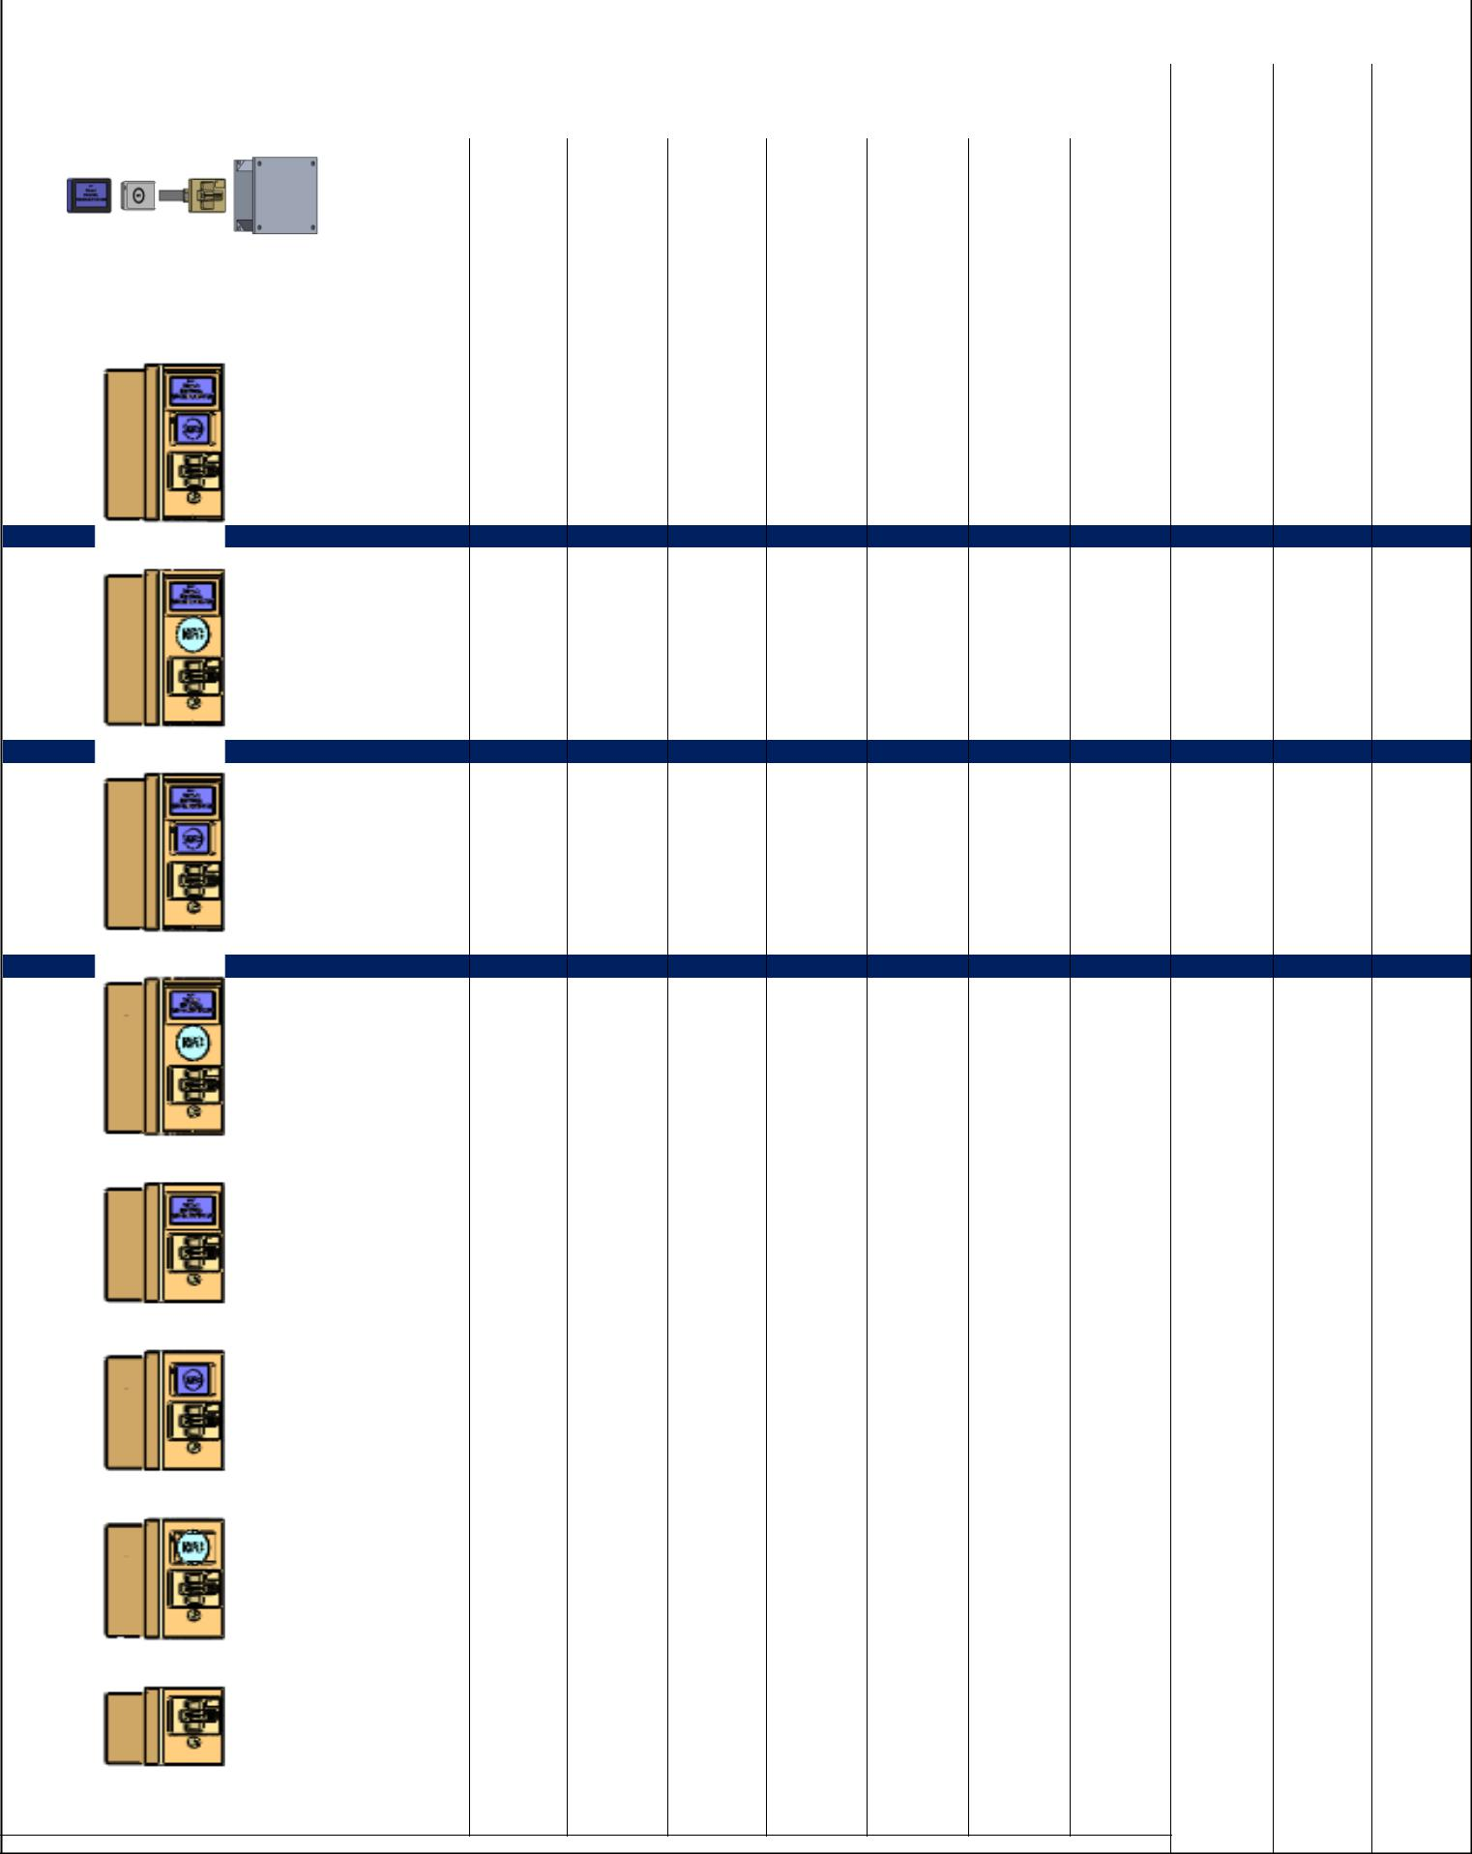

|  |  |  |  |  |  |  |  |  |  |  |  |  |  |  |  |
| --- | --- | --- | --- | --- | --- | --- | --- | --- | --- | --- | --- | --- | --- | --- | --- |
|  | **Type** | **Picture** | **Dimensions** |  |  |  |  | **Configuration** | |  |  |  |  |  |  |
|  | **(HxLxD) mm** |  |  |  |  |  |  |  |  |  |  |
|  |  |  |  |  |  |  |  |  |  |  |  |  |  |  |
|  |  |  |  |  |  |  |  |  |  |  |  |  |  |  |  |
|  |  |  |  | **Stainless** | **Contact CHIP** | **NFC Reader** | **Display 4.2''** | **Built in** | **External** | **Power source** | **Wiegand Port** | **Inputs** | **Ethernet Port** |  |  |
|  |  |  |  | **Steel Case** | **Reader** | **Controller** | **Controller** | **12V** | **Outputs Port** |  |  |
|  |  |  |  |  |  |  |  |  |  |
|  |  |  |  |  |  |  |  |  |  |  |  |  |  |  |  |
|  |  |  |  |  |  |  |  |  |  |  |  |  |  |  |  |
|  |  |  |  |  | **l** | **l** | **l** |  | **l** | **l** | **l** | **l** | **l** |  |  |
|  |  |  | Display: 76x120x20 | |  |  |  |  |  |  |  |  |  |  |  |
|  |  |  | NFC read: 65x98x13 | |  |  |  |  |  |  |  |  |  |  |  |
|  | PS 0 |  | CHIP read:74x107x120 | |  |  |  |  |  |  |  |  |  |  |  |
|  |  |  | Controller: 195x170x80 | |  |  |  |  |  |  |  |  |  |  |  |
|  |  |  | (includes power source) | |  |  |  |  |  |  |  |  |  |  |  |
|  |  |  |  |  |  |  |  |  |  |  |  |  |  |  |  |
|  |  |  |  |  |  |  |  |  |  |  |  |  |  |  |  |
|  |  |  |  | **l** | **l** | **l** | **l** | **l** |  | **l** | **l** | **l** | **l** |  |  |
|  | PS 1 |  | **312x138x124** | |  |  |  |  |  |  |  |  |  |  |  |

|  |  |  |  |  |  |  |  |  |
| --- | --- | --- | --- | --- | --- | --- | --- | --- |
| **l** | **l** | **l** | **l** | **l** | **l** | **l** | **l** | **l** |

|  |  |
| --- | --- |
| PS 2 | **312x138x124** |

|  |  |  |  |  |  |  |  |  |
| --- | --- | --- | --- | --- | --- | --- | --- | --- |
| **l** | **l** | **l** | **l** | **l** | **l** | **l** | **l** | **l** |

|  |  |
| --- | --- |
| PS 3 | **312x138x124** |

|  |  |  |  |  |  |  |  |  |  |
| --- | --- | --- | --- | --- | --- | --- | --- | --- | --- |
|  | **l** | **l** | **l** | **l** | **l** | **l** | **l** | **l** | **l** |
| PS 4 | **312x138x124** |  |  |  |  |  |  |  |  |
|  |  |  |  |  |  |  |  |  |  |
|  |  |  |  |  |  |  |  |  |  |
|  | **l** | **l** |  | **l** | **l** | **l** | **l** | **l** | **l** |
| PS 5 | **237x138x124** |  |  |  |  |  |  |  |  |
|  |  |  |  |  |  |  |  |  |  |
|  |  |  |  |  |  |  |  |  |  |
|  | **l** | **l** | **l** |  | **l** | **l** | **l** | **l** | **l** |
| PS 6 | **237x138x124** |  |  |  |  |  |  |  |  |
|  |  |  |  |  |  |  |  |  |  |
|  |  |  |  |  |  |  |  |  |  |
|  | **l** | **l** | **l** |  | **l** | **l** | **l** | **l** | **l** |
| PS 7 | **237x138x124** |  |  |  |  |  |  |  |  |
|  |  |  |  |  |  |  |  |  |  |
|  |  |  |  |  |  |  |  |  |  |
|  | **l** | **l** |  |  | **l** | **l** | **l** | **l** | **l** |
| PS 8 | **155x138x124** |  |  |  |  |  |  |  |  |
|  |  |  |  |  |  |  |  |  |  |
|  |  |  |  |  |  |  |  |  |  |