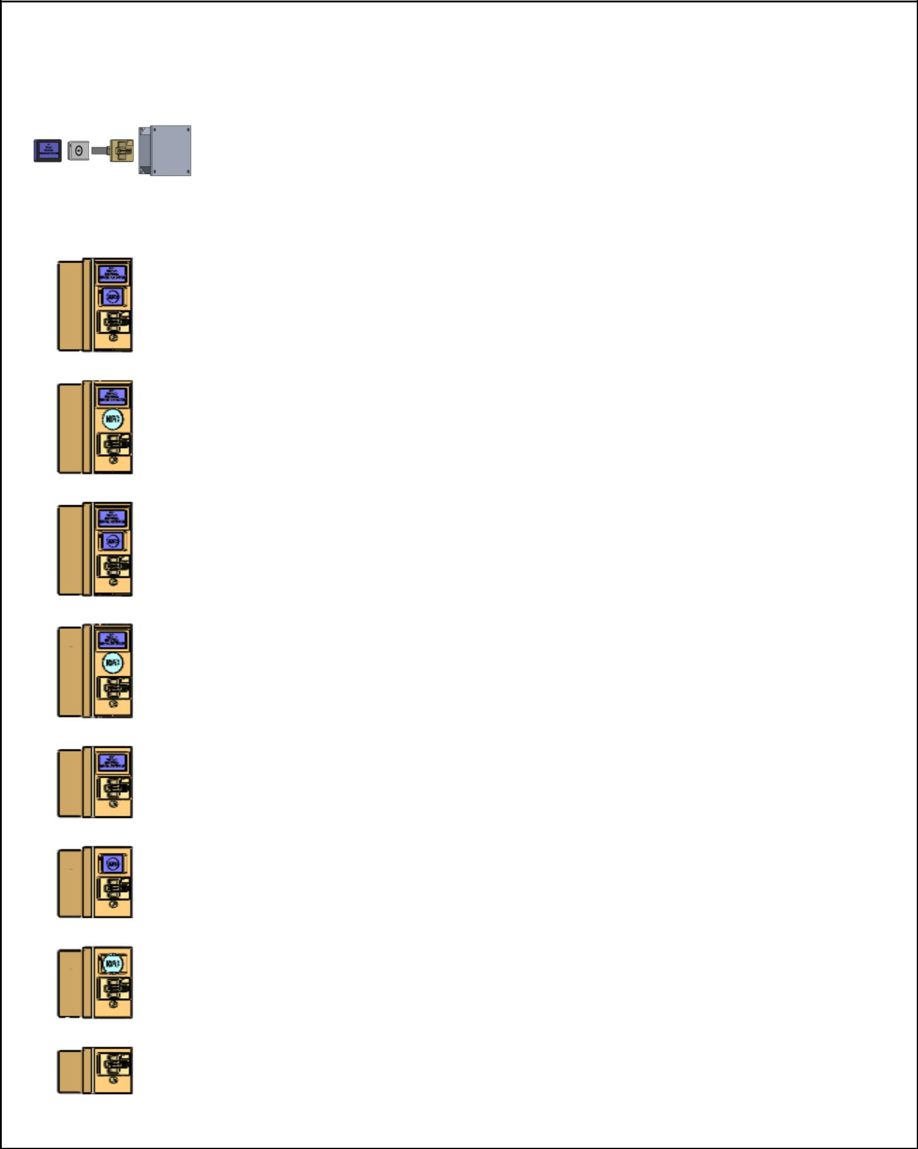**PASSCHIP**

|  |  |  |  |  |  |  |  |  |  |  |  |
| --- | --- | --- | --- | --- | --- | --- | --- | --- | --- | --- | --- |
| **Type** | **Picture** | **Dimensions (HxLxD)** |  |  |  | **Configuration** |  |  |  |  |  |
| **mm** |  |  |  |  |  |  |  |  |
|  |  |  |  |  |  |  |  |  |  |  |
|  |  |  |  |  |  |  |  |  |  |  |  |
|  |  |  | Stainless Steel Case | Contact CHIP Reader | NFC Reader | Display 4.2'' | Built in Controller | External Controller | Power source 12V |  |  |
|  |  |  |  |  |  |  |  |  |  |  |  |
|  |  |  |  |  |  |  |  |  |  |  |  |
|  |  |  |  | **l** | **l** | **l** |  | **l** | **l** |  |  |
|  |  | Display: 76x120x20 |  |  |  |  |  |  |  |  |  |
|  |  | NFC read: 65x98x13 |  |  |  |  |  |  |  |  |  |
| PS 0 |  | CHIP read:74x107x120 |  |  |  |  |  |  |  |  |  |
|  | Controller: 195x170x80 |  |  |  |  |  |  |  |  |  |
|  |  |  |  |  |  |  |  |  |  |  |
|  |  | (includes power |  |  |  |  |  |  |  |  |  |
|  |  | source) |  |  |  |  |  |  |  |  |  |
|  |  |  |  |  |  |  |  |  |  |  |  |
|  |  |  |  |  |  |  |  |  |  |  |  |
|  |  |  | **l** | **l** | **l** | **l** | **l** |  | **l** |  |  |
| PS 1 |  | **312x138x124** |  |  |  |  |  |  |  |  |  |
|  |  |  |  |  |  |  |  |  |  |  |  |
|  |  |  |  |  |  |  |  |  |  |  |  |
|  |  |  | **l** | **l** | **l** | **l** | **l** |  | **l** |  |  |
| PS 2 |  | **312x138x124** |  |  |  |  |  |  |  |  |  |
|  |  |  |  |  |  |  |  |  |  |  |  |
|  |  |  |  |  |  |  |  |  |  |  |  |
|  |  |  | **l** | **l** | **l** | **l** |  | **l** | **l** |  |  |
| PS 3 |  | **312x138x124** |  |  |  |  |  |  |  |  |  |
|  |  |  |  |  |  |  |  |  |  |  |  |
|  |  |  |  |  |  |  |  |  |  |  |  |
|  |  |  | **l** | **l** | **l** | **l** |  | **l** | **l** |  |  |
| PS 4 |  | **312x138x124** |  |  |  |  |  |  |  |  |  |
|  |  |  |  |  |  |  |  |  |  |  |  |
|  |  |  |  |  |  |  |  |  |  |  |  |
|  |  |  | **l** | **l** |  | **l** |  | **l** | **l** |  |  |
| PS 5 |  | **237x138x124** |  |  |  |  |  |  |  |  |  |
|  |  |  |  |  |  |  |  |  |  |  |  |
|  |  |  |  |  |  |  |  |  |  |  |  |
|  |  |  | **l** | **l** | **l** |  |  | **l** | **l** |  |  |
| PS 6 |  | **237x138x124** |  |  |  |  |  |  |  |  |  |
|  |  |  |  |  |  |  |  |  |  |  |  |
|  |  |  |  |  |  |  |  |  |  |  |  |
|  |  |  | **l** | **l** | **l** |  |  | **l** | **l** |  |  |
| PS 7 |  | **237x138x124** |  |  |  |  |  |  |  |  |  |
|  |  |  |  |  |  |  |  |  |  |  |  |
|  |  |  |  |  |  |  |  |  |  |  |  |
|  |  |  | **l** | **l** |  |  |  | **l** | **l** |  |  |
| PS 8 |  | **155x138x124** |  |  |  |  |  |  |  |  |  |
|  |  |  |  |  |  |  |  |  |  |  |  |
|  |  |  |  |  |  |  |  |  |  |  |  |

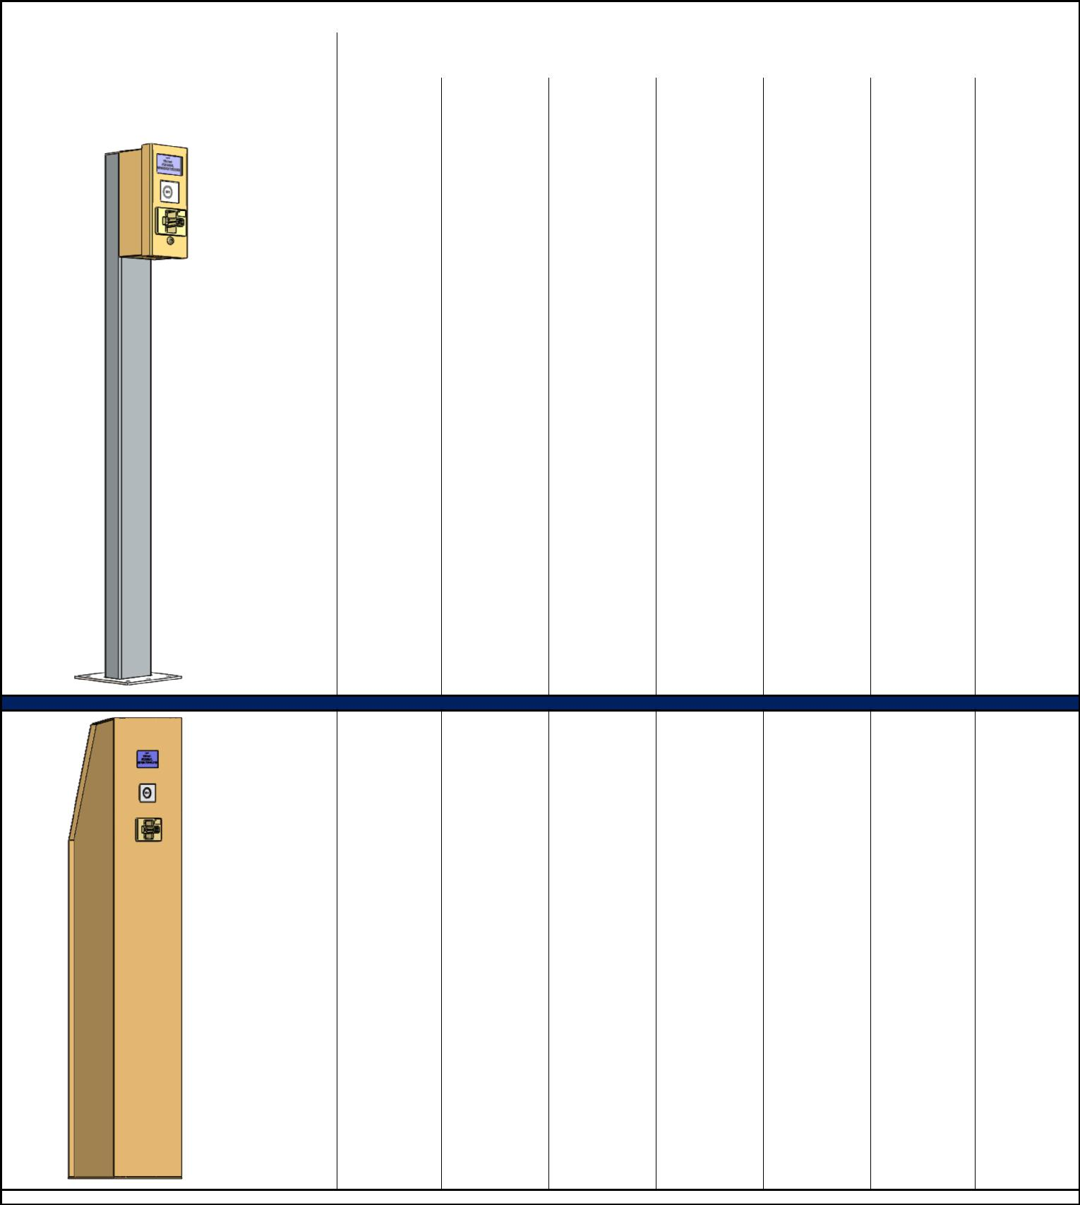**PASSCHIP**

|  |  |  |  |  |  |  |  |  |  |  |
| --- | --- | --- | --- | --- | --- | --- | --- | --- | --- | --- |
| **Type** | **Picture** | **Dimensions (HxLxD)** |  |  | **Configuration** |  |  |  |  |  |
| **mm** |  |  |  |  |  |  |  |
|  |  |  |  |  |  |  |  |  |  |
|  |  |  |  |  |  |  |  |  |  |  |
|  |  | Stainless Steel Case | Contact CHIP Reader | NFC Reader | Display 4.2'' | Built in Controller | External Controller | Power source 12V |  |  |
|  |  |  |  |  |  |  |  |  |  |  |
|  |  |  |  |  |  |  |  |  |  |  |
|  |  | **l** | **l** | **l** | **l** |  | **l** | **l** |  |  |

|  |  |
| --- | --- |
| Picior | 1500x138x180 |

|  |  |  |  |  |  |
| --- | --- | --- | --- | --- | --- |
| **l** | **l** | **l** | **l** | **l** | **l** |

|  |  |
| --- | --- |
| Totem | 1500x300x200 |
|  |  |
|  |  |