

1 2 3 4 5 6

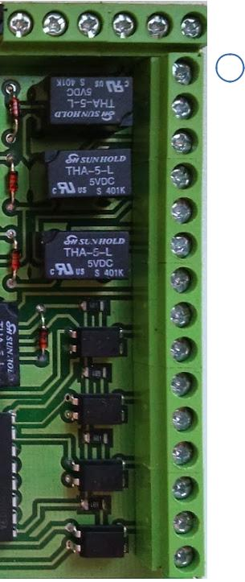

7



8



9

10

11

12

13

14

15

16

17

18

19

20

21



POWER SOURCE

12 V DC, 3A



RELAY 1A 30V DC

PIN Description



* Wiegand Data0

2 Wiegand Data1

3 Wiegand GND

4 INT BAT GND

5 INT BAT +5V

6 Not Connected

7 Door Relay NO

8 Door Relay NC

9 Door Relay COM

|  |  |  |  |
| --- | --- | --- | --- |
| 10 | Fault Relay NO | Cable |  |
| 11 | Fault Relay NC |  |
|  |  |

1. Fault Relay COM
2. Not Connected
3. GND
4. Inactive (Fire) (NO)
5. GND
6. PIR (NC)
7. GND
8. Exit Button (NO)
9. GND
10. CM (NC)
11. - 12V
12. +12V

|  |  |  |
| --- | --- | --- |
| Position | Description | Color |
| R1 | Wiegand Data0 |  |
| R2 | Wiegand Data1 |  |
| R3 | Wiegand GND |  |
| R4 | - 12V |  |
| R5 | +12V |  |
| R6 | Not Connected |  |
| R7 | Door Relay NO |  |
| R8 | Door Relay NC |  |
| R9 | Door Relay COM |  |
| R10 | Fault Relay NO |  |
| R11 | Fault Relay NC |  |
| R12 | Fault Relay COM |  |
| R13 | Not Connected |  |
| R14 | GND1 | verde |
| R15 | Inactive / Fire (NO) | a-verde |
| R16 | GND2 | albastru |
| R17 | PIR (NC) | a-albastru |
| R18 | GND3 | maro |
| R19 | Exit Button (NO) | a-maro |
| R20 | GND4 | portocaliu |
| R21 | Magnetic Contact (NC) | a-porto |
| R22 | TAMPER |  |
| R23 | TAMPER |  |
| R24 | GROUND |  |

