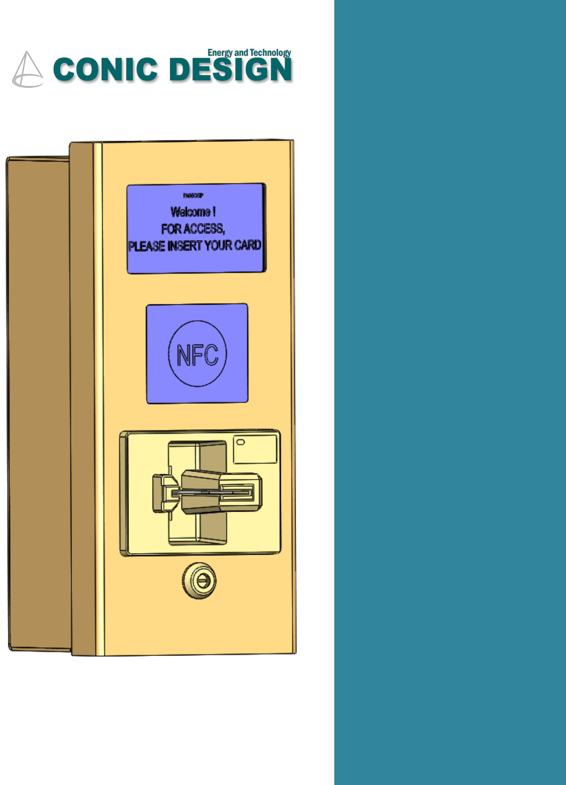

**PASSCHIP®**

**Smart card chip reader with Wiegand protocol for lobby entrance**

**PRODUCT: Banking Smart card chip reader with Wiegand protocol for advanced access control systems**

**PASSCHIP enables Banks to facilitate the access of customers to the 24Hours Self Service area, in a secured, automatic way. The system is very flexible allowing multiple possible configurations and combined with its simplicity and intuitive GUI makes PASSCHIP an advanced and easy to use Access Control System.**

**PRODUCT IMAGE of Applied model- Stainless Steel material:**

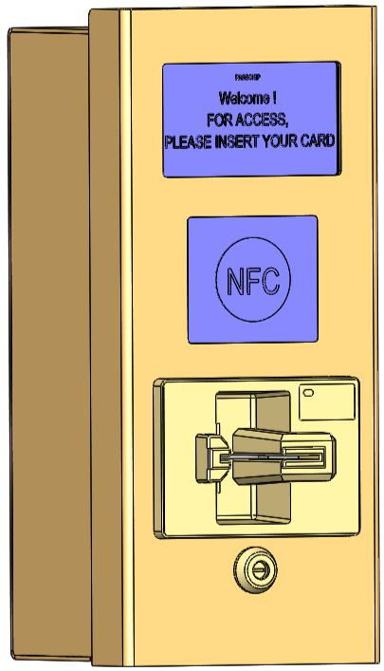

Dimension(WxHxD): 138x312x124 mm

**The access selection is made following one or more criteria, according with the specific application:**

*Name/Surname written on the credit cards(it is possible to define BLACK LISTS)

*Credit card number

*Type of credit card(Visa, Visa Electron, Visa Business, Visa Gold, Maestro....)

*Bank(the system may be programmed as only the bank’s clients to have access or full different

scenarios)

*Date of expiry

**Note: The system is a security product, it does not log on sensitive and personal data, nor financial data of readed cards.**

**It is designed only for access and management purposes.**

|  |  |  |  |  |
| --- | --- | --- | --- | --- |
| --- PASSCHIP® | Printed in Romania | | | Data subject to change without notice |
| 1 Piata Presei Libere, 1st District, 013888, Bucharest, Romania |  |  |  |  |
| Tel: 0040745342887, Fax: 0040378104216, office@passchip.com |  | [www.passchip.com](http://www.passchip.eu/) | |  |
|  |  |  |  |  |

|  |  |
| --- | --- |
| 1 = chip reader; 2 = electric lock; 3 = exit button; | 4 = |

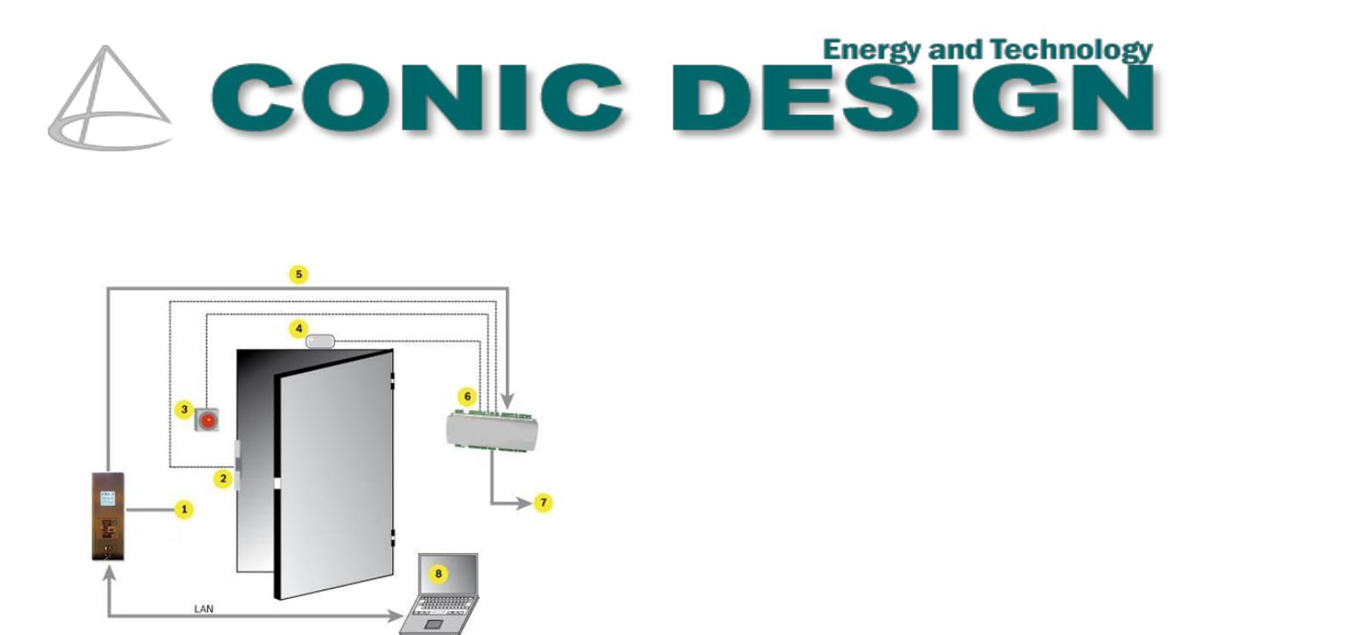magnetic contact; 5 = communication bus; 6 = access control module; 7 = control unit; 8 = computer with administration software

**This application runs on the Control Unit and has to authenticate a customer before allowing him to enter the 24Hours Self Service area.**

**Functionality:**

* Authentication / Authorization

authentication is initiated by the customer by presenting a smartcard to a PASSCHIP reader

* PASSCHIP reads the card details (Card Number and Expiration date) and then takes the appropriate action (allow or block access to the 24Hours Self Service area)

**Error! No sequence specified.**

**Features:**

* Fire - used in case of emergency – generated from an access control system
* External Timetable – used to control when to allow customers access to the 24Hours Self Service area - generated from an access control system
* Timetable – used to define the working schedule for the application
* Magnetic contact – used for confidentiality purposes after entrance
* PIR also for confidentiality purposes after entrance

|  |  |  |  |  |
| --- | --- | --- | --- | --- |
| --- PASSCHIP® | Printed in Romania | | | Data subject to change without notice |
| 1 Piata Presei Libere, 1st District, 013888, Bucharest, Romania |  |  |  |  |
| Tel: 0040745342887, Fax: 0040378104216, office@passchip.com |  | [www.passchip.com](http://www.passchip.eu/) | |  |
|  |  |  |  |  |

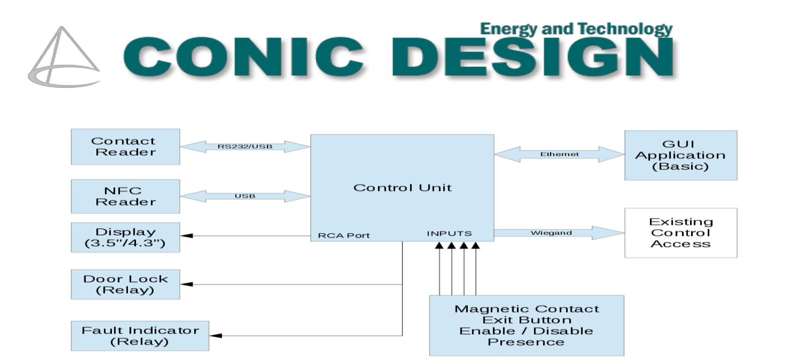

* ID List – this is the list of bank’s accepted ID for customer's smartcards; this feature is useful for blocking a specific type of smartcards (eg. Visa Electron
* BLK (blocked) List – this is a list of Card Numbers or Card Number prefixes that are not allowed to enter the 24Hours Self Service area; used for blocking a range of smartcards belonging to a bank or for blocking specific customers (eg. vandals).
* Door Timer – time period (seconds) that the Relay must be kept open; used to adjust the time period within which the customers are allowed to enter the 24Hours Self Service area
* Relay – PASSCHIP can control a relay which in turn locks / unlocks a door; this feature is useful for integrating PASSCHIP with a electromagnetic door lock
* Wiegand – PASSCHIP can act as a wiegand enabled reader which sends messages to an access control system; this feature is useful for integrating PASSCHIP with an existing access control system
* Different Display types (with different aspect ratios and resolutions) – during operation the display can be replaced with a different one
* Background Image customization – the background image can be replaced “on-the-fly” with a different one
* Text Messages customization – the text messages can be replaced “on-the-fly” with different ones

|  |  |  |  |  |
| --- | --- | --- | --- | --- |
| --- PASSCHIP® | Printed in Romania | | | Data subject to change without notice |
| 1 Piata Presei Libere, 1st District, 013888, Bucharest, Romania |  |  |  |  |
| Tel: 0040745342887, Fax: 0040378104216, office@passchip.com |  | [www.passchip.com](http://www.passchip.eu/) | |  |
|  |  |  |  |  |

Sample images visible on the Display:

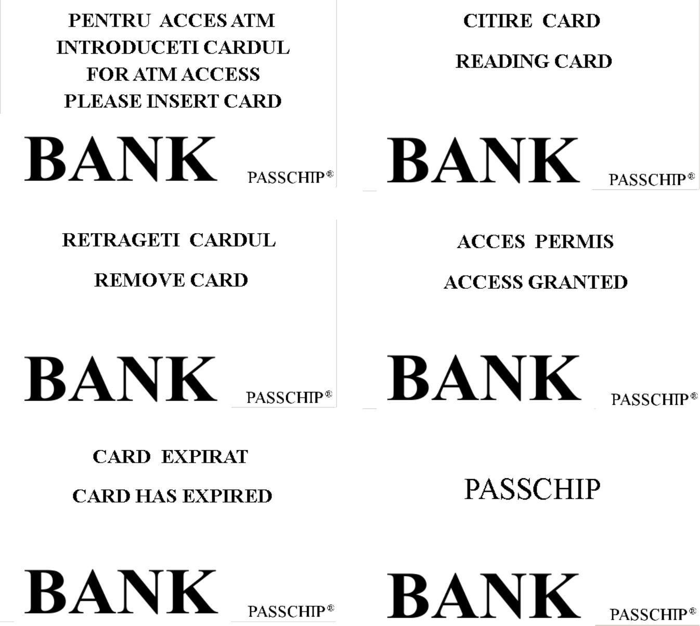

**Server application**

This application runs on a server and is responsible for controlling all PASSCHIPs and serving all requests from Client Application.

|  |  |  |  |  |
| --- | --- | --- | --- | --- |
| --- PASSCHIP® | Printed in Romania | | | Data subject to change without notice |
| 1 Piata Presei Libere, 1st District, 013888, Bucharest, Romania |  |  |  |  |
| Tel: 0040745342887, Fax: 0040378104216, office@passchip.com |  | [www.passchip.com](http://www.passchip.eu/) | |  |
|  |  |  |  |  |

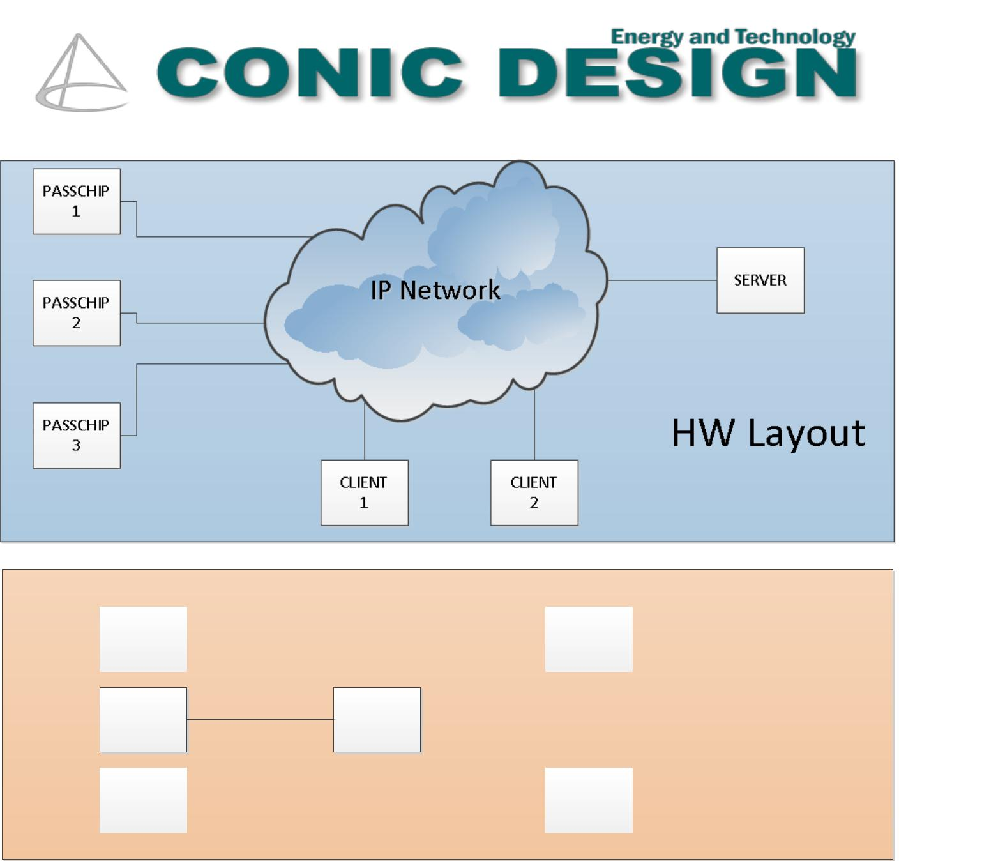

|  |  |  |  |  |  |  |
| --- | --- | --- | --- | --- | --- | --- |
|  |  |  |  |  |  |  |
| PASSCHIP |  |  |  |  |  | CLIENT |
| 1 |  |  |  |  |  | 1 |
|  |  |  |  |  |  |  |
|  |  |  |  |  |  |  |

PASSCHIP

SERVER

2

|  |  |  |  |  |  |  |
| --- | --- | --- | --- | --- | --- | --- |
|  |  |  |  |  |  |  |
| PASSCHIP |  |  |  |  |  | CLIENT |
| 3 |  |  |  |  |  | 2 |
|  |  |  |  |  |  |  |

Logical

Layout

Functionality:

* Logging
* Monitoring
* Statistics (Reports)
* User configuration
* PASSCHIP management

All persistent data is stored using an SQL database.

|  |  |  |  |  |
| --- | --- | --- | --- | --- |
| --- PASSCHIP® | Printed in Romania | | | Data subject to change without notice |
| 1 Piata Presei Libere, 1st District, 013888, Bucharest, Romania |  |  |  |  |
| Tel: 0040745342887, Fax: 0040378104216, office@passchip.com |  | [www.passchip.com](http://www.passchip.eu/) | |  |
|  |  |  |  |  |

**Client application**

This application runs on user workstations and is used for managing the entire system (both admin console and operator application).

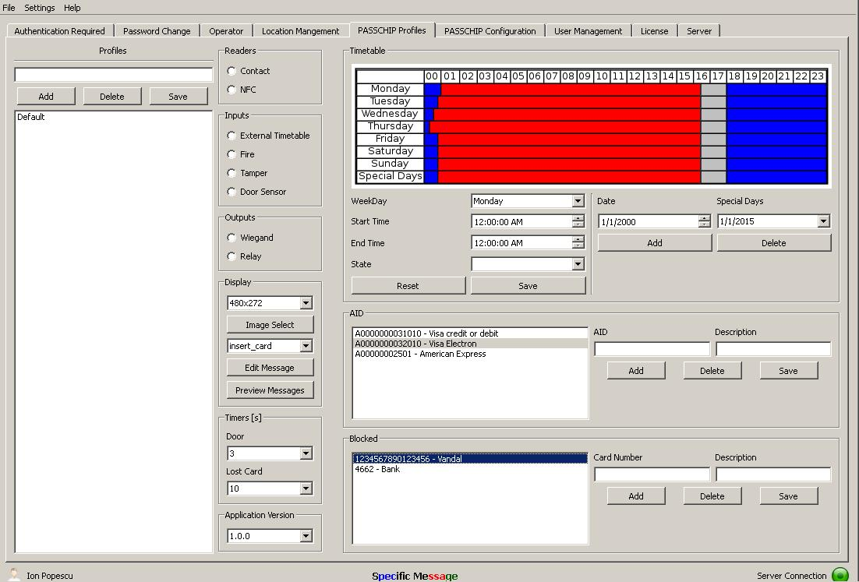

|  |  |  |  |  |
| --- | --- | --- | --- | --- |
| --- PASSCHIP® | Printed in Romania | | | Data subject to change without notice |
| 1 Piata Presei Libere, 1st District, 013888, Bucharest, Romania |  |  |  |  |
| Tel: 0040745342887, Fax: 0040378104216, office@passchip.com |  | [www.passchip.com](http://www.passchip.eu/) | |  |
|  |  |  |  |  |

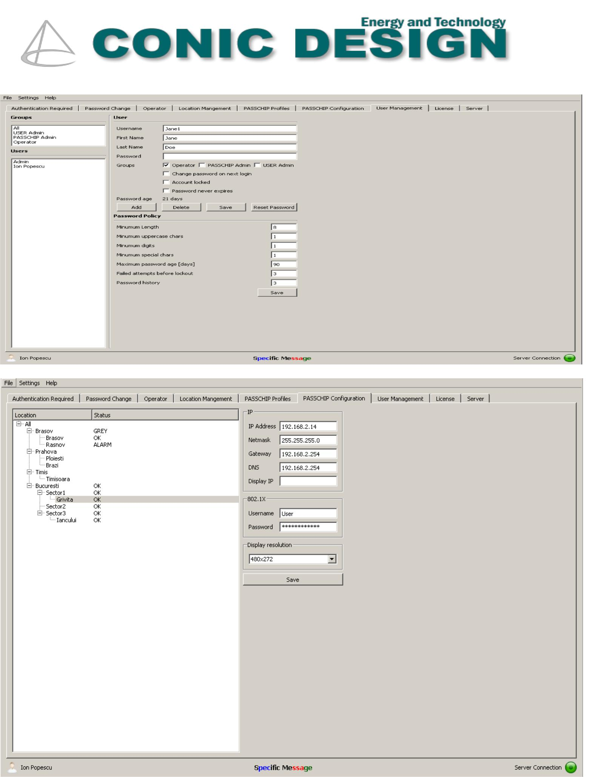

|  |  |  |  |  |
| --- | --- | --- | --- | --- |
| --- PASSCHIP® | Printed in Romania | | | Data subject to change without notice |
| 1 Piata Presei Libere, 1st District, 013888, Bucharest, Romania |  |  |  |  |
| Tel: 0040745342887, Fax: 0040378104216, office@passchip.com |  | [www.passchip.com](http://www.passchip.eu/) | |  |
|  |  |  |  |  |

Shield pinout:

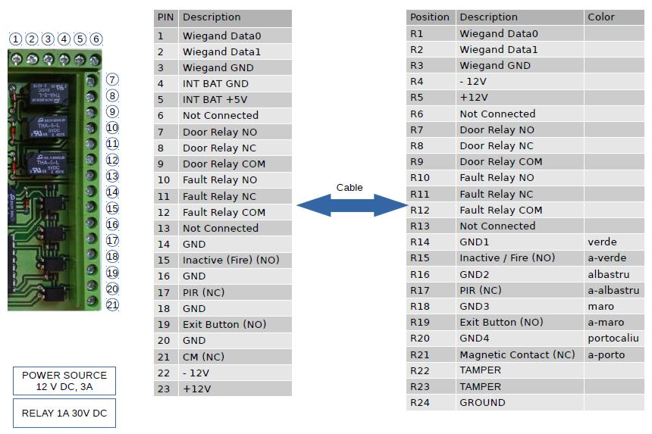

|  |  |  |  |  |
| --- | --- | --- | --- | --- |
| --- PASSCHIP® | Printed in Romania | | | Data subject to change without notice |
| 1 Piata Presei Libere, 1st District, 013888, Bucharest, Romania |  |  |  |  |
| Tel: 0040745342887, Fax: 0040378104216, office@passchip.com |  | [www.passchip.com](http://www.passchip.eu/) | |  |
|  |  |  |  |  |

|  |  |  |  |
| --- | --- | --- | --- |
|  | Communication | Ethernet 100 Base-TX/10Base-T RS232 up to 115200 Bit/sec |  |
|  |  | Clock and Data |  |
|  |  | Wiegand up to 64 bit |  |
|  |  |  |  |
|  | Memory | Internal DRAM 1 GB, record of min 50 configurable ID banking cards profiles |  |
|  |  | according EMV or non EMV standard, SD slot available 1xMMC |  |
|  |  | Real time clock with back-up Li-Ion maintenance free battery |  |
|  |  |  |  |
|  | Reference Standards | ISO 7816 with T=0 and T=1, EMVCo Level 1, ISO 7810, ISO 7811, JIS X6301, JIS |  |
|  |  | X6302I, contactless NFC |  |
|  |  |  |  |
|  | Processor | ARM 64-bit, 1.2 GHz, Quad |  |
|  | Operating System | Linux OS |  |
|  | Software Upgrade | On line, during functioning |  |
|  | Power Supply | 85-264 VAC, 45-65 Hz, Cold Start, |  |
|  |  |  |  |
|  | Power Consumption | Max. 30 W |  |
|  | History Log capacity | 5MB, aprox. 10 000 events with time stamp |  |
|  |  |  |  |
|  | Lifecycle | Min 125 000 functioning hours |  |
|  |  | Min 500 000 insertion cycles |  |
|  | Insertion Speed | 8-127 cm/sec |  |
|  | Construction | Applied mount in Stainless Steel case or Flush mount in Aluminium painted case, |  |
|  |  | Antiskimming, metal bezel, antivandal, UV filter for LCD screen |  |
|  |  |  |  |
|  | Display | LCD: 4.3” 480x272 pixels |  |
|  |  | Contrast ratio 300:1, Brightness min 300cd/sqm Color min QVGA 65 000 colors |  |
|  |  |  |  |
|  | Agency Approvals and Standards | CE Conformity |  |
|  |  |  |
|  |  |  |  |
|  | Ambient conditions | Operating Temp:-30 C +50 C |  |
|  |  | Storage Temp:-35 C +60 C |  |
|  |  | Humidity: 10-95% |  |
|  | Sound and interface | Multi-color LED and multi-tone buzzer |  |
|  | Size o f c ontr oller (W x H x D) | 138 x 312 x 124 mm-Applied mount |  |
|  |  | 170 x 195 x 80 mm-Flush mount |  |
|  | Weight | 3.90 Kg |  |
|  | Protection Class | IP65 for Stainless Steel Applied model |  |
|  |  | IP50 for Flush mount |  |
|  | Interaction with the user | Virtually any available known written language, pictograms and multitone |  |
|  |  | internal buzzer |  |
|  |  |  |  |
|  | Black list | YES, online programable for maximum 1 000 card profiles |  |
|  |  |  |  |
|  | NFC | OPTIONAL |  |
|  |  |  |  |

|  |  |  |  |  |
| --- | --- | --- | --- | --- |
| --- PASSCHIP® | Printed in Romania | | | Data subject to change without notice |
| 1 Piata Presei Libere, 1st District, 013888, Bucharest, Romania |  |  |  |  |
| Tel: 0040745342887, Fax: 0040378104216, office@passchip.com |  | [www.passchip.com](http://www.passchip.eu/) | |  |
|  |  |  |  |  |



|  |  |  |  |  |
| --- | --- | --- | --- | --- |
| --- PASSCHIP® | Printed in Romania | | | Data subject to change without notice |
| 1 Piata Presei Libere, 1st District, 013888, Bucharest, Romania |  |  |  |  |
| Tel: 0040745342887, Fax: 0040378104216, office@passchip.com |  | [www.passchip.com](http://www.passchip.eu/) | |  |
|  |  |  |  |  |