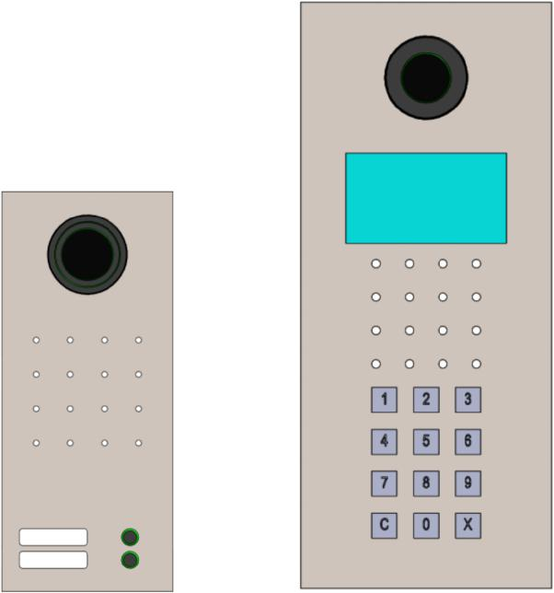

Functions

Voice and Video calls between Intercom Panels within the same LAN.

Brushed stainless steel build

Accept/reject incoming call

Initiate call to basic panel / video panel

Limited call duration - max. 5 min

Video camera:

* can only be viewed by peer video panel during call for Video Panels
* can be viewed by multiple video panels

Auto-answer incoming call

1 output controlled by peer video panel during call

2 way video call with another video panel

**PASSCHIP®**

**IP Video Intercom**

Our IP video intercom product line is dedicated to commercial, office buildings and residential large projects, ensures increased levels of security and comfort compared to conventional analog intercom systems due to its remarkable flexibility and friendly use.

With its slim design and minimalist appearance, it can be easily incorporated in most architectural styles. Made out of stainless steel, it provides long lasting and stable performance.

Taking advantage of the IP technology, the system can communicate with up to 1000 panels unlike most conventional systems which are limited to 255 panels.



Benefits

IP Video Intercom with up to 1000 Intercom Panels Integration with PASSCHIP® ACCESS CONTROL systems Unlock door from intercom

Wiegand integration with any access control system by allowing the intercom to act as a wiegand reader, sending to the access control system the wiegand card ID associated with the peer intercom panel. Management system: monitoring and configuration Network security achievable using encrypted VPNs Network can be extended to multiple sites using layer2 VPNs

|  |  |  |  |  |
| --- | --- | --- | --- | --- |
| CONIC DESIGN® --- PASSCHIP® | Printed in Romania | | | Data subject to change without notice |
| 1 Piata Presei Libere, 1st District, 013888, Bucharest, Romania |  |  |  |  |
| Tel: 0040745342887, office@passchip.com |  | [www.passchip.com](http://www.passchip.com) |  |  |

|  |  |  |
| --- | --- | --- |
| Installation |  | Technical Specifications |
|  |  |  |

Observations

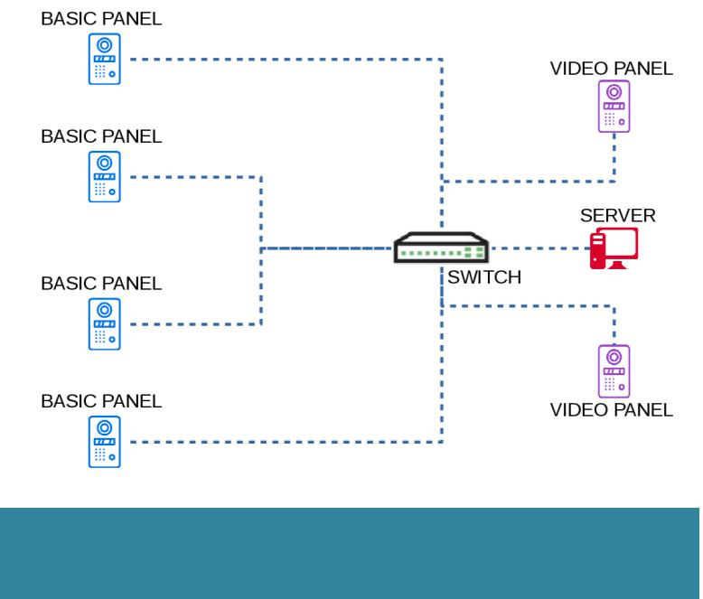

For installations up to 20 Panels the Server version is Mini (similar hardware with the aggregator), for larger installations the version is Full. Minimum specifications for Full version have to be determined with customer. Aggregators are used for 20+ Panels installations, each aggregator handles monitoring and configuration for up to 20 Panels.



Ordering Information

* VINDO1: Basic Intercom Panel Indoor version
* VOUTDO1: Basic Intercom Panel Outdoor version
* VVINDO2: Video Intercom Panel Indoor version
* VVOUTDO2: Video Intercom Panel Outdoor version
* AGR100: Aggregator
* VISERM: Server version Mini
* VISERF: Server version Full

|  |  |
| --- | --- |
| **Intercom Panel** |  |
| Communication | Ethernet 100 Base- |
|  | TX/10Base-T RS232 up to |
|  | 115200 Bit/sec |
|  | Wiegand up to 64 bit |
| Memory | Internal DRAM 1 GB |
|  | SD slot available 1xMMC |
|  | Real time clock with back-up |
|  | Li-Ion maintenance free |
|  | battery |
| Camera | 1 MP |
| Processor | ARM 64-bit, 1.2 GHz, Quad |
| Operating System | Linux OS |
| Software Upgrade | On line, during functioning |
| Power Supply | 85-264 VAC, 45-65 Hz |
|  | 12 VDC |
| Power Consumption | Max. 40 W |
| Max call duration | 5 minutes |
| Construction | Brushed stainless steel |
|  | vandal resistant |
| Agency Approvals | CE Conformity |
| and Standards |  |
| Ambient conditions | Operating Temp:-30 C +50 C |
|  | Storage Temp:-35 C +60 C |
|  | Humidity: 10-95% |
| Size of panel | 170 x 195 x 80 mm |
| (W x H x D) |  |
| Weight | 2 kg |
| Protection Class | IP67 |
| **Aggregator** |  |
| Communication | Ethernet 100 Base- |
|  | TX/10Base-T |
| Memory | Internal DRAM 1 GB |
|  | SD slot available 1xMMC |
|  | Real time clock with back-up |
|  | Li-Ion maintenance free |
|  | battery |
| Processor | ARM 64-bit, 1.2 GHz, Quad |
| Operating System | Linux OS |
| Power Supply | 85-264 VAC, 45-65 Hz |
| Power Consumption | Max. 10 W |

|  |  |  |  |  |
| --- | --- | --- | --- | --- |
| CONIC DESIGN® --- PASSCHIP® | Printed in Romania | | | Data subject to change without notice |
| 1 Piata Presei Libere, 1st District, 013888, Bucharest, Romania |  |  |  |  |
| Tel: 0040745342887, office@passchip.com |  | [www.passchip.com](http://www.passchip.com) |  |  |