**CENTRALIZED ADMINISTRATION SOFTWARE OF THE ID SMART ACCESS CHIP READERS FOR SELF SERVICE AREAS**



**PASSCON®**

**Basic**

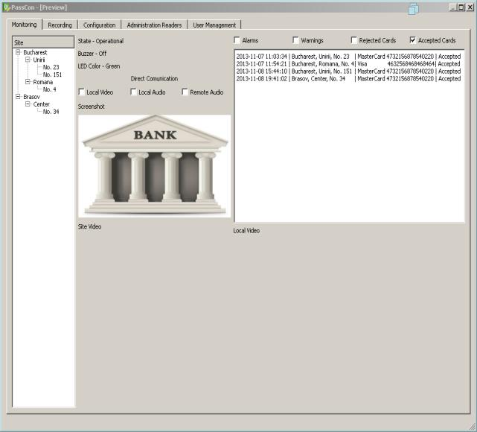

Main Functions



Complete IP control: Configuration, Administration, User Management, Monitoring and Recording

Centralized network upgrade of readers while running using an user friendly interface

Centralized access to internal PASSCHIP history resources, including sincronized time stamp

Centralized cards’ management, including BLACK LIST

Represents an advanced programming and configuration tool for PASSCHIP range of self service ID chip readers.

It provides an user friendly interface that simplifies the PASSCHIP control.

Offers a centralized Ethernet administration, using unique software functions for all the network; important savings are made in terms of time and specific resources of the security managers.

Facilitates PASSCHIP integration with CCTV, fire and intrusion detection through Wiegand, Ethernet and Serial interface.



Benefits

* Protection of customers during self-service procedures
* Protection of ATMs and banking assets against unauthorized usage
* Extremely reliable product with an excellent ROI rate
* Proven long life service
* May be integrated with third parties security softwares, including biometric applications
* May be linked and integrated with CCTV, fire and intrusion detection
* Excellent substitute to human guard patrol service

|  |  |  |  |  |
| --- | --- | --- | --- | --- |
| CONIC DESIGN® --- PASSCON® | Printed in Romania | | | Data subject to change without notice |
| 1 Piata Presei Libere, 1st District, 013888, Bucharest, Romania |  |  |  |  |
| Tel: 0040745342887, Fax: 0040378104216, office@passchip.com |  | [www.passchip.](http://www.passchip.)com |  |  |

**CENTRALIZED ADMINISTRATION SOFTWARE OF THE ID SMART ACCESS CHIP READERS FOR SELF SERVICE AREAS**



Installation Technical Specifications

Configuration example of PASSCHIP with door module:

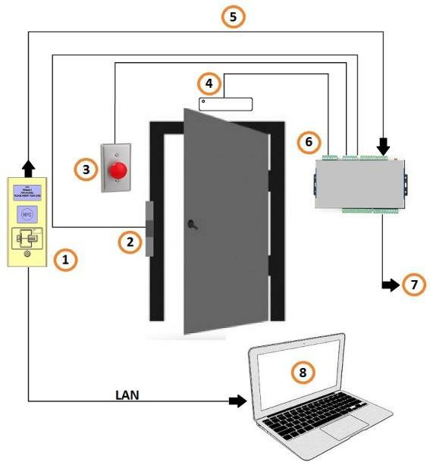

1. = PASSCHIP;
2. = Door lock;
3. = Exit button;
4. = Door magnetic sensor;
5. = Communication between readers and control unit;
6. = Control unit;
7. = Wiegand communication to an external access control system;
8. = PC with PASSCON Basic parameterization software via Ethernet



Ordering Information

* PASSCON BASIC: Administration platform software, unlimited number of panels, one user
* PASSCON GUI: Administration graphical software 0->100 panels, one simultaneous user
* GSSACDU: Upgrade option for GSSACD: 100->unlimited panels, one simultaneous user
* SMUS: Additional simultaneous user for GSSACD

|  |  |  |
| --- | --- | --- |
| Computer Requirements | Windows XP or higher |  |
|  |
|  | Intel CORE 2 or higher |  |
|  | 32 MB of RAM |  |
|  | 100 MB HDD free space |  |
|  | CD ROM player, keyboard and |  |
|  | mouse |  |
|  |  |  |
| PC Configuration | Max number of connected PC with |  |
|  |
|  | running PASSCON software: 1 |  |
|  | with basic license, unlimited |  |
|  | according additional licensing |  |
|  |  |  |
| Panels Configuration | Max number of panels on |  |
|  |
|  | administration platform: |  |
|  | unlimited(limited functions) |  |
|  | Max number of panels on graphical |  |
|  | platform: 100, unlimited according |  |
|  | additional licensing |  |
| Users Configuration | Max number of simultaneous |  |
|  |
|  | users: 1, unlimited according |  |
|  | additional licensing |  |
| Communication with PASSCHIP | Ethernet |  |
|  |
| Transfer of parameterization | On line, during PASSCHIP |  |
|  |
|  | functioning |  |
|  |  |  |
| NTP | YES |  |
|  |
|  |  |  |
| Black list management | YES, online programable for |  |
|  |
|  | maximum 1 000 card profiles |  |
|  |  |  |
| Panels’ History Log access | YES, limited to 5MB, aprox.10 000 |  |
|  |
|  | events with time stamp (panel’s |  |
|  | capacity) |  |
| Language | English |  |
|  |
|  |  |  |

|  |  |  |  |  |
| --- | --- | --- | --- | --- |
| CONIC DESIGN® --- PASSCON® | Printed in Romania | | | Data subject to change without notice |
| 1 Piata Presei Libere, 1st District, 013888, Bucharest, Romania |  |  |  |  |
| Tel: 0040745342887, Fax: 0040378104216, office@passchip.com |  | [www.passchip.](http://www.passchip.)com |  |  |