Settings to change for creating migrations
1. Change DB string in appsettings.json from defined db name in docker to localhost,1433
Update TenantMapping in DB
update [AppointmentMain].TenantMapping
set DBServer = 'localhost,1433'
2. Uncomment the following in AppointmentDataContextConfiguration.cs
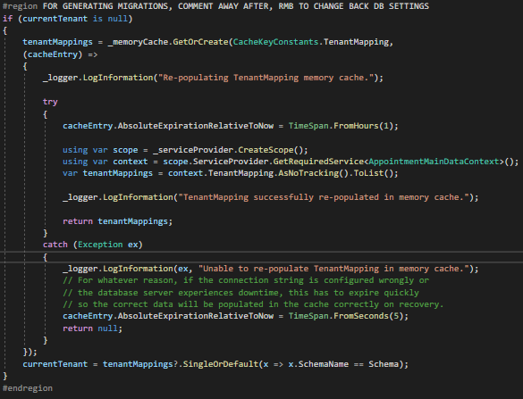
3. Uncomment the following in DatabaseExtension.cs
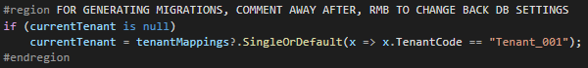
After that run mirgration scripts accordingly
dotnet-ef migrations add ChangeAlltoCommonID --project .\Appointment.Persistence\ -s .\Appointment.API\ --context AppointmentDataContext --output-dir Migrations\AppointmentData

dotnet-ef migrations remove --project .\Appointment.Persistence\ -s .\Appointment.API\ --context AppointmentDataContext

