Software Architecture and Design Specification
Project: Collaborative Study Material & Quiz Platform (Project #21)
Version: 1.0
Authors: Kruthika C B (PES1UG24CS670), Narendra Kanchi (PES1UG24CS678), Mohammed Al Zubed Hulgeri (PES1UG24CS674)
Date: 28-09-2026
Status: Draft for Part-1 submission
Format: IEEE-style SAD (IEEE 42010 / IEEE 1016 structure), following the course SAD template

Revision History
Version | Date | Author | Change Summary
1.0 | 28-09-2026 | Kruthika C B | First complete SAD, derived from SRS v1.0; diagrams embedded

Approvals
Role | Name | Signature / Date
Course Coordinator
Project Team Lead

Contents
1. Introduction
1.1 Purpose
1.2 Scope
1.3 Audience
1.4 Definitions
1.5 Conventions
2. Document Overview
2.1 How to use this document
2.2 Related Documents
3. Architecture
3.1 Goals & Constraints
3.2 Stakeholders & Concerns
3.3 Component (UML) Diagram
3.4 Component Descriptions
3.5 Chosen Architecture Pattern and Rationale
3.6 Technology Stack & Data Stores
3.7 Risks & Mitigations
3.8 Traceability to Requirements
3.9 Security Architecture
4. Design
4.1 Design Overview
4.2 UML Sequence Diagrams
4.3 API Design
4.4 Error Handling, Logging & Monitoring
4.5 UX Design
4.6 Open Issues & Next Steps
5. Appendices
5.1 Glossary
5.2 References
5.3 Tools

1. Introduction

1.1 Purpose
This document specifies the architecture and design of the Collaborative Study Material & Quiz Platform. It explains how the requirements in the Software Requirements Specification (SRS v1.0) are realised: the structure of the system, the responsibilities of each component, the data and interface design, and the security architecture. It is the design reference for developers and the basis for the design-level test cases in the Test Plan.

1.2 Scope
The design covers all functions in SRS Section 2.2: registration and login with roles, sharing of study material (upload, search, download), the shared question bank, quiz creation and timed quiz attempts with automatic grading, performance reports for Students and Contributors, and moderation by an Admin. It realises all 18 functional requirements (CSQ-F), 7 non-functional requirements (CSQ-NF), 3 security objectives (CSQ-SO) and 7 security requirements (CSQ-SR).
Out of scope, as in the SRS: live classes, video lectures, chat, payments, a native mobile app, grading of written answers, and copyright or plagiarism checking of uploaded material.

1.3 Audience
Developers, QA engineers (testers), security reviewers, the course instructor and assessment evaluators, and the administrator who will run the system.

1.4 Definitions
Acronyms: SAD, SRS, ADR, API, REST, JSON, JWT, RBAC, HTTPS, TLS, MERN, MCQ, STRIDE, TTL, RTM, UC, FR, NFR, SR, SO, DS.
Term | Meaning
SAD | Software Architecture and Design Specification (this document)
ADR | Architecture Decision Record – a short record of one design decision and its reasons (Section 3.5)
RBAC | Role-Based Access Control – access to a feature depends on the user’s role (Student, Contributor, Admin)
JWT | JSON Web Token – a signed token, sent with every request, that proves the user is logged in
MERN | MongoDB, Express.js, React, Node.js
STRIDE | Threat classification: Spoofing, Tampering, Repudiation, Information disclosure, Denial of service, Elevation of privilege
TTL index | A MongoDB index that deletes a record automatically after a set time
DS-xxx-## | Design Specification entry (Section 4.1.3) that realises one or more SRS requirements; these IDs are the ones used in the SRS RTM (SRS Section 8)
Backend Server | The Node.js/Express.js application tier as a whole (API gateway layer plus all modules); this is the term used in the SRS RTM
Attempt | One complete try of a quiz by a Student; each attempt is stored separately

1.5 Conventions
- Requirement IDs are those of the SRS: CSQ-F-###, CSQ-NF-###, CSQ-SO-##, CSQ-SR-###; use cases are UC-##.
- Design specification IDs follow DS-<area>-## (for example DS-Auth-01), exactly as referenced in the SRS RTM.
- Diagrams follow UML 2.x notation. Figures are numbered in order of appearance.

2. Document Overview

2.1 How to use this document
This document provides the architectural and design deliverables: a UML component diagram, three UML sequence diagrams, architecture decision records, a STRIDE threat model, the REST API design and the requirement-to-design traceability. Readers can go directly to the part they need:
Reader | Start with
Developers | Section 3.4 (components), 4.1 (design overview and DS entries), 4.2 (sequences), 4.3 (API)
QA engineers | Section 3.8 (traceability), 4.3 (API and error codes), 4.4 (error handling)
Security reviewers | Section 3.9 (security architecture), ADRs in 3.5, DS-Sec-01 to 07 in 4.1.3
Instructors / evaluators | Sections 3.1 to 3.9 for the architecture, 3.8 for the link back to the SRS

2.2 Related Documents
Document | Relationship
Software Requirements Specification (SRS) v1.0 | Source of all requirements realised here; its Section 3.4 states that the API is defined in this SAD
Software Test Plan (STP) | Test cases TC-xxx-## verify the designs in this document
Requirements Traceability Matrix (RTM) | SRS Section 8; its DS-xxx-## references point to Section 4.1.3 of this document

3. Architecture

3.1 Goals & Constraints
Goals (derived from the SRS quality attributes):
Goal | Target | SRS source
Performance | Search ≤ 2 s, quiz result ≤ 3 s under 100 simultaneous submissions, page load ≤ 3 s (95th percentile) | CSQ-NF-001, 002, 006
Availability | ≥ 99% per calendar month, excluding announced maintenance of up to 4 hours | CSQ-NF-003
Security | Role-based access, hashed passwords, validated input and files, HTTPS TLS 1.2+, audit trail | CSQ-SR-001 to 007
Usability | 9 of 10 first-time users finish register, download and quiz within 10 minutes | CSQ-NF-004
Compatibility | Latest 2 versions of Chrome, Firefox, Edge, Safari; widths 360 to 1920 px | CSQ-NF-005
Recoverability | Daily backup, 7 kept, restore within 4 hours | CSQ-NF-007
Modularity | Independent modules per feature area so that team members can build and test in parallel | Team goal

Constraints:
- The MERN stack must be used (MongoDB, Express.js, React, Node.js 20 LTS or newer; MongoDB 6.0 or newer).
- Browser and server communicate only through a REST API using JSON.
- Uploaded files are PDF, DOCX or PPTX, at most 20 MB. Questions are multiple-choice with four options and one correct answer.
- The interface is in English and only free and open-source tools may be used.
- The system is self-contained: it has no external service dependencies. Uploaded files are stored on the server disk (at least 50 GB free).

3.2 Stakeholders & Concerns
Stakeholder | Concerns | Addressed in
Students | Fast search, fair timed quizzes, instant and correct grading, clear feedback, privacy of results | 3.9, 4.1.3 (DS-Quiz, DS-Rep), 4.5
Contributors / Teachers | Quick upload and question entry, control over own content, quiz statistics | 4.1.3 (DS-Mat, DS-QB), 4.3
Admin | Removing inappropriate content, traceability of actions, simple operation | 4.1.3 (DS-Adm, DS-Sec-06), 4.4
Developers | Modularity, clear module boundaries, a defined API, a common stack | 3.4, 3.5, 4.3
QA engineers | Testable, measurable behaviour and traceable design | 3.8, 4.4
Instructors / evaluators | Conformance to the SRS and to the IEEE structure | 3.8, whole document

3.3 Component (UML) Diagram
Figure 1 shows the component view. The system has three tiers. The React Frontend runs in the browser and talks to the Backend Server only through the REST API over HTTPS. The Backend Server is one Node.js/Express.js application organised as an API gateway layer (routing, authentication, role check, validation, audit logging) followed by six feature modules. The modules use MongoDB for records and the File Storage for uploaded files.
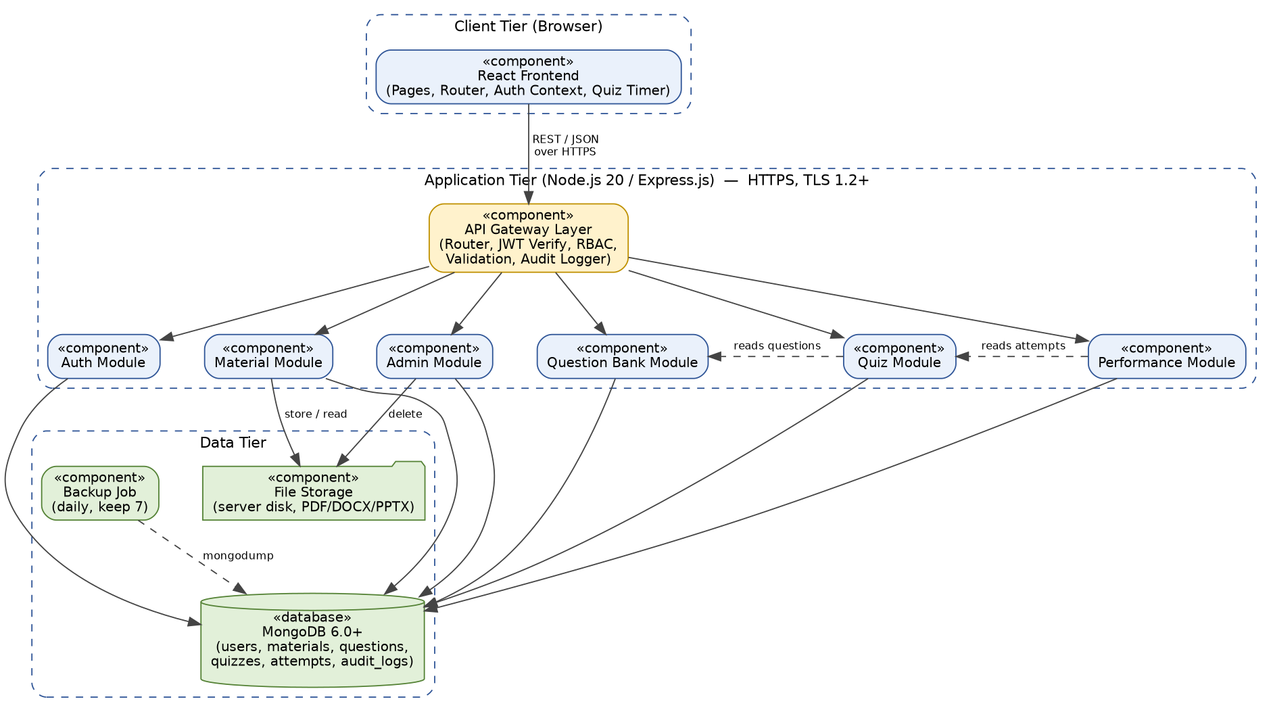
Figure 1: UML component diagram – Collaborative Study Material & Quiz Platform

3.4 Component Descriptions
Component | Responsibility | Main interfaces | SRS requirements
React Frontend | All pages (Register/Login, Home and Search, Material Details, Upload, Question Bank, Quiz Builder, Quiz Attempt, Quiz Result, Performance Dashboard, Admin Panel); role-based menu; countdown timer and auto-submit; client-side form checks | Calls REST API over HTTPS; keeps JWT in memory | CSQ-F-004, 031, 033; NF-004, 005, 006
API Gateway Layer (Backend Server) | Single entry point: HTTPS-only routing, JWT verification, role check (deny by default), input validation and sanitising, rate limiting, audit logging, central error handler | Express middleware chain: authenticate → authorize → validate → controller | CSQ-F-003; SR-002, 003, 005, 006, 007
Auth Module | Registration, login, logout, token refresh, password rule, bcrypt hashing, JWT issue and revocation | /api/auth/* | CSQ-F-001 to 005; SR-001, 003
Material Module | Upload with file checks, keyword/subject/topic search with paging, download with counter | /api/materials/*; File Storage; MongoDB | CSQ-F-010 to 012; SR-004; NF-001
Question Bank Module | Add, edit, delete own questions; topic and difficulty tags; filtering; in-use check | /api/questions/*; MongoDB | CSQ-F-020 to 022
Quiz Module | Create and publish quizzes; list published quizzes; start attempt with server-side timer; auto-grade; store attempt | /api/quizzes/*, /api/attempts/*; reads Question Bank data | CSQ-F-030 to 033; NF-002
Performance Module | Student performance page and Contributor quiz statistics using MongoDB aggregation | /api/reports/*; reads attempts | CSQ-F-040, 041
Admin Module | Removal of any material or quiz; moderation views (uses the same delete routes with the Admin role) | /api/materials/:id, /api/quizzes/:id (DELETE) | CSQ-F-050
MongoDB Database | Persistent records: users, materials, questions, quizzes, attempts, audit_logs, revoked_tokens | Mongoose ODM over the MongoDB driver | All; NF-007
File Storage | Uploaded files on the server disk, outside the web root, under random names | Node.js fs streams | CSQ-F-010, 012; SR-004
Backup Job | Daily database backup, keeps the last 7, restore script | mongodump / mongorestore (cron) | CSQ-NF-007

3.5 Chosen Architecture Pattern and Rationale
Pattern: a three-tier client–server architecture. The Backend Server is a layered modular monolith (routes → middleware → controllers → services → models), exposing a stateless REST API. The React client is a single-page application.
Rationale: the team is small, the user base is a school or college, and the project must be delivered on the MERN stack. A single deployable backend with clear module boundaries gives separation of concerns and parallel work without the cost of distributed systems. Rejected: (a) microservices – too much operational complexity (service discovery, distributed transactions, several deployments) for the expected scale of 100 simultaneous quiz submissions and 10,000 materials; (b) server-rendered pages – would not give the responsive, timer-driven quiz experience as simply as a React SPA; (c) a backend-as-a-service – violates the “no external dependency” and free/open-source constraints.
Table 3.5-1: Architecture Decision Records
ADR | Decision | Reason / alternatives considered | Requirements
ADR-001 | MERN stack with a modular monolith backend | Mandated by the project topic; modules can later be split if needed. Alternative: microservices (rejected above). | Constraint
ADR-002 | Stateless JWT (HS256) sessions, 30-minute lifetime, silent refresh while the user is active, and a revoked-token list (TTL) for logout | No session store needed and easy to scale. A pure JWT cannot end a session, so the token ID (jti) is stored on logout until the token expires. Refresh is needed because a quiz can last up to 180 minutes, longer than one token. | CSQ-F-004; SR-003
ADR-003 | bcrypt with cost factor 12 | SRS requires at least 10. 12 gives stronger protection at about 0.25 s per hash, still well inside the 3 s registration target. Alternative: argon2 (not chosen: extra native dependency). | CSQ-SR-001, F-001
ADR-004 | Central RBAC middleware driven by one permission map that mirrors SRS Table 1; deny by default | One place to change and test; the same map is sent to the frontend so menus match the server rules. | CSQ-F-003; SR-002
ADR-005 | Files on server disk under random names; metadata in MongoDB | Meets the “no external system” assumption and the 20 MB limit. Alternative: GridFS (rejected: heavier for 20 MB downloads and streaming). | CSQ-F-010, 012
ADR-006 | File type verified by content (magic bytes / ZIP structure), not by extension | SRS requires the real content type to be checked. | CSQ-SR-004
ADR-007 | Timer is server-authoritative: the server stores startedAt and expiresAt; the client counts down from server time | Prevents cheating by changing the browser clock and keeps client and server within 1 s. Submissions are accepted up to 5 s after expiresAt (network grace) so that auto-submit at 00:00 is not lost. | CSQ-F-031
ADR-008 | Grading only on the server; correct answers are never sent before submission | Protects quiz integrity; the answer key is loaded once per submission for speed. | CSQ-F-032; NF-002
ADR-009 | TLS terminated by an Nginx reverse proxy (TLS 1.2+, HTTP redirected to HTTPS); Node.js served on localhost only | Free/open-source, well-tested TLS configuration, also serves the React build with compression. | CSQ-SR-005; NF-006
ADR-010 | Validation with express-validator plus express-mongo-sanitize on every route | Blocks scripts and database operators server-side (400) as SRS requires; React also escapes output by default. | CSQ-SR-007

3.6 Technology Stack & Data Stores
Layer | Technology | Purpose
Client | React (SPA), React Router, Fetch/Axios, plain CSS with a mobile-first responsive layout | Pages, role-based navigation, quiz timer
Server | Node.js 20 LTS, Express.js, Mongoose, multer (upload), bcrypt, jsonwebtoken, express-validator, express-mongo-sanitize, helmet, express-rate-limit, pino/winston (logs) | REST API and business rules
Database | MongoDB 6.0+ | Records (Section 4.1.2)
File store | Server disk directory outside the web root | Uploaded material
Edge | Nginx reverse proxy with TLS certificate (for example Let’s Encrypt) | HTTPS, static files, compression
Process / ops | PM2 (cluster mode, auto-restart), cron, mongodump/mongorestore | Availability, backup
Quality tools | Jest and Supertest (unit/API tests), Postman/Swagger (API), k6 or Artillery (load tests) | Verification of the SRS test cases

Deployment view: one Linux (or Windows) server runs Nginx, the Node.js processes (PM2), MongoDB and the upload directory. Browsers connect to Nginx over HTTPS; Nginx forwards /api requests to Node.js on localhost. Data stores: MongoDB for all records and the disk directory for files.

3.7 Risks & Mitigations
ID | Risk | Mitigation
RK-01 | 20 MB upload takes longer than 10 s (CSQ-F-010) | Stream to disk with multer (no buffering in memory); reject early on size; no image processing on upload.
RK-02 | Search becomes slow with 10,000 materials (CSQ-NF-001) | MongoDB text index and compound indexes, page size 10, lean queries and projections; verified with load test TC-Perf-01.
RK-03 | 100 simultaneous submissions exceed 3 s (CSQ-NF-002) | Stateless grading with one answer-key read and one write per submission; PM2 cluster mode; connection pool; TC-Perf-02.
RK-04 | Clock differences or cheating on the quiz timer | Server-authoritative timer (ADR-007); client re-syncs with server time every 30 s.
RK-05 | Malicious or disguised file upload | Content-type check, size limit, random file name, files stored outside the web root and always sent as attachments (DS-Sec-04).
RK-06 | Stolen or reused session token | HTTPS only, 30-minute lifetime, revocation on logout, token kept in memory (not in local storage).
RK-07 | Single server is a single point of failure against the 99% target | PM2 auto-restart, health check and uptime monitoring; 99% allows about 7 hours of downtime per month; planned maintenance announced 24 h ahead.
RK-08 | Data loss | Daily automatic backup, 7 kept, restore drill (CSQ-NF-007); uploads directory is copied together with the database backup (see Section 4.6).
RK-09 | Database or NoSQL injection, cross-site scripting | Server-side validation and sanitising (DS-Sec-07), Mongoose schemas, React output escaping, Content-Security-Policy header via helmet.
RK-10 | Disk fills up with uploads | Disk-usage monitoring with an alert at 80%; 20 MB limit per file; Admin removal tool.

3.8 Traceability to Requirements
Every SRS requirement is realised by a design specification (DS) entry in Section 4.1.3. The table below gives the link; the DS IDs are the same as in the SRS RTM. Test cases are listed in the SRS RTM and the Test Plan.
Requirement | DS ID | Component(s) | SAD section
CSQ-F-001 Registration | DS-Auth-01 | Auth Module | 4.1.3, 4.3
CSQ-F-002 Login | DS-Auth-02 | Auth Module | 4.1.3, 4.2 (Fig. 2)
CSQ-F-003 Role-based access | DS-Auth-03 | API Gateway (authorize), Auth Module | 3.9, 4.1.3
CSQ-F-004 Logout | DS-Auth-04 | Auth Module, MongoDB | 4.1.3
CSQ-F-005 Password rule | DS-Auth-05 | Auth Module | 4.1.3
CSQ-F-010 Upload material | DS-Mat-01 | Material Module, File Storage | 4.1.3, 4.2 (Fig. 3)
CSQ-F-011 Search material | DS-Mat-02 | Material Module, MongoDB | 4.1.3, 4.3
CSQ-F-012 Download material | DS-Mat-03 | Material Module, File Storage | 4.1.3
CSQ-F-020 Add question | DS-QB-01 | Question Bank Module | 4.1.3, 4.3
CSQ-F-021 Edit / delete own question | DS-QB-02 | Question Bank Module | 4.1.3
CSQ-F-022 Tag and filter questions | DS-QB-03 | Question Bank Module | 4.1.3
CSQ-F-030 Create and publish quiz | DS-Quiz-01 | Quiz Module | 4.1.3, 4.3
CSQ-F-031 Attempt with timer | DS-Quiz-02 | Quiz Module, React Frontend | 4.1.3, 4.2 (Fig. 4)
CSQ-F-032 Auto-grade, show result | DS-Quiz-03 | Quiz Module | 4.1.3, 4.2 (Fig. 4)
CSQ-F-033 List published quizzes | DS-Quiz-04 | Quiz Module, React Frontend | 4.1.3
CSQ-F-040 Student performance page | DS-Rep-01 | Performance Module | 4.1.3
CSQ-F-041 Contributor quiz statistics | DS-Rep-02 | Performance Module | 4.1.3
CSQ-F-050 Remove material / quiz | DS-Adm-01 | Admin Module (Backend Server admin routes) | 4.1.3
CSQ-NF-001 Search ≤ 2 s | DS-Perf-01 | Material Module, MongoDB | 3.7, 4.1.3
CSQ-NF-002 Result ≤ 3 s | DS-Perf-02 | Quiz Module | 3.7, 4.1.3
CSQ-NF-003 99% availability | DS-Ops-01 | Backend Server, Nginx, PM2 | 4.4
CSQ-NF-004 Usability trial | DS-UX-01 | React Frontend | 4.5
CSQ-NF-005 Browser / screen support | DS-UX-02 | React Frontend | 4.5
CSQ-NF-006 Page load ≤ 3 s | DS-Perf-03 | React Frontend, Nginx | 4.1.3
CSQ-NF-007 Backup and restore | DS-Ops-02 | MongoDB Database, Backup Job | 4.4
CSQ-SR-001 bcrypt hashing | DS-Sec-01 | Auth Module | 3.9
CSQ-SR-002 Role check on every request | DS-Sec-02 | Backend Server (middleware) | 3.9
CSQ-SR-003 Reject invalid token (401) | DS-Sec-03 | Auth Module, middleware | 3.9
CSQ-SR-004 File type and size checks | DS-Sec-04 | Material Module, File Storage | 3.9
CSQ-SR-005 HTTPS TLS 1.2+ | DS-Sec-05 | Nginx, Backend Server, React Frontend | 3.9
CSQ-SR-006 Audit log | DS-Sec-06 | Backend Server, MongoDB | 3.9, 4.4
CSQ-SR-007 Server-side input validation | DS-Sec-07 | Backend Server (validation) | 3.9

Table 3.8-2: Use case realisation
Use case | Realised by | Sequence diagram
UC-01 Register / Login | Auth Module | Figure 2 (login)
UC-02 Upload Material | Material Module, File Storage | Figure 3
UC-03 Search / Download Material | Material Module | API in 4.3
UC-04 Add Question; UC-11 Tag Question | Question Bank Module | API in 4.3
UC-05 Create Quiz; UC-12 Select Questions from Bank | Quiz Module, Question Bank Module | API in 4.3
UC-06 Attempt Quiz; UC-09 Auto-grade; UC-13 Auto-submit on Timeout | Quiz Module, React Frontend | Figure 4
UC-07 View Performance | Performance Module | API in 4.3
UC-08 Moderate Content | Admin Module | API in 4.3

3.9 Security Architecture
Trust boundaries: (1) between the browser and Nginx (untrusted network, HTTPS only); (2) between Nginx and the Node.js processes (localhost); (3) between the Node.js processes and the data stores (MongoDB bound to localhost with authentication; upload directory outside the web root). Everything that crosses boundary 1 is treated as untrusted and validated on the server.
Table 3.9-1: Threat model (STRIDE)
Threat | Example in this system | Mitigation (design) | Requirement
Spoofing | Guessing passwords; using a stolen token; registering as Admin | bcrypt-hashed passwords; identical “Invalid email or password” message; rate limit on login and register; signed JWT with 30-minute lifetime; Admin cannot be chosen at registration | SR-001, 003; F-002
Tampering | Changing a token, request body or score; editing another user’s question | JWT signature check; server-side validation; grading only on server; ownership checks on edit and delete; HTTPS | SR-003, 005, 007; F-021
Repudiation | A user denies a deletion or upload | Append-only audit log of login (success and failure), upload and deletion with user ID and time | SR-006
Information disclosure | Reading another user’s results; seeing the answer key; password leak in logs | Owner-only report queries; correct answers only after submission; no passwords or tokens in logs; TLS; generic login errors | SR-001, 005; SO-01
Denial of service | Flooding login; huge or many uploads; huge result pages | express-rate-limit; 20 MB cap; fixed page size (10) and hard limit on page size; PM2 restart; Nginx request-size limits | F-010; NF-003
Elevation of privilege | Student calling a Contributor route; script or NoSQL operator injection | Deny-by-default RBAC on every request; 403 “Access denied”; validation and sanitising (400); Mongoose schemas | SR-002, 007; F-003

Other controls: helmet security headers (Content-Security-Policy, X-Content-Type-Options, HSTS); uploaded files are always sent with Content-Disposition: attachment; secrets (JWT key, database password) come from environment variables, never from the source code; the MongoDB port is not exposed to the internet. The design follows the OWASP Top 10 categories: broken access control, injection, cryptographic failures, identification and authentication failures, and logging failures.
Security objectives to design: SO-01 Confidentiality → DS-Sec-01, 03, 05; SO-02 Integrity and access control → DS-Sec-02, 03, 04, 07; SO-03 Accountability → DS-Sec-06.

4. Design

4.1 Design Overview

4.1.1 Structure of the Backend Server
Each request passes through the same chain: Nginx → Express router → authenticate (JWT) → authorize (role) → validate/sanitise → controller → service → model (Mongoose) → MongoDB / File Storage. Controllers only translate HTTP to service calls; services hold the business rules; models hold the schemas and indexes. Errors are thrown as typed errors and converted to the standard JSON error format by one central error handler (Section 4.4). The React Frontend is organised by page, with shared components (form fields, table, timer), an API client, and an auth context that holds the token and the role.

4.1.2 Data design (MongoDB collections)
Collection | Main fields | Indexes / notes
users | name, email, passwordHash, role (Student | Contributor | Admin), createdAt | Unique index on email. Admin accounts created by a setup script only.
materials | title (≤100), subject, topic, originalName, storagePath, mimeType, sizeBytes, ownerId, downloadCount, createdAt | Text index on title, subject, topic; index on createdAt (descending). storagePath is never sent to clients.
questions | text (≤500), options[4], correctIndex (0–3), topic, difficulty (Easy | Medium | Hard), ownerId, createdAt | Compound index on topic and difficulty; index on ownerId.
quizzes | title, timeLimitMinutes (5–180), questionIds[5–50], questionCount, status (draft | published | removed), ownerId, createdAt, publishedAt | Index on status and publishedAt; index on ownerId.
attempts | quizId, studentId, startedAt, expiresAt, submittedAt, status (in_progress | submitted), answers[{questionId, selectedIndex, correct, topic}], score, total, percentage | Index on studentId and submittedAt; index on quizId. One document per attempt; several per student and quiz are allowed.
audit_logs | userId (or null), action (LOGIN_SUCCESS | LOGIN_FAILED | UPLOAD | DELETE), targetId, timestamp, ipAddress | Append-only: no update or delete route exists. Index on timestamp and userId.
revoked_tokens | jti, expiresAt | TTL index on expiresAt so entries disappear when the token would have expired anyway.

4.1.3 Design specifications (DS)
Each entry realises the requirement(s) named in the SRS RTM. Numbers (30 minutes, 20 MB, 5–180 minutes, and so on) come from the SRS.
DS ID | Design specification | Req.
DS-Auth-01 | POST /api/auth/register validates name (2–50 chars), email format, and the password rule, then inserts the user. The role field accepts only Student or Contributor. The unique index on email gives “Email already registered” (409). Password is hashed with bcrypt before saving. Target: response within 3 s. | F-001
DS-Auth-02 | POST /api/auth/login finds the user by email and compares the password with bcrypt. Unknown email and wrong password give the same 401 “Invalid email or password” and create no session. On success a JWT (HS256) with sub, role, jti, iat and exp = iat + 30 min is returned together with the role; an audit entry is written. | F-002
DS-Auth-03 | A permission map (feature → allowed roles) mirrors SRS Table 1. Middleware authorize(feature) reads the role from the verified token and returns 403 “Access denied” if it is not allowed. GET /api/auth/me returns the role and allowed features so that the menu shows only permitted options. | F-003
DS-Auth-04 | POST /api/auth/logout stores the token’s jti in revoked_tokens. The authenticate middleware checks this list, so the token stops working immediately (401). The frontend clears its token and shows the Login page. | F-004
DS-Auth-05 | Password rule /^(?=.*[A-Za-z])(?=.*\d).{8,64}$/ is checked on the server (the client repeats it only for early feedback). Failure gives 400 “Password too weak”. | F-005
DS-Mat-01 | POST /api/materials (multipart) accepts one file plus title (≤100), subject, topic. Multer streams the file to disk with a 20 MB limit; the content type is verified by magic bytes (PDF header; DOCX and PPTX are ZIP packages with word/ or ppt/ entries). The file is saved under a random name outside the web root, the metadata is inserted, and an audit entry is written. Invalid file → 400 “Invalid file”. Target: confirmation within 10 s for 20 MB. | F-010
DS-Mat-02 | GET /api/materials?q=&subject=&topic=&page= uses the text index for keyword, exact filters for subject and topic, sorts by createdAt descending and returns 10 per page with the total count. An empty result returns an empty list; the UI shows “No materials found”. | F-011
DS-Mat-03 | GET /api/materials/:id/download streams the stored file with Content-Disposition: attachment and the original name, then increments downloadCount by 1 with an atomic $inc. | F-012
DS-QB-01 | POST /api/questions validates: text ≤ 500 chars, options array of exactly 4 non-empty strings, correctIndex 0–3 (so exactly one correct option), topic and difficulty present. ownerId is taken from the token. | F-020
DS-QB-02 | PUT and DELETE /api/questions/:id compare ownerId with the token user; otherwise 403 “Access denied”. Delete first checks whether the question is in any published quiz; if so → 409 “Question is in use”. | F-021
DS-QB-03 | topic (text) and difficulty (enum) are required by the schema. GET /api/questions?topic=&difficulty= applies either or both filters using the compound index. | F-022
DS-Quiz-01 | POST /api/quizzes creates a draft with title, timeLimitMinutes (5–180) and 5–50 distinct, existing questionIds; anything else → 400. PATCH /api/quizzes/:id/publish sets status to published, after which Students see it. | F-030
DS-Quiz-02 | POST /api/quizzes/:id/attempts creates an attempt with startedAt and expiresAt = startedAt + timeLimit and returns the questions without correctIndex, together with expiresAt and serverTime. The client counts down from the server-provided remaining time, re-syncs every 30 s (drift ≤ 1 s) and submits automatically at 00:00. The server accepts a submission up to 5 s after expiresAt and rejects later ones. | F-031
DS-Quiz-03 | POST /api/attempts/:id/submit loads the quiz’s questions in one query, gives 1 mark per correct answer and 0 for wrong or unanswered, computes score, percentage and per-question and per-topic results, saves them in one write, and returns score, percentage and the correct answer of each question. A second submit of the same attempt → 409. Target: within 3 s. | F-032
DS-Quiz-04 | GET /api/quizzes (Student) returns published quizzes with title, questionCount and timeLimitMinutes, newest first, using the status index. | F-033
DS-Rep-01 | GET /api/reports/student/me aggregates the Student’s submitted attempts: overall average percentage, percentage per topic (correct answers ÷ answered questions of that topic), and the last 20 attempts (quiz title, date, score). Only the token’s own data is queried. | F-040
DS-Rep-02 | GET /api/reports/quizzes/:id (Contributor who owns the quiz, else 403) returns number of attempts, average, highest and lowest score, and the 3 questions with the lowest percentage of correct answers, computed by aggregation over attempts. | F-041
DS-Adm-01 | DELETE /api/materials/:id and DELETE /api/quizzes/:id: Admin may remove any item. A material’s file and record are deleted; a quiz gets status removed (soft delete) so old attempts and reports stay consistent and it disappears from lists. An audit entry is written. | F-050
DS-Perf-01 | Text and compound indexes, page size 10, projection of list fields only, lean queries; checked by load test TC-Perf-01 with 10,000 materials. | NF-001
DS-Perf-02 | Stateless submit handler, one read of the answer key, one write, MongoDB connection pool, PM2 cluster mode with at least 2 workers; checked by TC-Perf-02 with 100 simultaneous submissions. | NF-002
DS-Perf-03 | React build with route-level code splitting, Nginx gzip/brotli compression and long-lived caching of hashed static files. | NF-006
DS-Ops-01 | PM2 restarts crashed workers; GET /api/health (database reachable) is polled by an uptime monitor whose monthly report proves the 99% target; planned maintenance (≤ 4 h) is announced 24 h ahead by a banner. | NF-003
DS-Ops-02 | A cron job runs mongodump (compressed archive) every 24 hours, keeps the newest 7 archives and deletes older ones; a documented restore script uses mongorestore and is rehearsed to finish within 4 hours. | NF-007
DS-UX-01 | Consistent layout, role-based menu, plain-language messages that say what to do next, inline form validation, and the shortest path for the three trial tasks (register → search and download → attempt quiz). See Section 4.5. | NF-004
DS-UX-02 | Mobile-first responsive CSS tested at 360, 768 and 1920 px; browserslist set to the last 2 versions of Chrome, Firefox, Edge and Safari; no browser-specific APIs without fallback. | NF-005
DS-Sec-01 | bcrypt with a random salt per password and cost factor 12 (≥ 10 required). Request logging redacts password and token fields; passwords are never returned by any endpoint. | SR-001
DS-Sec-02 | Router-level authenticate and authorize on every protected route; a route without an authorize rule is rejected at start-up (deny by default). Refusal → 403 “Access denied”. | SR-002
DS-Sec-03 | authenticate checks presence, signature, expiry (30 minutes from issue) and the revoked list; any failure → 401. POST /api/auth/refresh issues a new 30-minute token while the current one is still valid, so a long quiz is not interrupted. | SR-003
DS-Sec-04 | Upload filter: allow-list PDF, DOCX, PPTX; size ≤ 20 MB; real content type by magic bytes; extension and declared MIME type must agree with the detected type; otherwise 400 “Invalid file” and the temporary file is deleted. | SR-004
DS-Sec-05 | Nginx accepts only TLS 1.2 and 1.3, redirects HTTP to HTTPS (301), and sends an HSTS header. The frontend calls the API only through https URLs. | SR-005
DS-Sec-06 | An audit service writes {userId, action, timestamp} to audit_logs for LOGIN_SUCCESS, LOGIN_FAILED, UPLOAD and DELETE. The collection is append-only (no API can change or remove entries). | SR-006
DS-Sec-07 | express-validator schemas on every route, express-mongo-sanitize to strip $ and . operators, and a check that rejects markup such as <script> and database commands with 400. Text is escaped by React on output. | SR-007

4.2 UML Sequence Diagrams
Three flows that are central to the platform are shown. Figure 2 is the login flow (UC-01), Figure 3 the material upload flow (UC-02) and Figure 4 the quiz attempt with auto-submit and auto-grading (UC-06, UC-09, UC-13).

4.2.1 Login
The gateway validates the input, the Auth Module compares the password with the stored bcrypt hash and, on success, signs a 30-minute token. Both outcomes write an audit entry, and the failure message is the same for an unknown email and a wrong password.
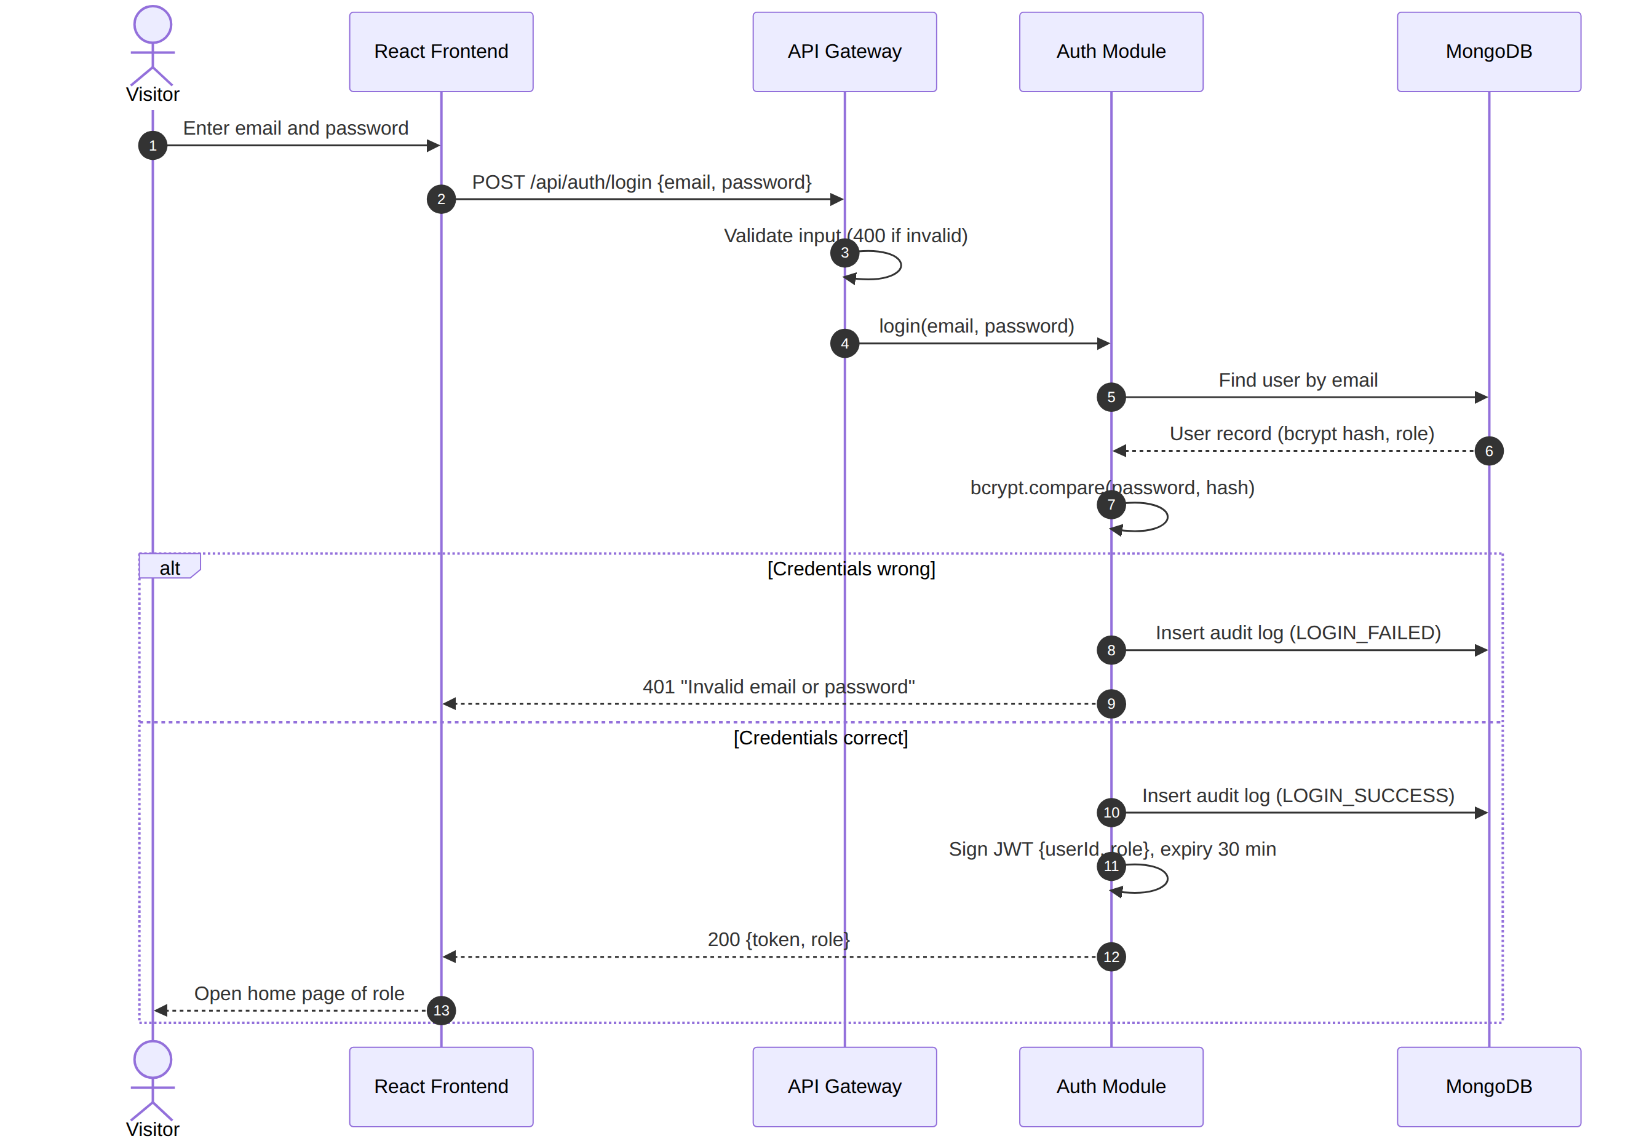
Figure 2: Sequence diagram – Login (CSQ-F-002, CSQ-SR-001, 003, 006)

4.2.2 Upload study material
The request passes token, role and input checks first. The Material Module then checks size and real content type before the file is stored and its record is created.
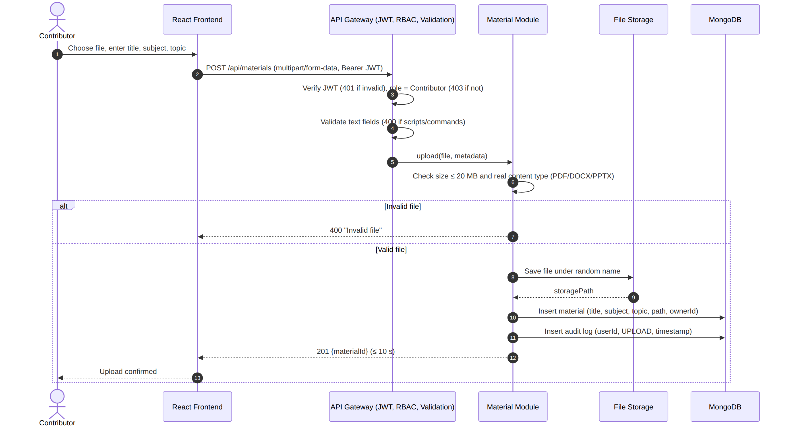
Figure 3: Sequence diagram – Upload material (CSQ-F-010, CSQ-SR-002, 004, 006, 007)

4.2.3 Attempt a quiz, auto-submit and auto-grade
The server fixes the start and end time of the attempt and never sends the answer key. The result is calculated on the server and returned with the correct answers.
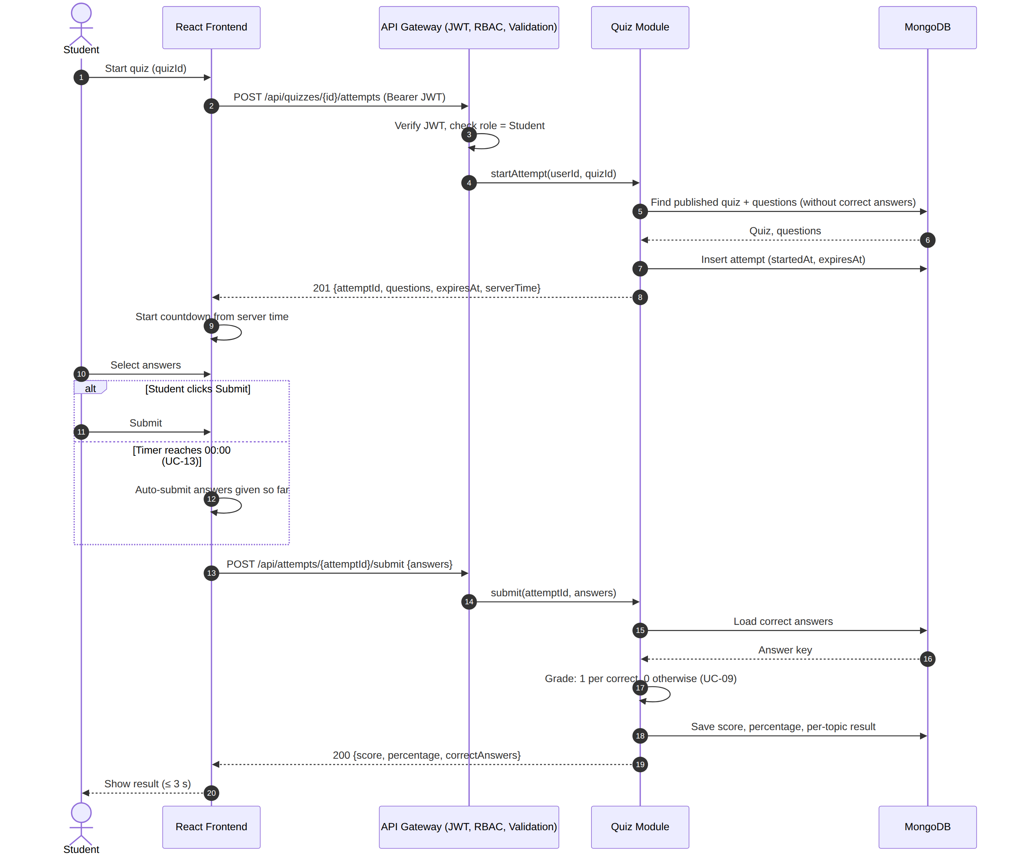
Figure 4: Sequence diagram – Attempt quiz, auto-submit and grading (CSQ-F-031, 032, NF-002)

4.3 API Design

4.3.1 Conventions
- Base path /api, JSON request and response bodies, HTTPS only. Protected endpoints need the header Authorization: Bearer <JWT>.
- Lists are paged with page (starting at 1); page size is fixed at 10 for materials and capped at 50 elsewhere.
- Errors use one format: { "error": { "code": "ACCESS_DENIED", "message": "Access denied", "details": [] } }. Messages are the exact texts given in the SRS.
Table 4.3-1: Endpoint summary
Method and path | Role | Purpose | Req.
POST /api/auth/register | Public | Create a Student or Contributor account | F-001, 005
POST /api/auth/login | Public | Log in, receive JWT and role | F-002
POST /api/auth/logout | Any | End the session (revoke token) | F-004
POST /api/auth/refresh | Any | Issue a new 30-minute token | SR-003
GET /api/auth/me | Any | Current user, role, allowed features | F-003
POST /api/materials | Contributor | Upload a study material file (multipart) | F-010
GET /api/materials | Any logged in | Search materials (q, subject, topic, page) | F-011
GET /api/materials/:id/download | Any logged in | Download file, count +1 | F-012
DELETE /api/materials/:id | Contributor (own), Admin | Remove a material | F-050
POST /api/questions | Contributor | Add a question | F-020
GET /api/questions | Contributor | List and filter questions (topic, difficulty) | F-022
PUT /api/questions/:id | Contributor (own) | Edit a question | F-021
DELETE /api/questions/:id | Contributor (own) | Delete a question not in a published quiz | F-021
POST /api/quizzes | Contributor | Create a quiz (draft) | F-030
PATCH /api/quizzes/:id/publish | Contributor (own) | Publish a quiz | F-030
GET /api/quizzes | Student, Contributor, Admin | Published quizzes (Student); own quizzes (Contributor); all (Admin) | F-033
DELETE /api/quizzes/:id | Contributor (own), Admin | Remove a quiz | F-050
POST /api/quizzes/:id/attempts | Student | Start an attempt | F-031
POST /api/attempts/:id/submit | Student (owner) | Submit answers and get graded result | F-032
GET /api/reports/student/me | Student | Own performance page | F-040
GET /api/reports/quizzes/:id | Contributor (own quiz) | Quiz statistics | F-041
GET /api/health | Public | Health check for monitoring | NF-003

4.3.2 Auth component
Item | Specification
Endpoint | POST /api/auth/register
Request | { name, email, password, role } role: "Student" | "Contributor"
Response | 201 { userId, name, role }
Errors | 400 Password too weak / validation error; 403 Access denied (role Admin requested); 409 Email already registered

Item | Specification
Endpoint | POST /api/auth/login
Request | { email, password }
Response | 200 { token, expiresIn: 1800, role, name }
Errors | 400 invalid input; 401 Invalid email or password; 429 too many attempts

4.3.3 Quiz component
Item | Specification
Endpoint | POST /api/quizzes
Request | { title, timeLimitMinutes (5–180), questionIds[5–50] }
Response | 201 { quizId, status: "draft", questionCount }
Errors | 400 validation (for example 4 or 51 questions, 4 or 181 minutes); 401 invalid token; 403 Access denied

Item | Specification
Endpoint | POST /api/quizzes/:id/attempts
Request | (no body)
Response | 201 { attemptId, title, timeLimitMinutes, expiresAt, serverTime, questions[{ questionId, text, options[4] }] } (no correct answers)
Errors | 401 invalid token; 403 Access denied; 404 quiz not found or not published

Item | Specification
Endpoint | POST /api/attempts/:id/submit
Request | { answers: [{ questionId, selectedIndex }] } (unanswered questions may be omitted)
Response | 200 { score, total, percentage, results[{ questionId, selectedIndex, correctIndex, correct }] }
Errors | 401 invalid token; 403 not the owner of the attempt; 409 already submitted; 400 submission after the time limit plus 5 s grace

4.3.4 Material component
Item | Specification
Endpoint | POST /api/materials
Request | multipart/form-data: file (PDF | DOCX | PPTX, ≤ 20 MB), title (≤ 100), subject, topic
Response | 201 { materialId, title, subject, topic, createdAt }
Errors | 400 Invalid file / validation error; 401 invalid token; 403 Access denied

Item | Specification
Endpoint | GET /api/materials?q=&subject=&topic=&page=
Response | 200 { items[{ materialId, title, subject, topic, downloadCount, createdAt }], page, pageSize: 10, total }
Errors | 401 invalid token; empty result is 200 with an empty list

Table 4.3-2: Status codes used
Code | Meaning | Typical message
200 / 201 | Success / created | –
400 | Validation failure, invalid file, submission too late, script or database command in input | Invalid file; Password too weak
401 | Token missing, altered, expired (older than 30 min) or revoked; wrong login | Invalid email or password
403 | Role not permitted or not the owner | Access denied
404 | Item not found | Not found
409 | Conflict | Email already registered; Question is in use
429 | Too many requests (rate limit) | Too many attempts, try again later
500 | Unexpected server error (no internal details shown) | Something went wrong. Please try again.

4.4 Error Handling, Logging & Monitoring
Error handling. All errors leave the server through one central handler in the standard format of Section 4.3.1. Messages are plain language and tell the user what to do next (SRS 3.1). Stack traces, database messages and file paths are never sent to the client. The frontend shows the message next to the field or in a banner and keeps the user’s input.
Logging. Two separate logs are kept. The application log (structured JSON, levels error, warn, info) records request method, path, status code, duration and a request ID. The audit log (collection audit_logs, DS-Sec-06) records who did what and when for login, upload and deletion. Passwords, tokens, the answer key and full personal data are never written to either log.
Monitoring. The health endpoint is polled every minute to compute monthly uptime (CSQ-NF-003). The following are tracked: 95th-percentile response time of search and quiz submit (targets 2 s and 3 s), error rate (HTTP 5xx), failed login count, disk usage of the upload directory (alert at 80%) and the success of the daily backup (CSQ-NF-007).
Backup and recovery. Daily mongodump at 02:00, seven archives kept, restore script tested in a drill of at most 4 hours (DS-Ops-02).

4.5 UX Design
Page | Roles | Main elements | Req.
Register / Login | Visitor | Name, email, password with inline “Password too weak” hint; Student or Contributor choice | F-001, 002, 005
Home and Search | All | Search box, subject and topic filters, result list 10 per page, “No materials found” state | F-011
Material Details | All | Title, subject, topic, download button, download count | F-012
Upload Material | Contributor | File picker (PDF, DOCX, PPTX, 20 MB hint), title, subject, topic, progress bar | F-010
Question Bank | Contributor | Question form (4 options, one correct, topic, difficulty); filter by topic and difficulty | F-020 to 022
Quiz Builder | Contributor | Title, time limit, question selector with filters, publish button | F-030
Quiz List | Student | Published quizzes with title, number of questions, time limit | F-033
Quiz Attempt | Student | Always-visible countdown timer, one question per screen or scroll list, answer navigation, submit button | F-031
Quiz Result | Student | Score, percentage, correct answer for each question | F-032
Performance Dashboard | Student, Contributor | Overall average, topic-wise scores, last 20 attempts (Student); quiz statistics (Contributor) | F-040, 041
Admin Panel | Admin | Lists of materials and quizzes with remove action and confirmation | F-050

- Navigation: the menu is built from the allowed-feature list of the logged-in role (DS-Auth-03), so users never see options they cannot use.
- Accessibility: every form field has a text label; all pages work with the keyboard alone; text meets a contrast ratio of at least 4.5:1; the timer also has a text form (for example “12:34 left”) so it does not depend on colour.
- Responsive layout: mobile-first CSS, tested at 360, 768 and 1920 px on Chrome, Firefox, Edge and Safari (CSQ-NF-005).
- Feedback: loading indicators for upload and submit; confirmation before deleting; errors in plain language.
- Usability check: the trial of CSQ-NF-004 uses 10 first-time users for the tasks register → find and download a material → complete a quiz within 10 minutes; at least 9 must finish.

4.6 Open Issues & Next Steps
The following points are not fixed by the SRS. The design makes a working choice for each; the team should confirm them at review.
# | Issue | Current design choice
OI-1 | SRS Table 1 lets a Contributor “remove materials and quizzes” but does not say whether this means only the Contributor’s own items. | Contributors may remove only their own items; Admin may remove any (DS-Adm-01).
OI-2 | A token lives 30 minutes (CSQ-SR-003) but a quiz can last up to 180 minutes. | Silent token refresh while the user is active (DS-Sec-03, ADR-002).
OI-3 | Editing a question that is already in a published quiz would change graded content; the SRS blocks only deletion. | Propose to block edits of such questions with “Question is in use”; needs approval because it extends CSQ-F-021.
OI-4 | Auto-submit at 00:00 can arrive slightly after the server deadline. | 5-second network grace period (ADR-007).
OI-5 | SRS backup requirement covers the database only. | Uploads directory is copied together with the database backup as a recommended addition.
OI-6 | The SRS use case list has no UC-10 (numbering goes from UC-09 to UC-11), and SRS 4.6 mentions inappropriate users while CSQ-F-050 covers only materials and quizzes. | No design impact; suggest correcting the SRS numbering. User moderation is not designed.

Next steps: (1) review of this SAD with the SRS and Test Plan; (2) create the OpenAPI (Swagger) file from Section 4.3; (3) set up the repository with the module structure of Section 4.1.1; (4) implement in this order: Auth, Material, Question Bank, Quiz, Performance, Admin; (5) run the load, security and compatibility tests; (6) update the RTM status column as items are achieved.
Future enhancements (outside the current SRS): e-mail verification and password reset, negative marking, question images, quiz scheduling, notifications, and an optional cloud file store.

5. Appendices

5.1 Glossary
SAD – Software Architecture and Design Specification; SRS – Software Requirements Specification; ADR – Architecture Decision Record; API – Application Programming Interface; REST – Representational State Transfer; JWT – JSON Web Token; RBAC – Role-Based Access Control; TLS – Transport Layer Security; HTTPS – HTTP over TLS; MERN – MongoDB, Express.js, React, Node.js; MCQ – multiple-choice question; STRIDE – threat classification model; TTL – time to live; RTM – Requirements Traceability Matrix; DS – Design Specification entry.

5.2 References
# | Reference
[1] | Software Requirements Specification – Collaborative Study Material & Quiz Platform, v1.0, 28-09-2026.
[2] | ISO/IEC/IEEE 42010:2011, Systems and software engineering — Architecture description.
[3] | IEEE Std 1016-2009, IEEE Standard for Information Technology — Systems Design — Software Design Descriptions.
[4] | ISO/IEC/IEEE 29148:2018, Systems and software engineering — Life cycle processes — Requirements engineering.
[5] | OWASP Top 10 and OWASP Application Security Verification Standard (ASVS).
[6] | NIST SP 800-160 Vol. 1, Engineering Trustworthy Secure Systems.
[7] | SAD template for SE (course model SAD), provided by the instructor.

5.3 Tools
Graphviz (component diagram), Mermaid (sequence diagrams), Swagger/OpenAPI and Postman (API), Jest and Supertest (tests), k6 or Artillery (load tests), Git (version control).

