Using Collabora Office / LibreOffice Windows Group Policy Template to take LibreOffice user data from Active Directory
Since Collabora Office 5.3-48/6.0, and LibreOffice 6.1, it’s possible to set user details (first/last name, initials, organization, etc.) from Active Directory using Collabora Office / LibreOffice Windows Group Policy Template.
After deploying the template to your Active Directory, open a GPO and navigate to Computer or User configuration (depending on your policy) → Policies → Administrative Templates → Collabora Office → Common.
First, define LDAP User Directory connection settings. As LibreOffice uses LDAP to connect to Active Directory, it will need to know the LDAP server to which it must connect, which credentials to use, which directory part to search, and which attributes to use for user data.
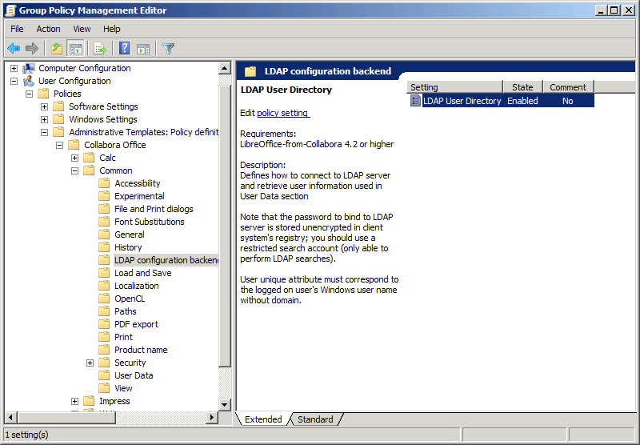
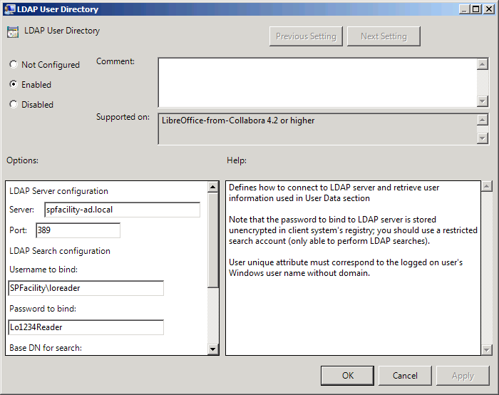
The settings are:
- Server: LDAP server name (usually a AD domain controller).
- Port: usually 389.
- Username to bind/Password to bind: a special service account with limited permissions (it only needs rights to search user information in domain). Note that the password is shown and stored in policy/registry in clear text, so the account should be really restricted.
- Base DN for search: root DN (AD container) under which user accounts are located.
- User object class: usually user.
- User unique attribute: an attribute of the LDAP object that holds the authenticated user name without domain part (usually sAMAccountName).
User directory will be searched under Base DN for search to find an object of User object class having User unique attribute equal to account name of currently logged-in user.
After having this part set up properly, User Data category should be configured.
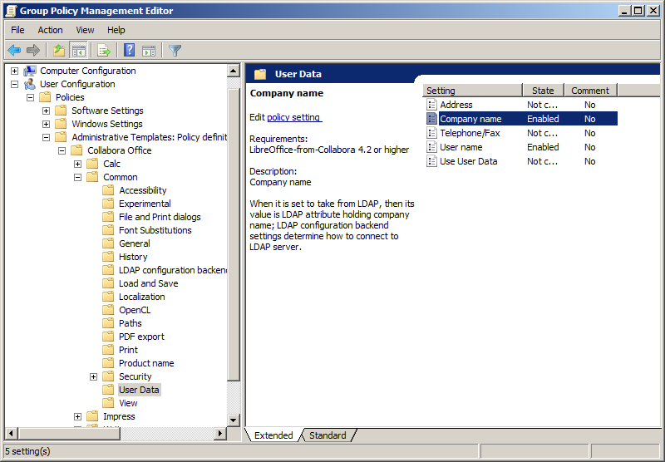
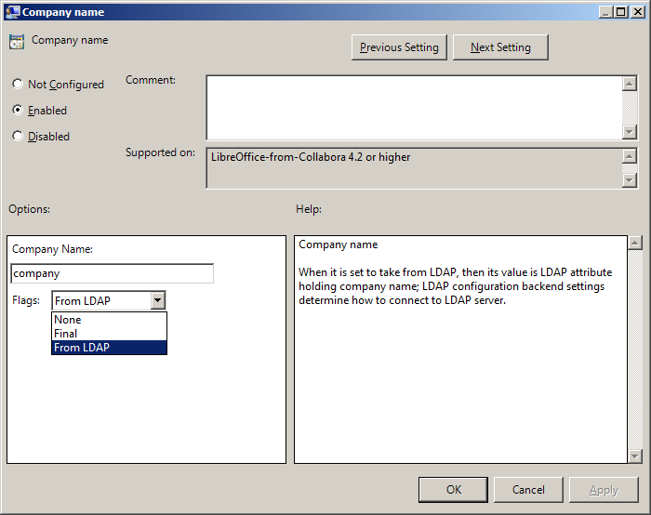
Each setting in this category now has a Flags property that supersedes former “Final” flag. None is equal to previous “Final” unchecked; Final is, naturally, equal to previous “Final” checked; and From LDAP means that the setting is actually a LDAP attribute name that holds the requested data. Please note that LDAP attribute names are case-sensitive.
The usual Active Directory setup has these attributes for the options present in this category:
- Address
  - streetAddress for Street
  - l for City
  - st for State
  - postalCode for ZIP Code
  - co for Country
- company for Company Name
- Telephone/Fax
  - telephoneNumber for Telephone
  - facsimileTelephoneNumber for Fax
- User name
  - givenName for Given Name
  - sn for Last Name
  - initials for Initials
After setting up the required options, they will be populated automatically in Collabora Office/LibreOffice that run on domain systems or by users affected by the GPO:
