
Project Report for FlickPond: A Reusable Cloud Media Processing Platform
Practice Module for Graduate Certificate in Architecting Scalable Systems
Team 17
Members:
Guruprasath Gopal
Ibrahim Mammadov
Nguyễn Kim Long
SWE5001 Architecting Scalable Systems · SE34FT · September–November 2026
Repository: github.com/Collaboration95/dc2 · Report version 1.0, 21 October 2026

CONTENTS
1. Introduction 4
1.1 Background 4
1.2 Business Needs 5
1.3 Stakeholders 6
1.4 Project Scope 6
2. Project Conduct 9
2.1 Project Plan 9
2.2 Project Status 10
2.3 Project Metrics 11
3. Solution Overview 14
3.1 Logical Architecture & Design 14
3.2 Physical Architecture & Design 25
3.3 Other Architectural Decisions 37
3.4 Architectural Limitation 38
4. Quality Attributes 40
4.1 Performance 41
4.2 Availability 42
4.3 Security 43
4.4 Extensibility and Maintainability 44
5. DevOps and Development Lifecycle 45
5.1 Source Control Strategy 45
5.2 Continuous Integration 47
5.3 Continuous Delivery 48
7. Other Things to Be Highlighted 52
7.1 What Team 17 Contributed beyond the Inherited Baseline 52
7.2 Lessons Learned 52
7.3 Responsibilities for Use Cases and Design Problems 53
7.4 Evidence and How to Reproduce It 53
7.5 AI Tool Declaration 54
8. Appendices 54
8.1 Use-Case Specifications and Traceability 54
8.2 Analysis and Design Models 57
8.3 Design Problems 62
8.4 Glossary 66

Introduction

Background
FlickPond began as a Project 1 video application. Users register and upload their own videos. FFmpeg workers turn each upload into an MP4 and adaptive HLS streams (360p, 480p and 720p), and the owner then plays the result through an owner-checked link. Project 1 was built by a five-member FlickPond team. It ran FastAPI, PostgreSQL, Redis with RQ, MinIO object storage, nginx and a browser frontend on one cloud virtual machine. It worked, but as one application: a single API handled identity, uploads, jobs and playback; the API, the workers and the recovery task shared one job model and one database; and the jobs table had a foreign key to the users table. Another product could not reuse the video workflow without importing FlickPond’s code or reading its database.
Team 17 was formed for this practice module from members of two Project 1 teams. Prof Boon Kui Heng approved the three-member team on 22 September 2026. Ibrahim Mammadov was a member of the FlickPond Project 1 team (track A: worker, queue and media-type checks). Guruprasath Gopal and Nguyễn Kim Long come from a different Project 1 team. The team chose to carry the frozen FlickPond code forward as its baseline, because it already contained a real, CPU-heavy asynchronous workload. The submitted proposal names repository Flickpond/Media_player, commit 890c5ec. The working plan used the team’s local checkout of the same frozen code, commit 8854537 (decision D-01, 9 October). No Project 1 feature work was continued, and inherited capabilities are not claimed as Project 2 work.
The proposal (4 October 2026) set the goal: turn FlickPond into a reusable media processing platform. Applications would use one documented API for upload, processing, status and playback, with processing running as an independently owned and scaled service. The lecturer accepted the proposal and asked the team to confirm the microservice choice through detailed domain analysis (feedback F-01). Section 3.1.4 records that analysis.
Current status (21 October 2026). The platform is built, deployed on AWS and verified.
- Two business services (Media Management and Processing) each own their database, image, IAM roles, CI lane and release unit. They communicate only through versioned messages on Amazon SQS. Neither calls the other synchronously.
- Two client applications use only the public API: the FlickPond web app and a new Publisher CLI.
- The persistent AWS environment dc2-live (ap-southeast-1) has run since 18 October. It scales to zero when idle, and the CD pipeline updates it in place after every green CI run on Main. The current release, c7c489c, was delivered and verified on 21 October.
- All seven use cases in the proposal are implemented, with automated tests and recorded cloud evidence. Measured misses against the proposal targets are reported as misses (section 4).
- The team presents on 26 October 2026, 14:35–15:15 SGT. The final report is due on 16 November 2026. The environment is torn down once, after that date.
The table summarises what Team 17 inherited and what it added.
Area | Inherited from FlickPond (Project 1) | Added by Team 17 (Project 2)
Service structure | One FastAPI application; workers and recovery task share its job code | Two bounded contexts, Media Management and Processing, found through DDD and connected only by asynchronous, versioned contracts
Data ownership | One database; jobs reference users | media_db and processing_db, each on its own Aurora cluster, with separate migration histories and least-privilege roles; no cross-database keys
Reuse | One browser application | A second, independent client (Publisher CLI) built against the published API only
Runtime | One VM with nginx, Redis/RQ and MinIO | Serverless AWS: CloudFront, API Gateway, Lambda container images, SQS, Aurora Serverless v2, S3 and finite ECS Fargate encoders that scale 0 → 3 → 0, and a Lambda lane for short clips
Security | Login, owner checks, TLS, signed output links, CI scans | Media-owned Gateway authorizer, trusted actor context, per-handler IAM roles, queue resource policies, bounded direct-to-S3 upload grants, pinned source versions, cloud negative tests
Delivery | Tests and scans in CI; manual deployment | Path-filtered per-service CI lanes, image scans and DAST; GitHub Actions CD over OIDC with per-owner release, smoke test and automatic restore
Evidence | Load tests that mostly read one completed video | Scaling, latency, recovery, release, security and reuse experiments with retained receipts
FFmpeg encoding, HLS output, worker replicas and the basic CI workflow are inherited capabilities. Team 17 reshaped and reused them, but does not count them as its own contribution.

Business Needs
Small content teams keep needing the same video capabilities. Training providers, course teams, small studios and community publishers are examples. They need:
- secure upload of videos they own;
- conversion into formats that play on any device;
- visibility of processing progress and failures;
- playback restricted to the owner.
Today each application rebuilds these capabilities or copies another team’s code. That duplicates effort and produces inconsistent security and operations. There is also a capacity problem: transcoding is CPU-heavy and bursty. When it shares a deployment unit with the user-facing API, a backlog of uploads competes with logins and status checks.
The business drivers for the platform follow from this:
- Reuse. A new application gets authenticated upload, processing, status and owner-checked playback by calling one published API, with no copied code and no database access.
- Independent capacity. Processing is its own service. Encoder capacity follows the backlog without scaling or redeploying the user-facing API.
- Repeatable, secure releases. Every change passes automated tests and security gates. Each service is then released on its own from an immutable image and verified by an automated upload-to-playback smoke test.
- Low idle cost. A small team’s platform is idle most of the time, so it should cost almost nothing when idle. The design target became scale-to-zero: about USD 3–5 a month at idle (AD-27).
In platform terms (section 3.1.4), the seed is an owned video asset and its processing job. Producers are content owners submitting videos through the web app or the Publisher CLI. Consumers are owners playing their processed output. Integrators build new clients against the OpenAPI contract. Operators release and scale the platform.

Stakeholders
The project has no external sponsor; it is team-proposed. Business stakeholders are represented by four planning personas defined in week 1 (project-roadmap/business-scope.json). They are fictional design assumptions, not interviewed customers.
Stakeholder | Type | Interest and need | Use cases
Content owners, e.g. course coordinator “Maya” (P-01) | Business: primary producer | Submit a folder of recordings once, see each result, retry failures and check playback | UC-1 to UC-5
Independent trainers, e.g. “Arun” (P-02) | Business: secondary producer and viewer | Upload one video in the browser, follow its status, watch the result; nobody else can see it | UC-1 to UC-4
Application developers, e.g. “Jules” (P-03) | Business/IT: integrator | Use the published API without copying service code or holding database credentials | UC-1, UC-3 to UC-5
Platform operators, e.g. “Sam” (P-04) | IT: operations | Change processing capacity and release Processing without touching Media; see failures and recover | UC-6, UC-7
Course lecturer and assessors (Prof Boon Kui Heng, NUS-ISS) | Academic sponsor and reviewer | Approved the three-member team and the proposal; assesses the architecture, evidence and delivery | All
Team 17 members | Delivery team | Guruprasath Gopal (cloud and delivery), Ibrahim Mammadov (backend services), Nguyễn Kim Long (domain, contracts and verification) | All
FlickPond Project 1 team | Upstream code owner | Authors of the inherited baseline; credited for inherited capabilities | Baseline
Amazon Web Services | IT: cloud provider | Hosts the managed services in ap-southeast-1 | Runtime
GitHub | IT: tooling provider | Source control, pull requests, Actions CI/CD, Pages for the study guide | Delivery

Project Scope
The scope is the proposal’s seven use cases (UC-1 to UC-7), delivered as two services, two clients and one AWS environment. There are three levels of scope:
- Architected. The two-context platform, its contracts, the AWS topology and the operating model.
- Implemented. Everything architected, plus three experiments built behind flags (AD-22): an unattended encoder launcher, a Lambda short-encode lane (#93) and one database cluster per service (#94, AD-29). All three run on the persistent V2-live environment; the last two were enabled and delivered by CD on 21 October.
- Experimentally verified. The results in section 4. Each result is labelled with the environment that produced it: local, AWS V1 per-run stack, or the persistent V2-live environment.
The project ran in three phases.
Phase | Dates | Delivered
0. Baseline and design | 22 Sep – 9 Oct | Team approval, proposal (4 Oct), lecturer feedback, frozen baseline, personas and use cases, DDD model, contracts, build preparation
1. V1: two services on AWS, per-run stacks | 10 – 18 Oct | Processing extracted (12 Oct), Media and Publisher adapted (13 Oct), AWS template and pipeline (15 Oct), cloud proof runs r1017b, r1018b, r1019a; tag project2-v1 (18 Oct)
2. V2-live: one persistent environment | 18 Oct – 16 Nov | dc2-live deployed (18 Oct), automatic in-place CD, unattended 0 → 3 → 0 encoders, security negatives, rollback proof, freeze (20 Oct), engineering hardening, presentation (26 Oct), final report (16 Nov)
The detailed scope sources are the proposal (§3), the use-case catalogue (docs/architecture/use-case-design.md) and the proposal-to-as-built deviation table (docs/architecture/decisions.md §4). Section 3 explains each deviation.

Functionality in scope
ID | Use case | Clients | Status
UC-1 | Register, log in and upload an owned video (100 MiB maximum) | Web app, CLI | Implemented. Direct-to-S3 upload with a 15-minute owner-scoped grant; bytes verified and the S3 version pinned before the asset exists
UC-2 | Process the video into MP4 and HLS (360p/480p/720p, never above the source height); HLS is best effort | Platform | Implemented on finite Fargate encoders
UC-3 | Track job status and play the processed result | Web app, CLI | Implemented. Owner-only status from Media’s projection; MP4 and HLS through short-lived signed URLs
UC-4 | Retry a failed job using the stored source | Web app, CLI | Implemented. A new fenced attempt over the same pinned source; no re-upload
UC-5 | Bulk-publish a folder of videos and report each result | CLI | Implemented in the Publisher CLI
UC-6 | Scale processing capacity without touching Media Management | Operator / platform | Implemented. 1–3 operator batches (V1); automatic 0 → 3 → 0 from the SQL backlog (V2-live)
UC-7 | Release a new Processing version on its own, with smoke test and rollback | Operator / pipeline | Implemented. Per-owner release by image digest and Lambda alias, with automatic restore on a failed smoke
Figure 1 shows the actors and the use cases, in scope and out of scope.
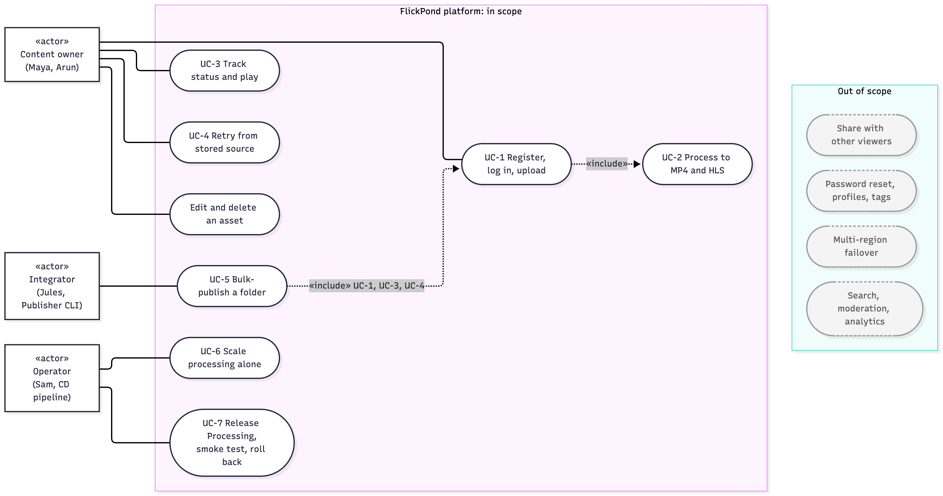
Figure 1. Use-case diagram: actors, the seven in-scope use cases with the added edit and delete capability, and the main out-of-scope cases.
The as-built platform also has three capabilities the proposal did not list. Each is small, and each reuses the same aggregates:
- Owner edit operations (clip, crop, scale, convert) that create a derived asset.
- Delete, recorded as a tombstone in both contexts and followed by source cleanup.
- Operator-only admin routes.

Functionality out of scope
These requirements are excluded, as recorded in the proposal (§3.5) and the briefing interpretation:
- The rest of the Project 1 feature list: profiles, password reset, titles and tags, sharing modes and external videos.
- Viewer identities other than the owner: public sharing, student or LMS access, shared team ownership, tenants and billing. The contract accepts a viewer role that nothing issues.
- Search, public discovery, moderation workflows and product analytics.
- Crop or clip editor UI, thumbnails, 4K output, and resumable uploads above 100 MiB.
- Kubernetes, general-purpose autoscaling, and multi-AZ database or multi-region failover.
- Historical data migration, malware scanning and full key rotation.
- A third client, a developer portal, live streaming, and a separate staging environment.
One earlier planning exclusion was superseded. The proposal excluded autoscaling, but V2-live does start finite encoders automatically from the SQL backlog, bounded by a hard cap of three (AD-27). This is bounded task launching, not a general autoscaling service.

Project Conduct

Project Plan
The briefing expects about 10 person-days (pd) per participant. The submitted proposal estimated 31 pd for three members across ten work packages (WBS). Each package had a lead member (proposal §4.1).
# | Work package | Lead | Estimate (pd)
1 | Freeze baseline, reproducible local setup, fix the inherited scan finding | Guruprasath | 2
2 | Domain analysis, service contracts and OpenAPI documents | Long (team review) | 3
3 | Extract Processing: service, own database and migrations, workers and recovery task | Ibrahim | 6
4 | Adapt Media Management: asset records, Processing client, web app routes and retry | Ibrahim | 3
5 | Boundary security: identity, owner checks, database roles, presigned URLs, negative tests | Guruprasath | 3
6 | Publisher CLI and contract tests | Long | 2
7 | AWS environment, per-service deployment, pipeline updates, smoke test | Guruprasath | 4
8 | Experiments: scaling, load, recovery and playback; raw results | Long | 3
9 | Integration fixes and repeat checks | All | 2
10 | Progress report, presentation and final report | All | 3
 | Total |  | 31
The proposal’s schedule had six periods:
- 5–7 October: baseline and domain model.
- 8–14 October: extraction and the web app end to end.
- 15–20 October: security, AWS, pipeline and experiments.
- 21–25 October: fixes and rehearsal.
- 26 October: the presentation.
- 27 October – 16 November: the final report.
The plan recorded four main risks:
- Tangled shared code.
- AWS account or cost issues.
- Little scaling gain.
- A three-member team.
Each had a mitigation: extract first; set up AWS in week 1 with cost alerts; cap CPU per worker and report honestly; narrow the scope.
Way of working.
- Backlog. Work was planned as GitHub issues with outcome, acceptance and verification sections. The issues sat on a GitHub Project board (Project 14) with Workflow, Wave, Priority, Risk and Area fields.
- Delivery waves, not timeboxed sprints. Wave 0–4 locally, then the AWS V1 bundles, then close-out.
- Integration. Pull requests went into integration branches (section 5.1), with CI on every change.
- Decisions. Recorded as ADRs and project decisions (F-01, D-01 to D-07).
- Reporting. One progress report was due on 16 October (decision D-06).
There were no formal sprint reviews or retrospectives. Their place was taken by:
- the 9 October planning review;
- independent plan reviews (docs/execution/reviews/);
- the 18 October audit and board reconciliation (#253, #258);
- the 20 October freeze, with its acceptance checklist.

Project Status
As of 21 October 2026, the project is complete for its committed scope, and is in the presentation and report phase.
Area | Status
Use cases UC-1 to UC-7 | All implemented and tested; cloud evidence for each (section 4)
Architecture | Two bounded contexts; asynchronous contracts; persistent AWS environment (AD-27)
Live environment | dc2-live up since 18 October; scales to zero; torn down once, after 16 November
Release identity | Team-accepted demo freeze at daee44b (20 October). Engineering release 629119c (20 October). The current verified release is c7c489c (21 October): the certifi remediation plus two delivery fixes, delivered by CD 39545554380 with an upload-to-playback smoke and a read-back of all images and aliases. The manifest records it as a post-freeze addendum.
CI | Every Main run green. Code release c7c489c: CI 39544952625 (Full verification); latest documentation push 1d68eff: CI 39550093697
CD | Two runs failed on 21 October, at the scan of the retained rollback image (39532075705) and at a cold-database login in the deploy smoke (39542434067). Both were fixed without weakening a gate (AD-28; PRs #285–#288) and redelivered by run 39545554380 (section 5.3). CD run 39644028238 (green) then delivered the Lambda short-encode lane and the per-service database split. Main and dev/closeout are both at 1d68eff.
Evidence | Results against every proposal target, including three measured misses (section 4)
Submission | Presentation 26 October 14:35–15:15 SGT; code submission 31 October (internal date); final report 16 November
Outstanding issues.
Item | Disposition
Three measured misses: two-worker scaling 1.449× (target 1.6×); Processing release 10.1–10.3 min (target 10 min); queue wait about 37 s on the standard lane (target 20 s; met on the Lambda short lane at 0.26 s) and end-to-end latency still above 20 s | Reported against the unchanged targets. Improvement options are in AISS-01 (section 3.4).
Evidence not established on AWS: lost-queue-entry timing, duplicate-output check after a worker kill, a restore drill, actual spend | AISS-05. The final October bill is read before 16 November.
Optional V2 experiments #68 and #80 | Closed on 21 October. #68 (unattended launcher) was adopted into V2-live, so it was closed as completed. #80 (the optional V2 migration epic) was closed as not planned, because the experiments live behind template flags (AD-22).
Presentation deck and rehearsal (#192), recordings (#254) | Prepared from this report and the frozen demo release before 26 October
Presentation feedback | Incorporated into the final submission after 26 October, as the briefing requires
Course administration (#257) | Canvas checks for the progress-report receipt, peer assessment and the final upload; owned by Guruprasath Gopal

Project Metrics
Milestones: planned against actual.
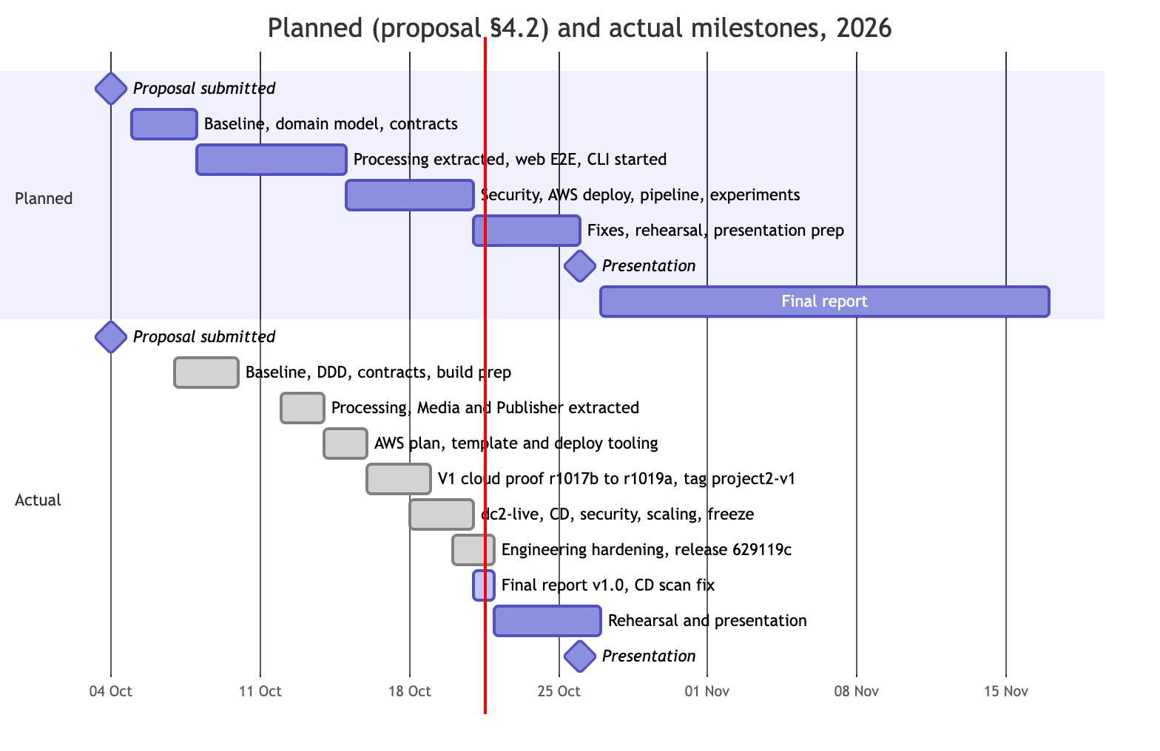
Figure 2. Planned (proposal §4.2) and actual milestones.
Planned (proposal §4.2) | Milestone | Actual | Evidence
4 Oct | Proposal submitted | 4 Oct | Team17-Proposal.docx
5–7 Oct | Baseline frozen; domain model and contracts drafted; lecturer review | 7–9 Oct (lecturer accepted; F-01, D-01 to D-07) | project-roadmap/records/project-decisions.txt
8–14 Oct | Processing extracted with its own data; web app end to end; CLI started | Processing 12 Oct; Media and Publisher 13 Oct (PRs #28–#30) | processing/, media/, publisher/
15–20 Oct | Security controls; AWS deployment and pipeline; experiments | AWS template and deploy tooling 15 Oct; CD workflow 18–19 Oct; cloud proof r1017b 17 Oct, r1018b and r1019a 18 Oct; tag project2-v1 18 Oct; dc2-live 18 Oct; security negatives and V2-live scaling 19 Oct; freeze 20 Oct | docs/evidence-index.md, docs/release/demo-release-manifest.md
21–25 Oct | Fixes, rehearsal, presentation preparation | Engineering release 629119c 20 Oct; final report v1.0 and CD scan fix 21 Oct; rehearsal 22–25 Oct | docs/release/engineering-handoff.md; this report
26 Oct | Team 17 presentation, 14:35–15:15 | Scheduled | Presentation guide p. 2
27 Oct – 16 Nov | Final report with presentation feedback | Report v1.0 complete 21 Oct; feedback revision after 26 Oct | This report
Baseline and design finished two days late, on 9 October, because the full design pack was completed before any code changed. Extraction still landed inside its planned window (12–13 October), helped by parallel integration branches. The AWS work grew from one deployment to three proof runs plus a persistent environment, and still finished inside the planned 15–20 October period.
Effort per member. The team agreed to split Project 2 effort equally across the three members (effort ledger, issue #191). The allocation below maps the proposal’s work packages onto that split; it is not a timesheet. One person-day is 8 hours. GG is Guruprasath Gopal, IM is Ibrahim Mammadov and NKL is Nguyễn Kim Long.
# | Work package | Planned | GG | IM | NKL | Actual
1 | Baseline, reproducible setup, inherited scan fix | 2 | 2 |  |  | 2
2 | Domain analysis, contracts, OpenAPI | 3 |  |  | 3 | 3
3 | Extract Processing (database, migrations, worker, recovery) | 6 |  | 5 |  | 5
4 | Adapt Media (asset records, Processing integration, retry) | 3 |  | 3 |  | 3
5 | Boundary security | 3 |  | 2 |  | 2
6 | Publisher CLI and contract tests | 2 |  |  | 2 | 2
7 | AWS environment, per-service deployment, CI/CD (deploy, release, rollback), smoke | 4 | 6 |  |  | 6
8 | Experiments: scaling, load, recovery, playback | 3 |  |  | 3 | 3
9 | Integration fixes and re-tests (close-out #265–#273) | 2 | 2 |  | 1 | 3
10 | Progress report, presentation and final report (to 20 Oct) | 3 | 1 | 1 | 1 | 3
11 | Release freeze and evidence index (not in the proposal) | 0 |  |  | 1 | 1
 | Recorded to 20 October | 31 | 11 | 11 | 11 | 33
10 | Remaining: rehearsal, presentation and feedback revision (forecast) |  | 1 | 1 | 1 | 3
 | Total at submission (forecast) | 31 | 12 | 12 | 12 | 36
Total effort.
- Recorded to 20 October: 33 pd (264 h), 11 pd (88 h) per member. This is 2 pd over the 31 pd estimate, because the CD workflow (#178) and the close-out fixes (CD script bugs, Aurora pause, queue drain) were added.
- Forecast at submission: 36 pd (288 h), 12 pd (96 h) per member, about 16 % over the estimate.
- Project 1 effort. Each member’s Project 1 effort is reported with their own Project 1. For Ibrahim Mammadov, that is FlickPond itself. The inherited FlickPond capabilities are credited to the FlickPond team and are not counted here.
Delivery metrics (GitHub and CI, collected on 21 October before PRs #285–#290). All commits, pull requests and issues in the repository were made through one GitHub account, Collaboration95, which owns the repository. The git history therefore cannot attribute work to individual members; the effort table above is the attribution of record.
Metric | Value
Pull requests | 128 opened, 123 merged over 9 days (12–21 Oct): 27 into Main, 42 into dev/closeout, 39 into dev/v1-integration, 4 into dev/v1, 11 into short-lived work/* and quality/* integration branches
Issues | 156 created (12–19 Oct); 147 closed, 9 open (deck, report, recordings, Canvas checks, audit index, two optional V2 items)
Project board | 118 items: 109 Done, 8 Todo, 1 In Progress
Commits on Main | 533 (140 merge commits), 28 September – 21 October
CI runs | 246 runs of the CI workflow: 201 pull request, 32 push, 12 manual, 1 weekly
Automated tests | 3,982 Python tests collected (2,452 test functions in 197 files) plus 177 frontend tests; full offline regression 3,697 passed [Local]
Coverage | Media 93.91 %, Processing 93.90 % (statements plus branches); all packages pass the 80 % floor; frontend 96.24 % of statements
Code size | Service and client code 10,062 lines of Python (Media, Processing, engine, contracts, delivery, runtime support, Publisher) plus 1,822 lines of frontend JavaScript; operator and CI tooling 42,075 lines; tests 54,011 lines
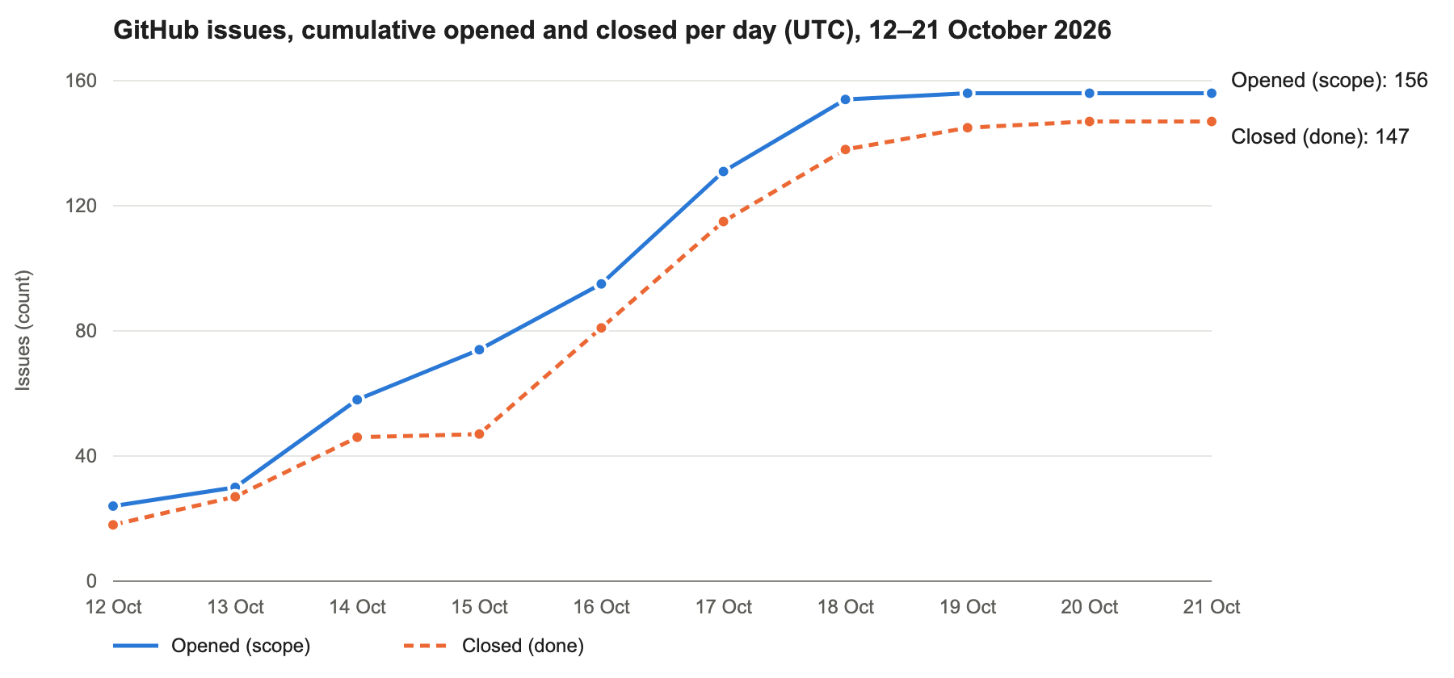
Figure 3. Issue burn-up derived from GitHub issue timestamps: scope (opened) grew in steps as the AWS readiness and close-out backlogs were added, and closure tracked it within one to two days.
The burn-up counts issues, not estimates; the issues carry no story points. The scope steps on 14–15 and 17 October are the AWS readiness backlog and the close-out backlog. The nine open issues are submission tasks and two optional experiments.

Solution Overview
This section describes the solution as built at the delivered engineering source. The proposal’s Figures 2–3 (synchronous SubmitJob, Redis/RQ, a service token) are the “before” design. Where the build changed a proposal decision, the change and its reason are recorded in the decision register (docs/architecture/decisions.md) and summarised here. Decision identifiers AD-01 to AD-29 are the register’s own. They are kept unchanged across sections 3.1.1, 3.2.1 and 3.3, rather than renumbered, so every reference in the repository still resolves.
Evidence labels used in this report:
- [AWS]: recorded in a live cloud receipt.
- [Local]: tests on real PostgreSQL 16 and FFmpeg, with Moto standing in for S3 and SQS.
- [Code]: read from source or the rendered CloudFormation template.
- [NOT_RUN]: implemented, never run against AWS.

Logical Architecture & Design
The architecturally significant elements, their types and their providers are listed below. “Team 17” marks custom code written in this project. “Inherited” marks code reshaped from the FlickPond baseline.
The logical view (Figure 4) groups these elements into tiers. The two domain services each have their own API, domain and persistence layers. They share only the published contracts and the delivery helpers, which are copied into each image at build time.
Element | Type | Provider | Responsibility
FlickPond web app (frontend/) | Custom browser SPA (plain JavaScript, vendored hls.js and Plyr) | Team 17, adapted from inherited UI | Register, log in, direct upload, status polling, MP4/HLS playback, retry, edit, delete
Publisher CLI (publisher/) | Custom Python client (stdlib plus httpx) | Team 17 (new) | Bulk publish, status, output and retry through the public HTTPS API only
Media Management (media/) | Custom FastAPI service and Lambda handlers | Team 17 | Accounts, ownership, upload grants and verification, the public job view, playback signing, deletion
Media authorizer (media/authorizer.py) | Custom Lambda REQUEST authorizer | Team 17 (part of Media) | Verifies the session cookie against the current user row; returns the trusted actor
Processing (processing/) | Custom FastAPI service and Lambda handlers | Team 17 | Jobs, attempts, leases, retry and cancel, output descriptors, recovery, encoder launch
Finite encoder (processing/worker/, media_engine/) | Custom container task | Team 17; FFmpeg command builders inherited and reshaped | Claims one attempt, verifies the pinned source, encodes MP4 and the HLS ladder, writes outputs
Shared kernel (contracts/, delivery/, runtime_support/) | Custom libraries copied into both images | Team 17 | Versioned envelope and actor contracts, outbox/inbox and SQS adapters, Lambda DB sessions and settings
Operator and delivery tooling (scripts/aws/v1/, scripts/ci/) | Custom Python CLIs and shell | Team 17 | Template rendering, deploy, session, release and restore, evidence harnesses, CD admission
FFmpeg and ffprobe | COTS open source | FFmpeg project (Debian package) | Probing and transcoding
FastAPI, Pydantic, SQLAlchemy, Alembic, asyncpg, boto3, PyJWT, bcrypt | Open-source libraries | Python community | Web framework, validation, ORM, migrations, PostgreSQL driver, AWS SDK, JWT, password hashing
Relational database (PostgreSQL 16) | Managed service | AWS (Aurora Serverless v2) | media_db and processing_db, one cluster each (AD-29)
Object storage | Managed service | AWS (S3) | Source, output and frontend buckets
Messaging | Managed service | AWS (SQS) | Three queues and three dead-letter queues
Edge, compute and operations | Managed services | AWS (CloudFront, API Gateway, Lambda, ECS Fargate, EventBridge, SSM, Secrets Manager, ECR, CloudWatch, Budgets, IAM) | Section 3.2
Source control, CI/CD and scanners | SaaS and open-source tools | GitHub (Actions, OIDC); Aqua Trivy, gitleaks, OWASP ZAP, Ruff | Section 5
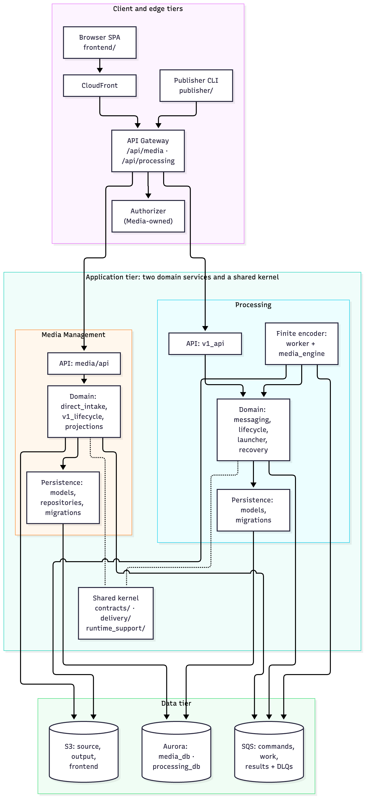
Figure 4. Logical view: client and edge tiers, the two domain services with their API, domain and persistence layers, the shared kernel, and the data tier.
The relationships that matter most are the ones that do not exist:
- Media never calls Processing, and Processing never calls Media. Every interaction is a message on SQS, or a read of the context’s own database.
- Neither service holds the other’s database credentials. Each Lambda role can read only its own domain’s connection string.
- The worker cannot send any message. It reports progress only through the Processing database, and the Processing outbox publishes the results.
Figures 5, 6 and 7 show the dynamic relationships for the core workflow (UC-1 to UC-3), split into its three phases. Section 3.2.4 explains each step.
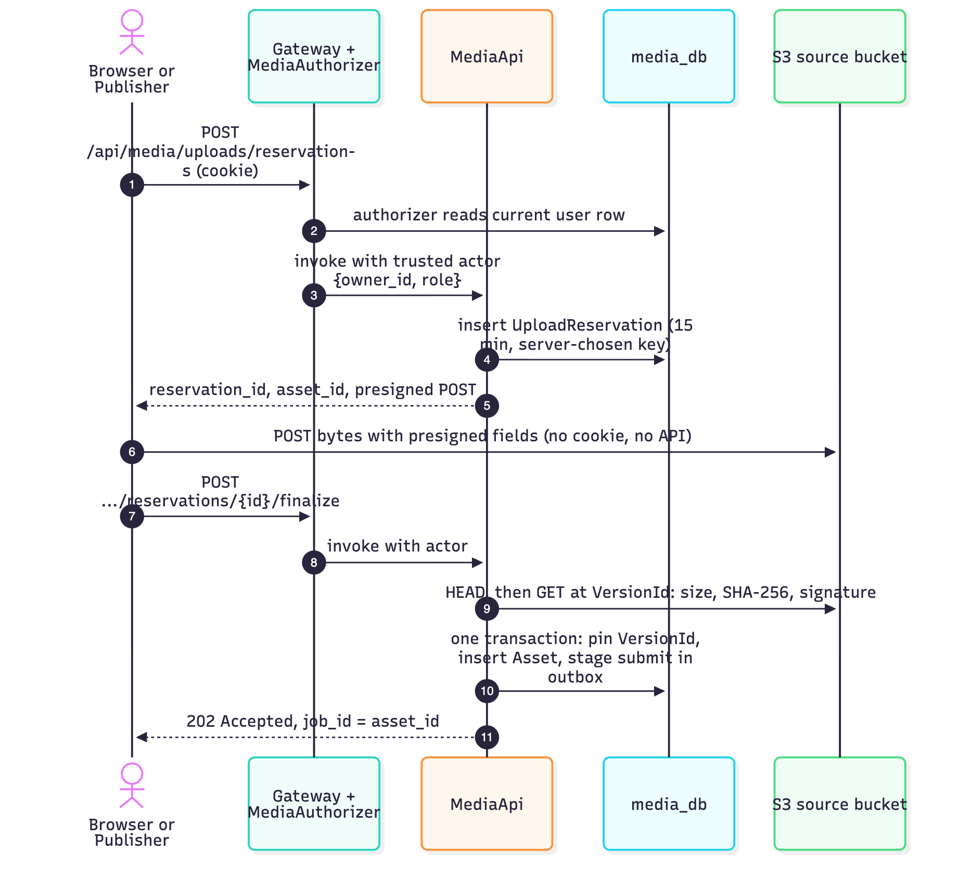
Figure 5. Dynamic view, phase 1, intake: reserve, direct upload to S3, verify and adopt.
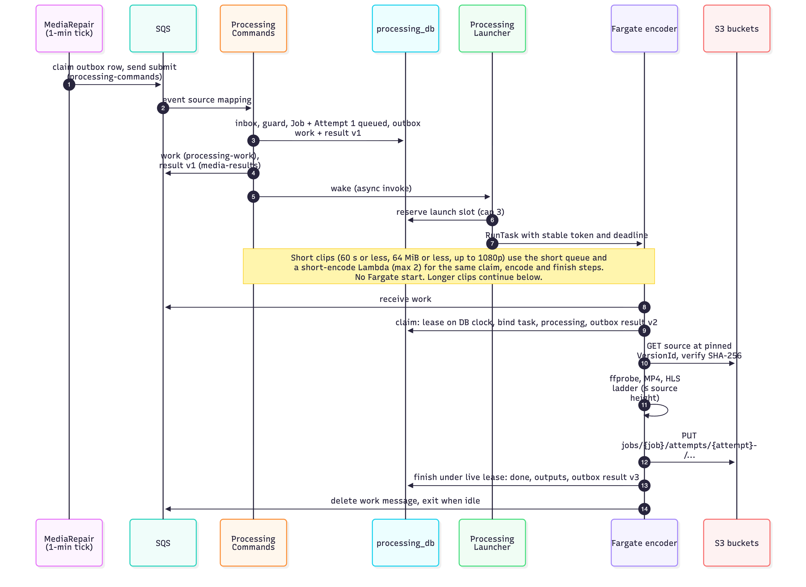
Figure 6. Dynamic view, phase 2, handoff and encoding: outbox → SQS → Processing inbox, launch, lease, encode, finish.
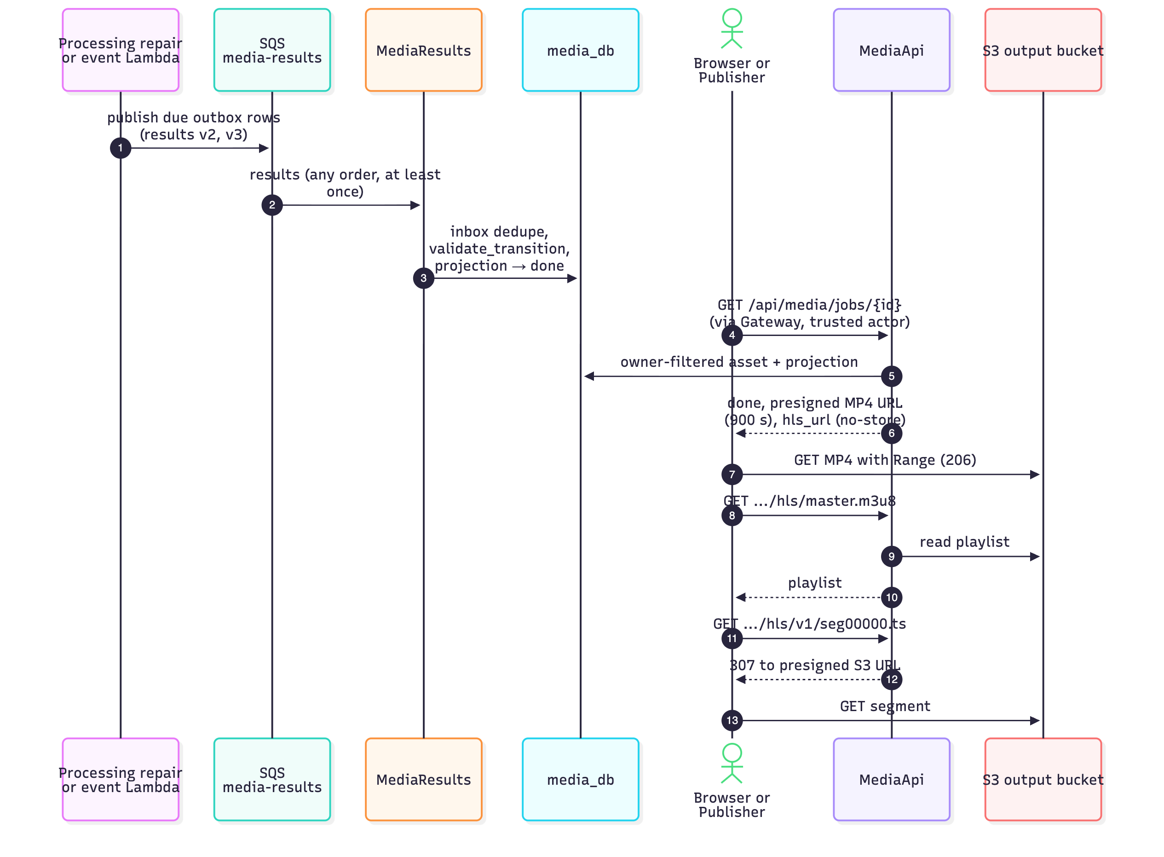
Figure 7. Dynamic view, phase 3, results and playback: Processing outbox → Media projection; owner-checked, signed playback.

Key Architectural Decisions
The significant decisions reflected in the logical view are summarised below. Each has a full record in the register (context, decision, alternatives, trade-off, evidence).
Identifier | Decision | Rationale and trade-off | Status
AD-01 | Extract Processing as the only new business service; Identity and Delivery stay inside Media | Processing has its own rules (claim, lease, attempt), lifecycle and CPU-bound scaling profile. Every playback or retry decision needs owner and asset together, so splitting Identity or Delivery out would turn single-database joins into cross-service calls. Four services were rejected as more contracts and operations than the need justifies. | Kept, confirmed by detailed DDD (F-01)
AD-02 | Database per service: media_db and processing_db, separate migration histories and roles (*_runtime DML only, *_migrator DDL, *_owner no login) | A real ownership boundary at low cost. Trade-off: V1 put both databases on one Aurora cluster, so logical ownership was real but failure isolation was not; since 21 October each service has its own cluster (AD-29). | Kept (hosting refined by AD-12 and AD-29)
AD-09 | API Gateway HTTP API with a Media-owned Lambda authorizer; the Gateway adapter builds the actor only from the authorizer context | Processing trusts the owner identity without holding Media’s JWT secret or user table. Result cache TTL is 0, so a deleted user or changed role takes effect at once. The cost is a database read per request. | New (supersedes AD-06 service token)
AD-11 | SQS with an SQL outbox and inbox in both databases, replacing Redis/RQ and synchronous SubmitJob | No always-on broker, and failure isolation: Media accepts uploads while Processing is down. The SQL-to-SQS handoff is not atomic, so repair is part of the design. Delivery is at least once, so duplicates are normal and consumers deduplicate. | New (supersedes AD-03; changes AD-04)
AD-14 | Direct-to-S3 intake: a presigned, owner-scoped reservation, then a finalize step that verifies size, SHA-256 and file signature at a pinned S3 VersionId | No 100 MiB body passes through Gateway or Lambda, and the bytes that were verified are exactly the bytes encoded. Trade-off: a two-step protocol; the client hashes the file first, and versioned buckets need cleanup. | New (changes AD-05)
AD-21 | Media-owned projection of Processing state, fenced by state_version and attempt | Media answers status and signs playback without querying Processing. The view is eventually consistent; stale or reordered results are ignored. | New
AD-24 | contracts/ as published language and shared kernel, versioned N / N-1 | Additive changes ship in either release order; consumers accept the current and previous versions and ignore unknown fields. Still a shared kernel: a breaking change needs two releases. | New
AD-26 | Retired peer-HTTP and Redis/RQ code quarantined in legacy/ and excluded from images by a build-time check | The submission shows no dead dependency between the services. Trade-off: the legacy package and its CI lane remain to maintain. | New

Tiers and Layers
Tier | Elements | Layers and modules
Client | Browser SPA, Publisher CLI | Presentation only. Both call the same public API. The browser uploads bytes straight to S3 with a presigned POST.
Edge | CloudFront, API Gateway, Media authorizer | TLS termination, routing (/api/media/*, /api/processing/*), identity, stage throttle
Application | Media Management, Processing | API layer: media/api/*, processing/v1_api.py; transport is FastAPI behind contracts/gateway.py. Domain and service layer: media/services/direct_intake.py, v1_lifecycle.py, media/projections.py; processing/messaging.py, lifecycle.py, launcher.py. Messaging layer: media/messaging.py, processing/messaging.py over delivery/. Persistence layer: models, repositories and Alembic migrations per service. Shared kernel: contracts/, delivery/, runtime_support/.
Execution | Lambda handlers, Fargate encoder | Queue consumers, one-minute repair ticks, ECS and S3 event handlers, the launcher, the encoder and the short-encode Lambda (processing/worker/ with media_engine/)
Data | Aurora, S3, SQS | media_db, processing_db; source, output and frontend buckets; commands, work and results queues
The dependency rules are enforced, not just documented:
- Processing’s API module imports no Media package.
- deploy/v1/check_runtime.py fails an image build if the opposite domain package, or any legacy/ module, can be imported.
- The engine package is pure command construction with no I/O.

Nodes and Subsystems
Subsystem | Responsibility | Nodes | Owner
Identity and intake | Accounts, JWT cookie, upload reservations, verified adoption of uploads | MediaApi, MediaAuthorizer Lambdas | Media
Playback | Owner-checked presigned MP4 URLs, HLS playlist and segment redirects | MediaApi | Media
Projection | Apply Processing results to Media’s read model | MediaResults Lambda | Media
Media repair | Publish the outbox, expire grants, clean up deleted sources | MediaRepair Lambda (one-minute rule) | Media
Job orchestration | Job and attempt lifecycle, retry, cancel, leases, state versions | ProcessingApi, ProcessingCommands Lambdas | Processing
Recovery | Rebuild lost work, expire leases, react to stopped tasks and late outputs | ProcessingRepair, ProcessingEcsEvents, ProcessingS3Events Lambdas | Processing
Capacity | Start finite encoders from the SQL backlog, at most three; clips of 60 s or less go to the short-encode Lambda instead | ProcessingLauncher Lambda (V2-live) | Processing
Encoding | Probe, MP4 or edited output, HLS ladder, upload outputs with SHA-256 | Fargate encoder task (2 vCPU, 4 GiB), 0 to 3 | Processing
Messaging | Envelope validation, outbox, inbox, SQS lanes, DLQ tooling | Library in both images | Shared kernel
Operations | Template, deploy, release and restore, evidence | CD runner or operator station | Platform
Media and Processing are the only business subsystems. The Lambdas, the encoder and the repair handlers are execution roles of one context. Each runs that context’s code under that context’s image, database role and IAM role. They are not extra services, because none has its own data, rules or release unit.

Platform Design
The platform design comes from domain-driven design (docs/architecture/ddd.md). The proposal drew the boundary from the language of the workflow (upload, submit, claim, encode, complete, play). The detailed analysis requested in lecturer feedback F-01 then checked that boundary against the code’s real invariants and transaction boundaries.
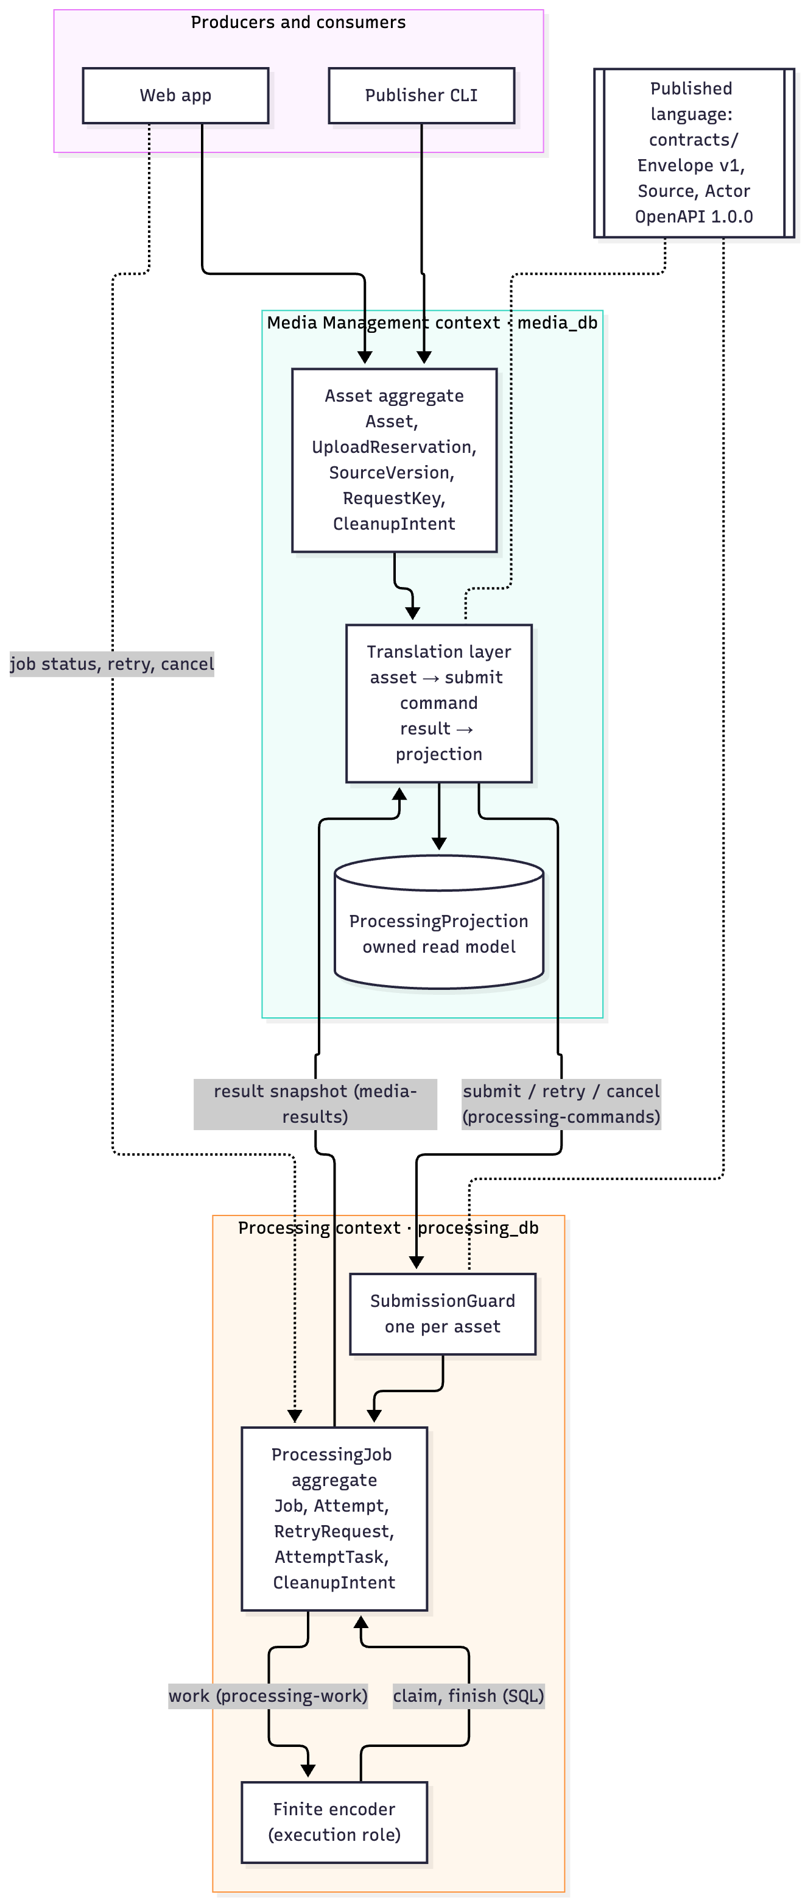
Figure 8. Context map: the Media Management and Processing contexts, their aggregates, the translation layer and the published language.
Bounded contexts.
Context | Owns | Does not own
Media Management | Accounts and login, ownership, upload intake, source versions, playback signing, the public job view, deletion and source cleanup (media_db) | Job state, attempts, leases and outputs. It holds only a projection.
Processing | Jobs, attempts, leases, retry and cancel, output descriptors, late-output cleanup, encoder claims and launch reservations (processing_db) | Users, assets, source bytes (read-only S3 grant) and playback links
Ubiquitous language (selected).
- Owner: the only principal that may read, retry, edit, delete or play an asset. Processing holds the owner as a plain UUID, never a foreign key.
- Asset: an owned video. Its UUID is also the public job_id.
- Upload reservation: a 15-minute, owner-scoped grant to write one S3 object.
- Source revision: the immutable bytes Processing may read, identified by the pinned S3 VersionId plus SHA-256 and size.
- ProcessingJob: exactly one per asset.
- Attempt: one numbered try, never reused.
- Lease: one worker’s time-limited right to finish an attempt, judged on the database clock.
- Output descriptor: the kind, key, size and SHA-256 of an output.
- Command, work and result: the three message families (below).
- Projection: Media’s own copy of Processing state.
Aggregates and their invariants. The Asset aggregate (root Asset, with UploadReservation, SourceVersion, RequestKey and CleanupIntent) enforces these rules:
- Only the owner can read or change an asset; anyone else gets 404.
- A reservation is idempotent per owner and request ID.
- The stored bytes must match the declared size, SHA-256 and signature.
- An adopted source cannot change.
- Adopting a source and staging its submit command happen in one commit.
- Retry is allowed only from failed.
- Delete is a tombstone plus a cancel command in one transaction.
The ProcessingJob aggregate (root Job, with Attempt, RetryRequest, AttemptTask and SubmissionGuard) enforces these rules:
- There is one job per asset; an identical repeat submit is a no-op.
- Commands must match the stored owner, asset, job and source.
- Transitions are one-way per attempt. A job returns to queued only through a new attempt.
- A worker needs a valid lease to start and to finish, and one task claims at most one attempt.
- Cancel before submit is permanent.
- state_version only increases, and every state change commits together with its outgoing messages.
Both aggregates are consistency boundaries. No transaction spans the two databases.
Commands, results and domain events. All five message kinds share one versioned envelope (contracts/v1.py): schema_version, message_id, kind, owner, asset, job and attempt IDs, state_version, an immutable source descriptor, and a payload. Payload values that look like secrets or URLs are rejected, so queues never carry bytes, credentials or signed URLs.
Message | Queue | Producer | Consumer | Purpose
submit | processing-commands | Media outbox (sent by MediaRepair) | ProcessingCommands | Process a newly adopted asset
retry | processing-commands | Media | ProcessingCommands | New attempt over the stored source
cancel | processing-commands | Media | ProcessingCommands | Tombstone; may precede submit
work | processing-work | Processing outbox | Fargate encoder | Wake an encoder for one attempt
result | media-results | Processing outbox | MediaResults | Full job state snapshot at a state_version
The system has no separately named domain events such as JobStarted, and it is not event sourced. Each claim, completion, failure, retry or cancel emits one result snapshot with a monotonically increasing state_version (event-carried state transfer). Producer authority is not part of the schema. Queue resource policies and per-handler IAM roles enforce it: a direct SendMessage from any other principal was refused on all three queues [AWS].
Context-map relationships.
- Customer/supplier. Media is the customer: it states what to process. Processing is the supplier and owns the answer.
- Translation on both sides. Media builds a submit envelope from its asset and pinned source, and turns each result into its own projection and public status. Processing turns each command into Job, Attempt and SubmissionGuard rows.
- Published language. contracts/v1.py, contracts/gateway.py, the two OpenAPI 1.0.0 documents, and frozen fixtures that a contract change must update in the same pull request.
Interaction with producers and consumers. The platform roles from the briefing map onto the design as follows.
Platform role | As built | How it interacts
Seed | An owned video asset and its processing job (Asset plus Job, linked by asset_id) | Created by finalize; the single shared identifier across contexts
Producers | The web app (one file at a time) and the Publisher CLI (batches) | Public API only: reserve → direct S3 POST → finalize; status, retry, edit, delete
Consumers | Owners playing their own output | Presigned MP4 with range requests; HLS playlist through Media; segments by 307 redirect to presigned S3 URLs
Integrators | Developers building new clients | Two OpenAPI documents, contracts/, and the Publisher as reference client. The Publisher has 0 imports from service code and 0 database credentials, enforced by a test.
Operators | The team | CD workflow, release and restore CLI, evidence harnesses; V2-live launches encoders automatically

Physical Architecture & Design
The platform runs in one AWS account, in region ap-southeast-1 (Singapore). One CloudFormation stack, rendered by scripts/aws/v1/definitions.py and checked in as deploy/aws/v1/template.json, defines all of it. The checked-in template is tested to be identical to the rendered output.
Two operating modes used the same template:
- V1 (10–18 October, tag project2-v1). One stack per proof run (r1017b, r1018b, r1019a). Each stack was closed outside booked sessions and deleted afterwards.
- V2-live (18 October to the end of the course). One persistent stack, dc2-live. It is always open, bounded by a throttle and a cost budget, and updated in place by CD after every green CI run on Main. It scales to zero when idle (AD-27).
Figure 9 shows the persistent topology. The network rules and data paths are listed after the component table.
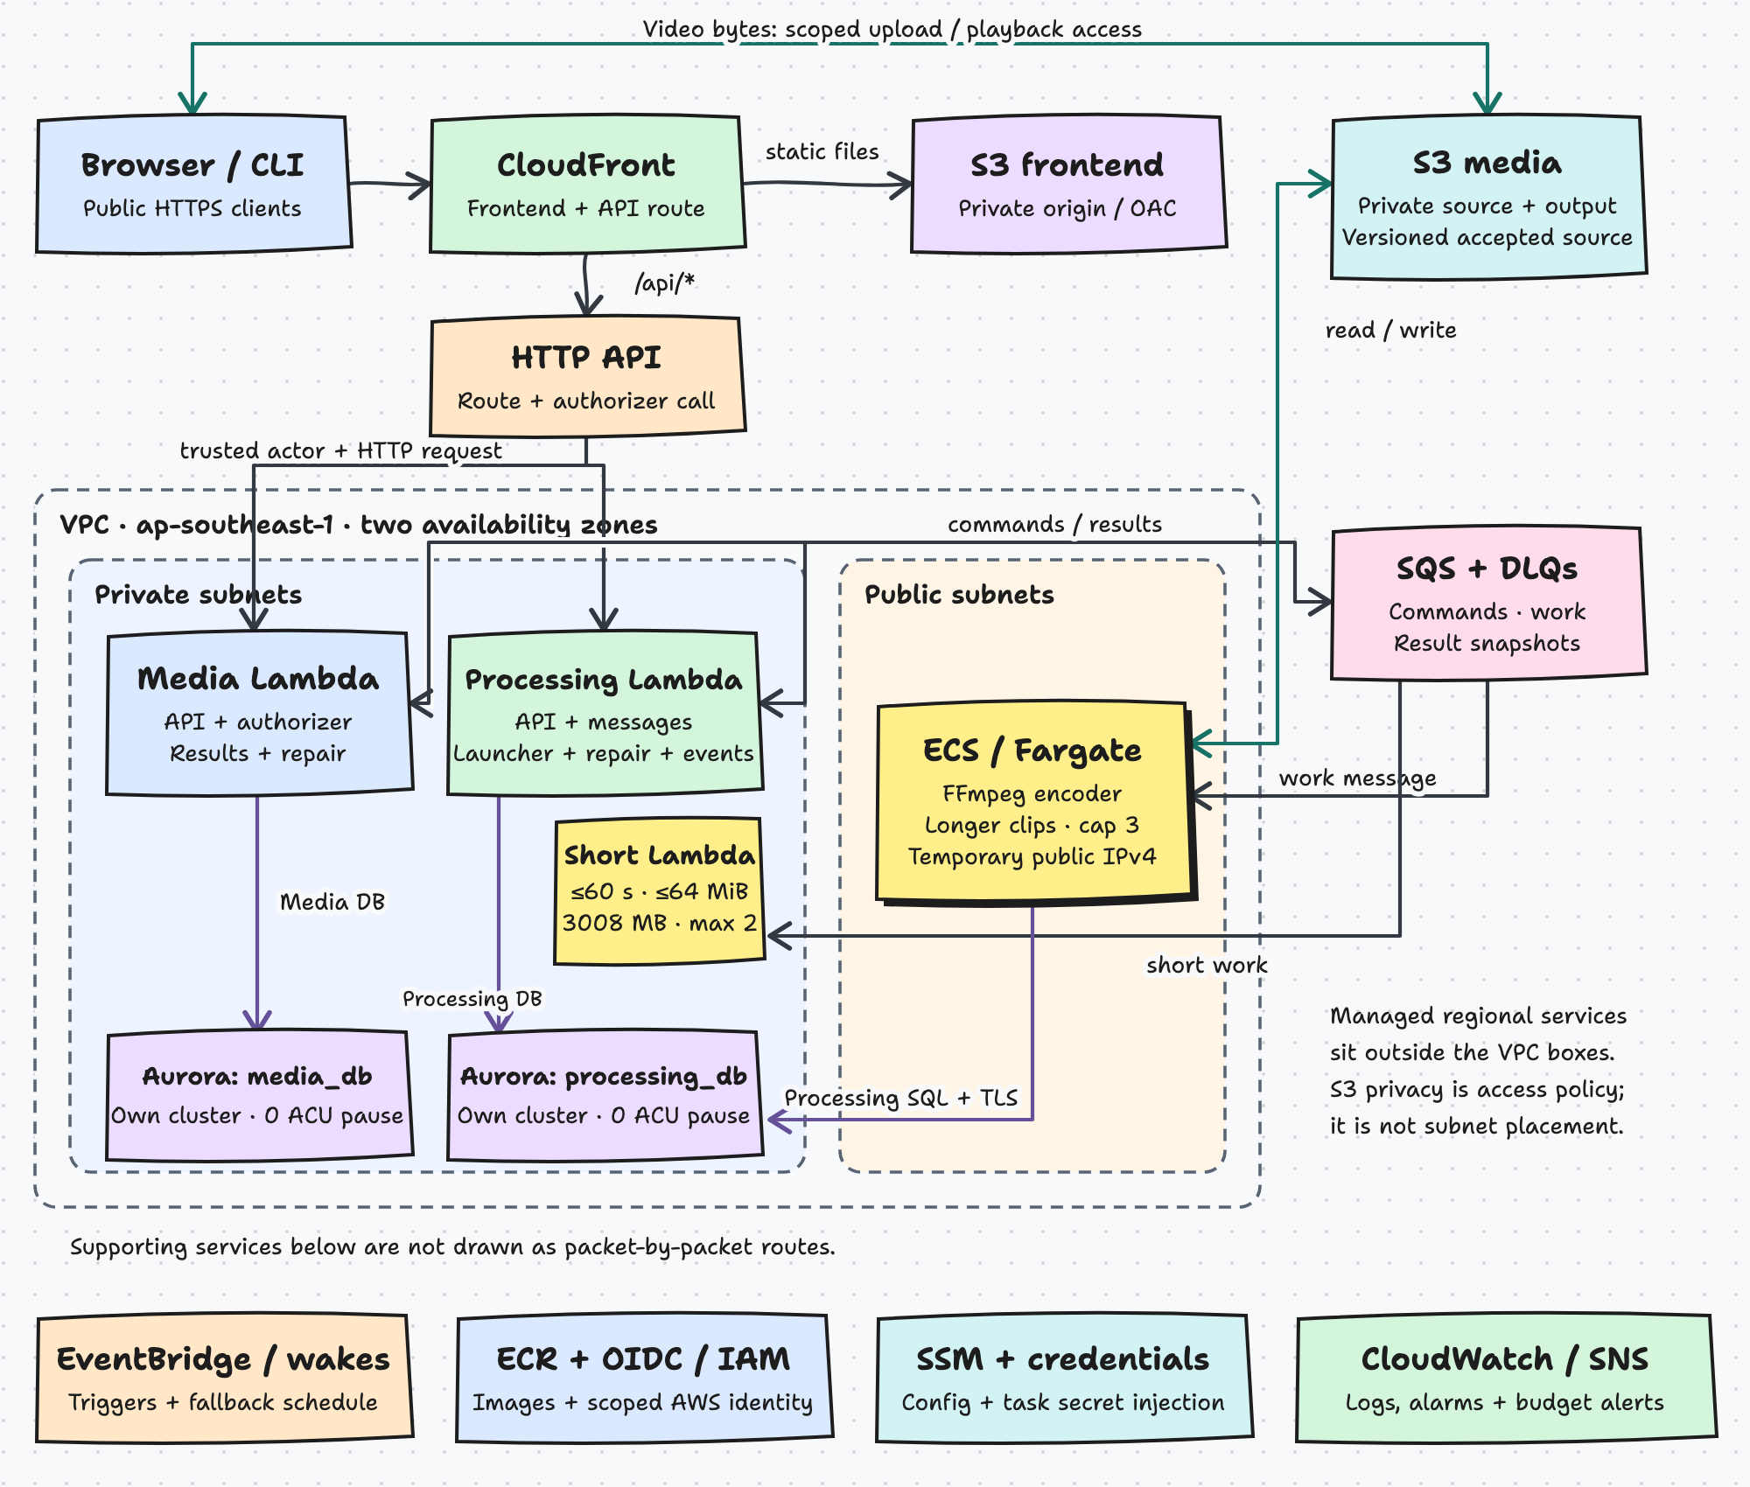
Figure 9. Persistent V2-live AWS topology (ap-southeast-1): public edge, VPC-attached Lambdas, finite Fargate encoders, the short-encode Lambda lane, two Aurora clusters, S3 and SQS.
Component | Deployed as | Placement and sizing
Web app | Static files in a private S3 bucket behind CloudFront (origin access control) | Global edge, HTTPS only (HTTP redirects); content-hashed assets
Public API | One API Gateway HTTP API: /api/media/*, /api/processing/*, one REQUEST authorizer | Regional; V2-live stage throttle 20 requests/s, burst 50
Media | One container image → 4 Lambda functions (MediaApi 2048 MB, MediaAuthorizer, MediaResults, MediaRepair), each with a live alias | Private subnets in two AZs, VPC-attached
Processing | One container image → 7 Lambda functions in V2-live (ProcessingApi, ProcessingCommands, ProcessingRepair, ProcessingEcsEvents, ProcessingS3Events, ProcessingLauncher, ProcessingShortEncoder) | Private subnets in two AZs
Encoder | Worker container image as an ECS Fargate task definition; no ECS service | 2 vCPU, 4 GiB; 0 when idle, at most 3; public subnet with a temporary public IPv4 while running
Short encoder | ProcessingShortEncoder: the Processing image as a Lambda container; SQS event source mapping on ProcessingShortWork | 3008 MB, 900 s timeout, 2 GB /tmp, MaximumConcurrency 2; private subnets. Takes clips of at most 60 s, 64 MiB and 1080p; longer clips use the Fargate encoder
Databases | Aurora PostgreSQL 16 Serverless v2: two clusters, one instance each: media_db (the original cluster) and processing_db (its copy-on-write clone) | Private subnets; 0–2 ACU each, auto-pause at 0 ACU; encrypted; rds.force_ssl=1
Object storage | Three S3 buckets: source, output, frontend | Versioned, SSE-S3, public access blocked, TLS-only policies
Messaging | Three Standard SQS queues and three DLQs | SQS-managed encryption, TLS-only, role-scoped resource policies
Scheduling | EventBridge: one-minute Media and Processing repair ticks, ECS task STOPPED, S3 Object Created | Regional
Configuration | SSM Parameter Store SecureStrings (four role DSNs, JWT secret); RDS-managed master secret | Each handler role reads only its own domain’s parameters
Images | Three ECR repositories (media, processing, worker) | Immutable tags, scan on push; releases address images by digest
Observability | CloudWatch log groups (7 days); 13 alarms (one per queue DLQ, one per function); ServicesDashboard; AWS Budget USD 20/month at 50/80/100 % | Per service
Network.
- One VPC (10.62.0.0/16 plus an Amazon IPv6 block) spans two Availability Zones, with one private and one public subnet in each.
- Private subnets have an IPv6 route through an egress-only internet gateway, no IPv4 default route and no NAT gateway. Lambdas reach SQS, SSM and ECS through dual-stack endpoints.
- One S3 gateway endpoint, attached to all route tables, is restricted to the source and output buckets.
- No security group has an inbound rule except the database’s, which admits only the Lambda, worker and migration groups on port 5432.
- An external scan of the public surface found only ports 80 and 443 open, and 80 redirects to HTTPS [AWS].

Key Architectural Decisions
These decisions are reflected in the physical view. Section 3.1.1 holds the logical ones.
Identifier | Decision | Rationale and trade-off | Status
AD-10 | Lambda container images, one image per domain; ImageConfig.Command picks the handler; every function has a live alias | Scale-to-zero compute with a per-domain release unit; FastAPI code runs unchanged behind an adapter. Trade-offs: cold starts, no pooled connections (per-invocation NullPool, so a paused database can stay paused), a 29 s Gateway timeout. | New (changes AD-07)
AD-12 | Aurora Serverless v2: one instance per cluster, separate roles; 0–2 ACU with auto-pause | Near-zero idle cost and real role separation. Trade-off: no replica failover; a request to a paused cluster resumes it (first read after a pause: 4.7 s [AWS]). V1 ran both databases on one cluster; AD-29 split them. | New (refines AD-02)
AD-29 | One Aurora cluster per service. Media keeps the original cluster; Processing gets a copy-on-write clone, and cleanup then drops the peer’s database from each. Both keep auto-pause at 0 ACU | Removes the shared capacity and failure boundary that role separation did not. The split was rehearsed on a throwaway stack first (receipt docs/results/engineering-20261021/database-split-rehearsal.json), a pre-split snapshot is kept, and CD applied it to the live stack on 21 October. Trade-off: a second cluster’s storage and wake cost; Processing must be idle during the split. | New (refines AD-02, AD-12)
AD-13 | Finite Fargate encoders: one task per attempt, a hard cap of 3, zero when idle; clips of at most 60 s, 64 MiB and 1080p run on a Lambda instead (#93, AD-22) | FFmpeg needs minutes of CPU, and nothing should run idle. Each task claims at most one attempt and exits after two empty polls. Alternatives rejected: an always-on ECS service with autoscaling (idle cost) and AWS Batch (another dependency). Trade-off: at most three concurrent encodes; Fargate start time adds to queue wait, which the Lambda lane avoids for short clips. | New
AD-15 | CloudFront as the single public entry for frontend and /api/* | Managed HTTPS without buying a domain; one origin for cookies. Trade-off: AWS-generated hostnames; the execute-api endpoint is also reachable directly (AISS-01). | New
AD-16 | Per-owner release and rollback by image digest and Lambda alias | Releases Processing without touching Media (UC-7). Each release builds and scans the owner’s image, publishes versions, moves live aliases, runs a smoke test, and restores the previous versions on failure. Trade-off: rollback is image-only, and schema changes must be additive. | New
AD-17 | GitHub Actions CD over OIDC: role dc2-github-deploy, assumed only from the aws environment, with no stored AWS key | Recorded, repeatable delivery. Trade-off: the role is broad (AdministratorAccess with a region lock), protected by the environment’s branch policy (AISS-04). | New
AD-18 | Private Lambda subnets with IPv6 egress only, an S3 gateway endpoint and no NAT | Avoids NAT and interface-endpoint hourly charges, the largest idle cost in a typical VPC design. Trade-off: every AWS dependency must be reachable over IPv6 or the gateway endpoint; Fargate tasks run in public subnets to pull images. | New
AD-20 | Least-privilege IAM per handler, native role credentials, queue resource policies | Producer and consumer authority is enforced by AWS, not by the message schema. ProcessingApi has no S3 or SQS access; MediaApi has no SQS access; the worker can read sources, write outputs and receive work, nothing else. Trade-off: the worker’s source read is bucket-wide, so owner binding is checked in code before any read. | New (supersedes AD-06)
AD-23 | One CloudFormation stack, applied in two phases (infrastructure, then applications pinned by digest) | The smallest operational surface for three people. Trade-off: infrastructure for both domains changes together; only code releases are independent. | New
AD-25 | Per-service alarms and one services dashboard | Failures are attributable to one service: one DLQ alarm per queue and one error alarm per function, tagged by owner. Trade-off: alarms are state to read, with no paging target. | New
AD-27 | One persistent, always-on environment, updated in place, scaling to zero | Per-run stacks cost a 25-minute deploy and a 25–40-minute teardown for every check. The stack already costs about USD 3–5 a month idle, so it now stays up, bounded by the throttle, the encoder cap and a USD 20 budget. Encoders start automatically from the SQL backlog. Trade-off: the environment is public all the time, and old and new code run side by side for a moment during a release. | New (supersedes AD-19 booked sessions)

Technology and Services
Technology or service | Used for | Rationale | Trade-off accepted
Python 3.12, FastAPI, Pydantic, SQLAlchemy 2 (async), Alembic | Both services, the worker and the tooling | Continuity with the inherited code; typed validation at every boundary; one migration history per database | One lockfile for the repository; owner extras keep each image to its own packages (40/36/33 exported packages)
FFmpeg and ffprobe | Probing, MP4 encoding, HLS ladder (360/480/720, capped at the source height) | Industry standard and already proven in Project 1 | CPU-bound; HLS is best effort; a large unfixed-CVE surface in the worker image (section 4.3)
Plain JavaScript SPA, hls.js, Plyr | Web client | No build step; browsers load app.js directly; Vitest tests it | No production bundling or minification
Python stdlib plus httpx | Publisher CLI | Proves reuse with the smallest dependency set: 491 lines in 6 files | Polling-based status; one cookie jar per process
AWS Lambda (container images) | APIs, consumers, repair, launcher | Pay per request, scale to zero, per-domain image release; also the short-encode lane | Cold starts; account concurrency limit of 10 observed
Amazon API Gateway HTTP API | Routing, authorizer hook, throttle | Cheapest managed HTTP front for Lambda; REQUEST authorizer | No WAF; one stage-level limit
Amazon CloudFront | HTTPS entry, static site, /api/* pass-through | Managed TLS, HTTP/2 and HTTP/3, no custom domain needed | Playback bytes come from S3 directly, not through CloudFront
Amazon SQS (Standard) with DLQs | Commands, work and results | Serverless, durable, cheap; redrive policy (5 receives) | Unordered and at least once, hence inbox dedupe and version fences
Amazon Aurora PostgreSQL Serverless v2 | Two owned relational databases, one cluster each | Transactions, constraints and SKIP LOCKED for outbox claims; scales to 0 ACU | One instance per cluster; cold resume of several seconds
Amazon S3 (versioned) | Sources, outputs, frontend | Presigned POST/GET keep bytes off the API; versioning makes the pinned source immutable | Cleanup must delete every version
Amazon ECS on Fargate | Finite encoders, migrations, bootstrap task | No hosts to manage; per-task CPU caps make capacity predictable | Task start median 25.6 s [AWS], which dominates queue wait
Amazon EventBridge | Repair ticks, ECS and S3 event hints | Rebuild lost work and react to stopped tasks without polling clients | One-minute granularity
AWS IAM, SSM Parameter Store, Secrets Manager | Per-handler roles, DSNs and JWT secret, Aurora master secret | Secrets stay out of code, images and the template | SSM read at cold start
Amazon ECR | Three image repositories | Immutable tags and digests are the release identity | Scan on push complements the CI and CD Trivy scans
Amazon CloudWatch, AWS Budgets | Logs, alarms, dashboard, cost alerts | Per-service observability at near-zero cost | 7-day log retention; no paging
GitHub Actions, OIDC, Pages | CI, CD, study-guide publication | Integrated with pull requests; no long-lived cloud keys | Hosted runner limits shape the CI lanes
Runtime and development tools are separate.
- Runtime images contain only the owning service’s code and its runtime extras. deploy/v1/check_runtime.py verifies this.
- Development tools run only in CI and on developer machines: pytest, Ruff, Vitest, Playwright, Moto, cfn-lint, actionlint, CodeQL, Trivy, gitleaks and ZAP.

Persistence Design
Relational data. Each service owns one PostgreSQL 16 database on its own Aurora Serverless v2 cluster (AD-29), with its own Alembic migration history (Media 0001_media … media_0008; Processing processing_0001 … processing_0007). No table has a foreign key into the other database. Owner and asset identifiers cross the boundary only as plain UUIDs inside messages. Figures 10 and 11 are the logical data models.
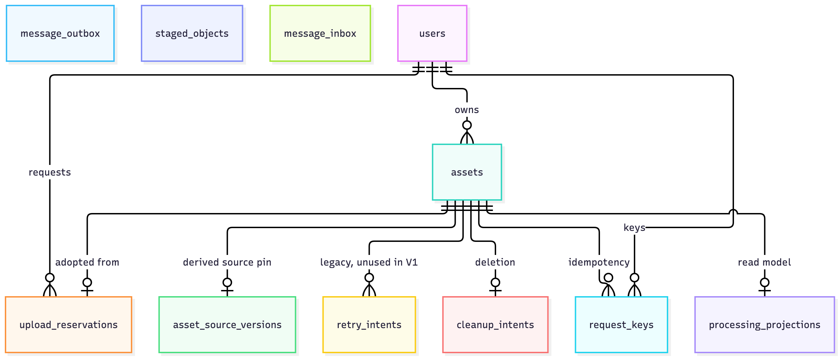
Figure 10. Media Management logical data model (media_db).
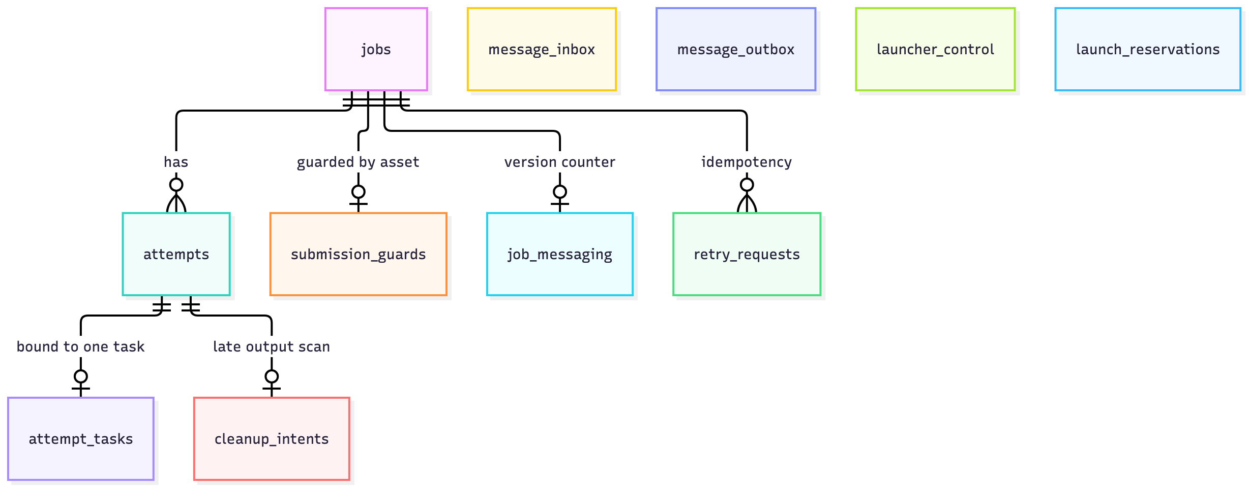
Figure 11. Processing logical data model (processing_db).
Database roles are created by a one-off bootstrap task:
- *_owner owns the database and cannot log in.
- *_migrator inherits the owner and runs Alembic.
- *_runtime has only SELECT, INSERT, UPDATE and DELETE plus sequence use.
PUBLIC has no access to either database, and neither domain’s login roles can connect to the other database. On AWS, a runtime login to the other database was refused, and DDL as the runtime role was refused [AWS]. Connections require verified TLS.
Transactions and concurrency. The design’s correctness rests on a few local-transaction rules:
- State and message commit together (outbox). Each state change stages its outgoing messages in message_outbox in the same transaction (delivery/sql.py:stage). A publisher claims due rows with FOR UPDATE SKIP LOCKED and a claim token, commits, sends outside the lock, and acknowledges only if the token still owns the row. A lost reply can resend the same message_id; it can never lose a committed message.
- Consume once per content (inbox). Consumers insert message_id plus a canonical body hash into message_inbox inside the domain transaction. The same ID with the same body is a no-op. The same ID with a different body is a conflict. Lambda acknowledges only after commit.
- Serialisation per asset. SubmissionGuard is locked first, then Job, then Attempt, so submit, retry and cancel for one asset never interleave. jobs.current_attempt_id is a deferrable foreign key, so a job and its first attempt can be inserted in one transaction.
- Leases on the database clock. Claim, heartbeat and finish compare lease_token, lease_expires_at and deadline_at with clock_timestamp(). Worker clocks are never trusted.
- Monotonic projection. processing_projections applies a result only if its state_version is newer, for the same job, source and attempt namespace. Older results are ignored, and conflicting content at the same version is rejected.
Object storage. S3 keys are an implicit contract enforced in code on both sides. Sources sit at staging/{owner}/{reservation}/source, or at sources/{owner}/{asset}/source for edit-derived assets, and are pinned by VersionId. Outputs sit at jobs/{job}/attempts/{attempt}/primary.* and …/hls/. Exactly one primary output is required, and HLS names are validated before Media serves them. Because buckets are versioned, cleanup deletes every object version, not just the latest.
What persists, and for how long. These are the values configured in the template and code. The lifecycle of this deployment as a whole is set by AD-08 (fresh demonstration data only) and AD-27 (the persistent environment is torn down once, after 16 November 2026).
Data | Persists beyond | Period configured
Session (JWT cookie) | One request | 1 hour (jwt_ttl_seconds 3600); not stored server-side
Upload grant | One request | 15 minutes; an expired reservation is rescanned for late writes and retired after a clean scan beyond a one-day horizon
Signed playback URL | One request | 900 seconds (signed_url_ttl_seconds)
Accounts | Session | Until environment teardown. No account deletion feature or purge schedule exists
Assets, sources and outputs | Session | Until the owner deletes the asset. Deletion is a tombstone; every source and output version is then deleted asynchronously. No age-based expiry and no S3 lifecycle rule are configured
Jobs, attempts and tombstone rows | Session | Until environment teardown; no hard-purge job
Outbox and inbox rows | Transaction | Until environment teardown; sent rows are kept for replay; no pruning job
SQS messages | Transaction | 7 days (DLQs 14 days); visibility timeout 420 s; redrive after 5 receives
Lambda and task logs | Request | 7 days
Aurora backups | n/a | 1-day automated backup retention on each cluster; the pre-split snapshot of the original cluster is kept, and one final snapshot is kept at teardown
CI and CD artifacts | Workflow run | 7, 14 or 60 days, depending on the artifact
Information architecture: data inventory and classification. The team uses four classification levels:
- Restricted: credentials, keys and secrets.
- Confidential: personal data and owners’ content.
- Internal: operational and processing metadata.
- Public: published static assets.
Account and authentication data (Confidential; Restricted for hashes and secrets)
- Data format: users rows (UUID, email, bcrypt hash at cost 10, role user or operator, timestamps). A stateless HS256 JWT in a host-only, HttpOnly, Secure, SameSite=Strict cookie. The signing secret is an SSM SecureString.
- Storage technology: PostgreSQL in media_db, chosen for unique constraints and transactional joins with asset ownership.
- Security requirements and controls:
  - Only the Media roles can read the JWT secret or the Media DSN.
  - The authorizer re-reads the current user row on every request, so role changes and deletions apply at once.
  - Password bytes are length-limited before hashing.
  - Authenticated responses use Cache-Control: private, no-store.
- Trade-off considered: A managed identity provider (Cognito) would add MFA and recovery flows, but brings a new dependency and token format. The team kept the inherited account model and moved verification to the edge (AD-09). There is no password reset, and no key rotation.
Owner media content: source videos and encoded outputs (Confidential)
- Data format: binary video objects up to 100 MiB, in the allowed video types. Outputs are an MP4 primary and an HLS ladder (.m3u8 playlists, .ts segments).
- Storage technology: versioned S3 buckets for sources and outputs. Object storage is the only sensible store at this size. Versioning gives each source an immutable identity (VersionId), which the pinned-source rule depends on.
- Security requirements and controls:
  - Public access is blocked and the bucket policies are TLS-only, with SSE-S3 encryption.
  - Uploads use a presigned POST whose policy fixes the key, the content type and a length range.
  - Downloads use presigned GET links that expire after 900 s, issued only after an owner check.
  - HLS segments are served by a 307 redirect to a fresh signature.
  - CORS allows only the frontend origin.
  - The worker’s read is limited to the source bucket, and the owner and source binding is checked in code before any read.
  - On AWS: tampered and expired URLs were refused, and an unsigned read returned 403 [AWS].
- Trade-off considered: Proxying bytes through the API would centralise control, but it breaks Gateway and Lambda payload limits and costs compute. Presigned URLs are bearer capabilities for their lifetime, so the lifetime is kept short.
Asset and upload metadata (Internal; original filenames are Confidential)
- Data format: assets, upload_reservations, asset_source_versions, request_keys, cleanup_intents, staged_objects and processing_projections rows. JSONB holds operations and outputs.
- Storage technology: PostgreSQL in media_db. Check constraints enforce the pinned-source rule (ck_upload_reservations_finalized_has_pin) and the status sets.
- Security requirements and controls: Every query is filtered by owner, and a foreign ID returns HTTP 404. The runtime role cannot run DDL. Idempotency keys make retries of finalize, edit and retry safe.
- Trade-off considered: Media keeps a projection instead of querying Processing (AD-21). That removes a runtime dependency, at the cost of eventual consistency.
Processing job data (Internal)
- Data format: jobs, attempts, submission_guards, retry_requests, attempt_tasks, job_messaging, cleanup_intents, launcher_control and launch_reservations rows. JSONB holds the source descriptor and the outputs.
- Storage technology: PostgreSQL in processing_db. Leases, row locks and SKIP LOCKED need a transactional store with a trustworthy clock.
- Security requirements and controls: Only Processing roles hold the DSN. Owner, asset, job and source must match the stored values on every command. The worker can update only its own leased attempt.
- Trade-off considered: DynamoDB or the RDS Data API would remove VPC attachment and connection handling. They were left to the V2 backlog because the lease and outbox logic depends on SQL transactions.
Messages in transit (Internal)
- Data format: JSON envelope v1 (identifiers, state_version, source descriptor, payload). No bytes, credentials or URLs are allowed in a payload.
- Storage technology: SQS Standard queues and DLQs, plus the message_outbox and message_inbox tables.
- Security requirements and controls: SQS-managed encryption and TLS-only policies. Resource policies deny SendMessage to every principal except the listed producer roles, and receive/delete to every principal except the listed consumer roles. A direct send was refused [AWS].
- Trade-off considered: FIFO queues would give ordering and deduplication, but at lower throughput and with message-group design work. The inbox and version fences already tolerate duplicates and reordering, so Standard queues are enough. The repository does not record a formal FIFO evaluation.
Secrets and configuration (Restricted)
- Data format: four role DSNs and the JWT secret as SSM SecureStrings. The Aurora master password is managed by RDS in Secrets Manager.
- Storage technology: SSM Parameter Store (no per-secret monthly fee) and Secrets Manager for the RDS-managed master secret.
- Security requirements and controls: Each handler role can read only its own domain’s parameters. The master secret is reachable only by the bootstrap operator. No AWS key is stored in GitHub; CD uses OIDC. gitleaks runs in CI.
- Trade-off considered: SSM has no automatic rotation, and rotation is out of scope. Cold starts read the parameters once.
Operational telemetry and delivery evidence (Internal)
- Data format: CloudWatch logs (bounded, redacted failure events), metrics, alarm state; CI and CD artifacts; sanitized JSON receipts committed under docs/results/ and docs/execution/aws/v1/evidence/.
- Storage technology: CloudWatch Logs (7 days), GitHub Actions artifacts (7–60 days), Git for sanitized receipts, and a private, versioned S3 state bucket for CD run state.
- Security requirements and controls: Signed URLs, cookies, secrets and account IDs are stripped before anything is committed. The state bucket is private because it holds the smoke account’s credentials.
- Trade-off considered: Seven-day logs keep cost and exposure low. Incident reconstruction after a week relies on the committed receipts.
Static frontend (Public)
- Data format: HTML, CSS and JavaScript, with content-hashed asset names.
- Storage technology: private S3 bucket behind CloudFront origin access control.
- Security requirements and controls: Integrity comes from the deploy pipeline. The bucket is not directly public.
- Trade-off considered: none material.

Detailed Design
Three architecturally representative use cases are described here. Section 7.1 traces every use case to its classes, modules, sequence views and tests. Section 7.2 holds the shared analysis and design class models and the grouped sequence views, and section 7.3 holds the three design problems with before-and-after views.
Case 1: upload, process and play (UC-1 to UC-3). This is the platform’s main flow (Figures 5–7).
Step | Class / function | What it does | Invariant protected
Reserve | media.services.direct_intake.reserve, storage.direct_upload_grant | Creates an UploadReservation (owner, request ID, filename, type, size, SHA-256) and a presigned POST that fixes the key, type and length; expires in 15 min | Idempotent per (owner_id, request_id); changed body → 409; type and 100 MiB size checked
Upload | Browser or Publisher → S3 | Sends the bytes straight to the versioned source bucket; no cookie and no API involved | Bytes never pass through Gateway or Lambda
Finalize | direct_intake.finalize, storage.verify_direct_upload, media.messaging.enqueue_submit | Reads size, SHA-256 and signature at an explicit VersionId, outside SQL locks; then, in one transaction, pins the version, creates the Asset and stages submit | The verified bytes are the bytes encoded; adoption and command are atomic; a missing object → 409, not adopted
Publish | MediaRepair → delivery.sql.publish_due | Claims due outbox rows (SKIP LOCKED), sends to processing-commands, acknowledges by claim token | At least once; no committed message is lost
Accept | processing.handlers.command_handler → messaging.handle_command | Records the inbox row; locks SubmissionGuard; creates Job and attempt 1 as queued; emit_state stages work and result v1 | One job per asset; duplicate submit is a no-op; owner and source must match
Launch | processing.launcher (V2-live) | Reserves a slot in SQL and starts a Fargate task with a stable RunTask token; at most 3. A clip of at most 60 s, 64 MiB and 1080p is instead staged on ProcessingShortWork and read by the ProcessingShortEncoder Lambda (cap 2); an executor probe that finds a longer clip returns the job to the standard lane | The cap holds under concurrent wakes and lost RunTask replies
Claim | processing.worker.sqs.decode_work → messaging.claim → lifecycle.claim | Binds the task to the attempt (AttemptTask), takes a lease on the DB clock, sets processing, stages result v2 | A valid lease is needed; one task, one attempt
Encode | processing.worker.tasks.pipeline, media_engine (same pipeline in the Fargate task and in the short-encode Lambda) | Downloads the source at its pinned VersionId and checks SHA-256; ffprobe; MP4; HLS variants via variants_for (never above the source height) | HLS failure keeps the MP4; outputs scoped to jobs/{job}/attempts/{attempt}/
Finish | lifecycle.finish | Under the live lease, records exactly one primary output plus optional HLS, sets done, stages result v3; the worker then deletes its SQS message | Terminal state commits before the work is acknowledged
Project | media.handlers.result_handler → projections.apply_result | Inbox dedupe; validate_transition; upserts the projection | Never moves backwards; checks job, source and attempt namespace
Play | projections.public_job, storage.sign_output, media/api/v1_hls.py | Returns owner-filtered status, a presigned MP4 URL and the HLS playlist; segments redirect (307) to presigned S3 URLs | Owner only; no-store caching; short-lived capability
Case 2: retry over the stored source (UC-4).
- media.services.v1_lifecycle.retry checks the owner, the projection state failed, the pinned source and an idempotency key (RequestKey).
- It then stages a retry command in the same transaction.
- In Processing, messaging._retry_locked locks the guard and job, and creates a new Attempt with the next number and a RetryRequest keyed by (job_id, request_id). A replayed retry returns the same attempt.
- If a retry arrives before its submit (SQS reordering), it is rolled back, including its inbox row, so redelivery can succeed later.
- A worker still holding the old attempt’s lease cannot finish: lifecycle.finish requires the current attempt and the same live lease_token.
No bytes are uploaded again. An expired lease marks the attempt abandoned and the job failed. The job is never re-queued automatically. A retry is always an explicit owner command, which keeps duplicate outputs and hidden loops out of the design. Tests: test_retry_idempotency_and_cancel_fence_old_and_current_attempts and test_publisher_retry_reuses_the_stored_source_after_a_transient_encode_failure.
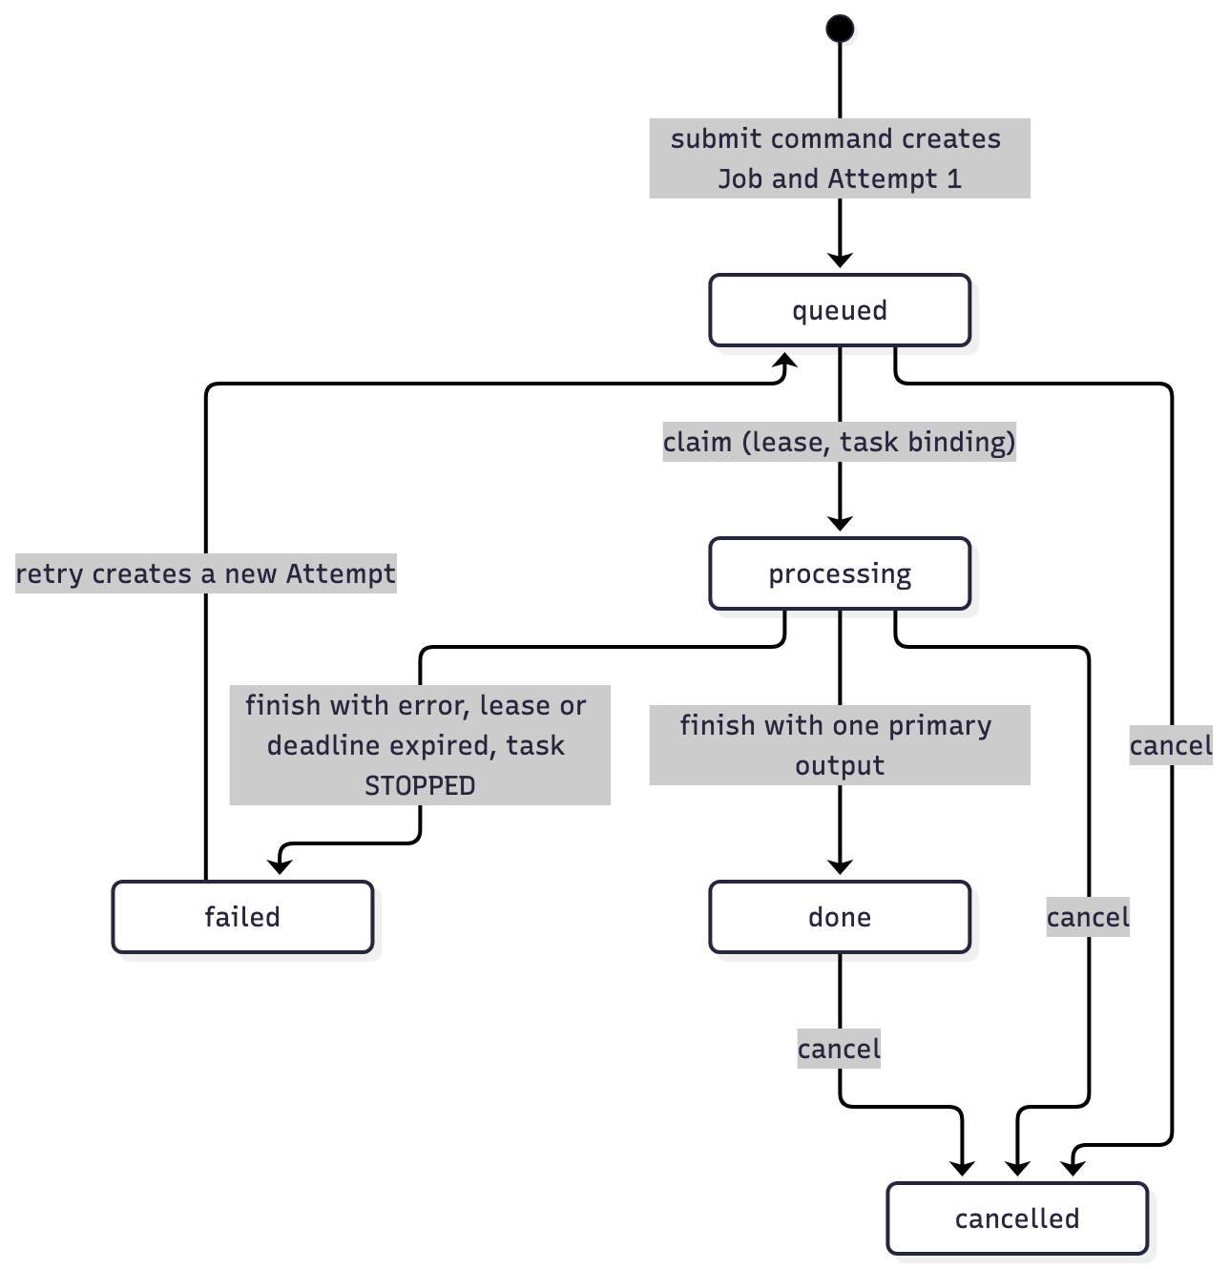
Figure 12. Job and attempt state machine: one-way transitions per attempt; a retry creates a new attempt.
Case 3: independent, safe release of one owner (UC-7).
- scripts/ci/cd.sh calls release_owner for each owner whose image build inputs changed. Media is untouched by a Processing-only change.
- scripts/aws/v1/release.py takes the journal lock and writes a durable pending_release intent before any mutation.
- It pins the candidate image digest and the resolved task definitions. It verifies the registry manifest bytes against the scanned image config, and checks migration compatibility (heads must be unchanged, or attested as additive).
- It publishes a Lambda version per function, moves each live alias, and runs the owner’s smoke test.
- On a failed gate or smoke, it restores the previous versions and records restored. A failed restore leaves the recovery intent in place for an explicit resume.
- deploy.py:adopt_release then writes the promoted images back into the stack, so the template still describes what runs.
Schema is never rolled back. This is why migrations must be additive. Tests: test_owner_release_applies_a_real_migration_and_failed_candidate_restores_aliases, test_pending_intent_before_mutation_and_real_bad_candidate_restore and test_owners_are_released_only_when_their_images_build_inputs_changed. [AWS]: CD run 39271754470 shipped a deliberately failing Processing candidate, and it restored automatically.

Other Architectural Decisions
The remaining register decisions, and the project decisions that shaped the architecture, are listed below. Where another section explains the rationale, the table points there.
Identifier | Decision | Rationale and trade-off | Status
AD-03 | Synchronous submit with asynchronous Redis/RQ processing (proposal) | Replaced so that no always-on broker runs and Media does not depend on Processing at request time; see AD-11 | Superseded by AD-11
AD-04 | Idempotent SubmitJob keyed on asset_id, plus reconciliation; outbox only if needed (proposal) | Idempotency (SubmissionGuard, unique asset_id) and reconciliation (repair_work, lease expiry) were kept. The outbox was adopted from the start because SQL plus SQS is not atomic. | Changed (AD-11)
AD-05 | Presigned URLs for source reads and output delivery (proposal) | Uploads and playback stay presigned. The worker reads the source with an IAM grant pinned to a VersionId instead, which removes a live Media callback from the encode path. This is broader than a signed URL, and owner binding is checked in code (section 3.2.3). | Changed (AD-14, AD-20)
AD-06 | Service token plus forwarded owner identity on a private network (proposal) | No private network exists between Lambdas, so IAM and the Gateway-trusted actor became the boundary | Superseded by AD-09, AD-20
AD-07 | Containers on AWS in one small environment (proposal) | Same intent, managed serverless mechanism. Only the encoder, migrations and bootstrap run as containers on Fargate. | Changed (AD-10, AD-12, AD-13, AD-15, AD-23)
AD-08 | Fresh demonstration data; no Project 1 data migration | Keeps effort on the contribution and sets the data lifecycle (section 3.2.3). The deploy pipeline seeds one smoke account. | Kept
AD-19 | Closed-by-default stack operated as booked sessions (V1) | Kept idle spend near zero, but made the platform unavailable outside sessions and cost a full deploy and teardown per check | Superseded by AD-27
AD-22 | Opt-in V2 experiments in the same template, off by default: unattended launcher (#68), short encodes on Lambda (#93), one cluster per database (#94) | Keeps experiments revertible: with default flags the template is byte-identical to V1, which a test checks. #68 ran on AWS and became the V2-live default (AD-27). #93 and #94 were enabled on dc2-live on 21 October and measured there (section 4.1, AD-29); per-run stacks keep the defaults. | New
AD-29 | One Aurora cluster per service, split in place from the shared one (section 3.2) | The shared cluster was a shared capacity and failure boundary. Rehearsed on a throwaway stack, delivered by CD, pre-split snapshot kept | New (21 October)
AD-28 | Release admission scans both the candidate and the retained rollback image, and handles a newly published advisory that affects only the retained image without bypassing the gate (section 5.3) | A restore target must not silently reintroduce a fixable HIGH/CRITICAL finding, but a newly disclosed advisory against the old image must not block the release that fixes it. The policy and its evidence are in docs/architecture/decisions.md. | New (21 October)
Project decisions with architectural effect.
ID | Decision | Effect
F-01 | Lecturer accepted the proposal and asked for detailed DDD to confirm the service choice | The DDD model and context map (section 3.1.4); AD-01 confirmed
D-01 | Baseline is the team’s local frozen FlickPond checkout 8854537 (the proposal named 890c5ec) | Inherited capability is identified separately from Team 17’s work
D-06 | One progress report, due 16 October | Project-conduct reporting (section 2)
Freeze, 20 Oct | Team-accepted demo release frozen at daee44b (docs/release/demo-release-manifest.md); afterwards, only blocker repairs with verification and a manifest update | Later engineering releases (629119c on 20 October, c7c489c on 21 October) are recorded as post-freeze addenda with their own receipts and blocker justification
#271 | A 503 instead of a 4xx when S3 refused an oversized upload was accepted as a known limitation at the freeze | Fixed in the later engineering release: a missing upload object now returns a recoverable 409, and real storage failures remain 503. The 100 MiB cap was enforced throughout.
Rationale already given elsewhere is not repeated here:
- Performance decisions (caching, scale-to-zero, direct-to-S3): section 4.1.
- Availability (outbox, leases, repair, DLQs): section 4.2.
- Security (IAM, authorizer, scanning): section 4.3.
- Maintainability (contracts, per-service lanes, legacy quarantine): section 4.4.

Architectural Limitation
The key outstanding architectural issues are listed below. Owners follow the agreed specialisms (cloud and delivery: Guruprasath Gopal; backend services: Ibrahim Mammadov; domain, contracts and verification: Nguyễn Kim Long).
The timeline has two horizons:
- C: within the course, by 16 November 2026.
- Post-course roadmap: applies if FlickPond is taken forward. Phase R1 is the first month, R2 is months 2–3 and R3 is later.
The persistent environment is torn down after 16 November 2026. Any post-course phase would start from the repository and the retained template.
Identifier | Issue and impact | Description | Resolution | Owner | Status
AISS-01 | Measured performance misses | Queue wait on the short lane is met: median 0.26 s against 32.6 s on Fargate (5 jobs per arm, 24 s clip, run sl1021) [AWS]. Longer clips still use Fargate, with a wait of about 37 s against 20 s; task start (median 25.6 s, n = 12) dominates it. End-to-end submit-to-done still misses 20 s on both lanes (warm Lambda median 45.2 s, Fargate 87.7 s), and 35–80 s per job outside queue wait and encode is unexplained. Two-worker speedup was 1.449× against 1.6× (three workers: 2.347× against 2.1×, passed), from a 6-clip backlog with one run per cap; the proposal’s 30-clip AWS comparison was not run. | R1: trace the unexplained 35–80 s per job with per-stage timestamps; rerun 30 clips × 3 repeats per cap with per-task CPU profiling, reported against the unchanged targets; measure a slimmer worker image. R2: raise the short-lane bounds only if measured | Long (verify), Guruprasath | Open, measured misses (section 4)
AISS-02 | Public API endpoint beyond CloudFront, no WAF | The execute-api URL is reachable directly. Only the authorizer and a single stage throttle protect it. | R1: CloudFront-only origin (secret origin header checked by the authorizer) plus AWS WAF managed rules | Guruprasath | Open
AISS-03 | Image-only rollback | Release restores images and aliases, never schema. Pair compatibility is an operator attestation backed by N/N-1 contract tests. | R2: enforce expand-and-contract migrations with an automated old-image-on-new-schema test in CI | Ibrahim | Accepted, mitigated by policy
AISS-04 | Operations hardening | The CD role has AdministratorAccess with a region lock. Promotion to the single environment is automatic after green Main CI, with no staging, no reviewer gate on the aws environment and no branch protection on Main. 13 alarms and a dashboard exist, but nobody is notified, there is no tracing, and logs last 7 days. | R1: a ruleset requiring Full verification on Main and dev/closeout; a least-privilege deploy policy; an SNS notification target and an alarm drill. R2: a staging stack from the same template | Guruprasath | Open
AISS-05 | Evidence not established | Not established: the AWS lost-queue-entry timing (120 s bound), the duplicate-output check after a worker kill, a restore drill, the Publisher’s 2 person-day effort, and actual spend (Cost Explorer showed USD 0.00 with credits applied). | C: read the final October bill in Cost Explorer before 16 Nov; R1: run the remaining experiments with retained receipts | Long, Guruprasath | Open
Items that are not limitations of this design are covered where they belong:
- Deliberate scope exclusions are listed in section 1.4.2: multi-zone and multi-region failover, general autoscaling, and sharing with other viewers.
- Design properties are explained with the decisions that chose them:
  - at-least-once delivery (section 4.2);
  - the quarantined legacy code (AD-26);
  - unfixable base-image findings (section 4.3);
  - the encoder cap (AD-13);
  - data retention for the demonstration environment (section 3.2.3).

Quality Attributes
Each attribute below gives the design tactics first, then the evidence against the proposal’s targets (proposal §3.4, unchanged). Results keep their environment, source, workload and timing boundary. Local results never stand in for AWS results, and misses stay misses. The complete record is in docs/results/actual-vs-target.md (with its CSV) and docs/evidence-index.md.
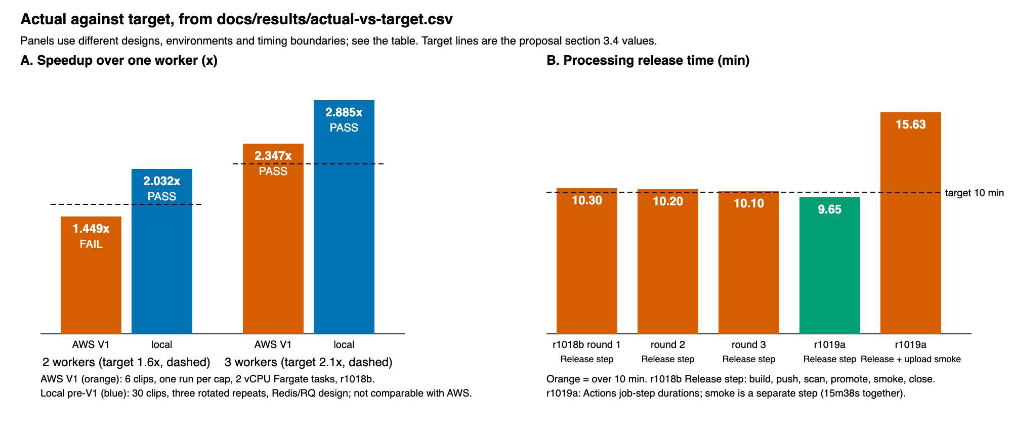
Figure 13. Speedup and Processing release time against target (AWS V1 and V2-live; misses shown as misses).
Attribute | Scenario (proposal target) | Result | Verdict
Scalability | 2 workers ≥ 1.6× and 3 workers ≥ 2.1× the jobs/min of 1 worker | AWS V1 (6 clips, one run per cap): 0.483 / 0.700 / 1.134 jobs/min → 1.449× and 2.347× | FAIL at 2; PASS at 3
Scalability | Median queue wait falls at each step; 0 failed jobs | 274.3 s → 135.7 s → 9.6 s; 0 failed; 0 encoders left running | PASS
Scalability | (same, local pre-V1 design, 30 clips × 3 repeats) | 2.032× and 2.885× | PASS (different design; not AWS)
Scalability | V2-live automatic scale 0 → 3 → 0 | 0 → 3 → 0 with 3 concurrent clips; 9-clip backlog at cap 3 in 239 s (2.26 jobs/min) | PASS (no 1/2/3 comparison)
Performance | 50 users polling status for 3 min: p90 ≤ 700 ms, < 1 % errors | p90 58.2 ms, 9,000 requests, 0 errors (in-region generator) | PASS
Performance | 20 concurrent logins: p90 < 2 s | p90 178 ms (20 samples) | PASS
Performance | Warm-job queue wait ≤ 20 s (V2-live), standard Fargate lane | about 37 s; Fargate start median 25.6 s (5-job sl1021 Fargate arm: 32.6 s median) | FAIL
Performance | Same wait on the Lambda short-encode lane (≤ 60 s clips, sl1021, 5 jobs, 24 s clip) | median 0.26 s (max 2.6 s) against 32.6 s on Fargate; processing 5.3 s against 8.0 s; billed compute USD 0.0003 against 0.0021 per encode; 0 failures | PASS (queue wait)
Performance | Submit-to-done, same run (no proposal target; 20 s end to end is the aim) | Lambda cold 92.0 s (n = 1), warm median 45.2 s; Fargate median 87.7 s | FAIL against 20 s on both lanes
Availability | Worker killed mid-encode: re-queued or failed within 5 min | Stop detected in 5.8 s; lease expiry marks the job failed; retry creates a new attempt | PASS (reaction time only)
Availability | Lost queue entry re-enqueued within 2 min | 23.5 s (local pre-V1); ≤ 120 s asserted on a simulated clock (local V1) | PASS locally; NOT_RUN on AWS
Availability | Processing temporarily unavailable while Media accepts uploads | Command consumer off for 48 s: Media answered 202 and held the command; job done 58.9 s after re-enable | PASS (consumer only)
Deployability | Release Processing alone, smoke-tested, in ≤ 10 min; Media unchanged | Operator promote 322.5 s; CD Release step 10.1–10.3 min (r1018b) and 9 m 39 s (r1019a); release plus a separate upload smoke 15 m 38 s; Media unchanged at every snapshot | FAIL (marginal); not established with the smoke
Deployability | Bad candidate restores automatically | CD run 39271754470 (bad_candidate=true) → restored | PASS (source 7928b7c)
Security | Negative tests 100 % rejected; 0 fixable HIGH/CRITICAL at release | All selected negatives rejected on AWS V1 and on dc2-live (#229); 0 fixable HIGH/CRITICAL at each release | PASS (checks run)
Reusability | Publisher CLI: 0 service imports, 0 database credentials, ≤ 2 person-days | 0 and 0, enforced by a test; 491 lines; effort not timed | PASS; effort NOT_MEASURED

Performance
Tactics in the design.
- No bytes through the API. Uploads go straight to S3 by presigned POST. Playback reads MP4 (with range requests) and HLS segments straight from S3 by presigned URL. Lambda handles only small JSON requests, and there is no payload limit to hit.
- Caching where it is safe. CloudFront caches the content-hashed frontend at the edge. API responses deliberately use the AWS managed caching-disabled policy, and authenticated responses carry Cache-Control: private, no-store: status and signed URLs are per-owner and short-lived, so caching them would leak or go stale. HLS playlists are never cached.
- Load balancing is managed. API Gateway and Lambda spread requests across concurrent executions. SQS distributes work across up to three encoders, and each encoder pulls one attempt at a time.
- Reads come from a local projection. Status is answered from Media’s own projection in one owner-local query (an earlier N+1 lookup was replaced by one outer join). There is no cross-service call per poll.
- Bounded, predictable encoding. Each encoder is a 2 vCPU / 4 GiB task. FFmpeg uses every core it sees, so the per-task cap is what makes the 1/2/3 comparison fair. The HLS ladder never exceeds the source height, so no work is wasted upscaling.
- Connections suited to a pausing database. Per-invocation sessions (NullPool) let Aurora pause at 0 ACU. The first read after a pause costs about 4.7 s; later reads take about 263 ms [AWS].
Results and explanation.
- Latency. Status p90 was 58.2 ms against 700 ms, and login p90 was 178 ms against 2 s [AWS]. The generator was a Fargate task in the same region, so these numbers exclude internet latency to end users.
- Two-worker miss. The 1.449× result is measured on six clips with one run per cap. Fargate task-time variability against a fast single-worker baseline is the most probable cause, but no per-task CPU profile was captured, so the cause is an inference. The three-worker result (2.347×) passed, and the median queue wait fell at each step.
- Queue-wait miss, and the short lane. The standard-lane wait of about 37 s is a deliberate trade-off of scale-to-zero: no encoder runs idle, so each burst pays a Fargate start (median 25.6 s) plus image pull. On 21 October the Lambda short-encode lane (#93, AD-22) was enabled on dc2-live: clips of at most 60 s, 64 MiB and 1080p are read by a Lambda (3008 MB, concurrency 2) and the queue wait fell to 0.26 s in a five-job comparison [AWS]. That is one 24 s clip, five jobs per arm (the Fargate arm used the same streams padded to route to the standard lane), so it shows the effect but not its spread. The end-to-end target is still missed: 35–80 s per job outside queue wait and encode is unexplained on both lanes. The target was not revised, and AISS-01 records the options.

Availability
Tactics in the design.
- Durable state first. SQL is the source of truth, and the outbox commits every message with its state change. A lost queue therefore delays work but cannot lose it: repair_work rebuilds queued work from jobs and attempts on the one-minute repair tick. ECS STOPPED and S3 Object Created events trigger the same pass early.
- Failure isolation between services. Media never calls Processing. While Processing’s command consumer was off, Media kept accepting uploads (202), and the job completed after re-enable [AWS].
- Fenced, disposable workers. Leases on the database clock, task binding and a hard deadline mean a dead or stuck worker cannot finish late. Its attempt is visibly abandoned/failed, and the owner retries from the stored source. The worker cannot send messages, so a dying worker cannot publish a half-finished result.
- Poison-message containment. Each queue redrives to a DLQ after five receives. A poison message reached the DLQ after 2,101 s and was removed [AWS]. A DLQ runbook covers redrive.
- Managed redundancy where it is free. Lambda, SQS, S3, API Gateway and CloudFront are regional or global managed services spanning multiple AZs. The subnets cover two AZs.
- Self-healing deploys. A failed release smoke restores the previous images automatically (section 5.3). Stateful resources use DeletionPolicy: Retain, and CloudFormation refuses a change set that would replace Aurora, a bucket or the distribution.
- Observability. Per-service alarms (DLQ depth per queue, errors per function: 13 in V2-live) and one dashboard. 13 of 13 alarms were OK after the backlog tests [AWS].
Limits, stated plainly.
- The platform is not highly available in the strict sense. Each service now has its own Aurora cluster (AD-29), so a database failure no longer takes both services down, but each cluster is one instance in one region with no replica; zone and region failover are out of scope (section 1.4.2).
- Backups are kept one day, and no restore drill was run.
- No uptime SLA is claimed.
- The lost-queue-entry timing was not measured on AWS (AISS-05).

Security
Controls in the solution.
Area | Control
Identity and access | Media-owned Lambda authorizer on every route except health, register, login and logout. It verifies the HS256 session JWT and re-reads the current user and role. The Gateway adapter strips caller-supplied x-owner-id, x-role and cookie headers and builds the actor only from the authorizer context. Owner filters apply in both services, and a foreign ID returns 404. Admin routes need the operator role.
Session | Host-only, HttpOnly, Secure, SameSite=Strict cookie through CloudFront; 1-hour token; private, no-store on authenticated responses
Hashing | bcrypt (cost 10) with a password byte limit; SHA-256 over every uploaded source and every output
Encryption | TLS everywhere: CloudFront HTTPS only (TLS 1.2+ to the origin), TLS-only S3 and SQS policies, rds.force_ssl=1 with verified CA. At rest: Aurora storage encryption, SSE-S3, SQS-managed encryption, SecureString parameters.
IAM (least privilege) | One role per Lambda, migration task and worker (17 roles at default flags). Queue resource policies deny unlisted producers and consumers. Separate database roles; native role credentials; no static keys anywhere. GitHub reaches AWS only through OIDC.
Input validation | Type allow-list and a 100 MiB cap, enforced at four points: the frontend, the grant, the S3 POST policy and the Publisher. Finalize checks size, hash and file signature at a pinned version. Envelope validation rejects secret- or URL-like payloads. HLS file names are allow-listed.
Network | No inbound security-group rules except the database’s internal rule; no NAT; private subnets for Lambdas and Aurora; only ports 80/443 public (80 redirects)
Secrets | SSM SecureStrings scoped per role; RDS-managed master secret; gitleaks secret scanning; receipts sanitized before commit
Supply chain and testing | Ruff security lint (flake8-bandit rules); Trivy on all three exact images in CI and again on the deployed builds in CD (zero fixable HIGH/CRITICAL gate); ECR scan on push; authenticated OWASP ZAP DAST; CodeQL (Python, JavaScript/TypeScript, GitHub Actions); gitleaks; dependency audits (npm audit: 0 findings); Dependabot alerts enabled
Scanner results and triage | Every scanner publishes SARIF to GitHub code scanning (the repository’s Security tab). On 22 October the 12 High CodeQL alerts were triaged: all are in test, proof-harness or developer-script code, none in deployed code, and each was dismissed with a recorded reason. The open alerts are ZAP low and informational findings on the OpenAPI documentation pages. One CVE is accepted unfixed: CVE-2025-52290 in ffmpeg (no fix in Debian 13; the worker is a finite task with no inbound network), recorded in docs/execution/aws/v1/scan-accepted-unfixed-20261017.json
Intrusion detection and prevention | Not deployed. There is no WAF, GuardDuty or IDS/IPS (AISS-02). The compensating controls are the authorizer, the stage throttle (20 rps, burst 50), the budget alarm and the per-service error alarms.
Verification. The proposal’s negative tests were run on AWS: on V1 stacks r1017b/r1018b, and in full on the persistent dc2-live environment for issue #229 on 19 October [AWS].
Control (proposal §3.3) | Result
Unauthenticated requests rejected | 401 on all six probed job routes, through CloudFront and directly through Gateway
User A cannot read, retry, edit, delete or play User B’s assets | 404 for B on every Media and Processing route for A’s job
Forged identity headers and token-less internal calls | Forged headers changed nothing; anonymous admin 401, non-operator 403
Direct queue send by an unlisted principal | 403 on all three queues; 0 messages accepted
Each service’s credentials refused on the other’s database | InsufficientPrivilegeError; runtime DDL denied
Expired and tampered presigned URLs; no public listing | Tampered 400/403; both 900 s expiries waited out (206/204 before, 403 after); unsigned S3 403
Invalid and oversized uploads | 100 MiB + 1 byte refused by S3 (400) and never adopted
External port scan; private datastores | Only 80 and 443 open; Aurora PubliclyAccessible=false; no 0.0.0.0/0 ingress
Secrets out of git and images | gitleaks green in CI
Zero fixable HIGH/CRITICAL image findings at release | Met at every release, with the retained-image incident described in section 5.3
Scope limits.
- “Zero fixable HIGH/CRITICAL” never means zero vulnerabilities. The images still carry unfixed findings (44/44/208 rows at the last scan), and an earlier accepted set included one CRITICAL with no fix available.
- DAST findings are report-only, cover seven selected routes, and ran against the local gateway, not the AWS edge. Eight low and eight informational entries remain, mostly missing hardening headers on the local bridge.
- SonarCloud analysis is advisory and was not configured with a token.
- The #229 negatives ran before the final frozen source and were not repeated on it.

Extensibility and Maintainability
How the platform is extended.
- A new client application. It uses only the two OpenAPI 1.0.0 documents and the public flow: reserve, upload, finalize, status, retry. The Publisher CLI is the worked example: 491 lines of Python in 6 files, using only the standard library and httpx. It has 0 imports from service code and 0 database credentials, enforced by an AST test, and it is validated against the published OpenAPI schema in CI.
- A new processing capability. Add an operation to media_engine/ (pure command builders) and to the operation list carried in submit. Additive payload fields need no contract version change, because consumers ignore unknown fields. The edit feature (clip, crop, scale, convert) was added this way without touching the transport.
- A contract change. The policy in contracts/README.md applies. Changes are additive within a version. Consumers accept versions N and N-1, and producers emit the lower version until every consumer reads the new one. Each consumer owns a fixture of the fields it reads, and the producer’s tests check its real messages against that fixture. A breaking change takes two releases, in either service order.
- More capacity. Raise the encoder cap behind the budget alarm. Media is unaffected.
What keeps it maintainable.
- Boundaries are enforced by tests and builds.
  - Image builds fail if the opposite domain or a legacy module is importable.
  - IAM permissions are generated from a code-to-permission map and asserted in tests/aws/v1/test_infrastructure.py.
  - The checked-in template is byte-compared with its generator.
- Per-service CI lanes. Path filters select tests and builds per service. CODEOWNERS maps the directories to the specialism leads.
- Tests and coverage. The complete offline regression is 3,697 tests (plus 177 frontend tests) [Local]. The five backend coverage tiers pass their floors (Media 93.91 % combined, Processing 93.90 %). Frontend coverage is 96.24 % of statements against a 90 % floor.
- Recent maintainability work.
  - Shared storage-credential policy: 253 → 175 lines.
  - Owner-image dependency exports: 44 → 40/36/33 packages.
  - The frontend dependency tree went from 214 to 171 packages, with 9 npm audit findings removed.
  - An obsolete 300-line Compose file and unused CI services were deleted.
  - Ruff formatting was applied everywhere except released migrations, whose bytes are protected by a release guard.
- Retired code is quarantined, not deleted. The legacy/ package keeps the Project 1 and proposal-era paths testable without shipping them (AD-26).
- Documentation sits next to the code. The ADR register, DDD model, views, use-case catalogue, runbooks and sanitized receipts are all in the repository. A study guide is published from the same sources (GitHub Pages).
Limits.
- contracts/ is still a shared kernel copied into both images.
- There is one lockfile and one CloudFormation stack for both services (AD-23).
- Only contract version 1 exists, so the N-1 path is exercised by tests rather than by a real second version.
- The Publisher’s two person-day build-effort target was not measured. Its first commit was on 13 October, with changes on 15 and 18 October.

DevOps and Development Lifecycle

Source Control Strategy
Repository strategy: one monorepo. Everything lives in one public GitHub repository, Collaboration95/dc2, with default branch Main: both services, both clients, the shared kernel, infrastructure as code, pipelines, tests, evidence and documentation. One repository keeps a contract change and both of its consumers in a single pull request, which the contract policy requires. Service independence is enforced inside the repository by path-filtered CI lanes, per-service images and CODEOWNERS, not by separate repositories.
Path | Contents | Release unit
media/ | Media Management service, its Alembic migrations | Media image
processing/, media_engine/ | Processing service, finite worker, FFmpeg command builders | Processing and worker images
contracts/, delivery/, runtime_support/ | Shared kernel: published language, outbox/inbox and SQS adapters, Lambda runtime | Copied into both images; a change releases both
frontend/, publisher/ | The two clients | Frontend bucket; Publisher package
deploy/, scripts/aws/ | Image recipes, CloudFormation generator and template, deploy, session, release and evidence CLIs | Stack and operator tooling
.github/workflows/, scripts/ci/ | CI, CD, DAST, V1 verification and Pages workflows; CI policy and CD scripts | Pipeline
tests/ | Unit, integration, contract, AWS-offline, CI-policy and browser tests (3,982 Python tests) | n/a
docs/, project-documentation/ | Architecture, ADRs, runbooks, sanitized receipts, course documents, this report | n/a
app/, legacy/, migrations/ | Inherited Project 1 application and retired peer-HTTP/Redis code, kept testable but excluded from images | Not deployed
Branching strategy: trunk plus short-lived integration branches.
- Main is the trunk. A push to Main triggers full CI, and a green run deploys automatically.
- Feature and fix branches (fix/*, docs/*, v1/*, v2/*, ci/*, release/*) are short-lived. They merge by pull request into an integration branch: dev/v1-integration then dev/v1 for the V1 build (16–17 October), and dev/closeout for close-out (17–21 October).
- Each integration branch merges into Main through one release-style pull request that runs the full verification.
- Merge commits are used throughout, so each PR’s history stays visible on Main (140 merge commits).
- Every PR body records its “Tech decisions”.
- The only tag is project2-v1, which marks the V1 release (18 October). Later releases are identified by source SHA and image digest in sanitized receipts.
Era | Branch flow | Example PRs
Local waves (12–14 Oct) | wave/*, fix/* → Main | #28–#30 (Processing, Media, clients)
AWS preparation (14–15 Oct) | work/aws2-* → work/aws2-prep → Main | #70
V1 build (16–17 Oct) | v1/* → dev/v1-integration → dev/v1 → Main | #112, #136, #194
Close-out (17–21 Oct) | fix/*, v2/*, docs/* → dev/closeout → Main | #239, #264, #269, #274, #277
Quality and hand-off (20–21 Oct) | quality/*, docs/* → Main | #278–#284
Pull-request checks. CI runs on every pull request:
- Into dev/closeout, it runs only the lanes whose inputs changed. The aggregate check is Dev gate.
- Into Main, it runs every lane. The aggregate check is Full verification.
Since 15 October, every first-parent commit on Main is a PR merge. Up to #284, 26 of the 27 PRs into Main merged with all checks green. The exception, #194, merged with the advisory third-party GitGuardian check failing.
Authentication and access of developers.
- The repository is owned by one personal GitHub account (Collaboration95), which is its only collaborator. All commits, PRs and issues were made through it, by the team and by the AI coding agents it ran.
- Branch protection and rulesets are not configured. “Dev gate” and “Full verification” are stable, enforceable check names, but nothing in the repository settings requires them, and no reviewer approval is required. Pull-request discipline was a team practice, not a setting.
- Secret scanning with push protection is enabled, gitleaks runs in CI, and Dependabot alerts are on.
- Scanner results reach GitHub code scanning as SARIF, so the Security tab is the single place to triage them: CodeQL default setup (Python, JavaScript/TypeScript, GitHub Actions), Trivy per image, authenticated OWASP ZAP, Ruff security rules (Bandit) and gitleaks. Triage on 22 October dismissed 12 High CodeQL alerts with reasons; all were in test, proof or developer-script code, none in deployed code (docs/ci/policy.md). CVE-2025-52290 (ffmpeg, no Debian 13 fix) is accepted unfixed for a finite worker with no inbound network.
- Cloud access is separate from repository access:
  - Human operators use IAM users with an MFA session helper (make aws-mfa-session).
  - The automation agent uses a dedicated IAM user (flickpond-agent, profile dc2-agent).
  - GitHub Actions uses OIDC only. No AWS key is stored in GitHub. The deploy role trusts only the immutable subject of this repository’s aws environment, and that environment admits only Main and dev/closeout.
The missing protection is recorded as AISS-04. For a multi-account team, the next steps are:
- add the members as collaborators;
- require “Full verification” and one review on Main and dev/closeout through a ruleset;
- require reviewers on the aws environment.

Continuous Integration
.github/workflows/ci.yml is the integration pipeline. Its reusable parts are v1.yml (V1 local verification) and dast.yml.
Triggers.
Trigger | Mode | Purpose
Pull request into dev/closeout or another integration branch | dev (selected) | Fast feedback: only lanes whose path inputs changed; aggregate check Dev gate
Pull request into Main | full | Every lane before integration; aggregate check Full verification
Push to Main | full | Verifies the exact merged source; a green run is CD’s admission ticket
Manual dispatch (candidate_sha) | full | Verify an exact candidate
Weekly schedule (Sunday 03:00 UTC) | full | Catches drift: new advisories, dependency and tool changes
scripts/ci/policy.py classify decides the mode and the selected lanes, and writes them to a ci-selection artifact. It has its own offline tests. The final gate job requires every selected check to pass and validates every intentional skip, so a lane cannot silently disappear.
Jobs.
Job | What it runs
Select verification policy; CI policy offline tests; planning validation | Lane selection and its tests
Lint and Python unit tests | Locked uv environment; Ruff lint and security rules; format check; the fast pytest tier with coverage
Frontend tests | npm audit --audit-level=high; Vitest with V8 coverage (90 % floors)
Legacy real integration | PostgreSQL 16, MinIO and FFmpeg integration of the inherited app
Processing worker, recovery and database ownership | Owned PostgreSQL and storage acceptance in Docker
Media owned persistence and boundary contracts | Media migrations and integration tests on PostgreSQL
Media service; Processing service | Per-service tests, then build the exact service image and verify its runtime (no opposite domain, no legacy modules, handlers start)
Independent Publisher HTTPS and cookie persistence | The Publisher against real TLS
Local HTTPS and browser trust | Playwright and Chromium against the local HTTPS stack: browser, public API and Publisher acceptance
V1 local verification (v1.yml) | cfn-lint (required); offline control-plane tests (template, IAM, release, launcher); V1 flows on PostgreSQL, Moto and FFmpeg with a browser leg; build of all three images, then Trivy on the exact images, failing on any fixable HIGH/CRITICAL
Combined backend package coverage | Merges five coverage tiers; at least 80 % per package
Scan container image (app / media / processing) | Trivy image scan matrix; reports kept 60 days and published as SARIF
Secret scan (gitleaks) | Full history with an allow-list; SARIF to code scanning
CodeQL (default setup) | Python, JavaScript/TypeScript and GitHub Actions; results in the Security tab
Exact-candidate DAST (dast.yml) | Authenticated OWASP ZAP against the local Media and Processing APIs; findings report-only, published as SARIF
SonarCloud SAST (advisory) | Skipped while Sonar is unconfigured
Dev gate / Full verification | Policy gate over the selected checks
On a representative full Main run (39531399249, source 4ae6a0b, 21 October), all 25 selected jobs passed and the 3 skips were intentional. Wall-clock time was 7 min 9 s, because the jobs run in parallel; the longest job, the browser trust suite, took 405 s. By the morning of 21 October, CI had run 246 times. Artifacts are bound to their source SHA: coverage fragments, image scan reports, DAST findings and selection records.

Continuous Delivery
.github/workflows/cd.yml and scripts/ci/cd.sh automate delivery.
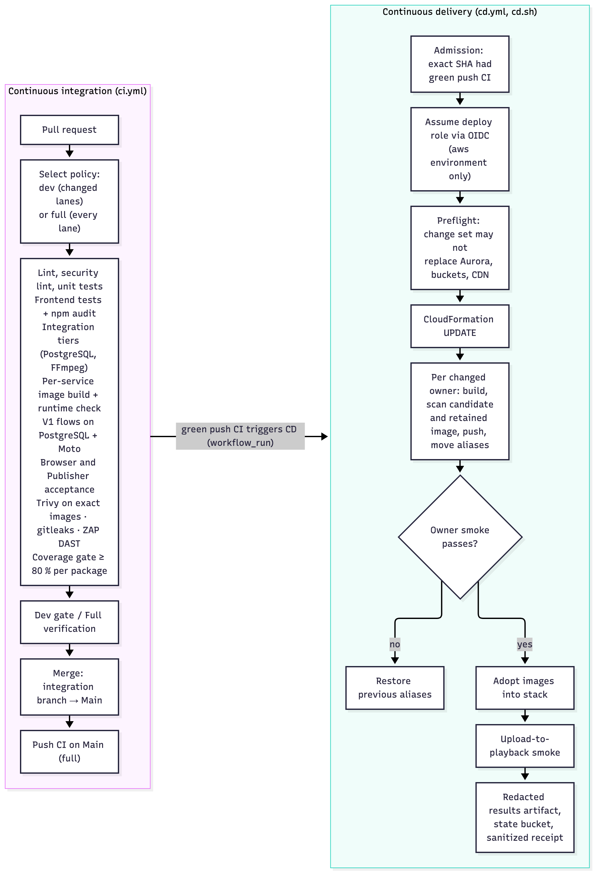
Figure 14. CI/CD pipeline: pull-request lanes, full verification on Main, exact-source admission, in-place stack update, per-owner release with scan, smoke and restore, and the receipts it retains.
Environments.
Environment | Purpose | How it is created
Developer machine | Fast checks; the full local V1 stack on PostgreSQL, Moto and FFmpeg, with the same images | make setup-v1, make v1-up, make v1-demo
CI (ephemeral) | Exact-source verification, image builds and scans, DAST | Every pull request and push
AWS V1 per-run stacks (historical) | The proof runs r1017b, r1018b, r1019a, each deleted afterwards | Dispatched deploy and teardown (AD-19)
AWS dc2-live (production demo) | The one persistent environment, updated in place | First deploy by a human dispatch; then automatically after every green CI run on Main (AD-27)
There is no separate staging environment (AISS-04). Two things stand in for it: the local V1 stack and CI’s exact-image verification exercise the same images before promotion, and every release smoke-tests production with an automatic restore on failure.
Promotion and who approves it.
- Promotion into Main is the approval. The person merging the release PR is the approver; in this project that was the repository owner, Guruprasath Gopal, the cloud and delivery lead.
- After that, promotion to dc2-live is automatic, with no manual gate:
  - CI on Main completes and triggers CD (workflow_run).
  - The admission gate job refuses the commit unless that exact SHA had a successful push CI run in this repository, then retains an admission record.
  - The deploy job assumes the AWS role through OIDC, only from the aws environment.
- Manual dispatch remains available for preflight, deploy, release (including a deliberate bad_candidate), and teardown. teardown requires confirm=live.
- A concurrency group prevents two deliveries running at once.
Deployment steps and verification.
- Preflight (reads only): account and region, stack state, a change set that must not replace Aurora, a bucket or the distribution, and the release journal.
- Stack update: a CloudFormation UPDATE change set from the checked-out template. For the live environment this step also applies the Lambda short-encode lane and the per-service database split (AD-29: snapshot, clone, smoke, then cleanup); run 39644028238 delivered both.
- Per-owner release, only for owners whose image build inputs changed:
  - build the image;
  - scan the candidate, and scan the retained rollback image (AD-28);
  - push it, and bind the registry manifest to the scanned config;
  - run the migration task if attested;
  - publish versions and move the live aliases;
  - run the owner’s health and authentication smoke;
  - restore the previous versions if anything fails;
  - adopt the images into the stack.
- Upload-to-playback smoke: a real clip is uploaded through the public API. The job must reach done, and the MP4, HLS playlist and segment must be playable.
- Receipts: redacted results are uploaded as an artifact. Run state is saved to a private, versioned S3 bucket. Sanitized delivery receipts are then committed (for example docs/results/engineering-20261020/delivery-629119c.json).
Recorded deliveries.
Run | Source | Outcome
39085599276 / 39087966647 / 39089615147 (r1019a) | 0b491e1, 358d169 | V1 deploy with smoke PASS; Processing release 9 m 39 s with post-release smoke PASS; teardown CLEAN
39105817431 | d2070db | First persistent dc2-live deploy; smoke PASS
39271754470 | 7928b7c | Deliberate bad Processing candidate: smoke failed (503) and the previous aliases were restored automatically
39286933644 | daee44b | Deploy of the team-accepted frozen demo release
39416747925 | 629119c | Both owners promoted, deployed-image scans clean, upload-to-playback smoke passed, read-back of 3 images, 10 aliases and the worker definition
39532075705 | 4ae6a0b | Failed: the scan of the retained Media rollback image found 1 fixable HIGH/CRITICAL (see below)
39542434067 | 6155951 | Failed: the stack-level public smoke met a paused Aurora cluster; login answered 503 (see below)
39545554380 | c7c489c | Success: both owners promoted, with the old images’ advisory recorded; zero fixable HIGH/CRITICAL in the deployed images; upload-to-playback smoke PASS, job done in 101.2 s; 3 images, 10 aliases and the worker definition read back (docs/results/engineering-20261021/delivery-c7c489c.json)
The 21 October scan incident. This was the only time the release gate blocked a correct release. The handling shows how the pipeline is meant to be operated.
- Detection. CD run 39532075705, for Main at 4ae6a0b (which bumped certifi for a new advisory), failed in Deploy with media: FAIL: Trivy has 1 fixable HIGH/CRITICAL. The upload-to-playback smoke was skipped. The live environment kept running the previous verified release, 629119c, untouched.
- Root cause, from the run log and the saved reports. The candidate image passed its scan. The failing scan was the rescan of the image running at the time, the rollback baseline (sha256:24bd78a8…, built from 629119c). It carried GHSA-6q48-6c7w-9gw2 in certifi 2026.7.22: emSign root CAs with compromised intermediate keys. The advisory was published on 20 October at 19:35 UTC, after that image shipped. The candidate’s certifi 2026.10.19 fixes it. So the gate refused to replace a vulnerable image because it was vulnerable, and the fix could never ship.
- Fix without weakening the gate (AD-28, PR #285 into dev/closeout, PR #286 into Main). The rules are now:
  - The candidate must still scan clean first.
  - Images that the release keeps are rescanned strictly.
  - Images that the release replaces are rescanned in a retained mode. A fixable finding there becomes RETAINED_FIXABLE: it is listed in the release receipt, annotated on the run and shown in the job summary, and it does not block.
  - Only the baseline role accepts that status. Promotion, publication and the good and bad image sets still require PASS.
  - Scanner errors and wrong-image reports fail in both modes.
  - Tests pin each rule. The real failing report, replayed through the scanner, fails in strict mode and is recorded in retained mode.
- A second, latent defect. With the scan fixed, CD run 39542434067 (6155951) reached the stack-level public smoke and failed with login:503. The update changed no migration, so nothing had touched the database before the smoke. Aurora had auto-paused at 0 ACU. The login is the smoke’s first database-backed call, and it met a cluster that was still resuming: MediaApi gave up after about 10.7 s and answered 503, and capacity read 1.0 ACU moments later. PRs #287 and #288 let the deploy’s smoke retry only the login, only on 502/503/504 or a transport failure, after 5, 10 and 15 s, within a 180 s deadline. Every attempt is recorded. Any other status, or a 503 that outlasts the pauses, still fails. The release smoke, which runs after its migration has woken the database, is not retried.
- Redelivery. CD run 39545554380, on c7c489c and admitted by Main CI 39544952625, succeeded:
  - gate job 7 s; Deploy step, including both owner releases and stack adoption, 22 min 56 s; upload-to-playback smoke 2 min 27 s;
  - the smoke job reached done 101.2 s after acceptance, with MP4 and HLS served;
  - the release receipts list the certifi advisory against the three replaced images;
  - read-back confirmed the deployed digests: Media sha256:dafbb19d…, Processing sha256:3c83e4ba… and worker sha256:eed6fbbb…, with the ten live aliases and dc2-live-worker:12 matching.
- The receipt is docs/results/engineering-20261021/delivery-c7c489c.json. The documentation follow-up (#289, #290) redeployed with no releases, and its smoke passed in 116.1 s. Two things remain unexercised: the wake retry did not fire in the live run, and the replaced image’s rollback was not run. The receipt records both.
A scheduled weekly rescan of retained images would surface such advisories before a release meets them.

Other Things to Be Highlighted

What Team 17 Contributed beyond the Inherited Baseline
Project 2 did not add product features to FlickPond. It changed how FlickPond is built, deployed and reused. The contribution, measured against the inherited baseline:
- A domain-driven split into two bounded contexts. Each has an aggregate with invariants enforced by constraints and code, its own database and roles, and its own image, IAM roles, CI lane and release unit (sections 3.1.3 and 3.1.4).
- An asynchronous, failure-isolated integration: outbox, SQS and inbox in both directions, version-fenced projections and SQL-driven repair. Media keeps working while Processing is unavailable (section 4.2).
- A second client built only against the published contract, proving reuse (section 4.4).
- A cloud-native runtime that costs almost nothing idle. No servers, no NAT, Aurora at 0 ACU, and encoders that exist only while there is work (section 3.2).
- A delivery pipeline that releases one owner at a time from immutable, scanned images, and restores itself on a failed smoke test (section 5).
- An evidence discipline. Every claim in this report links to a test, a CI run or a sanitized cloud receipt labelled with its environment and source. Misses and not-run items are kept.

Lessons Learned
- Design for the transport you actually have. The proposal assumed synchronous HTTP between the services. Once both ran as Lambdas with no private network, a transactional outbox and inbox became necessary, not optional. Adopting them early (AD-11) avoided a dual-write class of bugs.
- “Scale to zero” moves cost into latency. Scale-to-zero made the platform cheap to keep running, which is why V2-live replaced booked sessions (AD-27). The same choice is the main cause of the 37-second queue-wait miss. Both effects are measured and reported.
- Idle is a behaviour that needs testing. Aurora never paused at first, because cleanup rescans woke it every few minutes. #273 added activity markers and backoff, and a CloudWatch reading of 0 ACU confirmed it.
- Pipelines need tests too. Two CD script bugs (#265, #267) and one workflow-startup error (#281) stopped deployments partway. All were fixed with tests and actionlint. Formatting once changed a released migration’s bytes, so Media’s release was held (#282); migrations are now excluded from formatting and guarded.
- At-least-once delivery means duplicates in practice. A burst produced stale duplicate work messages that broke a smoke test (#270). The fix drains them, and the re-test still recorded 18 sends for 9 jobs. The design tolerates duplicates; it does not pretend to remove them.
- Security gates must work in both time directions. On 21 October a newly published advisory affected the retained rollback image, and the gate blocked the very release that remediated it. AD-28 keeps both scans and handles that case explicitly instead of weakening the gate (section 5.3).
- A fix can uncover the next defect. Once the scan gate let the remediation through, the deploy smoke met a database that had paused since the last release, and login returned 503. The smoke now waits for a waking database for one call only, with every attempt recorded, instead of being retried wholesale.
- Keep misses visible. Two-worker scaling (1.449× against 1.6×), Processing release time (10.1–10.3 min against 10 min) and queue wait (37 s against 20 s on the standard lane; 0.26 s on the Lambda short lane, with end-to-end latency still above 20 s) are reported as measured. The targets were not changed after the fact.

Responsibilities for Use Cases and Design Problems
Each member led one specialism and reviewed the other two. For the presentation and assessment, each use case and design problem has a responsible member who explains it and answers questions on it. The allocation follows the team-agreed specialisms (effort ledger, PR #279).
Member | Specialism | Use cases | Design problem (section 7.3)
Guruprasath Gopal | Cloud and delivery: AWS, CI/CD | UC-6, UC-7 | DP-1 Bounded cloud capacity and safe per-owner release
Ibrahim Mammadov | Backend services: Processing and Media | UC-1, UC-2, UC-4 | DP-2 Durable asynchronous Processing handoff
Nguyễn Kim Long | Domain, contracts and verification | UC-3, UC-5 | DP-3 Trusted owner identity and reusable public contract

Evidence and How to Reproduce It
Evidence | Location
Architecture: ADR register, DDD model, views, use-case catalogue | docs/architecture/decisions.md, ddd.md, views.md, use-case-design.md
Results against targets (table, CSV, figure) | docs/results/actual-vs-target.md; regenerate with python scripts/dev/results_summary.py
Scenario-by-scenario evidence index | docs/evidence-index.md
Cloud receipts (sanitized) | docs/execution/aws/v1/evidence/, docs/results/engineering-20261020/, docs/results/engineering-20261021/
Release identity and freeze | docs/release/demo-release-manifest.md, docs/release/engineering-handoff.md
Runbooks | docs/execution/aws/v1/deploy-runbook.md, dlq-runbook.md
Study guide (public) | https://collaboration95.github.io/dc2/
Run locally | make setup-v1, make v1-up V1_RUN_ID=demo1, make v1-demo V1_RUN_ID=demo1 OPEN=1
Tests | make lint, make format-check, make test; frontend cd frontend && npm ci && npm test
Live environment (until teardown after 16 Nov 2026) | Frontend https://d1e1dpefd6hp9x.cloudfront.net; API https://nqxf2hclhi.execute-api.ap-southeast-1.amazonaws.com
This report’s sources | project-documentation/final-report/ (Markdown sources, figures, build script)

AI Tool Declaration
The team used AI coding and writing assistants (Anthropic Claude models through Claude Code, and OpenAI GPT models for independent review) during the project:
- generating and refactoring code and tests under the team’s direction;
- reviewing pull requests;
- drafting and proof-reading documentation, including this report;
- producing diagrams;
- running and recording verification steps.
Every result in this report comes from a retained test, CI run or cloud receipt, not from an AI statement. The team is responsible for the content and the quality of the submitted work.

Appendices

Use-Case Specifications and Traceability
Each specification is condensed from the use-case catalogue (docs/architecture/use-case-design.md), which links every test named here to its exact assertion. The personas are fictional planning personas (section 1.3).
UC-1 Register, log in and upload an owned video (Maya or Arun; web app or Publisher CLI)
- Pre: the account exists or is created; the caller owns a supported video of at most 100 MiB.
- Normal: authenticate; Media reserves an owner-scoped S3 grant; the client uploads directly to versioned S3; finalize verifies the bytes and pins the VersionId, then atomically adopts the Asset and stages submit; the API returns 202 with the asset and job ID.
- Exceptions: refused when the caller is anonymous, the type is unsupported, the declared size is too large, the owner is wrong, the request changed or the reservation expired. Missing, truncated, changed or unversioned bytes are not adopted and enqueue no work; a missing object returns a recoverable 409.
- Post: one owned Asset, an immutable verified source and one durable command. A replay returns the same Asset without a second command.
UC-2 Process the video into playable outputs (platform worker, asynchronous)
- Pre: UC-1 committed a valid source and command.
- Normal: consume the command; create Job and Attempt; launch an encoder within the cap; claim under a DB-clock lease and task binding; verify the pinned source; encode the MP4 and the optional HLS ladder; commit the terminal state and result before acknowledging the work; update Media’s projection.
- Exceptions: duplicates and reordering are fenced. A dependency, FFmpeg or deadline failure becomes a visible failed. An expired lease does not re-queue automatically. An HLS failure keeps the MP4. Poison messages follow the DLQ policy.
- Post: on success, exactly one primary output and optional HLS, scoped to the job and attempt. A failure is visible.
UC-3 Track status and play the result (owner; browser or CLI)
- Pre: the caller is authenticated and owns the Asset.
- Normal: Media reads the owner-filtered Asset and its local projection, and returns the status. When the job is done, it also returns a short-lived signed MP4 capability. The HLS playlist is served through Media, and segments redirect to signed S3 URLs.
- Exceptions: foreign and unknown IDs return not found. Stale results cannot replace a newer projection. An expired URL needs a fresh authorized read.
- Post: owner-only status and expiring playback access; no domain mutation.
UC-4 Retry from the stored source (owner; web or CLI)
- Pre: the caller owns a failed job whose accepted source remains available.
- Normal: a bodyless retry with an idempotency key. Media checks the owner, the failed projection and the pinned source. Processing serializes on the SubmissionGuard and creates a new Attempt. A replay returns that attempt. No bytes are uploaded again.
- Exceptions: a foreign or deleted job returns not found. A non-failed state or a changed request conflicts. A stale old-attempt worker or result cannot overwrite the current attempt.
- Post: the source identity is unchanged and one new Attempt is queued.
UC-5 Bulk-publish a folder and report results (Maya through Publisher; Jules as integrator)
- Pre: credentials and a folder of owner-held videos.
- Normal: authenticate; submit each eligible file through the published API; continue through the batch; report one outcome and job reference per file. status, output and retry share the public contract.
- Exceptions: one refused file does not hide later successes. Transport uncertainty preserves accepted IDs and request keys. Sensitive server error text is withheld.
- Post: per-file outcomes survive. Any failure makes the batch exit non-zero without losing successful references.
UC-6 Scale processing capacity independently (Sam, operator)
- Pre: a durable Processing backlog; Media is deployed independently.
- Normal: in V2-live, work sends wake the launcher, with a one-minute schedule as fallback. The launcher checks SQL and visible SQS demand, reserves slots and starts finite Fargate tasks, up to three. In V1, the operator started batches of 1 to 3.
- Exceptions: no visible work means no launch. An ambiguous RunTask reply keeps its reservation until resolved. An uncertain inventory fails closed. Excess work stays queued.
- Post: Processing capacity varied without any change to Media; concurrent triggers stayed within three slots.
UC-7 Release Processing on its own and demonstrate rollback (Sam through CD)
- Pre: the candidate has green required CI, an immutable and scanned image, migration evidence and a retained previous image.
- Normal: green Main CI updates the stack, and only changed owners release. The release validates the candidate, moves that owner’s aliases and task definition, runs the smoke test and adopts the release. Media is unchanged.
- Exceptions: a failed gate stops promotion. A failed smoke restores the previous image. A failed restore leaves a durable recovery intent. Migrations are never reversed automatically.
- Post: success records the owner image and the smoke result; failure records the restore.
Traceability matrix. Analysis objects come from the shared analysis class model (Figure 16). Design classes come from the implemented design class model (Figure 15).
UC | Analysis objects | Design classes and modules | Sequence views | Key tests | Responsible
UC-1 | Owner, UploadRequest, OwnedAsset | User, UploadReservation, Asset, SourceVersion, Envelope; media/services/direct_intake.py, storage.py, media/messaging.py | Figs 5, 17 | test_publisher_direct_post_encode_projection_and_ownership, test_finalize_pins_the_exact_version_it_verified, test_wrong_owner_cannot_finalize_or_observe_a_reservation, test_missing_object_is_retryable_not_adopted | Ibrahim
UC-2 | ProcessingJob, ProcessingAttempt, PlayableOutput | Job, Attempt, SubmissionGuard, AttemptTask, Output, Source; processing/messaging.py, lifecycle.py, worker/tasks.py, media_engine/ | Figs 6, 17 | test_success_output_namespace_validation_and_atomic_terminal_result, test_a_failing_ladder_leaves_the_mp4_and_reports_no_ladder | Ibrahim
UC-3 | Owner, OwnedAsset, PlayableOutput | ProcessingProjection, Actor; media/projections.py, media/api/v1_hls.py, storage.sign_output | Figs 7, 17 | test_local_status_hls_and_signed_range_capability, test_wrong_owner_source_job_and_output_rejected, test_exported_handler_reads_owned_projection_without_peer | Long
UC-4 | ProcessingJob, ProcessingAttempt | RetryRequest, Attempt, SubmissionGuard, RequestKey; media/services/v1_lifecycle.py:retry, processing/messaging.py:_retry_locked | Fig 18; section 3.2.4 case 2 | test_publisher_retry_reuses_the_stored_source_after_a_transient_encode_failure, test_retry_idempotency_and_cancel_fence_old_and_current_attempts, test_retry_and_cancel_are_commands | Ibrahim
UC-5 | IntegrationBatch, UploadRequest | Publisher cli.py, client.py, state.py; OpenAPI documents in docs/api/ | Fig 18 | test_cli_mixed_batch_keeps_every_file_outcome, test_module_entry_and_import_boundary, test_public_schema_conformance_and_explicit_ca | Long
UC-6 | Operator, ProcessingCapacity | LauncherControl, LaunchReservation, AttemptTask; processing/launcher.py, launcher_trigger.py | Figs 6, 19 | test_always_on_concurrent_wakes_never_exceed_the_cap_without_a_session_end, test_a_backlog_of_ten_launches_at_most_three_and_later_ticks_add_none, test_a_lost_runtask_response_is_resolved_by_token_without_a_second_launch | Guruprasath
UC-7 | Operator, ReleaseCandidate | Planner, Journal, CLITransport; scripts/aws/v1/release.py, deploy.py, scripts/ci/cd.sh | Fig 19; section 3.2.4 case 3 | test_owner_release_applies_a_real_migration_and_failed_candidate_restores_aliases, test_pending_intent_before_mutation_and_real_bad_candidate_restore, test_owners_are_released_only_when_their_images_build_inputs_changed | Guruprasath

Analysis and Design Models
Transition from analysis to design. Each analysis responsibility became a design structure (static change) and an interaction protocol (dynamic change). The table records the affected use cases and the rationale.
Analysis responsibility | Affected UCs | Static design (classes, data) | Dynamic design (interactions) | Rationale
Owner submits an asset and follows its job | UC-1, UC-3 | Media owns User, Asset, UploadReservation, SourceVersion and a local ProcessingProjection; Processing owns Job and Attempt; UUIDs, not foreign keys, cross the boundary | Reserve → direct upload → finalize; result snapshots update the projection | Two logical databases with their own roles; no runtime dependency between the services
Owner identity and authorization | UC-1, UC-3, UC-4, UC-5 | Actor value type; Media authorizer; Gateway adapter | The authorizer reads the current user row per request; the adapter strips caller headers | No shared JWT secret and no caller-controlled owner header at Processing
Upload bytes and source identity | UC-1, UC-5 | UploadReservation with a pin check constraint; Source descriptor | Presigned POST to S3; verify outside SQL locks; adopt in one transaction | Bytes never pass through Lambda; the verified source cannot be replaced
Cross-context asynchronous work | UC-1, UC-2, UC-4 | message_outbox, message_inbox in each database; Envelope v1 | Stage in the domain transaction; publish after commit; consumer commits inbox and state before ACK | SQL and SQS are not one atomic resource; at-least-once delivery is absorbed
Retry, worker failure and output | UC-2, UC-4 | RetryRequest, AttemptTask, lease columns, Output | A new attempt per retry; DB-clock leases fence old workers | No duplicate terminal writes; no hidden automatic requeue
Operator capacity and release | UC-6, UC-7 | LauncherControl, LaunchReservation; release journal and pending intent | SQL-reserved RunTask with a stable token; per-owner alias move, smoke and restore | Capacity and code change independently; bounded cost
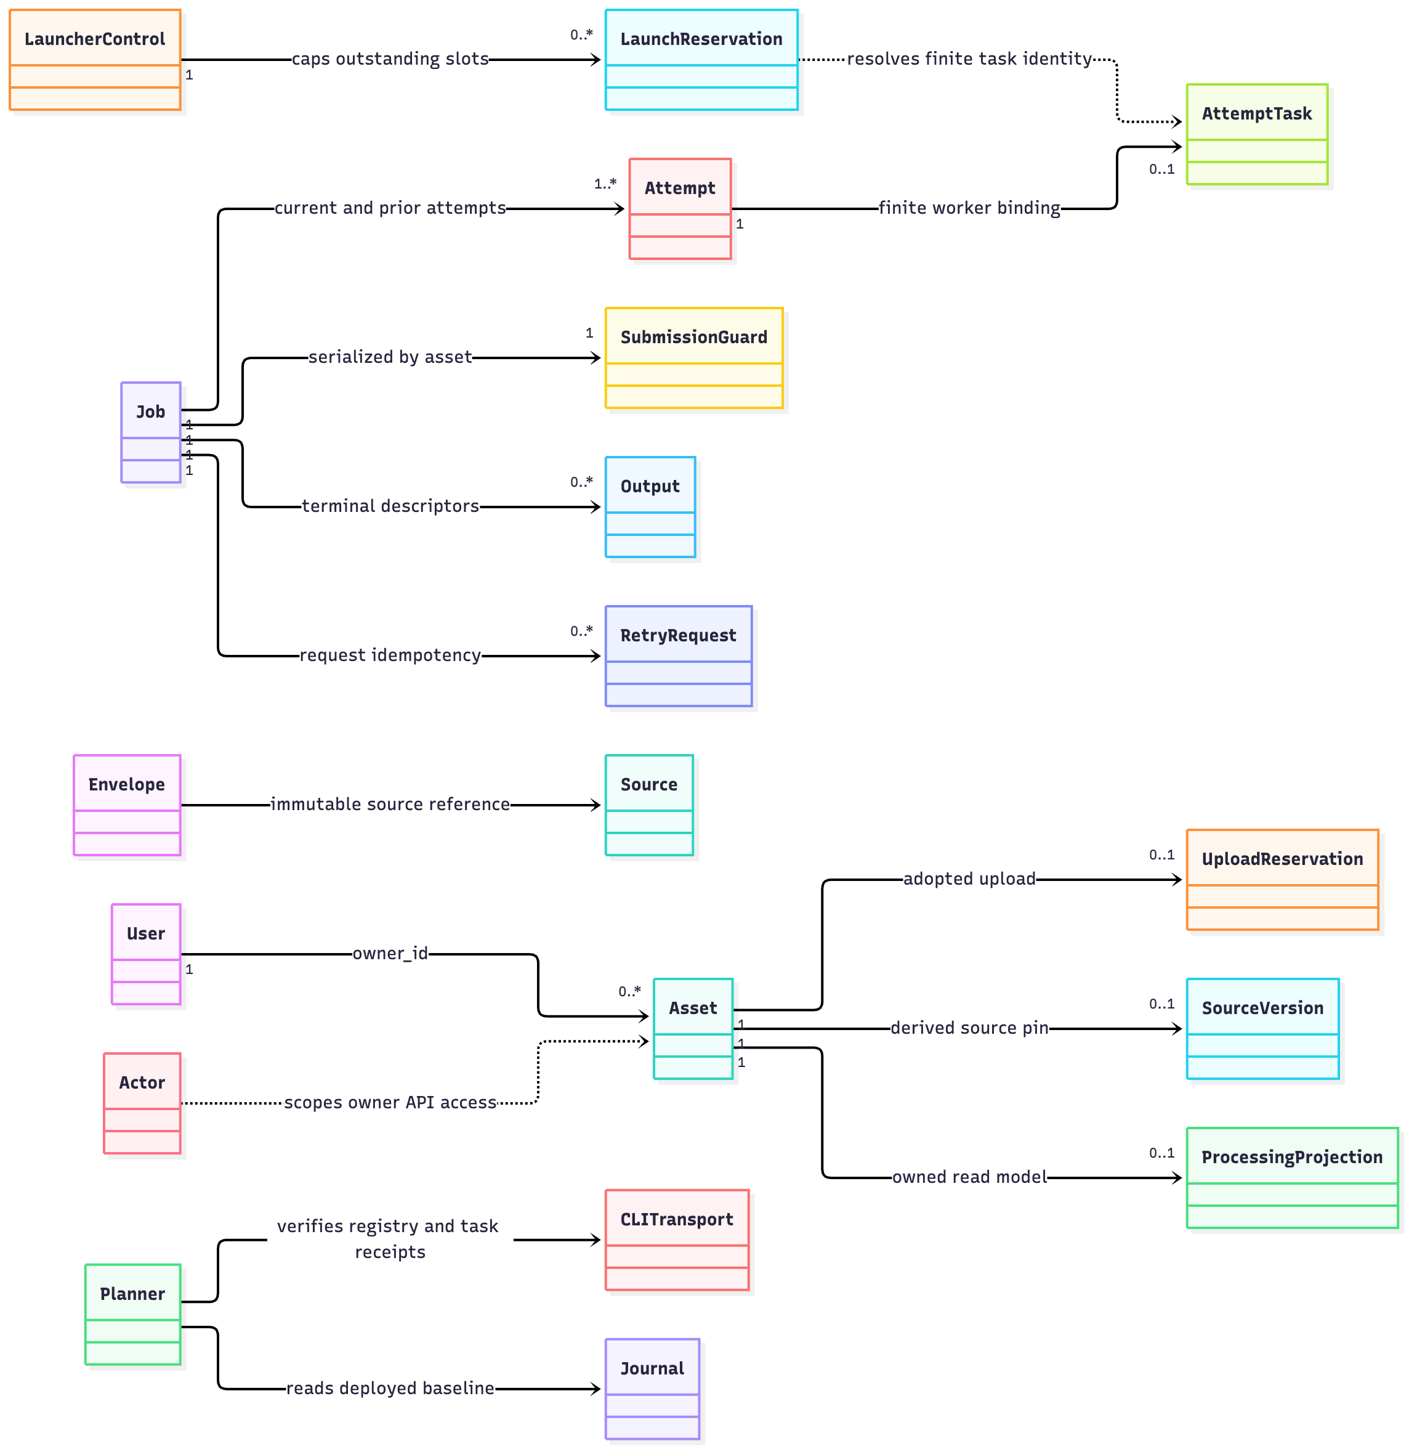
Figure 15. Common implemented design class model for UC-1 to UC-7 (domain, contract and operator-tool types).

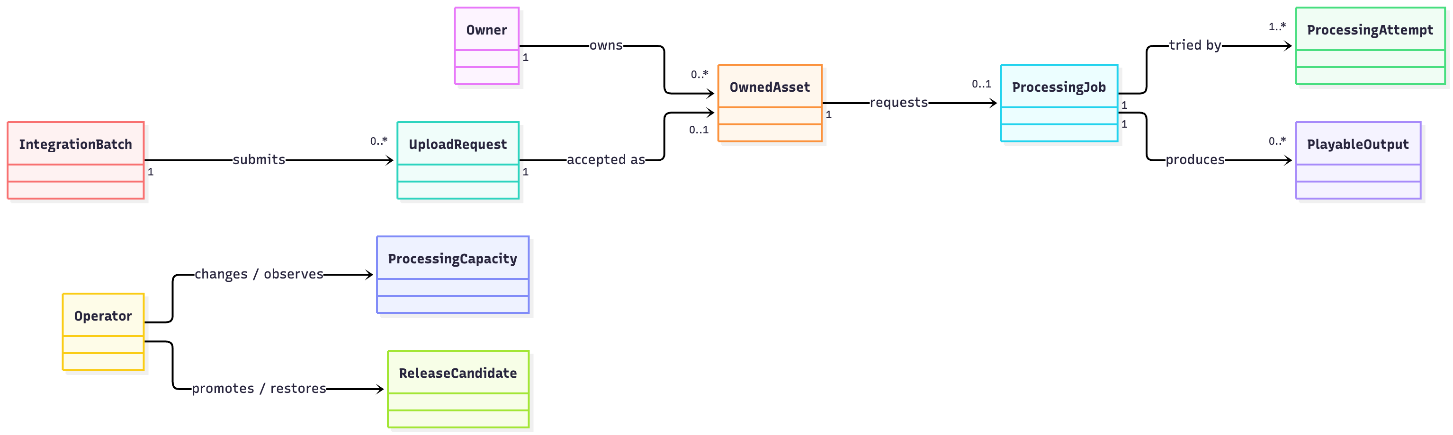
Figure 16. Shared analysis class model (conceptual objects only).
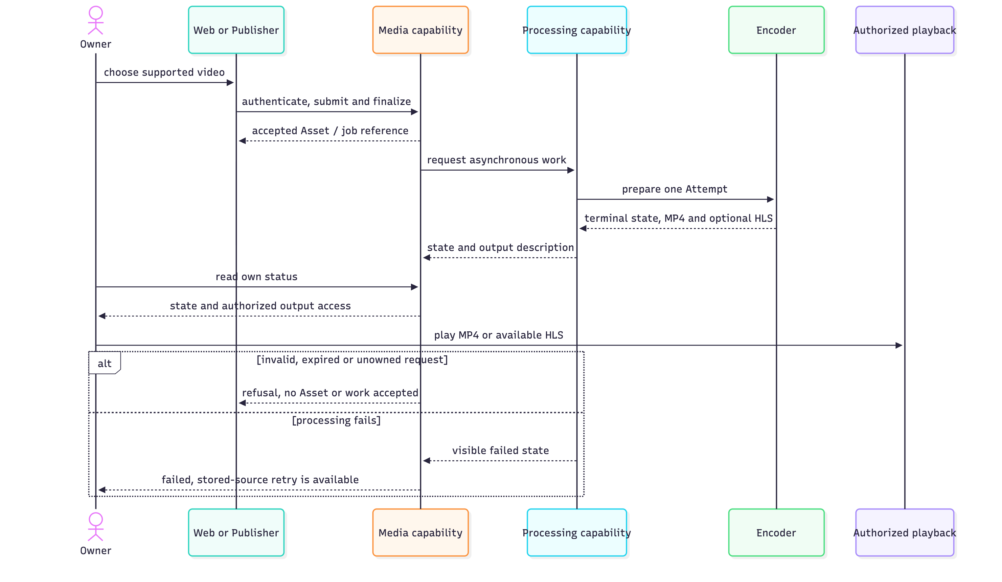
Figure 17. Analysis sequence, UC-1 to UC-3: the core workflow.
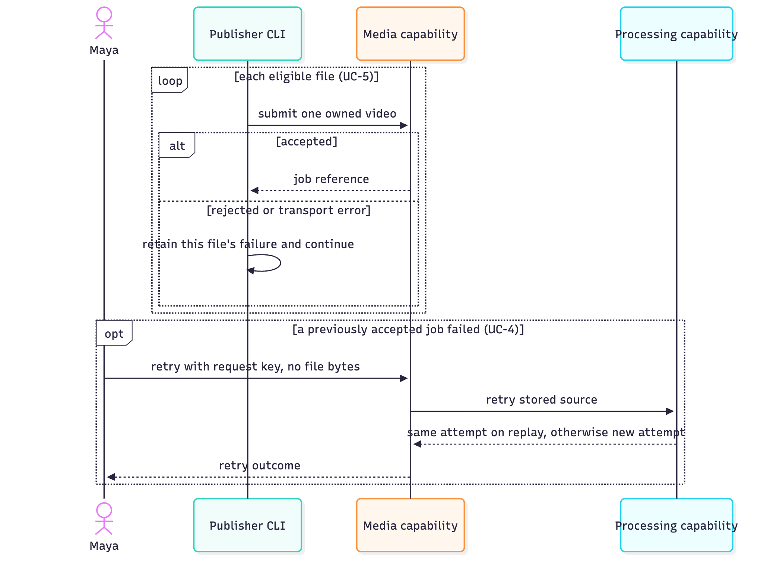
Figure 18. Analysis sequence, UC-4 and UC-5: stored-source retry and Publisher integration.
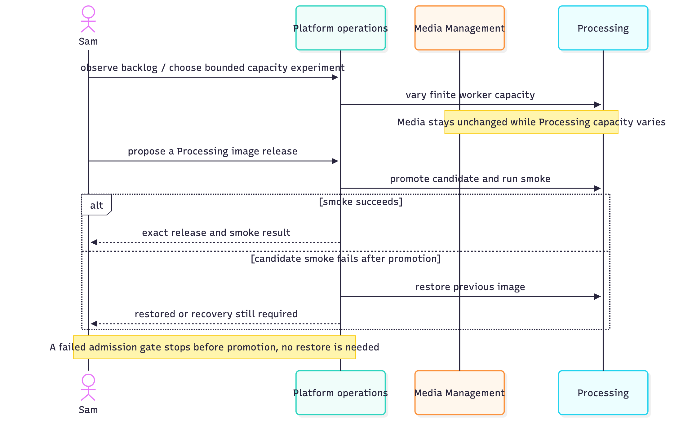
Figure 19. Analysis sequence, UC-6 and UC-7: capacity and release.

The implemented (design-level) sequences for the same three groups name every Lambda, queue and table. They are too wide to print legibly. They are kept as source in the catalogue and rendered in docs/architecture/use-case-design.md. The compact design sequences in Figures 5–7 cover the core workflow.

Design Problems
The three significant design problems are listed below. Each one covers the problem, the alternatives, the decision, a before-and-after view, the resulting behaviour and the evidence. The “before” is the submitted proposal design or the V1 operating mode. These are as-built design decisions, not claims that a named GoF pattern was chosen. They do use well-known architectural patterns: transactional outbox and inbox, anti-corruption layer, and lease-based fencing.

DP-1 Bounded cloud capacity and safe per-owner release (Guruprasath Gopal)
- Problem. The environment must be usable at any time while idle cost and the blast radius of a release stay small. Processing must change without releasing Media. An ambiguous cloud response must never create extra workers, or falsely report a successful rollback.
- Alternatives.
  - Keep per-run stacks and booked sessions: slow, at about 25 minutes to deploy and 25–40 minutes to tear down.
  - Keep one long-open session: a booking under another name.
  - Release all code with a full stack update: couples the domains.
  - Use mutable image tags: loses the tested identity.
  - Add a separate staging environment: out of scope for the time available.
- Decision. AD-27 with AD-16. One persistent stack is updated after green Main CI. Only owners whose image inputs changed are released, by immutable digest, with a smoke test and automatic restore. A SQL-backed launcher reserves at most three encoder slots, and a stable RunTask token survives lost replies.
- Behaviour. A failed preflight or smoke is never counted as a promotion. A journal lock and a pending_release intent precede any mutation. The previous image is retained for restore and, under AD-28, is scanned before promotion.
- Evidence. The tests named under UC-6 and UC-7 (section 7.1). [AWS]: 0 → 3 → 0 scaling, the 9-clip backlog, and the bad-candidate restore in run 39271754470.
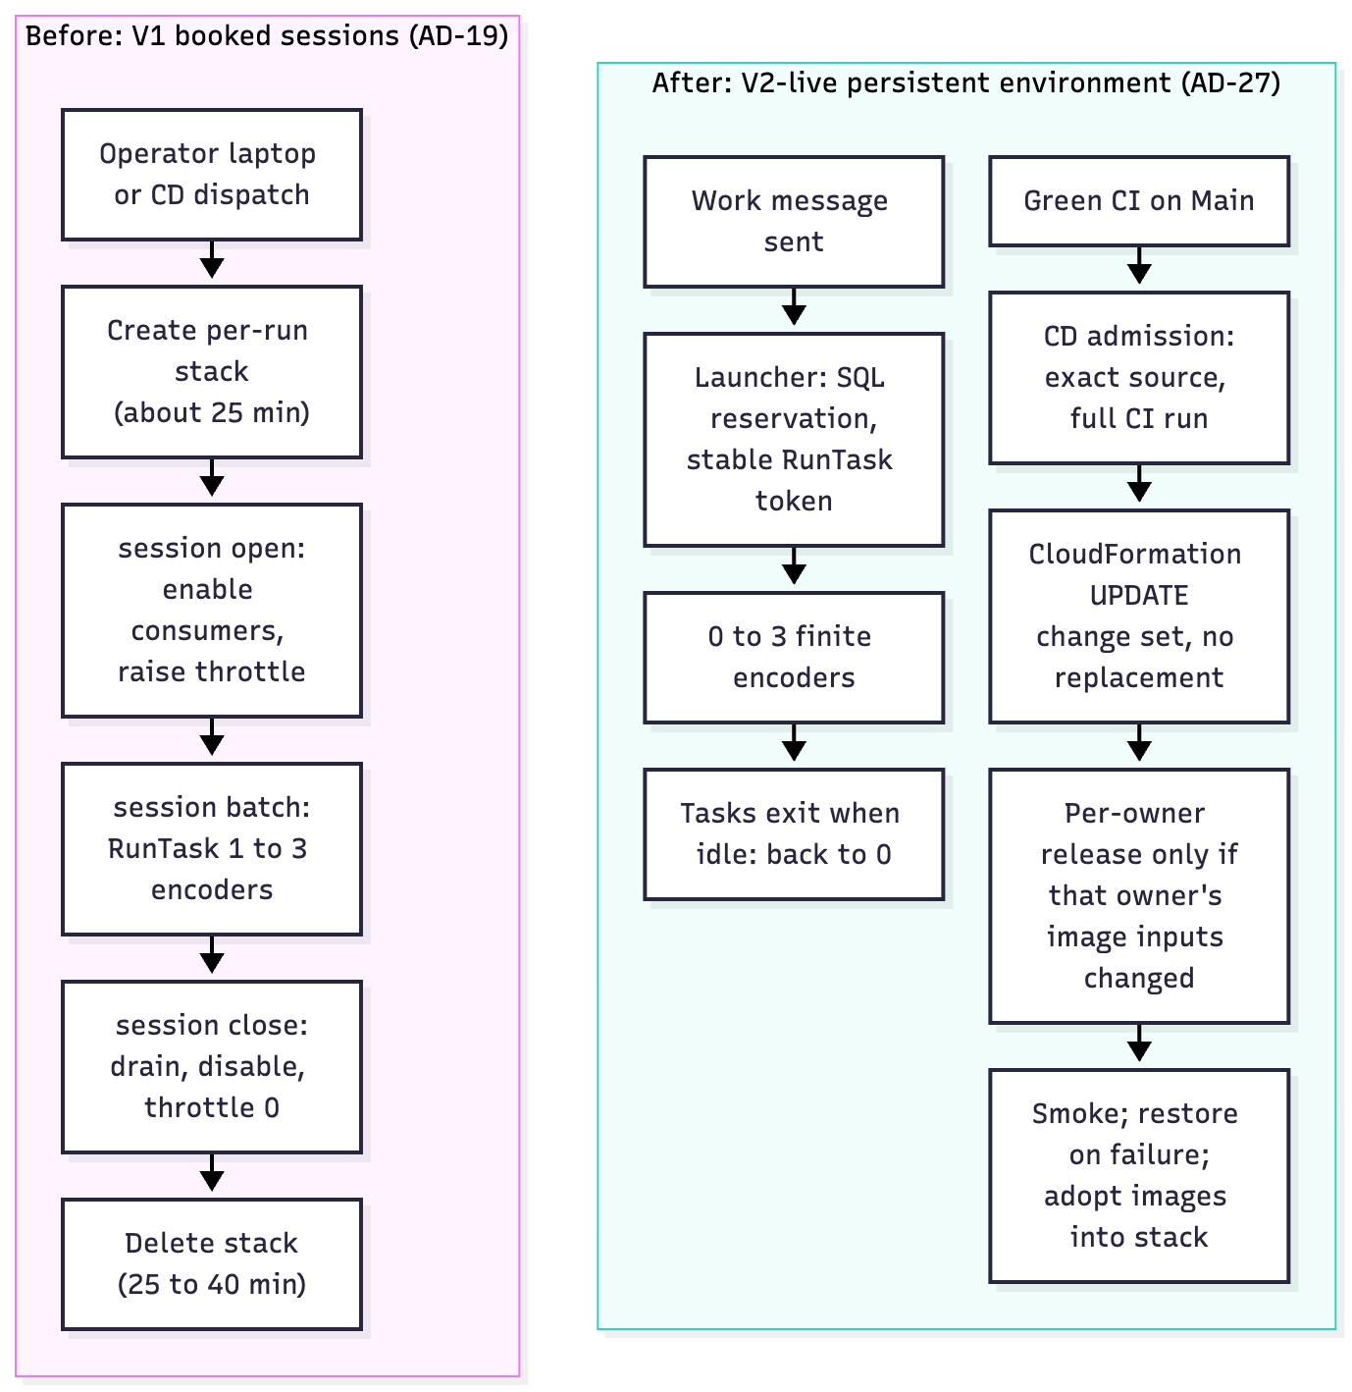
Figure 20. DP-1 before and after: booked per-run sessions (left) and the persistent, automatically updated environment with SQL-reserved finite encoders (right).

DP-2 Durable asynchronous Processing handoff (Ibrahim Mammadov)
- Problem. An upload must stay accepted if Processing or SQS is temporarily unavailable. No Job may exist without a durable command, and no work may be published before its state commits.
- Alternatives.
  - Keep peer HTTP with Redis/RQ: couples availability, and needs an always-on broker.
  - Perform an unprotected SQL-plus-SQS dual write from the API: can lose or orphan messages.
  - Add another broker or a workflow service: more operations.
- Decision. AD-11 with AD-21: a transactional outbox and inbox in each database, SQS between them, and a version-fenced projection in Media.
- Behaviour.
  - The Media API role cannot send to SQS; a repair publisher claims rows and releases SQL locks before network I/O.
  - Duplicates are possible. Consumers commit inbox, state and follow-on outbox rows before ACK.
  - Reordering is handled by state_version, attempt, guard and lease fences.
  - repair_work rebuilds missing queue entries from SQL.
- Evidence. test_messaging_sql.py: lost-send replay, an SQS-emulator end-to-end run, and stale-attempt fencing [Local]. [AWS]: the Processing-down isolation run, and the DLQ poison message.
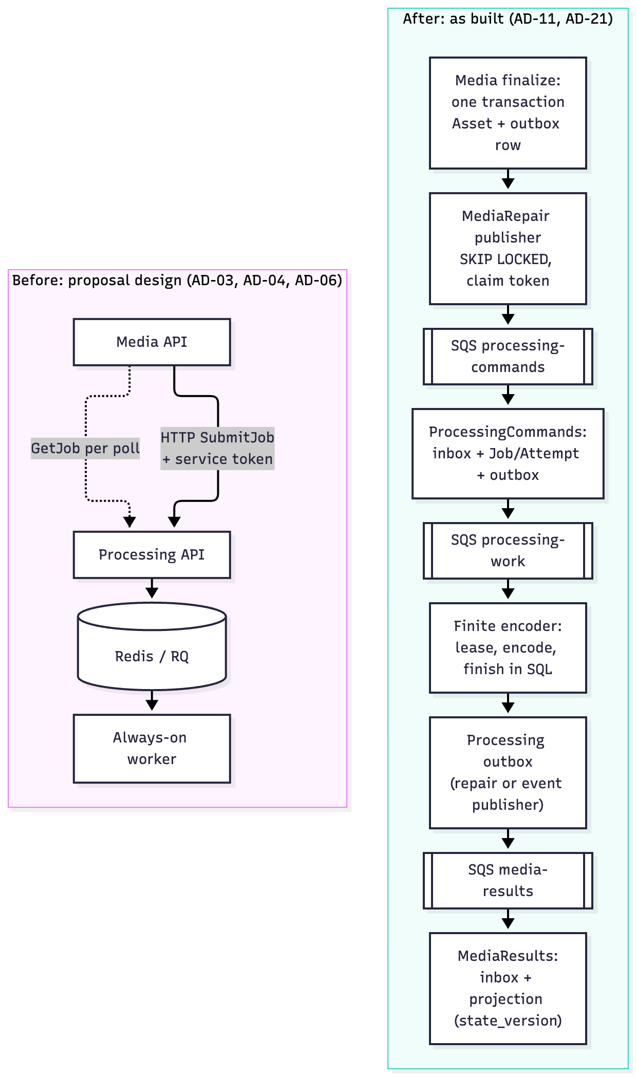
Figure 21. DP-2 before and after: synchronous SubmitJob with Redis/RQ (left) and the outbox → SQS → inbox chain with Media’s projection (right).

DP-3 Trusted owner identity and reusable public contract (Nguyễn Kim Long)
- Problem. An independent client (Jules) and Processing need the same owner decision. Neither may trust a caller-supplied owner header, and Processing must not get Media’s JWT secret or user table.
- Alternatives.
  - Trust X-Owner-Id/X-Role headers.
  - Give the JWT secret and user lookup to both services.
  - Create a separate identity provider or service.
- Decision. AD-09 with AD-20 and AD-24. A Media-owned authorizer passes a validated Actor. The Gateway adapter strips the public identity headers, and Processing filters by the trusted owner. IAM and queue policies, not the envelope schema, establish producer and consumer authority. The OpenAPI and contracts/ documents are versioned, so a client like Publisher needs no service imports or credentials.
- Behaviour. Forged headers change nothing; a foreign job returns 404; direct queue sends are refused.
- Evidence. test_local_gateway.py (forged-header and anonymous-denial tests), test_contract_fixtures.py (trusted owner propagation) and the Publisher import-boundary test [Local]. [AWS]: forged-identity, anonymous-denied, sqs-direct-send, and the #229 cross-owner negatives.
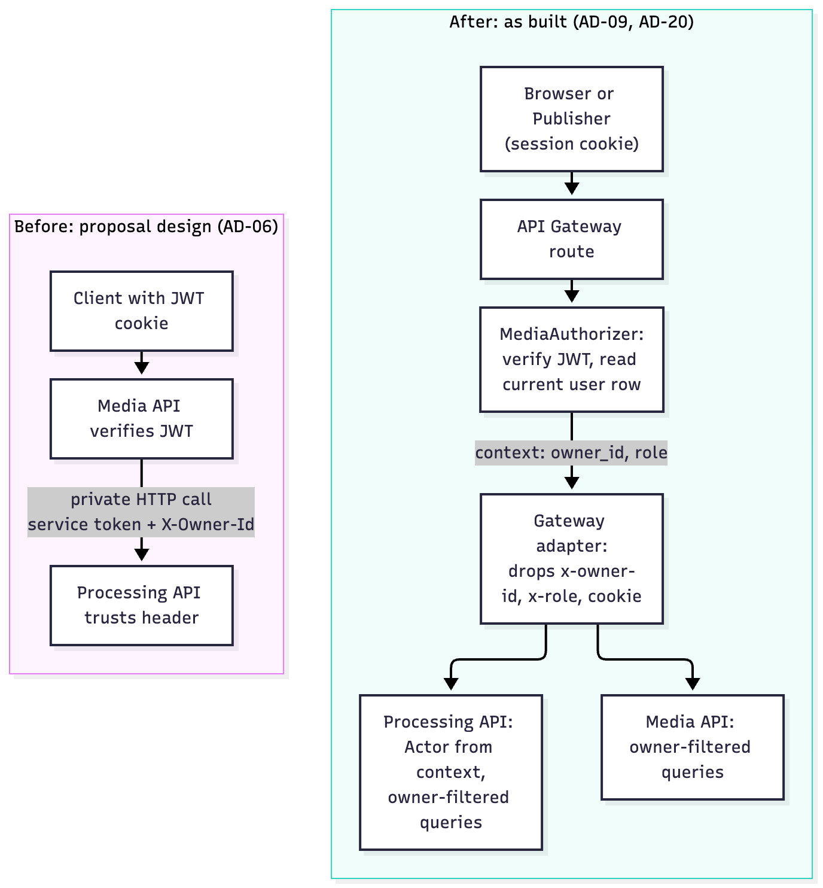
Figure 22. DP-3 before and after: service token with a forwarded owner header (left) and the Gateway-trusted actor from the Media authorizer (right).

Glossary
Term | Meaning
ACU | Aurora capacity unit; Serverless v2 scales between 0 and 2 ACU here
ADR / AD-nn | Architecture decision record and its identifier in docs/architecture/decisions.md
AISS-nn | Outstanding architectural issue (section 3.4)
Attempt | One numbered try at a job; never reused
CD / CI | Continuous delivery / continuous integration (GitHub Actions)
dc2-live | The persistent V2-live AWS environment (stack name)
DLQ | Dead-letter queue: receives a message after five failed receives
Inbox / outbox | Per-database tables that deduplicate received messages / stage outgoing messages in the same transaction as the state change
Lease | A worker’s time-limited right to finish an attempt, judged on the database clock
OIDC | OpenID Connect: lets GitHub Actions assume an AWS role without stored keys
Projection | Media’s own read model of Processing state, fenced by state_version
Release (per owner) | Moving one service’s Lambda aliases and task definition to a new image digest, with smoke and restore
Seed / producer / consumer | The platform’s core asset (an owned video and its job) / who submits it / who uses the result
V1 / V2-live | Per-run booked-session stacks (to 18 Oct) / one persistent environment (from 18 Oct, AD-27)
VersionId | The S3 object version that pins an accepted source

