FlickPond: A Reusable Cloud Media Processing Platform
Project Proposal — SWE5001 Architecting Scalable Systems Practice Module (SE34FT, Sep–Nov 2026)
Project title | FlickPond: A Reusable Cloud Media Processing Platform
Project sponsor | Team-proposed project (no external sponsor)
Team | Team 17
Project members | Guruprasath Gopal · Ibrahim Mammadov · Nguyễn Kim Long
Submission date | 4 October 2026
Team 17 combines members from two Project 1 teams. Prof Boon Kui Heng approved the three-member team on 22 September 2026. He also accepted that we reuse FlickPond, the Project 1 system built by Ibrahim’s original team, and that search, moderation and analytics stay outside Project 2.

1 Overview

1.1 Context
FlickPond is a video application built in Project 1. Users register, upload their own videos, and FlickPond converts each upload into MP4 and adaptive HLS streams (360p, 480p and 720p) with FFmpeg workers. Owners then follow the job status and play the result through a signed, owner-checked link. The system runs on FastAPI, PostgreSQL, Redis with RQ, MinIO object storage, nginx and a browser frontend, deployed with TLS on a single cloud virtual machine.
FlickPond works, but it is built as one application. A single API handles identity, uploads, jobs and playback. The API, the workers and the recovery task share the same job models and one database, and the jobs table has a foreign key to the users table. Another product cannot reuse the video workflow without importing FlickPond’s code or reading its database.
Project 2 uses the frozen Project 1 code as its baseline: repository Flickpond/Media_player, commit 890c5ec. We do not depend on any future Project 1 feature work.

1.2 Business problem
Small content teams such as training providers, course teams, small studios and community publishers keep needing the same video capabilities:
- secure upload of owned videos,
- conversion into formats that play well on any device,
- visibility of processing progress and failures,
- playback restricted to authorised viewers.
Today each application rebuilds these capabilities, or copies and modifies another team’s code. This duplicates work and leads to inconsistent security and operations. There is also a capacity problem: video transcoding is CPU-heavy and bursty. When it shares a deployment unit with the user-facing API, a backlog of uploads competes with logins and status checks.

1.3 What the platform provides
We will turn FlickPond into a media processing platform. Applications will use one documented API for the full workflow: upload, process, track and play. They will not need to know how storage, queues or FFmpeg work. The platform offers three benefits:
- Reuse. A new application gets authenticated upload, processing, status and authorised playback by calling the published API. It needs no copied code and no database access.
- Independent capacity. Processing is its own service, so operators can add or remove workers to match the backlog without scaling or redeploying the user-facing API.
- Repeatable, secure releases. Every change passes automated tests and security gates. Each service is then deployed separately from versioned images and checked by an automated end-to-end smoke test.
We will demonstrate reuse with two applications. The first is the existing FlickPond web app. The second is a new Publisher CLI, a command-line tool that a course team could use to bulk-publish lecture recordings.

1.4 What is new in Project 2
Area | Inherited from Project 1 | New in Project 2
Service structure | One API; workers and recovery task share its job code | Separate Media Management and Processing services, found through domain analysis and connected by an authenticated contract
Data ownership | One shared database; jobs reference the users table | Each service owns its data and migrations, enforced with separate database roles; services share identifiers, not tables
Reuse | One browser application | Second, independent client (Publisher CLI) that uses only the published API
Security | Login, owner checks, TLS, signed output links, CI scans | Service-to-service authentication, owner checks inside Processing, least-privilege storage access through presigned URLs, and boundary security tests
Delivery | Tests and scans in CI; manual, operator-driven deployment | Scripted per-service deployment of versioned images, health checks and an automated upload-to-playback smoke test
Evidence | Load tests that mainly read one completed video | New experiments: processing throughput with 1, 2 and 3 workers, recovery from failures, API latency after the split, and integration effort for a new client
FFmpeg processing, HLS output, worker replicas and the basic CI workflow are inherited capabilities. We will reuse them but do not claim them as Project 2 contributions.

2 General Architecture

2.1 Platform context
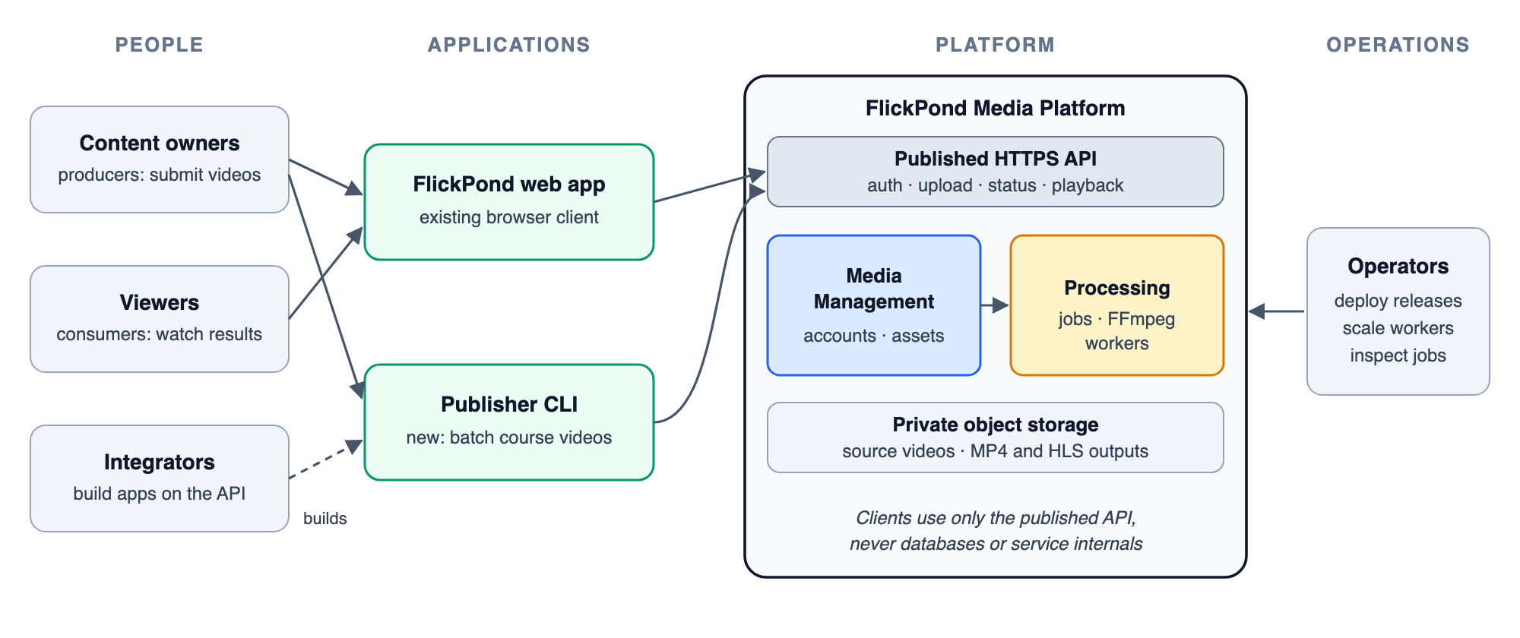
Figure 1. Who uses the platform. Applications use only the published API. Operators deploy releases and scale processing.

2.2 From one application to two services
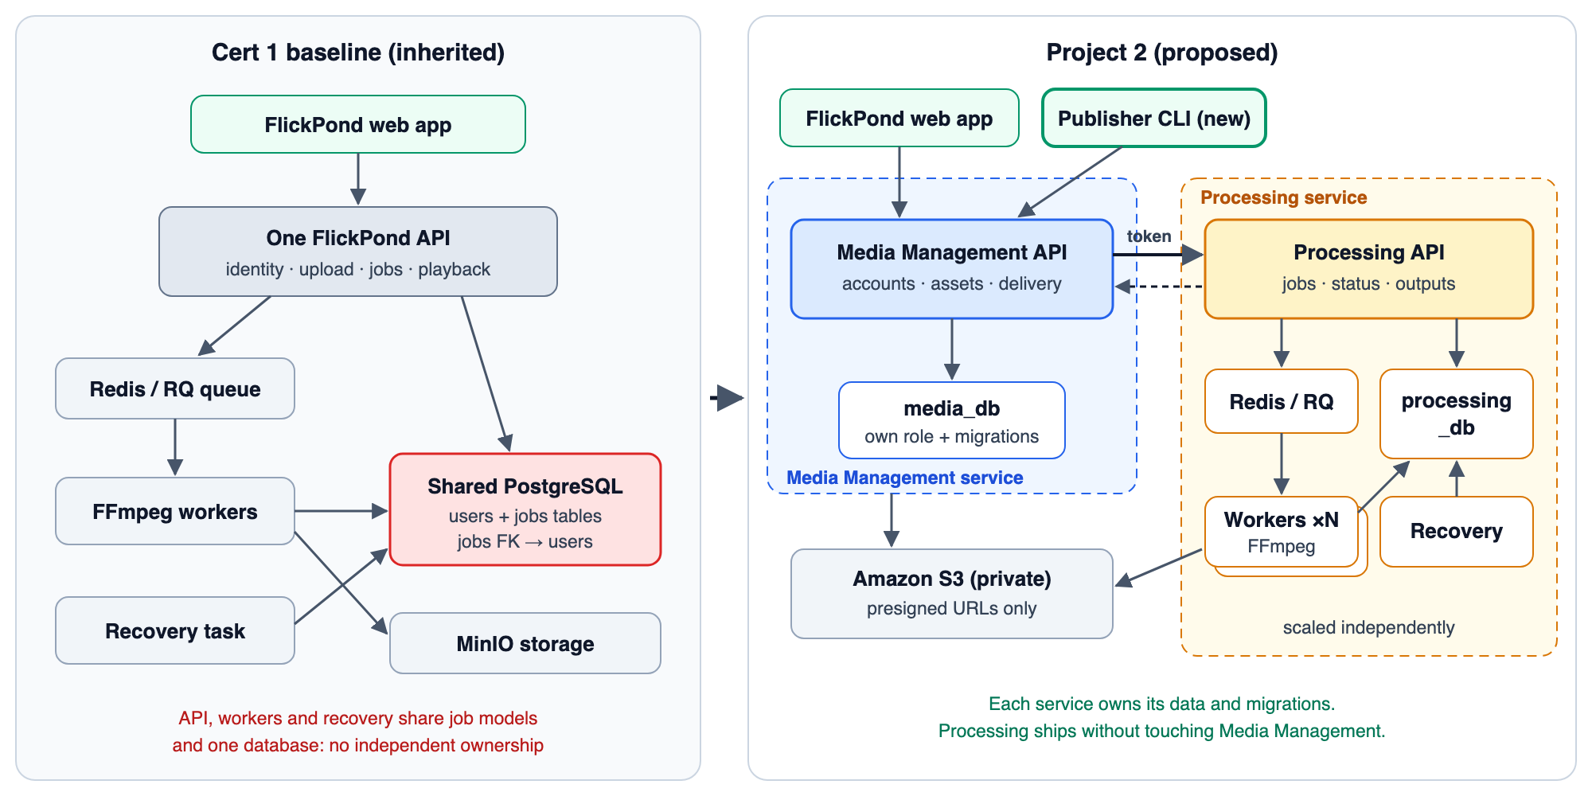
Figure 2. Left: the inherited Project 1 structure. Right: the proposed structure, with Media Management and Processing as separately owned and separately deployed services.
Media Management is the platform’s front door. It handles accounts and login, upload checks, source-asset records, and delivery of playback links after an ownership check. Both applications call only this service.
Processing owns everything about turning a source into playable output: processing jobs and their state, the queue, the FFmpeg workers, output records, and the recovery task. It is reachable only on the private network and only with a service token.

2.3 Finding the service boundary
We drew the boundary from the business workflow rather than from the existing code layout. We followed the language used at each step (upload, submit, claim, encode, complete, play) and grouped together the concepts that share rules and change together. The four initial candidates were Identity, Media, Processing and Delivery.
- Identity, Media and Delivery combine into Media Management. Every playback decision needs the owner and the asset, and these concepts change at the same pace as the user-facing product.
- Processing stands alone. It has its own lifecycle (queued → processing → done | failed) and its own consistency rule: only a valid claim may start an attempt. It runs asynchronously and has a very different resource profile, mostly CPU and scaled by worker count.
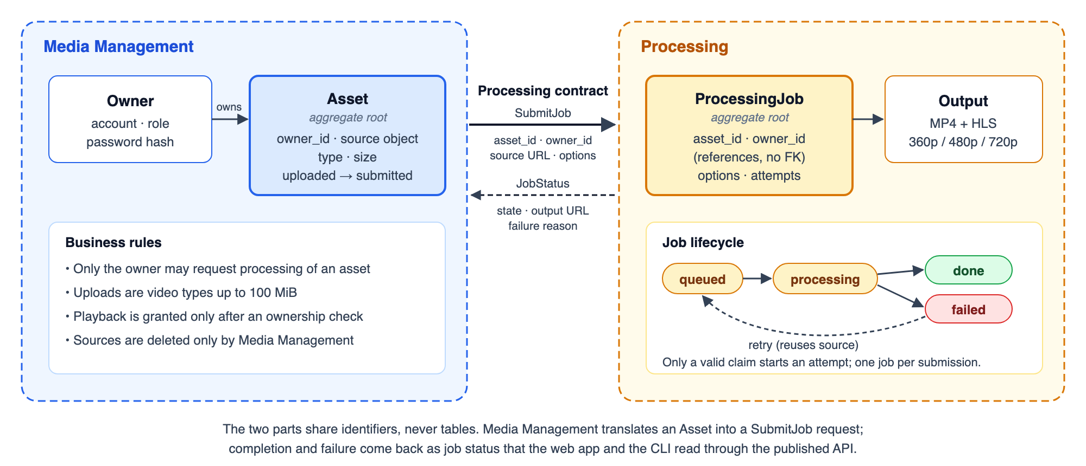
Figure 3. Each service has its own model and business rules. Asset and ProcessingJob are each a consistency boundary (an aggregate). Processing keeps owner and asset identifiers as plain references, with no foreign keys across services. Media Management translates its Asset into a SubmitJob request, so neither service depends on the other’s internal model.
The contract is small and versioned:
Operation | Caller → service | Purpose | Key rules
Log in / log out | Client → Media Management | Session (JWT cookie or bearer token for the CLI) | Existing password hashing and token expiry
Upload asset | Client → Media Management | Store the source and request processing | Video types only, ≤ 100 MiB, caller becomes owner
Get asset / list assets | Client → Media Management | Status and playback link | Owner-only; the playback link is a short-lived presigned URL
Retry asset | Client → Media Management | Re-run a failed job | Reuses the stored source; no re-upload
SubmitJob | Media Management → Processing | Create a job for an asset | Service token required; idempotent on asset_id, so a repeated call returns the existing job
GetJob / ListJobs | Media Management → Processing | Job state, failure reason and output reference | Every query is filtered by the forwarded owner identity
RetryJob | Media Management → Processing | Re-queue a failed job | Allowed only from failed; attempts are recorded
Exact paths and schemas will be published as OpenAPI documents and checked by contract tests in the pipeline. Media Management keeps the routes the FlickPond web app already uses, so the frontend needs only small changes.

2.4 Key architectural decisions
ID | Decision | Rationale | Alternative considered
AD-01 | Extract Processing as the only new service | It has distinct rules, lifecycle and scaling needs, which gives the most value per unit of effort | Keep the modular monolith (shared data blocks independent ownership); split into four services (more contracts and operations than the business need justifies)
AD-02 | Database per service on one Amazon RDS for PostgreSQL instance: separate databases, roles and migration histories | Real ownership boundary at low cost; either role is refused access to the other’s tables | Separate database servers: more cost, little extra value at our scale
AD-03 | Synchronous submit, asynchronous processing: the REST call creates the job; the queue drives the work | Keeps the existing Redis/RQ workers and gives clients an immediate job reference | New event broker: adds operations without a demonstrated need
AD-04 | Idempotent SubmitJob keyed on asset_id plus the existing reconciliation task | Makes retries across the boundary safe without a distributed transaction or an outbox | Transactional outbox: added only if experiments show reconciliation is not enough
AD-05 | Presigned URLs for source reads and output delivery | Workers never hold Media Management’s storage credentials; viewers get time-limited access | Shared storage credentials across services
AD-06 | Service token + forwarded owner identity for internal calls, on a private network | Simple and testable; Processing still enforces ownership itself | Mutual TLS: stronger, but too much certificate work for a two-service demonstration
AD-07 | Run the services on one Amazon EC2 instance with Docker Compose, worker replicas capped at 2 vCPU each | Low cost, reuses the team’s existing Compose tooling, and gives a fair and repeatable scaling experiment | Amazon ECS on Fargate or EKS: better for production scaling, but adds operational work outside the project’s focus
AD-08 | Use AWS managed services for state and operations: RDS for PostgreSQL, S3, ECR, SSM Parameter Store and CloudWatch | No database or storage server to run; S3 presigned URLs and bucket policies give least-privilege media access natively; managed backups and metrics | Self-hosting PostgreSQL and MinIO on the instance: cheaper, but more operational work and weaker isolation
AD-09 | Define the AWS resources in Terraform (VPC, security groups, EC2, RDS, S3, ECR, IAM) | The environment can be recreated and reviewed like code; changes go through pull requests | Console set-up: faster at first, but not repeatable or reviewable
AD-10 | Fresh demonstration data | Avoids migrating historical accounts and videos, and keeps effort on the contribution | Migrating Project 1 data

2.5 Physical architecture and delivery pipeline
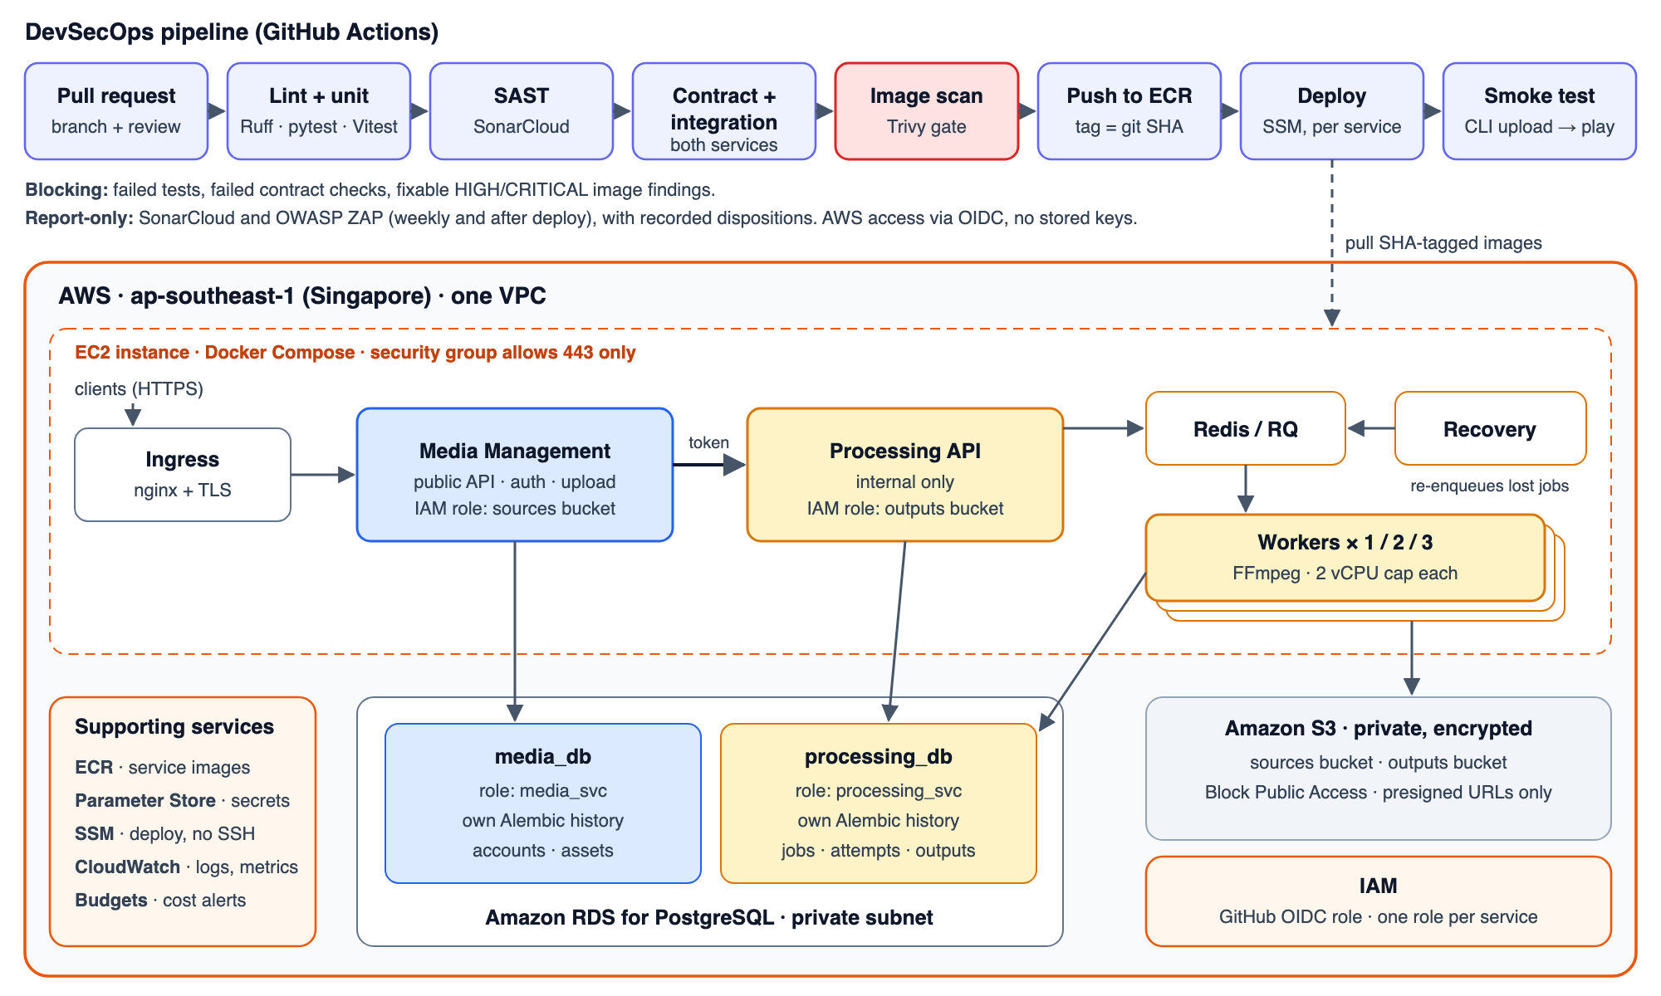
Figure 4. Every change passes the GitHub Actions pipeline. Images are pushed to Amazon ECR and deployed per service to an EC2 instance through AWS Systems Manager. Only HTTPS is exposed; RDS sits in a private subnet and S3 buckets are private.
The whole platform runs on AWS in the Singapore region (ap-southeast-1):
Need | AWS service | How we use it
Compute | Amazon EC2 | One instance runs ingress, both service APIs, Redis, the workers and the recovery task with Docker Compose. 4 vCPU / 8 GiB for development; resized to 8 vCPU / 16 GiB for the scaling experiment so three 2-vCPU workers have room
Relational data | Amazon RDS for PostgreSQL | Single-AZ instance in a private subnet holding media_db and processing_db, each with its own role
Media files | Amazon S3 | Private, encrypted sources and outputs buckets with Block Public Access; access only through presigned URLs
Images | Amazon ECR | One repository per service; images tagged with the commit SHA
Secrets | SSM Parameter Store | Service token, database passwords and JWT signing key as SecureString parameters
Deployment access | IAM + SSM | GitHub Actions assumes a deploy role through OIDC (no stored access keys) and deploys with SSM Run Command; no SSH port is open
Observability and cost | CloudWatch, AWS Budgets | Container logs and CPU/memory metrics for the experiments; budget alerts at 50% and 80%
All resources are defined in Terraform. The EC2 and RDS instances are stopped outside work and test sessions, and the target AWS spend is under US$100 for the project.
The same images also run locally with Docker Compose, using PostgreSQL and MinIO containers (MinIO speaks the S3 API) in place of RDS and S3, so every scenario can be reproduced on a developer machine before it runs on AWS.

3 Scope of Work

3.1 Platform components
Role | Who or what | In this project
Seed | An owned video asset and its processing job | Upload, process, track, retry and play
Producers | Content owners submitting videos | Through the FlickPond web app (one at a time) and the Publisher CLI (batch)
Consumers | Authorised viewers | Play MP4/HLS output through presigned, owner-checked links
Integrators | Developers building new applications | Use the OpenAPI contract and the CLI as a reference client
Operators | The team as platform operators | Deploy per service, scale workers, inspect jobs and failures

3.2 Use cases in scope
ID | Use case | Applications
UC-1 | Register, log in and upload an owned video | Web app, CLI
UC-2 | Process the video into MP4 and HLS (360p/480p/720p), with HLS as best effort | Platform
UC-3 | Track job status and play the processed result | Web app, CLI
UC-4 | Retry a failed job using the stored source | Web app, CLI
UC-5 | Bulk-publish a folder of videos and report the results | CLI
UC-6 | Scale processing workers without touching Media Management | Operator
UC-7 | Release a new Processing version on its own, with smoke test and rollback to the previous image | Operator / pipeline
Core workflow. (1) The client uploads a video to Media Management. (2) Media Management checks the type, size and owner, stores the source privately and records the asset. (3) It calls SubmitJob with the asset ID, the owner ID and a presigned source URL. (4) Processing records a queued job and enqueues it. (5) A worker claims the job, encodes the video and writes the outputs. (6) The client polls status through Media Management, which asks Processing on the owner’s behalf. (7) Once the job is done, the client receives a short-lived playback URL.

3.3 How the implementation demonstrates the course areas
Scalability and performance. Processing capacity scales by adding workers, independently of the API. We will process a fixed backlog of identical clips with 1, 2 and 3 workers, each capped at 2 vCPU, and record:
- jobs per minute,
- queue wait,
- processing time,
- failures,
- CPU and memory use.
FFmpeg uses every core it can find, so the CPU caps make the comparison fair: one uncapped worker would already saturate the host and hide any gain. We will also rerun Locust load tests on the status and playback routes after the split, and measure login separately.
Cloud-native design.
- Services are packaged as immutable, versioned containers stored in Amazon ECR.
- APIs and workers are stateless; durable state lives in managed services (RDS and S3).
- Configuration and secrets are kept outside the images, in SSM Parameter Store.
- The environment is defined in Terraform and can be recreated from code.
- Health checks drive the deployment.
- Workers are disposable: interrupted jobs are reconciled rather than lost.
- Each service is released independently, with no change to the other service.
Platform engineering.
- One published, versioned API covers the whole video workflow, documented with OpenAPI.
- Each service owns its data and migrations.
- Contract tests protect integrators from breaking changes.
- A second application is built with no imports from service code and no database credentials. We record its effort and size as evidence of reuse.
DevSecOps.
- GitHub Actions runs lint and unit tests (Ruff, pytest, Vitest), SonarCloud static analysis (SAST), contract and integration tests for both services, image builds tagged with the commit SHA, and a Trivy image scan.
- Failed tests and fixable HIGH or CRITICAL findings block the pipeline.
- A deploy script releases each service and checks its health, then the CLI runs an upload-to-playback smoke test.
- An OWASP ZAP dynamic scan (DAST) runs weekly and after each deploy.
- Report-only findings receive a recorded disposition.
- We will fix the known fixable HIGH finding in the inherited image in week 1.
Security controls and tests.
Control | Verified by
Public routes require a valid session; the uploader becomes the owner | Unauthenticated requests are rejected
Owner checks in Media Management and Processing | User A cannot read, retry or play User B’s assets
Internal API requires a service token and is not publicly routed | Forged and token-less internal calls are rejected; the port is unreachable from outside
Separate database roles | Each service’s credentials are refused on the other’s database
Presigned, time-limited S3 URLs; private buckets with Block Public Access; each service’s IAM role reaches only its own bucket | Expired and tampered URLs fail; no public bucket listing; each role is denied on the other bucket
Input checks on type and 100 MiB size | Invalid and oversized uploads are rejected
Security groups expose only 443 (and 80 for certificate renewal); RDS accepts connections only from the EC2 security group; no SSH | External port scan; RDS unreachable from the internet
Secrets in SSM Parameter Store; GitHub Actions uses short-lived OIDC credentials | No secrets in git or images (secret scanning in CI); no long-lived AWS keys exist
Availability and recovery. Durable job states, conditional claims and the reconciliation task make failures visible and recoverable. We will test three failure cases:
- killing a worker during an encode,
- losing a queue entry after the job is committed,
- a temporary Processing outage while Media Management is accepting uploads.

3.4 Quality scenarios and initial targets
These targets are our starting commitments. After a short baseline run in week 2, we may adjust them, but only before the final tests, and we will report the results against the targets whether they pass or fail.
Quality attribute | Scenario | Initial target
Scalability | Fixed backlog of 30 identical 60-second 720p clips; 1 → 2 → 3 workers at 2 vCPU each | 2 workers ≥ 1.6× and 3 workers ≥ 2.1× the jobs/minute of 1 worker; median queue wait falls at each step; 0 failed jobs
Performance | 50 concurrent users polling status for 3 minutes | p90 ≤ 700 ms, < 1% errors (Project 1 measured 660 ms p90 for comparable reads before the split)
Performance | 20 concurrent logins, measured separately | p90 < 2 s
Availability | Worker killed mid-encode | Job is re-queued or marked failed within 5 min; a retry succeeds; no duplicate outputs
Availability | Queue entry lost after the job is committed | Reconciler re-enqueues the job within 2 min
Deployability | Release a new Processing version on its own | Deployed and smoke-tested in ≤ 10 min; Media Management container and media_db migrations unchanged
Security | Negative tests in §3.3 | 100% rejected; 0 fixable HIGH/CRITICAL image findings at release
Reusability | Publisher CLI built against the published API | 0 imports from service code, 0 database credentials; built within 2 person-days

3.5 Out of scope
- The remaining Project 1 feature list (profiles, password reset, titles and tags, sharing modes, external videos).
- Search, public discovery, moderation workflows and product analytics.
- Crop/clip editor UI, thumbnails, 4K output, and direct or resumable uploads above 100 MiB.
- Kubernetes (EKS), ECS/Fargate, Auto Scaling groups, and multi-AZ or multi-region failover.
- Historical data migration, malware scanning and full key rotation.

3.6 How this proposal answers the briefing’s key questions
Question | Our answer
Which ecosystem pain point is solved? | Every content application rebuilding secure upload, processing and playback (§1.2)
Which common services does the platform provide? | Identity and ownership, asset intake, processing jobs, output delivery, and a reference client (§2.2, §2.3)
What does a new use case gain over building from scratch? | The full workflow, its security controls and its scaling through one API. Shown by the Publisher CLI and its recorded effort (§3.3)
What scale can it support, and how is that proven? | Throughput grows with workers until the CPU limit. Proven by the 1/2/3-worker experiment and the API load tests (§3.4)
How are benefits measured? | The quality scenarios and targets in §3.4, reported against raw results
What value does the cloud-native design add? | Independent release and scaling, disposable workers with recoverable state, managed AWS data services, infrastructure as code, and automated, gated delivery (§2.5, §3.3)

4 Effort Estimates and Plan

4.1 Work breakdown
The briefing expects about 10 person-days per participant. Our estimate is 31 person-days for three members.
# | Work package | Lead | Person-days
1 | Freeze baseline, reproducible local setup, fix the inherited scan finding | Guruprasath | 1
2 | Domain analysis, service contracts and OpenAPI documents | Long (team review) | 3
3 | Extract Processing: service, own database and migrations, workers and recovery task | Ibrahim | 6
4 | Adapt Media Management: asset records, Processing client, web app routes and retry | Ibrahim | 3
5 | Boundary security: service token, owner checks, database roles, presigned URLs, negative tests | Guruprasath | 3
6 | Publisher CLI and contract tests | Long | 2
7 | AWS environment in Terraform (VPC, EC2, RDS, S3, ECR, IAM), OIDC deploy role, per-service deployment, pipeline adaptation, smoke test | Guruprasath | 5
8 | Experiments: scaling, load, recovery and playback; raw results | Long | 3
9 | Integration fixes and repeat checks | All | 2
10 | Progress reports, presentation and final report | All | 3
 | Total |  | 31
The resulting split is about 10 person-days for each member.

4.2 Schedule
Period | Milestone
4 Oct | Proposal submitted
5–7 Oct | Baseline frozen and reproducible; domain model and contracts drafted; lecturer review on 7 Oct
8–14 Oct | Processing extracted with its own data; web app working end to end across the boundary; CLI started; first progress report
15–20 Oct | Security controls and tests; AWS deployment and pipeline; baseline run, then final experiments
21–25 Oct | Fixes, demonstration rehearsal and presentation preparation
26 Oct, 14:35–15:15 | Team 17 presentation
27 Oct–16 Nov | Final report, including presentation feedback; second progress report

4.3 Main risks
Risk | Impact | Mitigation
Shared job and identity code is more tangled than expected | Delays the extraction | Do the extraction first; reach one working upload-to-playback flow before any other work
AWS account limits or cost overrun | Late experiments or blocked environment | Provision with Terraform in week 1 and check the vCPU quota early; budget alerts; stop instances when idle; identical Compose stack runs locally
Scaling shows little gain | Weak scalability evidence | CPU caps per worker; profile the bottleneck and report it honestly
Three-member team | Less capacity than a 4–5 member team | Narrow scope, no new product features, clear ownership per work package

4.4 Assumptions
- The team has an AWS account with enough EC2 vCPU quota in ap-southeast-1 by week 1.
- The frozen Project 1 baseline is used as is. Missing Project 1 features are not completed.
- All demonstration data is new test content owned by the team.

