Project Progress Report for Rewind

Practice Module for Certificate in Designing Modern Software Systems

Sprint 2 hosted Demo — Review ready
Through 26 September 2026 — sprint not closed
Team and member details pending confirmation

CONTENTS
1. Introduction 3
1.1 Project Name & Description 3
1.2 Project methodology 3
1.3 Project Summary 3
2. Project Progress Report 4
2.1 Reporting period 4
2.2 Sprint number 4
2.3 Sprint objectives 4
2.4 Sprint accomplishment 4
2.5 Sprint Burn down chart 7
2.6 Problems encountered, action plan, status 7
2.7 Sprint retrospective 8
3. Project Team Members Contribution Summary 9
4. Other things to be highlighted 10

1. Introduction

1.1 Project Name & Description
Rewind helps private groups of two to ten friends record short original videos, keep contributions sealed, and watch a chronological group film after a four-week cycle. Quotas, chat, prompts, reminders and an authorised archive support the shared experience. The current demonstration compresses the cycle to one day and uses clearly labelled synthetic members and media.

1.2 Project methodology
Work is organised through sprint plans, issue contracts, short-lived branches, pull requests and automated checks. The report distinguishes implemented code, focused tests, integrated verification and acceptance on the target device and hosted environment. Ticket closure alone does not establish a delivered user journey.
The recorded evidence supports incremental delivery and review-driven fixes. Ceremony attendance, team effort and a daily burndown series have not been confirmed; this report makes no claims about them. Course evidence must also connect each member’s use case and design problem to implementation and verification.

1.3 Project Summary
Status: Review ready — sprint not closed. Sprint scope is limited to the synthetic Demo; real accounts/OIDC and remote/PWA reminders move to the next sprint. Combined quality, responsive tests and two consecutive production-shaped local E2E runs pass. Native keyboard/send and archive contrast/context checks pass. The final c65a076 gate passes. Review/merge and human hosted acceptance remain outstanding; manual archive swipe acceptance is unconfirmed.
Hosted acceptance remains outstanding. Fresh read-only cloud inspection found no Lightsail instances or static IPs in ap-southeast-1 and no distributions in us-east-1. Infrastructure ownership is already settled: Guruprasath owns apply and Andrew reviews the exact plan and runs the non-author acceptance. Four execution weeks remain, from 27 September to 24 October 2026.

2. Project Progress Report

2.1 Reporting period from and to date
Reporting period: actual implementation and integration from 2 to 26 September 2026. Status cut-off: 26 September 2026; four execution weeks remain.

2.2 Sprint number
Sprint 2 hosted Demo. The scope boundary is confirmed; the sprint remains open for review and hosted acceptance.

2.3 Sprint objectives
A reviewer should open the HTTPS application, enter synthetic Demo access, create or join a group, submit a synthetic clip, observe it sealed, advance the cycle and play the released film. The journey should deny non-member access, survive restart, reset cleanly and be repeatable by a non-author without a developer terminal.

2.4 Sprint accomplishment
The synthetic Demo implements groups/invites, contribution quotas, sealed media, FFmpeg processing, durable jobs, cycle transition, film compilation, archive access, chat and device-local reminders. Local full-cycle and core native evidence support implementation progress; final integrated native and hosted acceptance remain open.
Five cloud-free release-bundle, wake, recovery, atomic-restore and lifecycle-guard suites passed with fixtures/mocks, not live AWS. At ec69af8, the sanitized plan confirms 5 creates, 3 updates and 0 deletes; the ZIP contains exactly two runtime modules, fixing local bytecode/test packaging. Source has since changed: rebuild the exact plan for Andrew’s review before Guruprasath applies. No apply occurred.
A disposable two-service Docker Compose run is healthy: /api/health and the PWA manifest are served, with nginx and rewind users. This is local container evidence, not a hosted AWS result.
Release #205 at 5a94537 uses patched pinned Node/Alpine/FFmpeg and non-root web. Both image HIGH/CRITICAL scans now pass without blanket CVE exceptions. The IaC gate passes with exactly five exceptions, owned by Guruprasath and expiring 10 October 2026: AWS-0345 for the human Terraform admin role; AWS-0132 separately for state, backup and audit-log encryption; AWS-0015 for CloudTrail encryption. The role retains broad S3* and IAM permissions until separate least-privilege OIDC work (#174). Four encryption exceptions retain private, versioned SSE-S3/AES256 storage to avoid customer-managed-key cost/operations. These risks remain subject to PR review, not eliminated; other findings stay gated.

2.4 Sprint accomplishment continued
Integrated work | Evidence and present status
Client and performance | PR #207 adds bounded history, cached integrity, a 96 MiB/three-snapshot budget and native UI fixes. State-safety regressions pass: StrictMode retains one live message, and an old-group archive page cannot merge into a new group. Head 240902a includes the archive ScrollView fix; 27 focused tests and the full gate pass. Manual swipe acceptance is unconfirmed.
CI and security checks | All four PRs are green at exact heads: #204 9e23ebe, #205 5a94537, #206 481e5c4 and #207 240902a. #204 includes image/security scans, three CodeQL languages, IaC exceptions, fixtures and browser checks; #205–#207 quality/GitGuardian pass. Required reviews and merges remain.
Container and data | Actual Alpine/FFmpeg container: 203/203 server tests pass with 768 MiB, 128 PIDs, read-only root and all capabilities dropped. Test-only exec /tmp and 32 MiB /app/.local-data tmpfs support wrappers/preflight fixtures; production configuration is unchanged. Fresh migration/consistency has no findings.
Working integration | Final candidate c65a076 passes the full gate. Nineteen responsive tests pass; after correctness 481e5c4, production-shaped E2E passes twice consecutively, 2/2 each. PRs #204–#207 remain unmerged. The final check snapshot confirms all four PRs green; required review/merge remains.

Verification evidence
Final c65a076 gate: 31 root, 203 server, 357 Jest/40 suites and 6 accessibility tests pass. Nineteen responsive tests pass. Prior frontend coverage at a975b93 was 78.31% statements, 72.54% branches, 81.08% functions and 82.21% lines; final-head coverage was not supplied.

Acceptance evidence
Two consecutive local production-shaped E2E runs passed after correctness head 481e5c4, each 2/2 including reset-to-reveal. They are local automated evidence; human hosted acceptance remains outstanding.

2.4 Native evidence
Local iPhone 15 Pro / iOS 17.5 / Expo Go 57.0.9. Screenshots support the observed UI results; they do not establish hosted or independent-human acceptance.
Chat: keyboard clearance | Archive: context and contrast
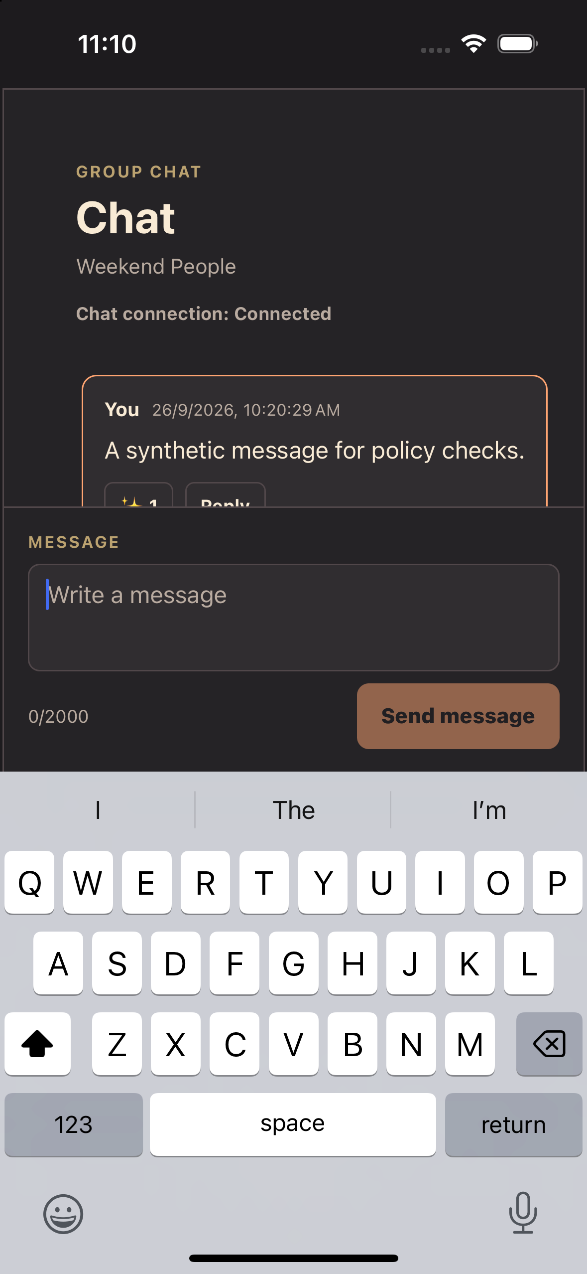 | 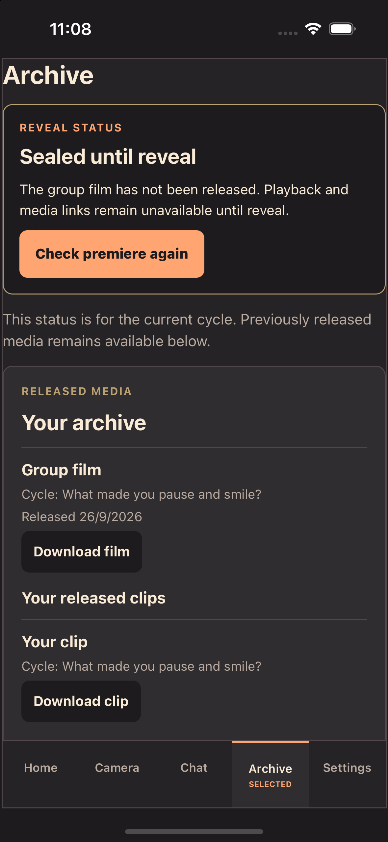
Figure 1. Send is visible above the on-screen keyboard (left); “Hi” was sent and persisted on return to Chat. Archive labels distinguish the sealed current cycle from released media, with readable download actions (right). Manual archive swipe acceptance remains unconfirmed.

2.5 Sprint Burn down chart
A daily remaining-work series and agreed estimates were not supplied. No burndown is reconstructed. Historical merged-PR throughput and board counts do not measure remaining effort or accepted outcomes, especially while Project metadata is being reconciled.

2.6 Problems encountered, action plan, status
Review-ready checklist. The sprint is not closed. Complete the remaining review, exact-plan and hosted acceptance gates before closing the synthetic Demo sprint.
Gate | Current status and completion evidence
Integration and full check | PASS: final c65a076 gate, 19 responsive tests, container 203/203 and E2E 2/2 twice. All four exact-head PR checks are green. PRs #204–#207 remain unmerged; complete required reviews and preserve checks after any rebase.
Native and fixture acceptance | #199 Review/Test. Core flow, unread/reconnect, keyboard-visible Send, persisted “Hi” and archive contrast/context pass. Archive ScrollView fix: 27 focused tests and full gate pass. Manual swipe acceptance is unconfirmed; retain that check.
Governance | ACTIVE. Strict quality checks, one review, non-author last-push approval, admin enforcement and resolved conversations are required. #204 verifies merge blocking. Dependabot is enabled; configured release review is unused by a deployment job.
Infrastructure plan and apply | #190 BLOCKED. ec69af8 plan: 5 creates, 3 updates, 0 deletes; ZIP verified. Rebuild for current source/state; Andrew reviews the exact plan, then Guruprasath applies. Reconcile Lambda/IAM updates before wake. No apply has occurred.
Hosted acceptance | #145/#200 BLOCKED on live verification. #200 code is already on main cfb9dc7 (PR #188); only live distribution acceptance remains. Retain two clean hosted runs plus Andrew’s non-author run and restart/reset/denial/recovery evidence.
Audit and report closeout | #203 In Progress. Retain final checks and review/merge evidence; confirm member attribution. #199 Review/Test; #190/#145/#200 Blocked. #142 CLOSED; operational ownership is settled. Report is review ready, not sprint closure.

2.7 Sprint retrospective

2.7.1 What went well
The project now has a substantial vertical implementation and automated local evidence across the runtime, media workflow and application. The audit reproduced concrete integration and fixture problems rather than relying on broad completion percentages. Focused fixes were combined into a single integration tree for full verification.
Main protection and Dependabot are active; an actual failing PR demonstrated merge blocking. The configured release environment names AndrewNguyenLKN and blocks self-review, but no deployment job uses it. Manual AWS apply therefore still requires the runbook’s exact-plan human review.

2.7.2 What could have done better
Milestone closure, Project status and feature-level checks ran ahead of end-to-end acceptance. Plain mocks failed to expose a class-method binding problem and missing native transport wiring. Seed data also reported ready outputs and quota usage inconsistently. Future test selection should exercise real adapters and the full state transition at the boundary where users encounter it.
Hosted evidence must identify the environment, release SHA, operator and result. The wake guard rejects the recorded plan’s cost-audit Lambda, scheduler-policy and power-policy updates. Reviewed infrastructure reconciliation must precede wake; exact plan review is renewed after any source/state change. This is a concrete readiness blocker, not an unresolved ownership decision.

2.7.3 What will try next
Use one issue and bounded file set per implementation lane, with a different reviewer. Agree method signatures, error shapes, fixture IDs and migration ownership before work splits. A single integrator should coordinate shared entry points, migrations and dependency files; integrate daily and keep evidence attached to the issue or PR.
Begin the next sprint’s OIDC and remote-reminder contracts in parallel with Demo closure verification. Accept those capabilities only after expiry/logout, private-group access and permission/delivery/retry behaviour are demonstrated on the chosen native and installed-PWA targets. Reserve explicit time for independent device runs, recovery rehearsal and course evidence.
These are evidence-based reflections and proposed working agreements. No retrospective meeting or attendance record is asserted.

3. Project Team Members Contribution Summary
The team roster, individual contributions and effort figures have not yet been confirmed. The official contribution table is retained for completion. Repository authorship or agent activity is not converted into human work allocation or hours.
Project Member Name | Activity Description | Achievement Status (Completed / In-progress) | Remarks
Pending team confirmation | Pending individual attribution | Not reported | Complete from confirmed member evidence; no hours inferred.

Confirmed operational responsibilities
Guruprasath is the Terraform apply and break-glass owner. Andrew is the required reviewer of the exact plan/apply and owns the hosted non-author acceptance run. These responsibilities were accepted on 23 September; #142 is closed. Exact Terraform plan review remains a human runbook gate. The configured release environment reviewer is AndrewNguyenLKN, with self-review blocked, but no deployment job currently uses that environment.
These named responsibilities do not establish the full project roster, completed implementation contributions or time spent. Actual apply and hosted acceptance remain pending.

Evidence needed for member attribution
For each confirmed member, record the activity, linked issue/PR or deliverable, current status and a short verification remark. The course brief also calls for each member to own an in-scope use case and a design problem/pattern discussion. Confirm that mapping before the final report.

4. Other things to be highlighted

Next sprint and remaining four weeks
The next sprint is scoped to real accounts/OIDC and remote reminders, including installed-PWA delivery. Plan execution across 27 September–24 October 2026; do not add implementation weeks from the tentative November assessment dates. Staffing and available hours remain unconfirmed.
Period | Parallel execution and acceptance focus
27 Sep–3 Oct | Finish integrated Demo checks and reviewed hosting plan. In parallel, define OIDC member/group mapping, expiry/logout and private-media access; define reminder scheduling, consent, tokens and retry contracts.
4–10 Oct | After reviewed apply, run hosted Demo acceptance. Implement identity and reminders in separate modules against agreed contracts; start native and installed-PWA device proof early.
11–17 Oct | Integrate real-account and reminder paths. Verify isolation, logout/expiry, notification receipt/retry and failure recovery. In parallel, complete use-case/design evidence and targeted performance checks.
18–24 Oct | Freeze feature scope, resolve accepted defects, rehearse the same release twice, retain rollback/recovery evidence and package report/presentation material.

Coordination and scope control
Run client/device, identity, reminder delivery, release/operations and independent acceptance/evidence work in parallel only where staffing permits. Keep one active issue per lane and serialize shared route, schema and dependency edits. Guruprasath and Andrew retain the established infrastructure responsibilities; other delivery owners require team assignment.
Keep the current modular architecture unless the real-account or reminder contract requires change. Bound archive/history and chat replay work by measured risk; defer broad infrastructure migration and cosmetic expansion when they compete with acceptance. Track user identity under #168 and remote/PWA reminders with an owned test matrix. GitHub-to-AWS OIDC under #174 is next-sprint delivery trust work, separate from user sign-in.
Sources: project brief, sprint plan, 26 September audit, runbook, supplied checks/screenshots and read-only governance/cloud/plan evidence. Consult the handoff for late heads and CI snapshots.

