Rewind Sprint 2 Progress Report
  - Private group time capsules
Practice Module for Certificate in Designing Modern Software Systems
Team 14 | 27 September–10 October 2026
Evidence snapshot 10 October 2026
Current dev revision 7bab402 | Main release revision bac471c

Sprint summary
Sprint 2 moved Rewind from a synthetic demonstration to a product for real accounts and private groups. Members can contribute photos and videos, keep moments sealed, participate in group chat, and access the compiled film and archive after release. The sprint also added private S3 media, web push reminders, a clearer mobile interface, and automatic deployment to hosted dev.
The final days brought the implementation closer to the submitted architecture: hosted dev gained managed PostgreSQL, recorded backup and recovery results, and Cognito sign-in. Those changes have not yet reached the main release environment. The remaining work includes release environment completion, a lossless database rollback, and evidence for the intended physical-device journeys.
Measure | Recorded position
PRs merged during the period | 128 to dev; 3 to main; 1 to another branch
Issues closed during the reporting period | 145 unique issues; 123 non-archived and 22 archived
Issues opened during the reporting period | 143 new issues across the repository
Latest dev Quality and deployment | Both succeeded for revision 7bab402 on 9 October
Local fast test duration | 71.4 s before; 28.3–28.5 s after
Recorded dev database recovery | 5.6 min recovery point age; 17 min to restore

Team members: Nguyen Kim Long, Gopal Guruprasath, Jiang Jiayu, Sang Haoxiang and Phan Mai Tan Loi.
Reading guide: objectives and delivery; proposal parity; delivery charts; performance and recovery; quality and deployment; problems and actions; team contributions; retrospective and next steps; source notes.

1 Introduction and sprint objectives

Project purpose
Rewind gives small groups a private way to preserve everyday moments. Instead of publishing each contribution immediately, it collects them within a cycle and reveals a chronological group film later. The shared reveal is the central experience; capture, chat and reminders support it.

Methodology and reporting boundary
The project uses Scrum, with work tracked through issues and Sprint milestones. Changes are integrated into dev through pull requests and an aggregate Quality check; main remains the reviewed release branch. The reporting period is 27 September–10 October 2026 and includes work assigned to the Sprint 3 milestone.
At the start of Sprint 2, Rewind had a synthetic Demo, local SQLite persistence and hosted verification still pending. Sprint 2 shifted the product to real-account journeys while retaining SQLite for local runs and tests. The evidence snapshot was taken at 20:44 SGT on 10 October 2026.

Work plan compared with actual delivery
Intended outcome | Actual position at the snapshot
Real members can enter private groups | Account sessions, group creation, invitations and selected-group context were delivered; Cognito was added to dev late in the sprint.
Photo and video contributions stay sealed | Both media types and the contribution ledger are present. Capture, Safari playback and privacy defects received follow-up fixes.
Cycle completion produces a shared film | Scheduler, compilation, reveal, archive and next-cycle behavior were integrated into the real-group flow.
Hosted product and reminders | Dev deployment, S3 media and browser/Home Screen web push were delivered. Native push remains disabled.
Proposal architecture and recovery | Managed PostgreSQL and measured recovery were delivered on dev; release database and Cognito follow-ups remain open.
Installable and usable clients | The current iOS route is the PWA. Android build support exists, with distribution and device evidence less complete.

Sources: PR 266; PR 280; PR 287; PR 416; PR 506; PR 510

2 Sprint accomplishments
Product and delivery improvements were integrated throughout the sprint.
Period | Delivered change | Representative PRs
27–30 September | Established the dev workflow and real-account entry; delivered group creation, invite acceptance, profiles, photo/video capture, chat and contribution accounting. | 231, 266, 268, 280–289
1–3 October | Automated hosted dev deployment; added controlled real-account browser fixtures, capture cleanup, direct/private media tests, and local performance measurements. | 324, 326, 369–378, 388, 396
4 October | Integrated private S3 media and web push scheduling; added short real-account cycles, a single hosted URL, release environment infrastructure, and the first dev-to-main promotion. | 333, 408, 411, 416–420, 421
5–6 October | Reworked the mobile interface and corrected keyboard, capture, film playback, safety and legal-page behavior. Removed the synthetic Demo and completed web push routing. | 437, 440, 442, 462, 464, 466, 473, 479, 487
7–9 October | Repaired backup prerequisites, introduced PostgreSQL and dev cutover, recorded recovery, added Cognito and its runtime packaging fix, accelerated tests, and retired obsolete cost audit and hibernation machinery. | 492, 506–511, 516–519

Changes to the product boundary
The synthetic Demo was removed on 6 October, and its unresolved defects were archived. The historical demo name remains in hosting scripts and infrastructure, while the application now centres on real-account use.
Photo capture remains alongside video, and the iOS delivery route is the installed PWA. Browser web push replaces the active native-push route. App Store submission tasks remain outside the current delivery path. These decisions reduce competing flows while preserving the delayed-reveal experience.
PostgreSQL and Cognito work was delivered on 7–8 October, ahead of its Sprint 3 milestone assignment. These changes brought hosted dev closer to the proposal architecture; deployment to the release environment remains outstanding.
Sources: PR 421; PR 473; PR 487; PR 506; PR 508; PR 510; PR 517

3 Proposal parity
The submitted proposal is the requirements baseline. The tables summarise the current dev implementation, deliberate scope changes and remaining gaps, including limitations in hosted and physical-device verification.

Core product behavior
Proposal requirement | Sprint 2 position | Remaining difference
Managed OIDC identity | Partial. Cognito code and PKCE flow exist on dev web/PWA; developer sign-in remains local/dev. | Release has no deployed Cognito pool; native builds use developer sign-in.
Invite-only groups with 2–10 members | Implemented. Owner groups, expiring/revocable invites, capacity and membership checks. | Physical-device invitation return has less evidence than the web code and fixtures.
Camera-first vertical video, up to 15 s | Changed. Video trim/review plus photos; landscape sources and browser camera sheet supported. | Entry opens group Home. Photos and landscape capture extend the original design.
Five clips and 30 s per weekly window | Implemented. Server ledger enforces 5 contributions, 30 s total and 15 s per clip. | Photos become three-second film segments and consume contribution budget.
One correction before cutoff | Implemented. One eligible deletion in the seven-day window restores allowance; replacement is explicit. | Correction remains restricted to the eligible collecting cycle.
Contributions sealed until release | Implemented. Metadata ledger, membership checks and publication gates protect media. | Fixture tests establish those boundaries within their exercised environment.
Four retro looks before upload | Partial. Web photos and capable browser video apply the look before upload. | Native and incapable-browser paths send originals for server processing.
Private chat and owner prompts | Implemented. Text, supported reaction/reply, group-scoped events and owner prompt/timezone controls. | Features remain bounded to the private-group use case.
Four-week cycle and 24-hour premiere | Implemented. Server closure, compilation, next-cycle creation and publication-based premiere timing. | Short test cycles accelerate verification; they do not represent a four-week elapsed run.
Chronological film and archive filler | Implemented film; partial filler. Vertical 720p output, normalized audio and labelled archive reuse. | Filler uses one current clip plus a recent same-group archive clip, not a general duration/member-first policy.

Sources: PR 280; PR 289; PR 414; PR 419; PR 487; PR 510; Issue 352

3 Proposal parity continued

Architecture and client delivery
Proposal requirement | Sprint 2 position | Remaining difference
Revealed film and own clip downloads | Implemented. Authorized playback and download capabilities; permanent archive after premiere. | No pre-reveal download. Live/device evidence remains narrower than automated access tests.
Private S3 and direct media transfer | Implemented on dev. Scoped intents and storage transfers separate media from API control calls. | Disk remains local. Live storage access and retention need further verification.
Processed-media-only retention | Implemented cleanup paths. Jobs retain outputs and remove staged originals after processing. | Native/fallback paths initially upload raw source; correct immutable versions must be retained/deleted.
PostgreSQL relational store | Partial. Managed PostgreSQL, reconciled import and hosted-dev cutover are delivered. | Release uses SQLite. Dev has no standby; inspection access is public with TLS and generated logins.
Managed backup and recovery | Partial. Dev snapshots/PITR and restore-verified logical backups; recorded recovery rehearsal. | Release backup/database work remains open; SQLite fallback loses post-cutover writes.
Weekly reminders with member control | Changed. Sunday 19:00 group-timezone schedule, snooze/disable and web-push outbox. | Expo/native push is paused. iPhone requires Home Screen installation; acceptance by a provider is not visible delivery.
Android, iOS and installable PWA | Partial and changed. Shared client/build setup; PWA is current iOS delivery route. | Compiled native iOS is out of scope. Completed Android distribution/device acceptance is not established.
Logs, operational metrics and pipeline | Implemented records and Quality; changed alert scope. Redacted logs and persisted operational outcomes. | CloudWatch paging and dashboards are not implemented. The latest dev run skipped browser/export checks.
Original membership/privacy boundary | Added scope. Account deletion, report/block controls and privacy/support pages. | These additions do not establish a full moderation service or independent legal/privacy review.

The remaining proposal gaps are universal pre-upload retro processing, release deployment of managed identity and PostgreSQL, and the original breadth of client distribution. The low-contribution filler rule and notification provider also differ.
Sources: PR 416; PR 437; PR 506; PR 508; PR 510; Issue 504; Issue 505; Issue 515

4 Delivery data
Delivery activity peaked on 29 September and 4 October, when dependent product and hosting changes were integrated. Across the reporting period, 132 PRs merged: 128 into dev, three into main and one into a working branch. The three main merges include one release promotion and two maintenance/documentation changes.
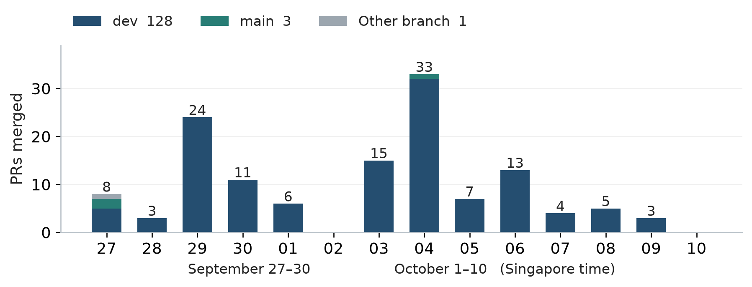
Figure 1 Daily PR merges by destination branch, dated in Singapore time. The 10 October bar ends at 20:44 SGT. PRs include product changes, documentation, dependencies, tests and infrastructure.
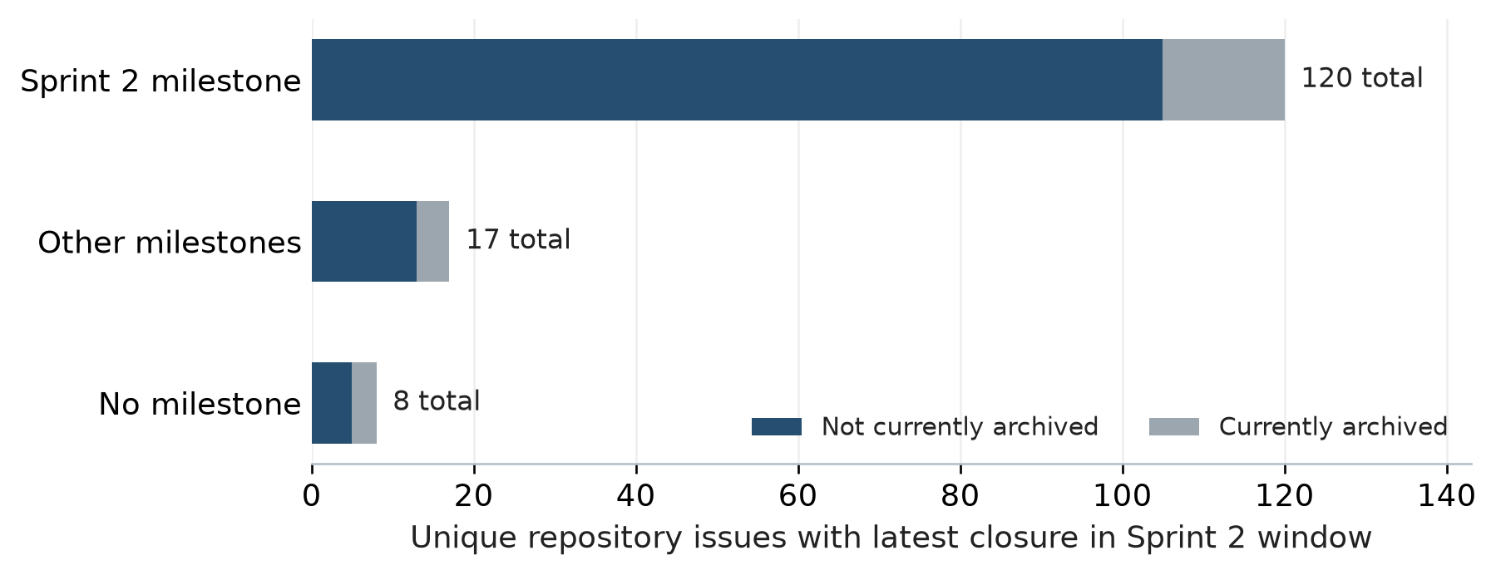
Figure 2 All repository issues closed during the reporting period, including additional scope. Milestone assignment and archived labels reflect the snapshot. Each issue is counted once; 22 archived closures are shown separately.
During the reporting period, 143 issues were opened and 145 distinct issues were closed. Of the closures, 120 are assigned to Sprint 2, 17 to other milestones and eight have no milestone. The total includes 123 non-archived closures and 22 archived items, which cover retired or superseded scope.
The current Sprint 2 milestone contains 135 issues, with 126 closed and nine open. This includes issues closed before the reporting period. The two open mvp-labelled items are release environment completion (#230) and final-report assembly (#362).
Daily effort and stable story-point estimates were not recorded. The charts show issue state and delivery activity; reopening an issue does not represent an additional feature.
Sources: Sprint 2 milestone; Issue 230; Issue 362; PR 421

5 Performance measurements

Reducing database round trips
After the PostgreSQL bridge was introduced, request timing exposed unnecessary database round trips. Batched statements, cached signed-in identity and simpler chat writes reduced the work required by common requests. Chat submission fell from 38 to six round trips; archive retrieval fell from 21 to two.
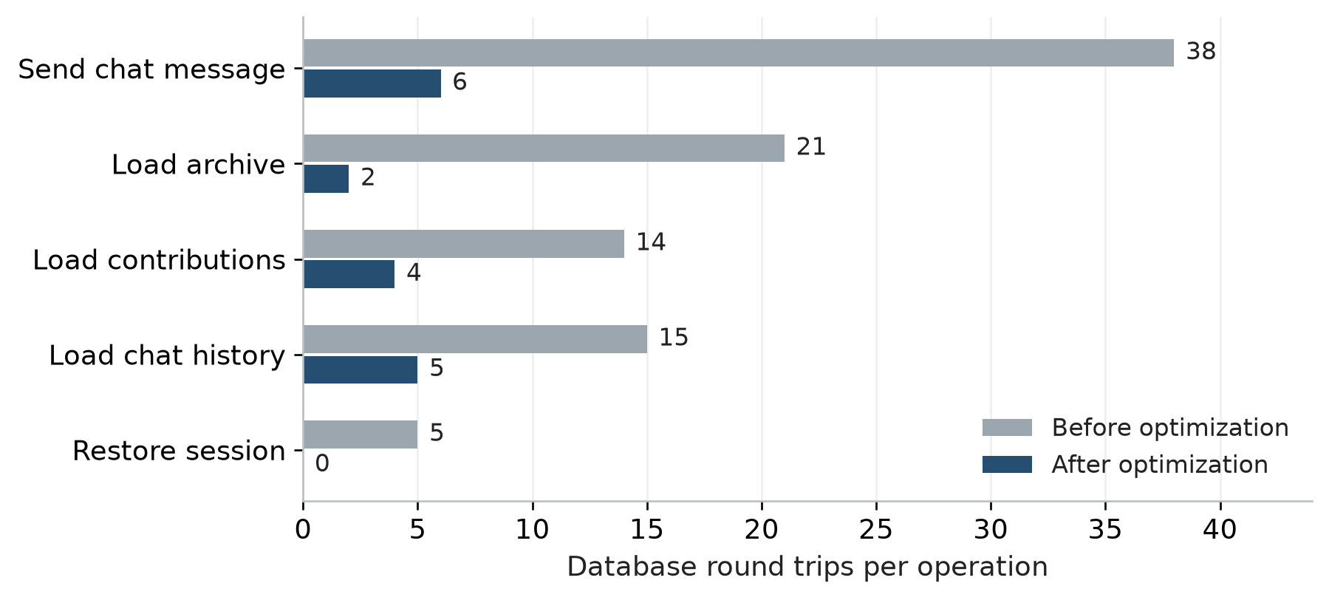
Figure 3 Database round trips reported in PR 506 and ADR 0003. Values count database exchanges, not response time. Zero for session restore depends on a reusable cached identity; it does not describe every cold or invalidated session request.

Local API and film measurements
Measured workload | Recorded result | Interpretation
Four API operations, three repetitions | 1,200 requests; no errors. p95 across operations/runs: 4.804–5.659 ms. | Local SQLite and loopback HTTP. The proposal target is p95 below 2 s under its bounded acceptance workload.
Five members and 25 six-second clips | Film end-to-end times: 4.566, 4.527 and 4.734 s. Output: 150.4 s. | Generated media and 180 × 320 output. The proposal target is compilation within 10 min; this is a local scenario.
Chronology, audio and privacy assertions | All 25 inputs decoded; output measured −17.4 LUFS; local owner/outsider denials passed. | Generated media was used for local decode and audio assertions. Captured camera footage, physical-device playback and hosted S3 were not measured.

The 3 October benchmark predates later capture and 720p film changes. It measures local SQLite and loopback HTTP behavior, not hosted PostgreSQL, Cognito, S3, remote networks or the latest film configuration.
Sources: PR 376; PR 506; Local measurement record

6 Recovery and engineering feedback
Local fast tests completed in 28.3–28.5 seconds after the runner improvements. A separate hosted-dev recovery rehearsal restored the database in 17 minutes, with a 5.6-minute recovery-point age.
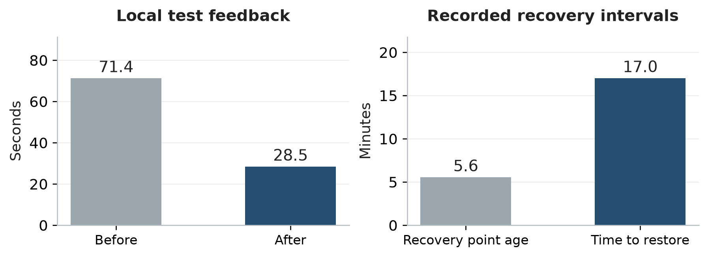
Figure 4 Local test timing and recorded dev recovery intervals. Test timing after the change was 28.3–28.5 s over three runs; the chart uses the slowest run. Recovery values come from a separate 7 October rehearsal. The proposal sets no numerical RPO or RTO threshold.

Managed database recovery
Recovery observation | Recorded result
Recovery point age at restore | 334 s, approximately 5.6 min
Time to a verified restored database | 1,022 s, approximately 17 min; 1,017 s was instance creation
Data reconciliation | 38 tables and 889 rows identical to live
Independent logical backup | Nightly dump restored and verified before upload; 38 tables
Fallback limitation | Returning to the retained SQLite snapshot loses subsequent PostgreSQL writes; lossless export is open in #505

The managed database provides automatic snapshots and point-in-time recovery. The independent nightly logical copy offers a separate recovery route; the runbook states a 24-hour recovery-point bound if managed backups are also lost. The database has no standby. Point-in-time restore is the recovery path for instance loss.

Faster feedback without dropping checks
PR 517 builds the server once and runs the root, server and Jest suites concurrently with capped workers. The reported local test:fast duration dropped from 71.4 s to 28.3–28.5 s. CI also split static checks, cached browser tooling and removed duplicate setup. These timings describe recorded local runs rather than a guarantee for every CI attempt.
Sources: PR 508; PR 517; Issue 172; Issue 505

7 Quality and deployment
The latest dev Quality run and deployment succeeded for revision 7bab402 on 9 October. Quality completed at 13:21 SGT and deployment at 13:24 SGT.

Latest executed test suites
Suite | Passed | Skipped
Root suite | 167 | 1
Python IaC gate tests | 6 | 0
Server on SQLite | 469 | 8
Server on PostgreSQL 17 | 443 | 34
Frontend Jest | 568 tests in 53 suites | 0

SQLite and PostgreSQL run the same server suite with engine-specific exclusions, so their results are reported separately. All listed suites reported zero failed tests.
Coverage measure | Server V8 | Frontend Jest
Statements | 89.06% | 75.55%
Branches | 83.94% | 72.99%
Functions | 88.47% | 72.58%

Statement, branch and function coverage was measured for the instrumented server and frontend source.

Workflow attempts during the reporting period
Workflow | Success | Failure | Cancelled
Quality, all events | 497 | 65 | 48
Dev deployment, dev push events | 71 | 13 | 0

The 610 Quality and 84 deployment records are workflow attempts, including retries; they are not pass rates or counts of unique releases. The first Cognito deployment failed because the runtime image omitted required packages. PR 511 corrected the packaging and added a regression check.
The latest dev run skipped web export and browser/accessibility checks. Physical-device evidence remains incomplete for the installed Home Screen journey, managed sign-in and visible reminder delivery.
Sources: Latest Quality; Latest dev deployment; PR 511

8 Problems encountered and action plan
The remaining work concerns release parity, lossless recovery and client verification.
Problem or constraint | Action and current position | Tracking
Dev and release have different capabilities | Dev uses PostgreSQL and Cognito. Release remains on an older main revision and SQLite; complete the isolated release environment and managed-service deployment. | Open #230, #504, #515
Database rollback is not lossless | The retained SQLite snapshot excludes writes made after cutover. Add validated PostgreSQL-to-SQLite export and rehearse preservation of new writes. | Open #505
Device proof is narrower than implementation | Use the real Safari/Home Screen path for capture, sign-in, invitation return, reveal and reminders. Treat simulator and protocol fixtures according to what they exercised. | #249, #352; recorded limits
Hosted deployment exposed missing dependencies | Cognito packages were omitted from the pruned server image. Runtime roots and an import-closure check were added; the latest deployment succeeded. | Resolved by PR #511
CI still waits by polling Quality | Local and CI execution improved, but deploy triggering remains a follow-up. Connect deployment to the completed Quality event without weakening the exact-revision check. | Open #497, #498
Operational records do not provide paging | API errors, job/reminder failures and transitions are recorded. CloudWatch paging and dashboards are not implemented; operators inspect logs and PostgreSQL state. | #166, PR #518
Contribution and effort imbalance | Sang Haoxiang completed no work during Sprint 2. Assign the remaining work across the participating members. | Team contribution record
Final project report remains open | Complete the final project report and contribution records. | Open #362

Retired operational work
The Demo-era cost-safety audit was removed after its delivery mechanism had failed and its alarm had no recipients. Existing budget alerts remain. Backup-gated hibernation was retired because hosted dev now runs continuously with PostgreSQL and S3.
Sources: Issue 230; Issue 504; Issue 505; Issue 515; PR 516; PR 518; PR 519

9 Team contribution summary
Work covered requirements, implementation, integration and verification. Individual effort hours were not recorded.
Project member | Activity and workstream | Achievement and remarks
NGUYEN KIM LONG | Contributed to backlog refinement, real-account and private-group requirements, invitations, and access-rule review. | Account and group capabilities were delivered as part of the team’s integrated product work.
GOPAL GURUPRASATH | Contributed to implementation coordination and pair programming, capture and contribution integration, and infrastructure and release work. | The core increment was integrated. Hosted release work remains in progress.
JIANG JIAYU | Contributed to technical integration, runtime boundaries and the server and media workflow, including persistence, jobs, compilation and recovery. | Runtime work was integrated into the product. Release persistence and lossless rollback remain outstanding.
PHAN MAI TAN LOI | Contributed to the application shell, mobile layouts, capture, chat and archive interactions, accessibility, and journey evidence. | Interface improvements were integrated. Target-device verification remains incomplete.
SANG HAOXIANG | No work completed during Sprint 2. | Sang Haoxiang completed no work during Sprint 2. This non-contribution was raised with Prof Chandra.

Capacity implications
Assign owners to the remaining release, device-verification and final-report work, and record completed contributions.

10 Retrospective and next sprint

What went well
The team delivered an integrated real-account flow covering private groups, contribution, compilation, reveal and archive. Follow-up fixes addressed integration behavior that isolated component tests had missed, including Safari media handling, keyboard coverage and runtime image dependencies.
The late database work brought persistence closer to the proposal and produced measurable recovery evidence. Request timing identified avoidable round trips, while faster local tests improved iteration without removing assertions or the aggregate check.

What could have been better
The Sprint milestone changed substantially during the period, and some tasks closed through scope decisions. Scope and milestone changes complicated tracking of the planned Sprint work. Release promotion also lagged behind dev: the first promotion occurred on 4 October, while later PostgreSQL and Cognito changes remain dev-only.
Physical-device verification and individual effort records remain incomplete. Participation was uneven, while release, device-verification and reporting work remains outstanding.

Actions for 11–24 October
Priority | Next outcome | Tracking
Release consistency | Complete isolated release operation, managed PostgreSQL and backup support, and managed sign-in; deploy and verify these capabilities in the release environment. | #230, #504, #515
Recovery integrity | Deliver and rehearse a lossless rollback that preserves post-cutover writes. | #505
Client journey evidence | Verify account entry, invitation return, capture, reveal, archive and reminder consent and delivery in Safari and the Home Screen app. Record any remaining limitations. | Real product flow
Engineering feedback | Complete the deploy-trigger follow-up and keep Quality tied to the exact deployed revision. | #497, #498
Assessment and contributions | Complete the final report covering requirement changes, current diagrams, verified results and team contributions. | #362

11 Supporting records
Supporting records cover the original requirements, measured performance, database recovery and automated verification.

Project proposal and Sprint scope
Original project outcomes and the Sprint 2 delivery scope used to assess progress.
Rewind project proposal

Performance measurements
The local workload record and database design decision underpinning the reported timing and round-trip results.
Local measurement record
PostgreSQL batching decision (ADR 0003)

Database recovery records
Operations guidance for managed backups, restoration and the limits of the recorded recovery exercise.
PostgreSQL operations and recovery runbook

Automated verification and deployment
Executed workflow records for the latest dev Quality check and deployment at the reported revision.
Latest dev Quality run
Latest dev deployment

