**Online Appendix:**

**Socially-interacting or indifferent neighbors? Randomization of movement paths to tease apart social preference and spatial constraints**

**Construction of Biased Correlated Random Walk (BCRW) models**

We parameterized our BCRW simulations to correspond with the empirical lizard data. For all scenarios we simulated a population of 60 agents with an initial density of 0.97 agents per ha. Each model included 5000 time-steps distributed as 50 steps on each of 100 days. We sampled *L* from a gamma distribution with scale of 1.96 and shape of 3.571 resulting in a positive step length range of ca. 0 to 40 m (effectively: 0.05-39.62 m) and daily paths length of 343±35 m (mean±STD; range: 220-482). We sampled *μ* from a Von-Mises distribution with concentration parameter of Kappa=3. The weight of the correlation component was 0.7 (i.e. the weight of the bias is 0.3) resulting in a maximal daily displacement of 84±29 m (24-246).

Agents were placed randomly and independently of each other at the beginning of each simulation, with the exception of the ‘paired agents’ scenario, where pairs where placed within 200 m from each other. Scenarios differed in the movement rules, and specifically in the protocol for selecting the bias point (but not in the weight of the bias component). In the ‘static activity area’ scenario the bias-point of each agent was set as its origin for the entire simulation, effectively functioning as the centre of its home range (HR). In contrast, in the ‘paired agents’ scenario the bias point was updated every time step, to be the mean spatial location of the agent’s origin and the current location of its partner. This resulted in agents maintaining confined HR along with conspecific attraction towards a specific agent.

In a third simulation, aimed at providing another control for false negative (Type II) errors, we constructed a scenario of ‘sociable agents’ with conspecific attraction (see map in Figure 1; main text). In this scenario agents are attracted towards the (currently) nearest agent. Here, the bias point of each agent is updated every time-step to be the location of the nearest agent, regardless its identity and distance (i.e., there is no preference to particular agent). Since agents lack a fixed bias point they randomly drift in space and their movement is not confined to a HR. The original PBSN in this scenario should have substantially higher degree and edge-weight compared to the realizations generated by path-randomizations (that break movement synchrony among agents). Indeed the PBSN generated by the ‘sociable agents’ scenario included many more associations than other scenarios (e.g., indices were 4 to 12 fold higher than those of the ‘static activity-areas’ scenario with *socially indifferent* agents) with a total of 28080 associations. Each agent had 936.0±73.6 associations (779-1070), degree of 27.3±7.2 (9-42) and edge-weight of 0.187±0.015 (0.156-0.214). These values are also significantly higher than those obtained after path-randomizations: Degree: 18.7±5.5; *T*59=17.7, *P*=2*10-25; *X* ∼ *B*(60, 0.5), *P*(*X* ≤ 0)= 8.6*10-19; Edge-weight: 0.0179±0.0055; *T*59=99, *P*=2*10-37; *X* ∼ *B*(60, 0.5), *P*(*X* ≤ 0)= 8.6*10-19 (Figure A1).

**Additional results for Part I: path-randomization method**

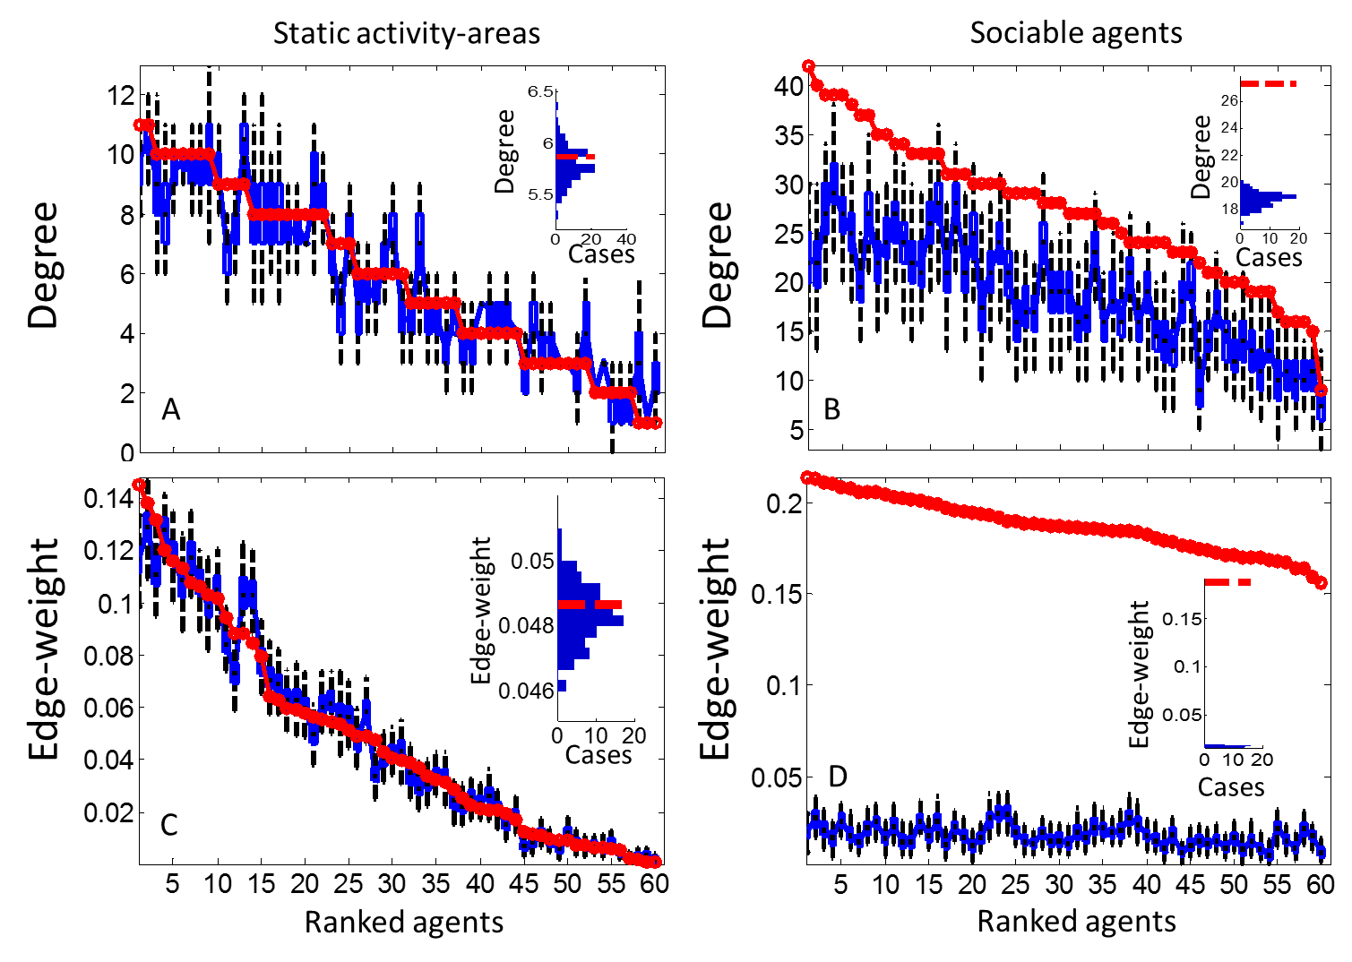

**Figure S1.** The effect of PBSN randomization on agents degree (A, B) and edge-weight (C, D) for ‘static activity-areas’ (A, C) and ‘sociable-agents’ (B, D) simulation scenarios. For each agent, index value in the original PBSN (solid, thick, red line) is compared with the corresponding range of values from 100 realizations (blue boxplot: 25th to 75th percentiles, whiskers: 1.5 interquartile distance). The insets to the right present histograms of the mean index values for the entire population across realizations (red dashed line- the original PBSN). For the ‘static activity-areas’ scenario simulating *socially indifferent* agents the randomized PBSNs did not differ from the original one (i.e., there was no Type I error). For the ‘sociable agents’ scenario, the degree and edge weights were much higher in the original network (i.e., there was no Type II error).

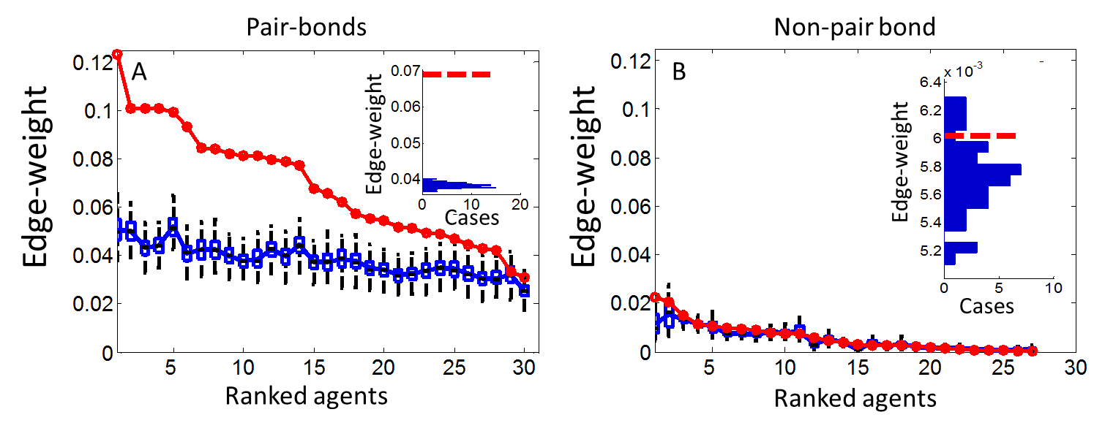

**Figure S2.** Partitioning the contribution of pair-bonds (A) and non-pair bonds (B) to the difference in edge-weight between the original and the randomized PBSNs in the ‘paired agents’ simulation scenario (see Figure 2C; main text). For each agent, original edge-weight (solid, thick, red line) is compared with the corresponding range of values from 100 realizations (blue boxplot: 25th to 75th percentiles, whiskers: 1.5 interquartile distance). The insets to the right present histograms of the mean values for the entire population across realizations (red dashed line- the original PBSN). Note that there are 30 agents in the pair-bond PBSN (A; one from each pair), but 3 of those had no associations with other agents (B). By disrupting the synchronised, sociable movements of the pairs the randomizations result in lower values than from the original PBSN for these edges (A), but they have no effect on the association rates of other dyads (B) indicating that these are not different from random.

**Method resilience to missing data and biased sampling across individuals**

A common problem in many movement studies is the structure of the dataset. Even when using advanced loggers like GPS tags that presumably sample locations at fixed time intervals, gaps of missing data points are frequent from various reasons, such as the different deployment times, behaviour of the focal organism (e.g. , going into dens) or the habitat they reside in (e.g., locations with dense forest canopy). These gaps can vary in magnitude among tracked individuals, resulting in uneven sampling intensity, with some individuals being tracked for shorter periods or simply having higher frequencies of missing data points. Synchrony among individuals in timing of missing points can also vary between fully synchronized (e.g. when fix failure is driven by external conditions like overcast) to independently-timed gaps for each individual.

To test the sensitivity of our path-randomization method to these issues we used our BCRW simulation where subsampling allows us to create uneven datasets and compare it to a full dataset. Specifically, we have used the ‘paired agents’ scenario where, in accordance with the *a-priory* expectation, the randomized realizations resulted in similar degrees but lower edge weights compared to the original PBSN. Hence, when applied to a subsetted dataset the method can be considered as being consistent with the correct results if it detects no difference in agents Degree but a significant different in the edge-weight when comparing a PBSN with its realizations. In contrast, finding a significant difference in degrees can be considered as a false positive and failing to detect a difference in edge-weight as a false negative error.

We subsetted the original dataset from this scenario to have 25%, 50%, 75% and 100% of the agents with missing data at levels of 5%,25%, 50%, 75% and 95% of their data points. This resulted in 20 subsetted datasets. For instance, since the original datasets contains 3*105 data points (60 agents*5000 time steps) a subtest in which 25% of the agents have only 50% of their points includes 262500 data points (data for agents with missing data+ data for remaining agents with complete data: 60*0.25*5000*0.5 + 60*(1-0.25)*5000). Further, we have repeated this design twice - once with independent timing of missing points (i.e., a new set of missing points is drawn for each agent that has missing data); second, with fully synchronized gaps (i.e. all agents with missing data have the same missing data points). Altogether this subsetting strategy allows us to account for the effect of increasing levels of missing data (e.g., comparing results for subsets with 100% of the agents having different levels of missing data), increasing levels of uneven sampling (comparing subsets with different proportions of missing individuals) and the effect of synchrony in missing data. We present the results as a heat-map for each network index (degree and edge-weight), separately for independent and synchronized missing data (Figure A3). To account for the fact that each scenario (e.g. degree, independent) included 20 comparisons we also apply Bonferroni correction for multiple comparison (i.e., using a critical *P* of 0.0025).

We found that our method provided the comparable results (i.e., the same results as in the original dataset) over a wide range of data subsetting regimes (Figure A3). When missing data points were not synchronized among agents, the method was able to distinguish the edge-weights between the PBSN and its realizations in all subsetted datasets except the case were all 60 individuals had 95% of their data points missing. In few instances with high levels of missing data points or for many agents we found marginally significant differences (0.017<*P*<0.05) in agents degree between the original PBSN (based on a subsetted dataset) and its realizations (i.e., a false positive error) but none of these differences remained significant after Bonferroni correction. When missing points where fully synchronized among agents with missing data the ability to detect the true pattern was hampered in high levels of missing data. Subsetting datasets with 75% or more of the data points missing for 50% of the agents (and vice versa) resulted in false positive rejection of degree similarity. In subsets with 95% missing data for 50% of the agents or more we also encountered false negative errors, were we failed to detect the difference in edge-weight between the original PBSN and its realizations. In both subsetting regimes edge weight were less sensitive than degrees. Since agents in this scenario associated frequently with their partners, and only infrequently with other agents, the edge-weight distribution is highly skewed and strongly influenced by the pair-bond. Hence, losing a proportion of the associations had a weak effect on edge-weight, but stronger effect on degree (for a dyad that interacted once in the original dataset a single association loss will affect agents degree).

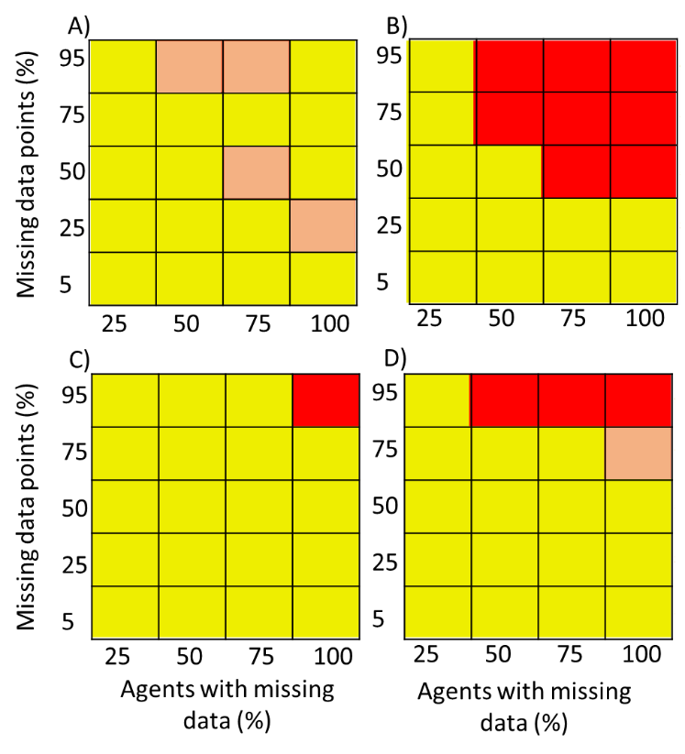

**Figure S3.** Heat map for the performance of our path-randomization method on incomplete datasets with different subsetting designs. Panels are agents degree (A, B) and edge-weight (C, D) for datasets with missing points chosen independently for each agent (A, C) or in full synchronization among agents (B, D; i.e., the same data points are missing for all agents that have missing data). Yellow- results that agree with *a-priory* expectations and with results for the complete dataset (similar degrees in the original PBSN and its randomization; significantly stronger edge-weights in the original PBSN). Orange- an error (e.g. rejecting similarity between the original PBSN and its realizations where they should be similar) that is not significant after Bonferroni correction. Red- an error that remains significant after Bonferroni correction.

**Additional results for Part II: accounting for temporal dynamics by time window adjustment**

**The ‘changing activity-areas’ BCRW scenarios**

As illustrated below (Figure A4), temporal changes in animals space use can result in an apparent signal of social response when they are not accounted for by the randomization method. To demonstrate this problem as well as the ability of our path-randomization method to solve it, we introduce two scenarios where the socially indifferent agents shift their activity areas during the simulation. In these scenarios (see map in Figure 1; main text) the location of the bias point changes along the simulation, and they are otherwise identical to the ‘static activity areas’ scenario in all parameters. In the ‘abruptly-changing activity-areas’ scenario, the bias point of each agent shifts from its origin 50 m to the right after 2500 time steps (50 days), simulating a spatial shift of an important resource. Consequently, HRs for the entire 5000 steps will spread-out on the east-west axis while all other variables (e.g., density, travelled distance) remain unchanged. In the ‘gradually-changing activity-areas’ scenario the bias-point gradually changes its position (0.5 m day-1) to obtain the same shift of 50 m (we tested both scenarios also with shifts of 100 and 200 m).

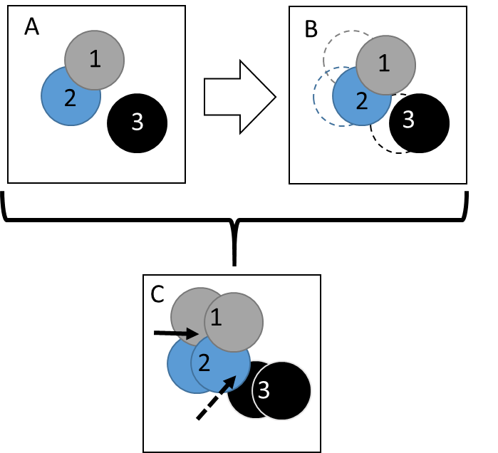

**Figure S4.** A cartoon illustrating how changes in activity areas can generate false signals of social structure if the effects of these temporal dynamics are not addressed. Here, three hypothetical individuals shift their activity areas (numbered circles) along time. A) Activity areas during the first period (e.g., days 1-50 in the ‘abruptly-changing activity area scenario’, or lizards during the early season). B) Activity areas during a subsequent period after a spatial shift to the right (e.g., days 51-100 in the simulation, or lizards during late season). C) The overall activity areas during the both periods combined. The solid arrow indicates how randomization of the entire track (from both early and late parts of the area) may underestimate the encounter intensity (edge-weight) of individuals 1 and 2 by allowing them to move over larger areas, thus creating a false positive of observed conspecific attraction. The dashed arrow indicates how randomization of the entire track may allow encounters between individuals 2 and 3. Since this encounter is impossible in real life, such randomization may lead to overestimation of expected degrees and to a false positive signal of conspecific avoidance (see also Figure A5).

**Table S1.** An illustration of the randomization protocol for part I and part II with a dataset of 12 days. In Part I the original days are shuffled within the entire dataset (here, one example is given). In part II shuffling is constrained among days within a period defined by the time window (tw). Here we provide two examples using tw=3 and tw=4 and annotate periods with different letters. Arrows indicate the shuffled positions of the first day in the randomized datasets.

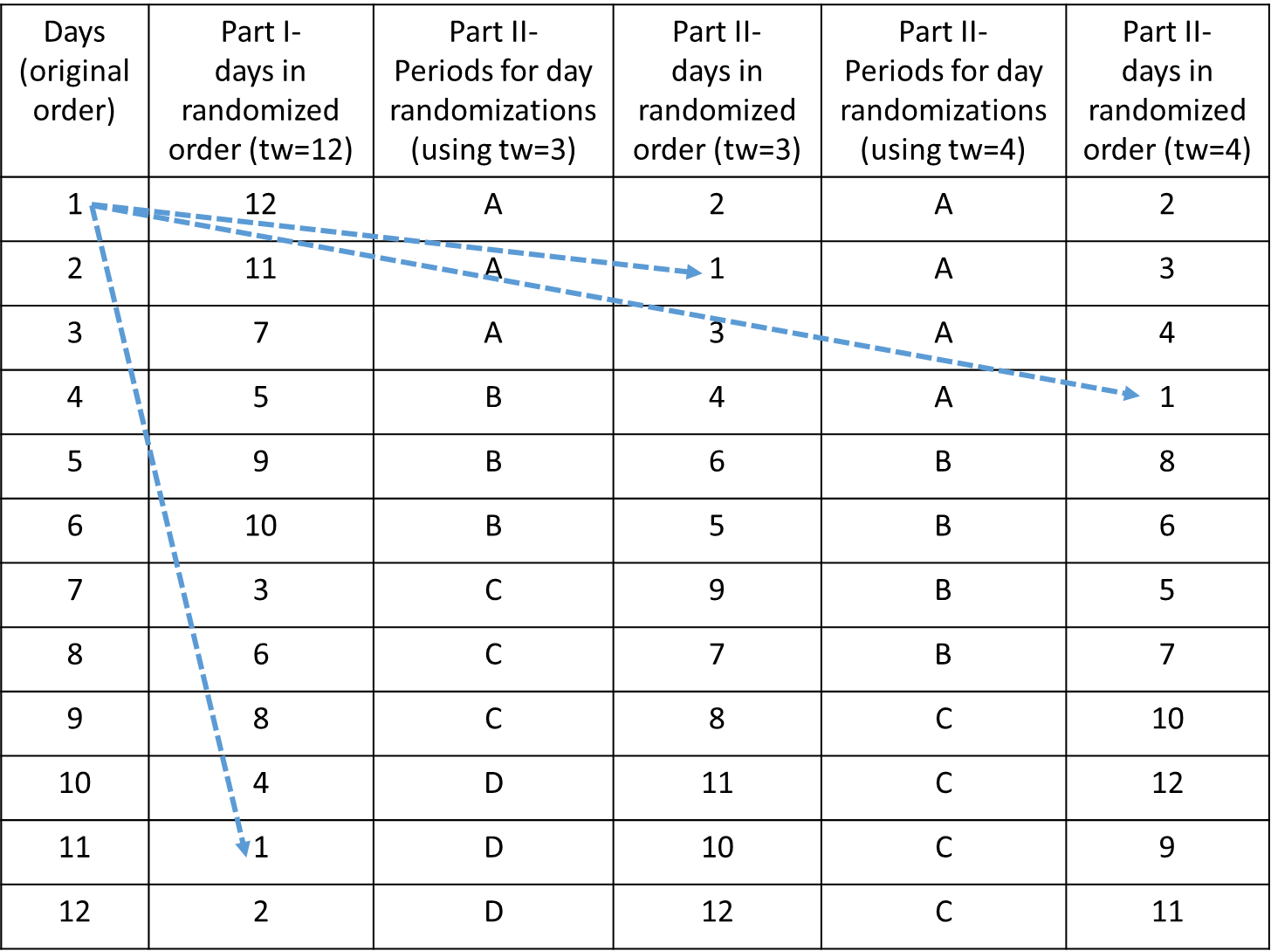

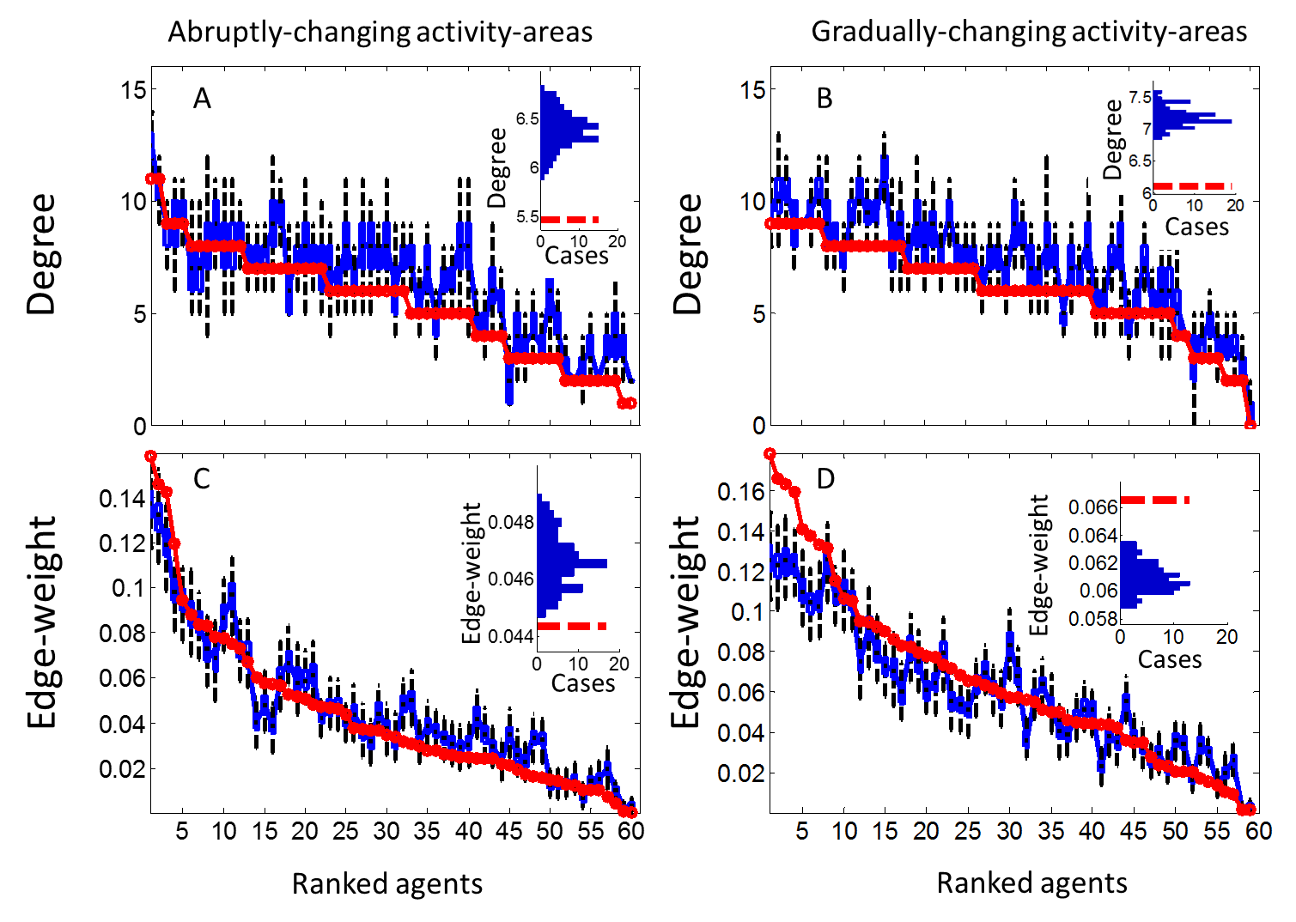

**Figure S5.**  The effect of PBSN randomization on individuals’ degree (A, B) and edge-weight (C, D) for ‘abruptly-changing activity-areas’ (A, C) and ‘gradually-changing activity-areas’ (B, D) simulation scenarios. For each agent, index value in the original PBSN (solid, thick, red line) is compared with the corresponding range of values from 100 realizations (blue boxplot: 25th to 75th percentiles, whiskers: 1.5 interquartile distance). The insets to the right present histograms of the mean index values for the entire population across realizations (red dashed line- the original PBSN). There is a significant difference in degrees between the original PBSN in the abrupt scenario and its realizations (*T*59=6.88, *P*=4.3*10-9; *X* ∼ *B*(60, 0.5), *P*(*X* ≤ 50)= 1.5*10-8), implying that agents appear as interacting with less agents than expected by chance. The population’s mean for agent’s edge-weight is also significantly lower (*X* ∼ *B*(60, 0.5), *P*(*X* ≤ 40)= 0.003), but this difference is very small (~0.02, equivalent to 1-2 time steps in the simulation) and non-significant in a paired design (*T*59=1.75, *P*=0.08). Since both scenarios included socially indifferent agents that shift their activity area throughout the simulation, the differences between the randomized networks and the original ones are an artefact (i.e., only an *apparent* conspecific avoidance). Overall, this figure demonstrates how failing to account for the effects of temporal environmental dynamic may result in false-positive identification of a social structure.

**Figure S6.** The effect of randomization time-window (*tw*) on deviation of the PBSNs realization from the original network using two BCRW scenarios. Data points are the deviation of populations’ mean degree (A, B) or edge-weight (C, D). The zero base-line and expected 1/*tw* fit to the data are presented (red-dashed and dotted-black lines, respectively). In the ‘gradually-changing activity-areas’ scenario (A, C) the bias-point of the agents changes daily leading to larger deviations (from the observed PBSN) as *tw* grows. For the ‘sociable agents’ scenario (B, D) the original PBSN has higher degree and edge-weight than its realizations since even short *tw*s interfere with synchronized movements. Error-bars are S.E. of mean values over 100 PBSN realizations. Note log-scale for X axis and the different scales of the y axes.

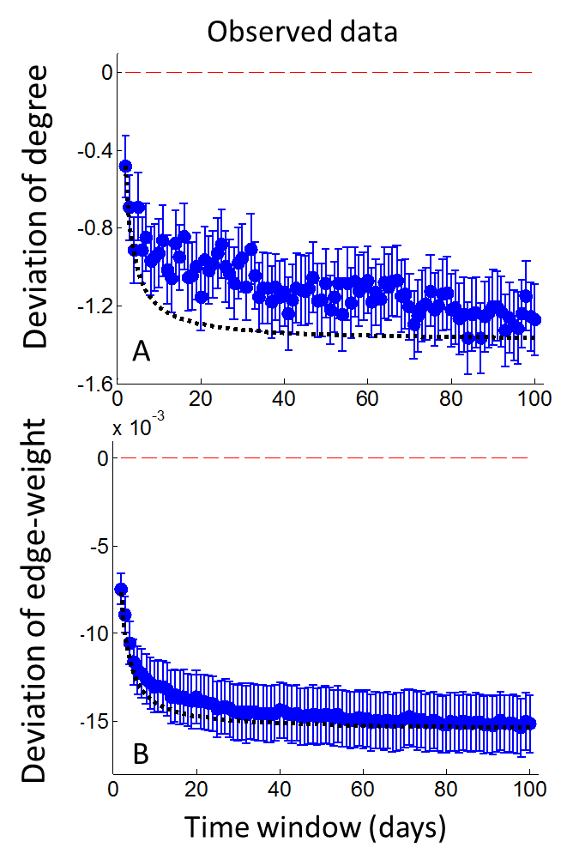**Figure S7.** The effect of randomization time-window (*tw*) on deviation of the PBSNs realizations from the observed networks in the lizards’ population in degree (A) and edge-weight (B). The zero base-line and expected 1/*tw* fit to the data are presented (red-dashed and dotted black-lines, respectively). This figure repeats the analysis presented in the main text using 99 values of *tw* (2-100; instead of a subset of 9 values used in Figure 4) to demonstrate how *tw* can be modified continuously. Changes in degree are noisier than in edge-weight since for each iteration (N=30 instead of 100 in the original analysis) the former is averaged across individuals within the population (n=60) whereas the latter is also averaged on the different edges of each individual. Error-bars are S.E. of mean values over 30 PBSN realizations.