Linear Scales
An experimental field for musical composition

« perceptions can be learned »

I DEFINITIONS
Musical Scale, a series of frequencies fixing the pitches of the sounds , according to a given musical system.
any graduated sequence of notes, tones, or intervals dividing what is called an octave.(Britannica)
Gamme, any graduated sequence of notes, tones, or intervals dividing what is called an octave.
Octave, a series of notes occupying the interval between (and including) two notes, one having twice or half the frequency of vibration of the other.
Harmonics are a series of overtones resulting when the frequencies are exact multiples of the fundamental frequency.
Arithmetic progression or arithmetic sequence is a sequence of numbers such that the difference between the consecutive terms is constant. The sequence of harmonics f, 2*f, 3*f,...n*f , is an arithmetic progression.
Linear Gamme (GL), in this document, a sequence of notes, in the span of an octave, such that the difference between the consecutive pitch frequencies be constant.
A Linear Gamme is a finite arithmetic progression. It is a discrete set of frequencies of the harmonics arithmetic progression in the interval of an octave:
where b is the base and f the fundamental frequency(Hz)
Base of a Linear Gamme, in this document, this is the integer ,which is the the rank of the first harmonic of the finite progression :
example : b=6
linear gamme base 6, GL6 [6f,12f] , the progression is 6f, 7f, 8f, 9f, 10f, 11f, 12f.
There is an infinity of Linear Gammes from to

The first column indicates the rank of the first note therefore the base of the linear scale considered.
fig. 1 Linear Gammes from base 1 to base 9

Linear Pitch , in a given Linear Gamme the pitch of one note is given by the corresponding harmonic number.
Interval, or distance betwe en two pitches, is mathematically described as the ratio of the frequency of the first pitch to the frequency of the second.
Epimore Intervals or superparticular ratio, the ratio of two consecutive integer numbers, the interval between two consecutive pitches of a Linear Gamme.

fig. 2: Epimore intervals from 1 to 18
Epimere intervals or superpartient ratios, in this document, the ratios between pitches of a Linear Gamme and the pitch of the base.
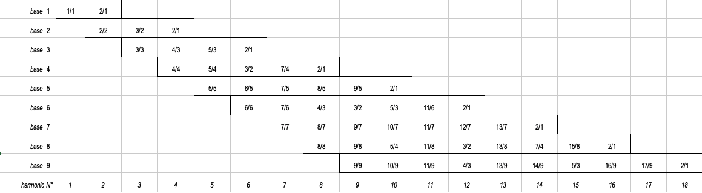
fig. 3: Epimere intervals of Linear Gammes base 1 to base 9

Each octave in the series of harmonics has its own specific system of intervals.
linear gamme presents a specific system of intervals (figure 2). that we find the intervals in consonance order;
note that in the scale 'base 2 we find the 3/2 fifth, in the third we find the fourth, the major sixth, in the fourth we find the triad major third 5/4 and fifth 3/2 and a remarkable interval 7 / 4, the seventh harmonic minor which will polarize the preceding triad. The fifth nexus 5 scale features the third harmonic minor 6/5, Euler's tritone 7/5, the minor sixth 8/5 and the minor seventh just 9/5 with an interval a little larger than the harmonic minor seventh.
Note that a linear range with a given Nexus contains all the intervals of the lower Nexus ranges.

Linear scale, not to be confused with a Linear Gamme, is a musical scale system using Linear Gammes.

Compound Linear Scale, a Linear Scale build with two Linear Gammes in the span of the octave:

II THE EXPERIMENTAL FIELD

Compound Linear Scales BxBy

Convention 1: 12 notes per octave
To use the western modern music notation, notehead on the staff lines.
To implement the tuning linear scales system on piano/keys and some real or virtual instruments.

Convention 2: two Linear Gammes overlapped in the span of one octave,
the note C being the common first degree of each one
Let BxBy be a compound linear scale composed of 2 gammes Glx of base x and Gly of base y: according to convention 1, the sum of the degrees of GLx and GLy must be 12 (counting only once the common notes).
- Example B6B7: the only common note of B6B7 is C. The sum of the degrees will be equal to 6+7-1=12.
- Example B6B8: 2 common intervals , 1/1 and 3/2. The sum of the degrees will be equal to 6+8-2=12.
- Example B6B9: 3 common intervals, 1/1, 4/3 and 5/3. The sum of the degrees will be equal to 6+9-3=12.

Convention 3: C, the common first degree of both gammes.
Corollaries :
- The frequency is the same for the first degree (C) of each Linear Gamme.
- The fundamental frequencies of the two overlapped gammes are in the inverse ratio of their bases :
Example B6B7:

Convention 4: the reference frequency (diapason) is A3 (440 Hz)

To assign a note to each degree assuming an increasing progression and therefore to compare the intervals, for example 7/6 of B6 compared to 8/7 of B7, no need to calculate the values ​​in cents, just use the cross product:
(ad)> (bc) ==> (a / b)> (c / d) so 7x7> 6x8.

A first field of experience: the B6B7 composite scale

Allocation of notes for the B6 scale

fig. 4: notes allocation for B6 scale

The B6 scale is a series of 6 sounds in the octave:
Let Fb6 be the fundamental frequency (E-3)
- degree 1: C corresponds to the frequency Fb6 x 6
- degree 2: D corresponds to the frequency Fb6 x 7
- ...
- degree 6: A# corresponds to the frequency Fb6 x 11

Consecutive super-partial intervals are 7/6, 8/7, 9/8, 10/9, 11/10

The fundamental frequency Fb for a given octave corresponds to the degree of the scale: d = 9 - b located 4 octaves below.
The frequency Fb corresponds to degree 9-b = 9-6, E-3

Allocation of notes for the B7 scale

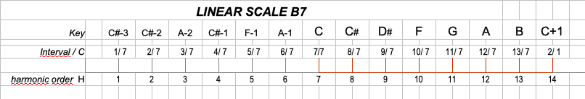fig. 5: notes allocation for B7 scale

The B7 scale is a series of 7 sounds in the octave:

- degree 1: C corresponds to the frequency Fb7 x 7
- degree 2: C# corresponds to the frequency Fb7 x 8
- ...
- degree 7: B corresponds to the frequency Fb7 x 13

Consecutive super-partial intervals are 8/7, 9/8, 10/9, 11/10, 12/10, 13/10
The frequency Fb7 corresponds to degree 9-b = 9-7, C # -3

mode, in music, any of several ways of ordering the notes of a scale according to the intervals they form with the tonic, thus providing a theoretical framework for the melody. A mode is the vocabulary of a melody; it specifies which notes can be used and indicates which have special importance. Of these, there are two principal notes: the final, on which the melody ends, and the dominant, which is the secondary centre. The modes of Greek antiquity were placed by theorists in orderly fashion within a larger context. Although the modes were a series of seven-note diatonic scales …(100 of 2490 words)

Goldstone, R. L., & Byrge, L. A. (2015). Perceptual Learning

