aka_name

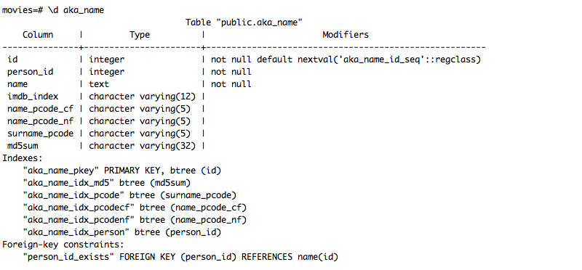

aka_name_id_seq

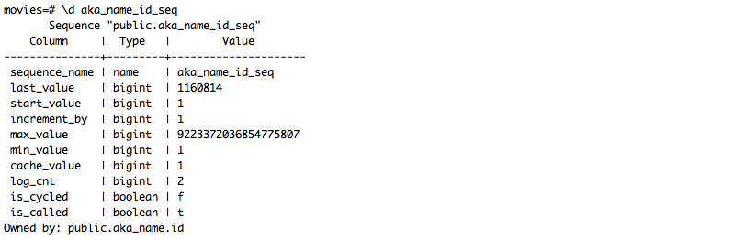

aka_title

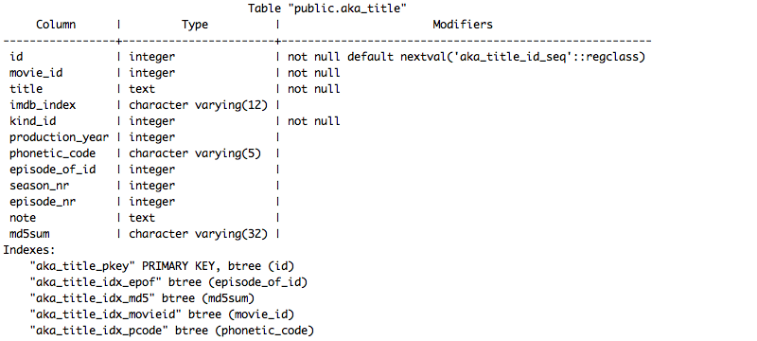

aka_title_id_seq

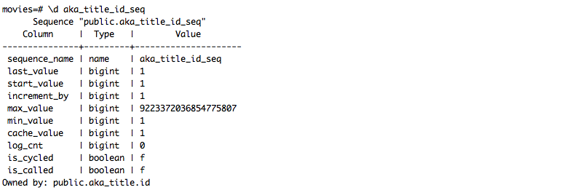

cast_info

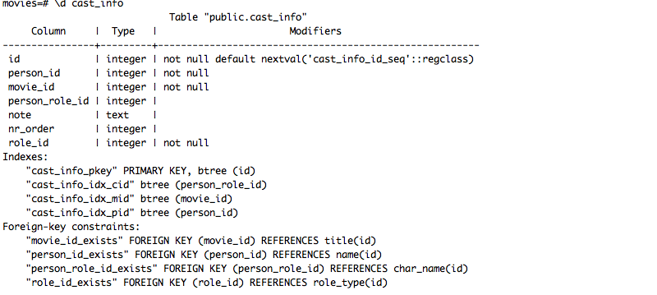

cast_info_id_seq

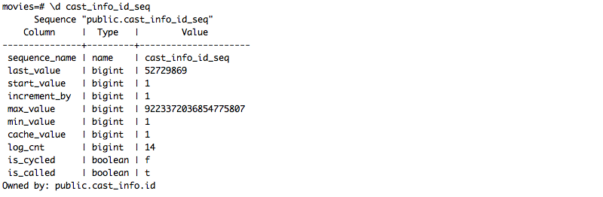

char_name

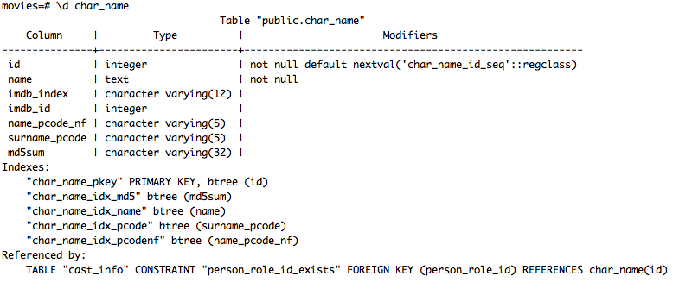

char_name_id_seq

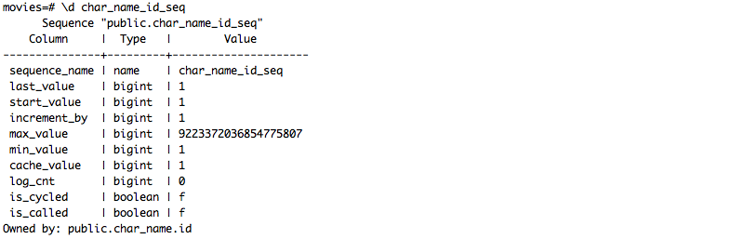

comp_cast_type

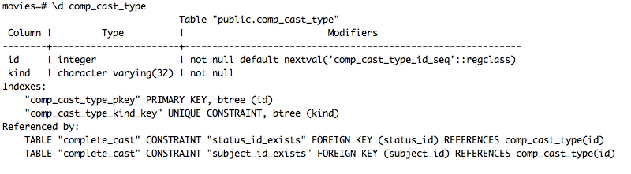

comp_cast_type_id_seq

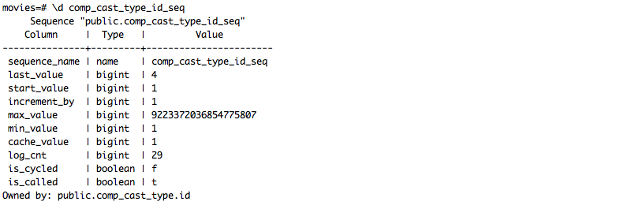

company_name

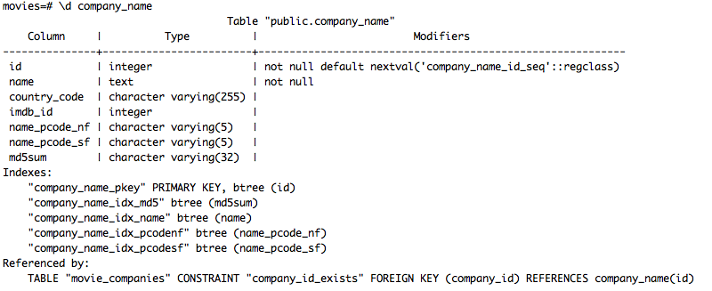

company_name_id_seq

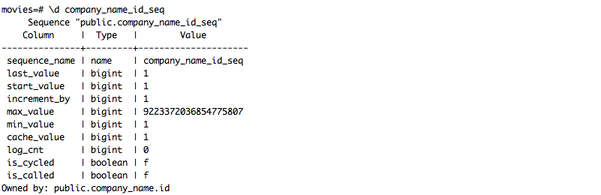

company_type

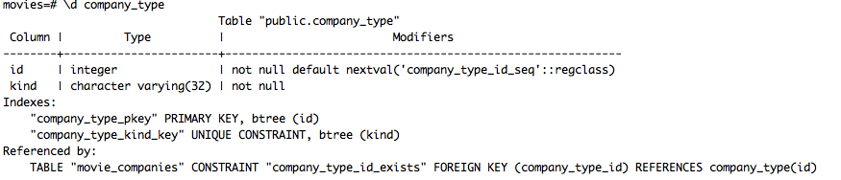company_type_id_seq

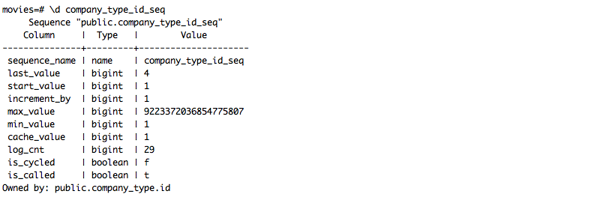

complete_cast

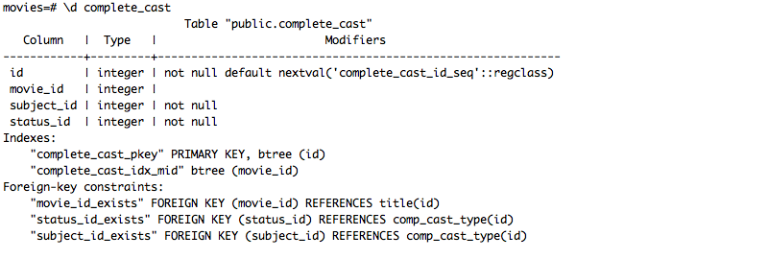

complete_cast_id_seq

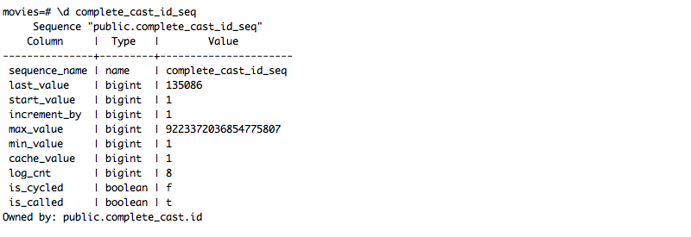

info_type

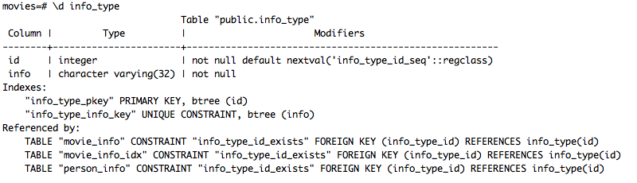

info_type_id_seq

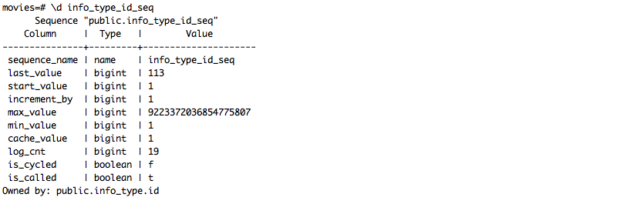

keyword

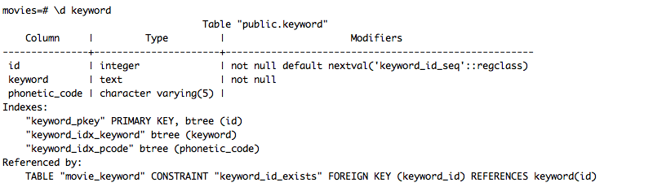

keyword_id_seq

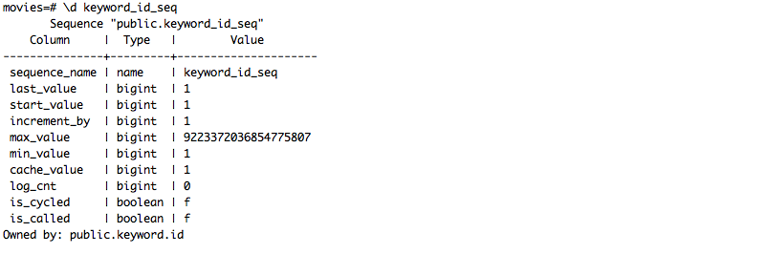

kind_type

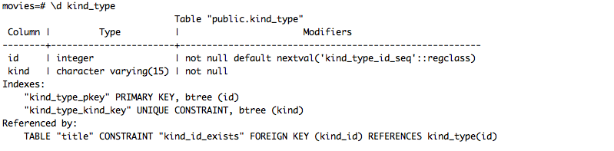

kind_type_id_seq

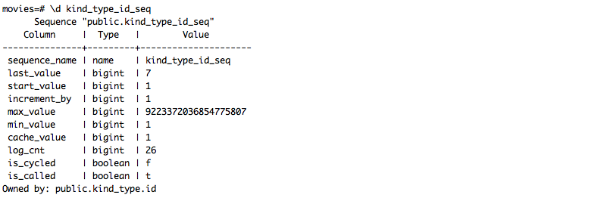

link_type

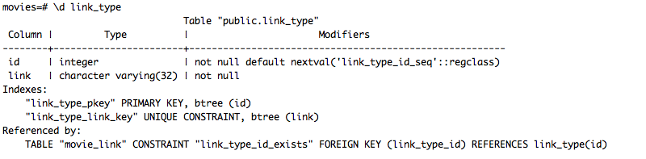

link_type_id_seq

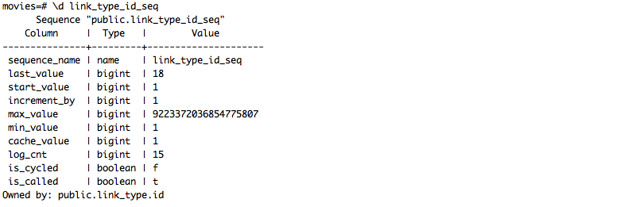

movie_companies

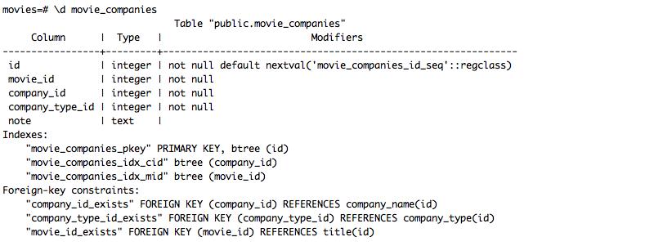

movie_companies_id_seq

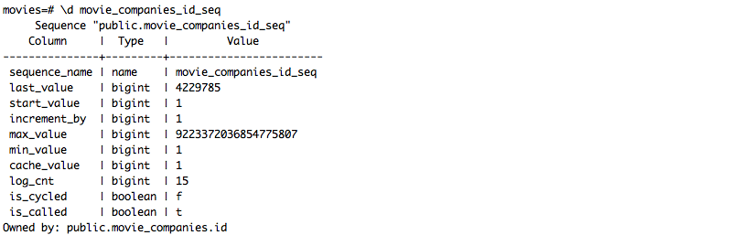

movie_info

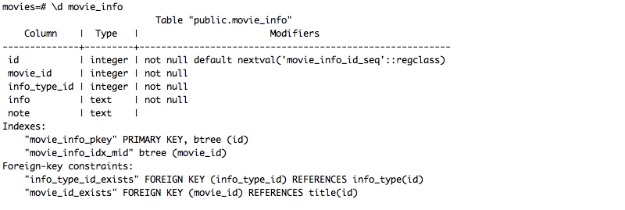

movie_info_id_seq

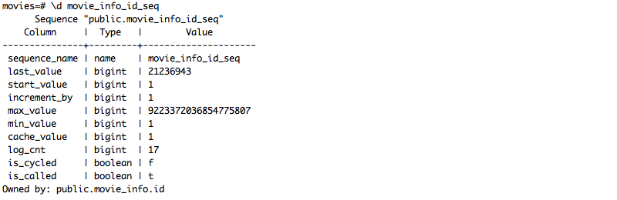

movie_info_idx

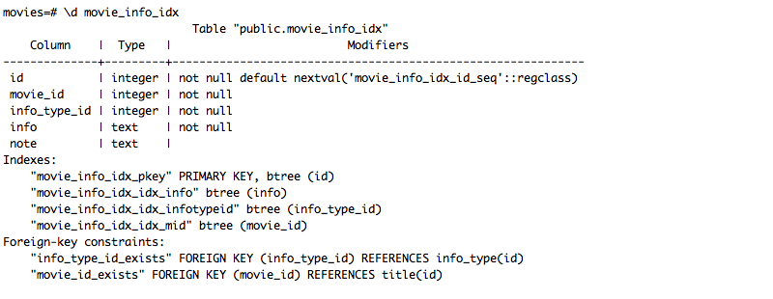

movie_info_idx_id_seq

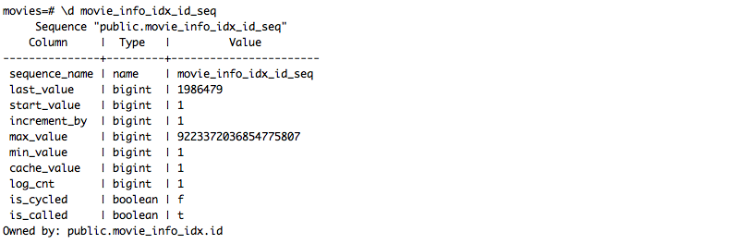

movie_keyword

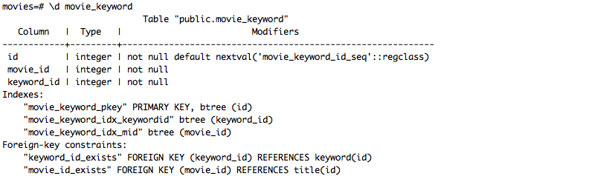

movie_keyword_id_seq

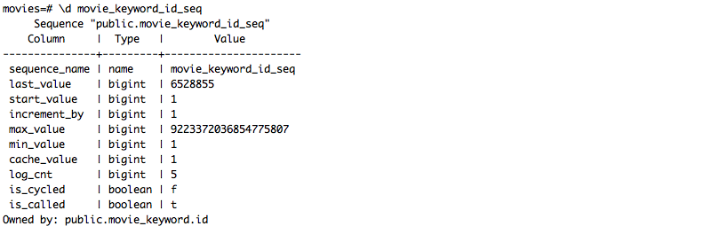

movie_link

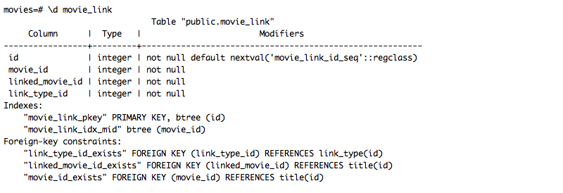

movie_link_id_seq

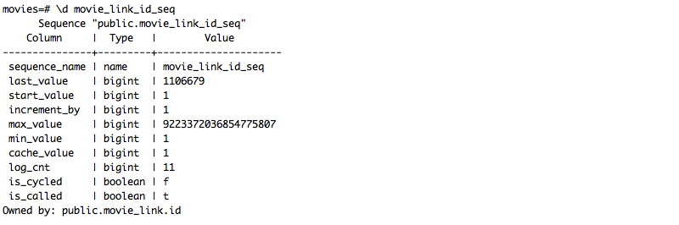

name

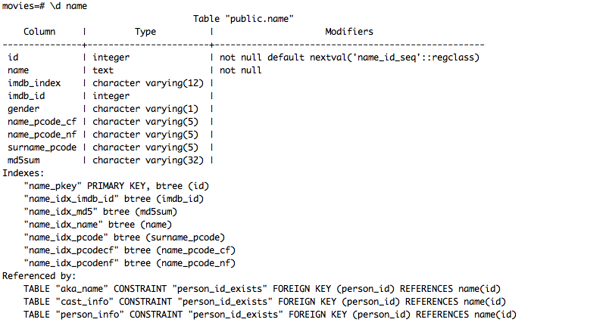

name_id_seq

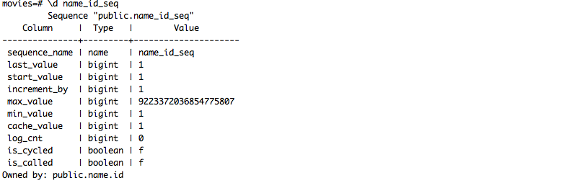

person_info

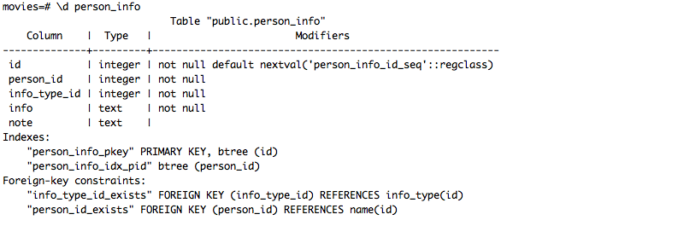

person_info_id_seq

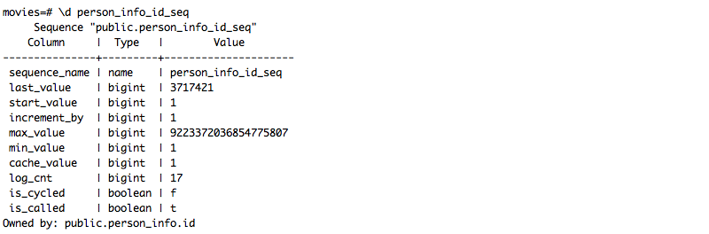

role_type

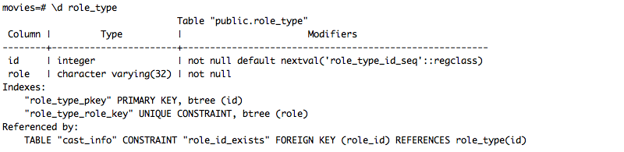

role_type_id_seq

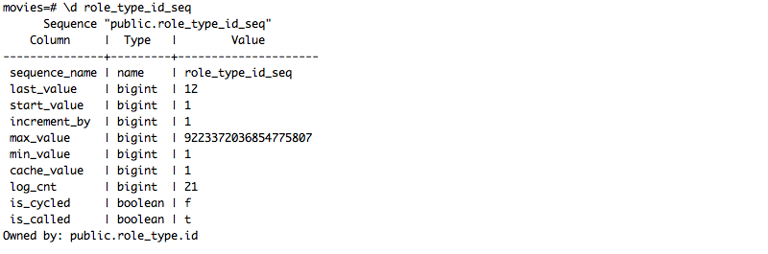

title_id_seq

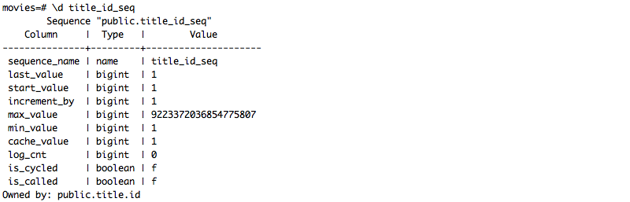

title

