**1050 Programming Logic**

Lab 3 (20 points total)

Name: __**Colleen Overbaugh**_________________________

*Paste your code and screenshots below.*

1. Compare and contrast the if single-selection statement and the while repetition statement. How are these two statements similar? How are they different? (2 Points). **The if single-selection statement and the while statement only run when the statement is true otherwise the program skips the action and ends. The difference between the two is that the while statement is used to increment and decrement values and will repeat zero or more times.**
2. Declare two int variables: 1) speedLimit and 2) speed. Assign values speedLimit=35 and speed=42. Write an if statement that displays “SLOW NOW” if speed is greater than speedLimit. (2 points)
3. if-else statement - Write a program that declares and assigns a value to a Boolean variable called isTrue. Use a condition to output “It is True!” or “It is False!” based on the assigned value. Paste your code and screenshots of your program running with both true and false values (3 points).

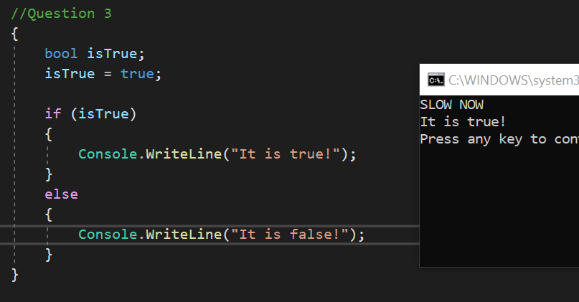

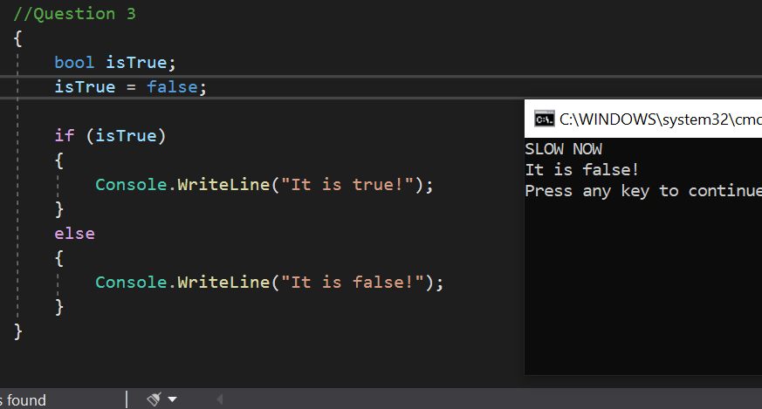

1. if statement - Write a program that converts a Fahrenheit temperature to Celsius. The user should be able to input the temperature at the Command prompt and it should output the temperature. In addition, you should output “It is cold” if the Fahrenheit value is less that 40 or it should output “It is hot” if the temperature is over 90 (4 points). ***Code to read a value: double fahrenheit = Convert.ToDouble(Console.ReadLine()); Code to convert: celsius = (fahrenheit - 32d) * 5d / 9d;***
2. **Write a while loop** that outputs values 1-10. Increment by 1 (3 points).
3. **Write a while loop** that outputs values 60 to 20. Decrement by 1 (3 points)
4. **Create a while** that outputs values 10-20 (3 points).