**LAB 3 PRELAB – Operating System**

PART A –

i) Directory for running processes and the kernel: /proc

ii) Directory for boot loader files: /boot

iii) User home directory: /home/<username>

iv) Log files: /var/log

v) Home directory of root: /root

vi) Configuration files: /etc

vii) Temporary mount systems: /tmp

viii) Device files: /dev

ix) System administration binary files not required for boot: /sbin

x) Directory for files copied to new user's home directory: /etc/skel

xi) Object libraries, dynamic libraries, and executables: /usr/lib

xii) Directory for shared libraries necessary for boot and running root commands: /lib

xiii) Manual pages: /usr/share/man or /usr/local/man

xiv) Mailboxes: /var/mail

PART B

a –

b –

c-

d-



PART C –

10 a-

10 b-

11- Because the directory is not empty, the right command should be rm -rf

12- It deletes because the directory was empty and rmdir is used to delete empty directories only

14 –

15.

16-



PART D

17- 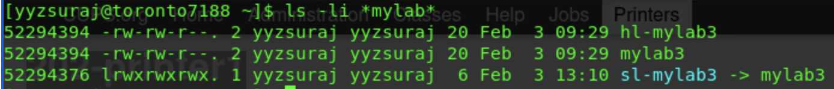

18-



PART E

25-

