Lab 6 - Application Programming

1.

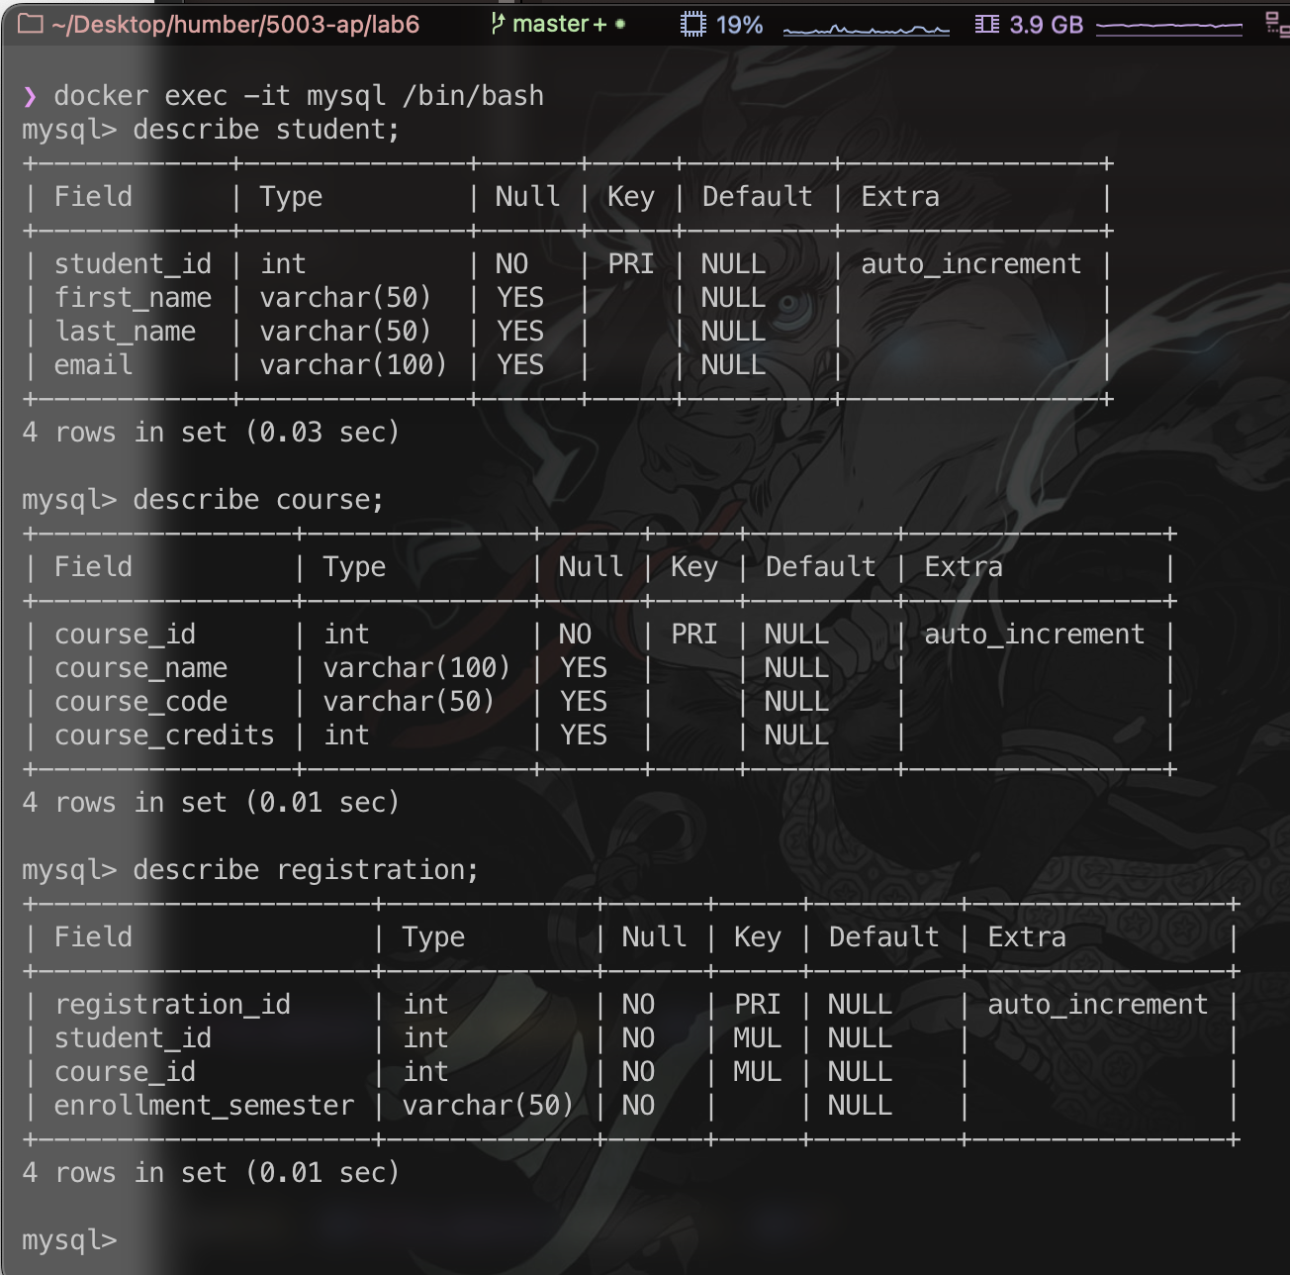Scripts to generate the tables are in migrations > create_tables.py

You can execute this by selecting/entering the hidden option 444

2.

3.

4.

5.

6.

