**Perform the following DB operations using Cassandra.**

1.Create a keyspace by name Employee

create keyspace employee with replication = {‘class':'SimpleStrategy' , 'replication_factor' :1};  
2. Create a column family by name  
Employee-Info with attributes  
Emp_Id Primary Key, Emp_Name,  
Designation, Date_of_Joining, Salary,  
Dept_Name

create table employee_info(emp_id int,emp_name text, designation text, doj timestamp, salary double, dept_name text, primary key(emp_id,salary));

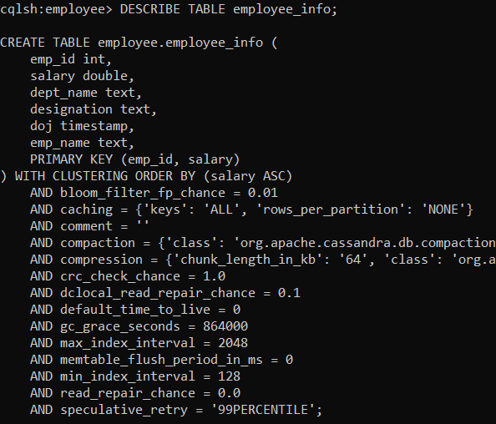

3. Insert the values into the table in batch

BEGIN BATCH

INSERT INTO employee_info(emp_id, emp_name, designation, doj, salary, dept_name) VALUES (121, 'Ravi', 'Manager', '2012-03-29', 200000, 'RD')

INSERT INTO employee_info(emp_id, emp_name, designation, doj, salary, dept_name) VALUES(122, 'David', 'Worker', '2013-02-27', 20000, 'Transport')

APPLY BATCH;

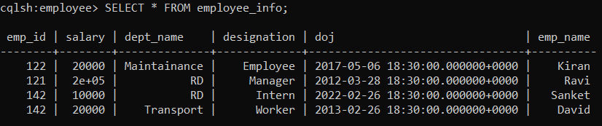

4. Update Employee name and Department of Emp-Id 121

update employee_info set emp_name='Ravi S', dept_name='Research' where emp_id=121 AND salary=200000;

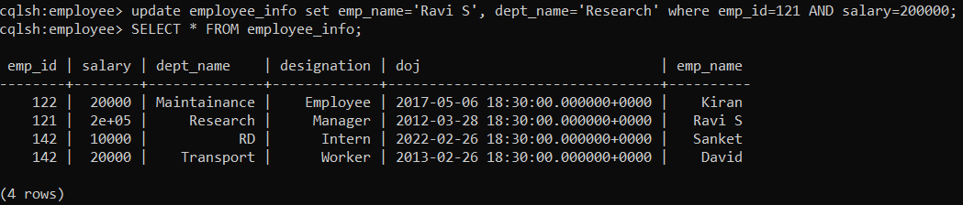  
5. Sort the details of Employee records based on salary

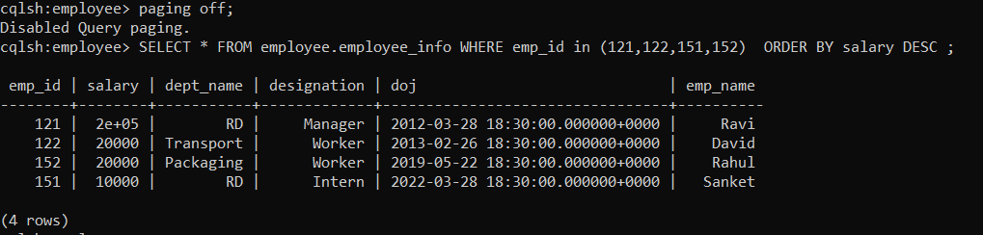

6. Alter the schema of the table Employee_Info to add a column Projects which stores a set of Projects done by the corresponding Employee.

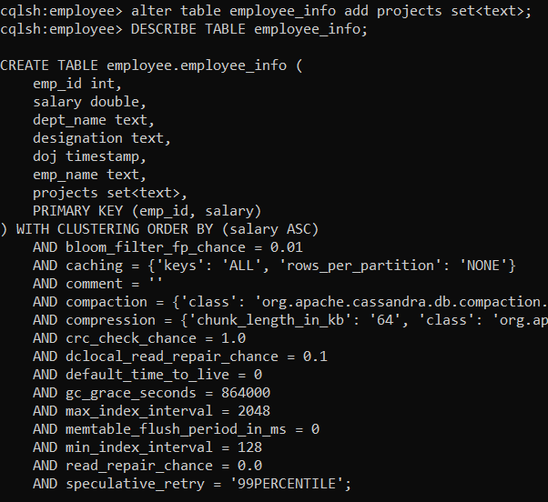

7. Update the altered table to add project names.

update employee_info set projects=projects+{'VGST'} where emp_id=121 AND salary=200000;

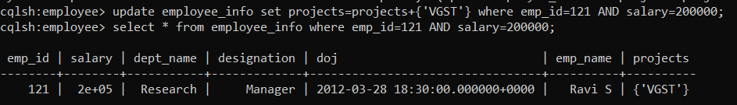  
8.Create a TTL of 15 seconds to display the values of Employee

cqlsh:employee> INSERT INTO employee_info(emp_id, emp_name, designation, doj, salary, dept_name) VALUES(149, 'Saket', 'Developer', '2021-02-20', 100000, 'RD') USING TTL 15;

cqlsh:employee> select ttl(emp_name) from employee_info Where emp_id=149;

