Create a key space by name Library



Create a column family by name Library-Info with attributes Stud_Id Primary Key,

Counter_value of type Counter,



3. Insert the values into the table in batch



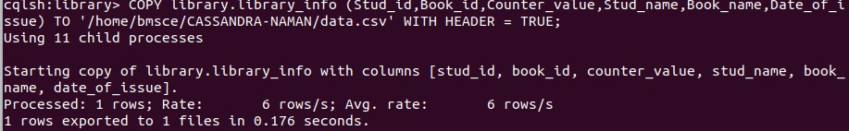Display the details of the table created and increase the value of the counter

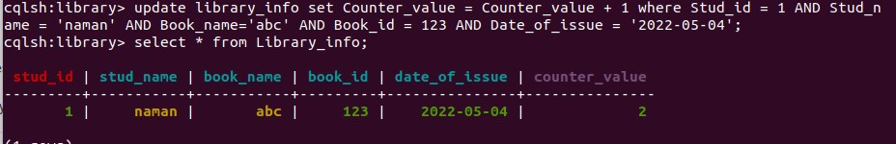

Write a query to show that a student with id 112 has taken a book “BDA” 2 times.

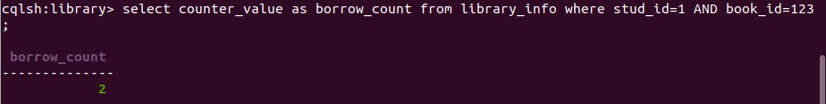

xport the created column to a csv file

Import a given csv dataset from local file system into Cassandra column family

