第2次作业

登录窗口

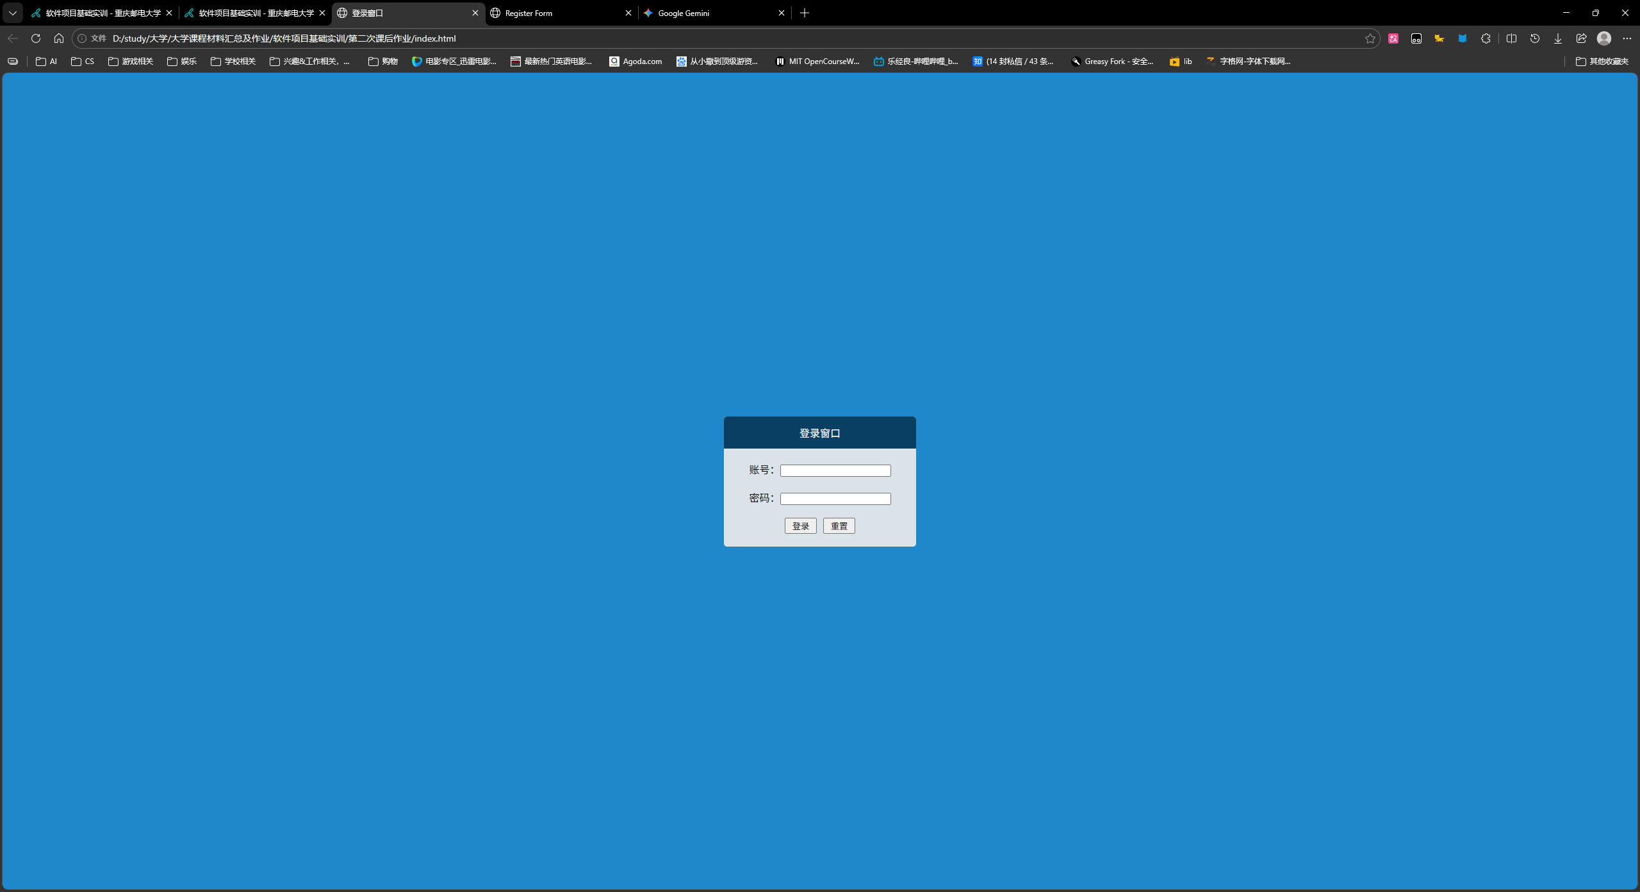
运行截图

index.html
<!DOCTYPE html>
<html lang="zh-CN">
<head>
<meta charset="UTF-8">
<meta name="viewport" content="width=device-width, initial-scale=1.0">
<title>登录窗口</title>
</head>
<body>
<div class="container">
<div class="header">登录窗口</div>
<div class="main">
<div>账号：<input type="text"></div>
<div>密码：<input type="password"></div>
<div class="button-wrap">
<button class="button">登录</button>
<button class="button">重置</button>
</div>
</div>
</div>
</body>
</html>

<style>
*{
margin: 0;
padding: 0;
box-sizing: border-box;
}

body{
background-color: #1F88CA;
display: flex;
flex-direction: column;
justify-content: center;
align-items: center;
height:100vh;
}

.container{
border-radius: 5px;
background-color: #DAE3E8;
display: flex;
flex-direction: column;
justify-content: center;
align-items: center;
gap:10px;
}

.header{
border-radius: 5px 5px 0 0;
display: flex;
justify-content: center;
align-items: center;
width: 300px;
height: 50px;
color:#fff;
background-color: #093F63;
}

.main{
margin-top: 10px;
display: flex;
flex-direction: column;
gap:20px;
}

.button-wrap{
margin-bottom: 20px;
display: flex;
justify-content: center;
align-items: center;
gap:10px;
}

.button{
width: 50px;
height: 25px;
}
</style>

Register Form

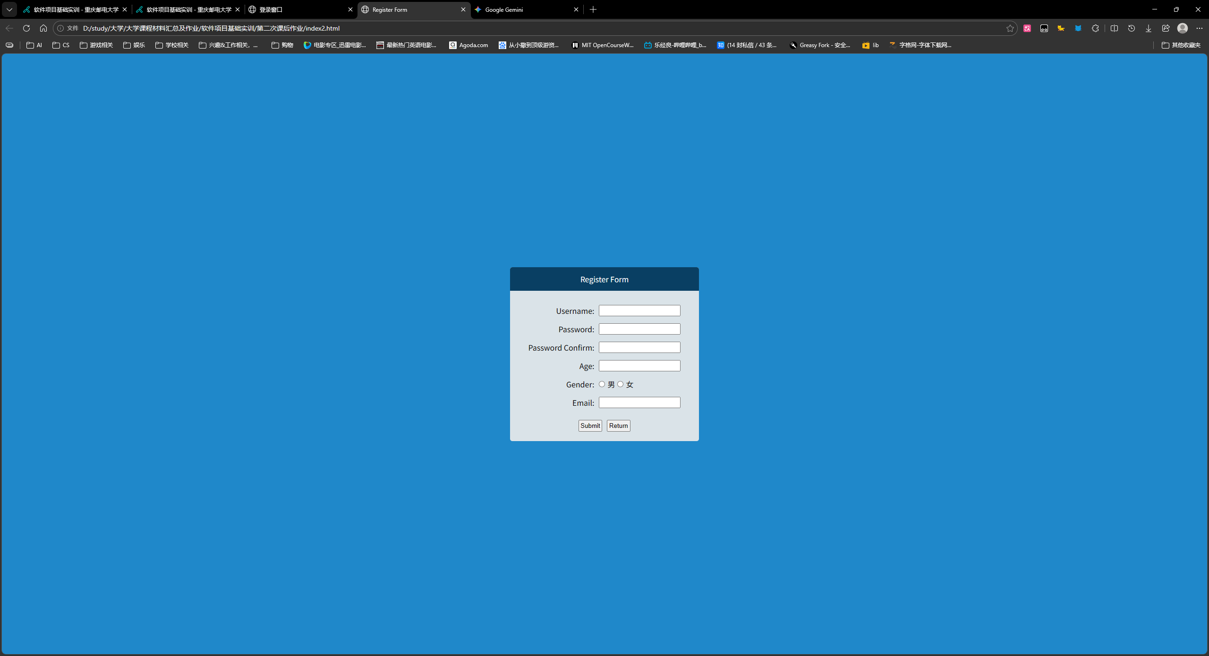
运行截图

index2.html
<!DOCTYPE html>
<html lang="zh-CN">

<head>
<meta charset="UTF-8">
<meta name="viewport" content="width=device-width, initial-scale=1.0">
<title>Register Form</title>
</head>

<body>
<div class="container">
<div class="header">Register Form</div>
<div class="main">
<div class="label">Username:</div> <input type="text">
<div class="label">Password:</div> <input type="password">
<div class="label">Password Confirm:</div> <input type="password">
<div class="label">Age:</div> <input type="text">
<div class="label">Gender:</div>
<div class="gender">
<input type="radio" name="gender">男<input type="radio" name="gender">女
</div>
<div class="label">Email:</div> <input type="text">
<div class="button-wrap">
<button class="button">Submit</button>
<button class="button">Return</button>
</div>
</div>
</div>
</body>

</html>

<style>
* {
margin: 0;
padding: 0;
box-sizing: border-box;
}

body {
background-color: #1F88CA;
display: flex;
flex-direction: column;
justify-content: center;
align-items: center;
height: 100vh;
}

.container {
border-radius: 5px;
background-color: #DAE3E8;
display: flex;
flex-direction: column;
justify-content: center;
align-items: center;
gap: 10px;
}

.header {
border-radius: 5px 5px 0 0;
display: flex;
justify-content: center;
align-items: center;
width: 400px;
height: 50px;
color: #fff;
background-color: #093F63;
}

.main {
margin-top: 10px;
display: grid;
grid-template-columns: auto 1fr;
gap: 15px 10px;
padding: 10px 20px;
}

.label {
text-align: right;
}

.gender {
display: flex;
gap: 5px;
}

.button-wrap {
grid-column: span 2;
margin: 10px 0;
display: flex;
justify-content: center;
align-items: center;
gap: 10px;
}

.button {
width: 50px;
height: 25px;
}
</style>

