SAT Math Algebra

1.  The graph of line g is shown in the xy-plane. Line k is defined by the equation $40x+py=w$. If line k is graphed in this xy-plane, resulting in the graph of a system of two linear equations, the system of two linear equations will have infinitely many solutions. Given the points $(0,1)$ and $(6,9)$, what is the value of $p+w$ where those points lie on the same line as line k?

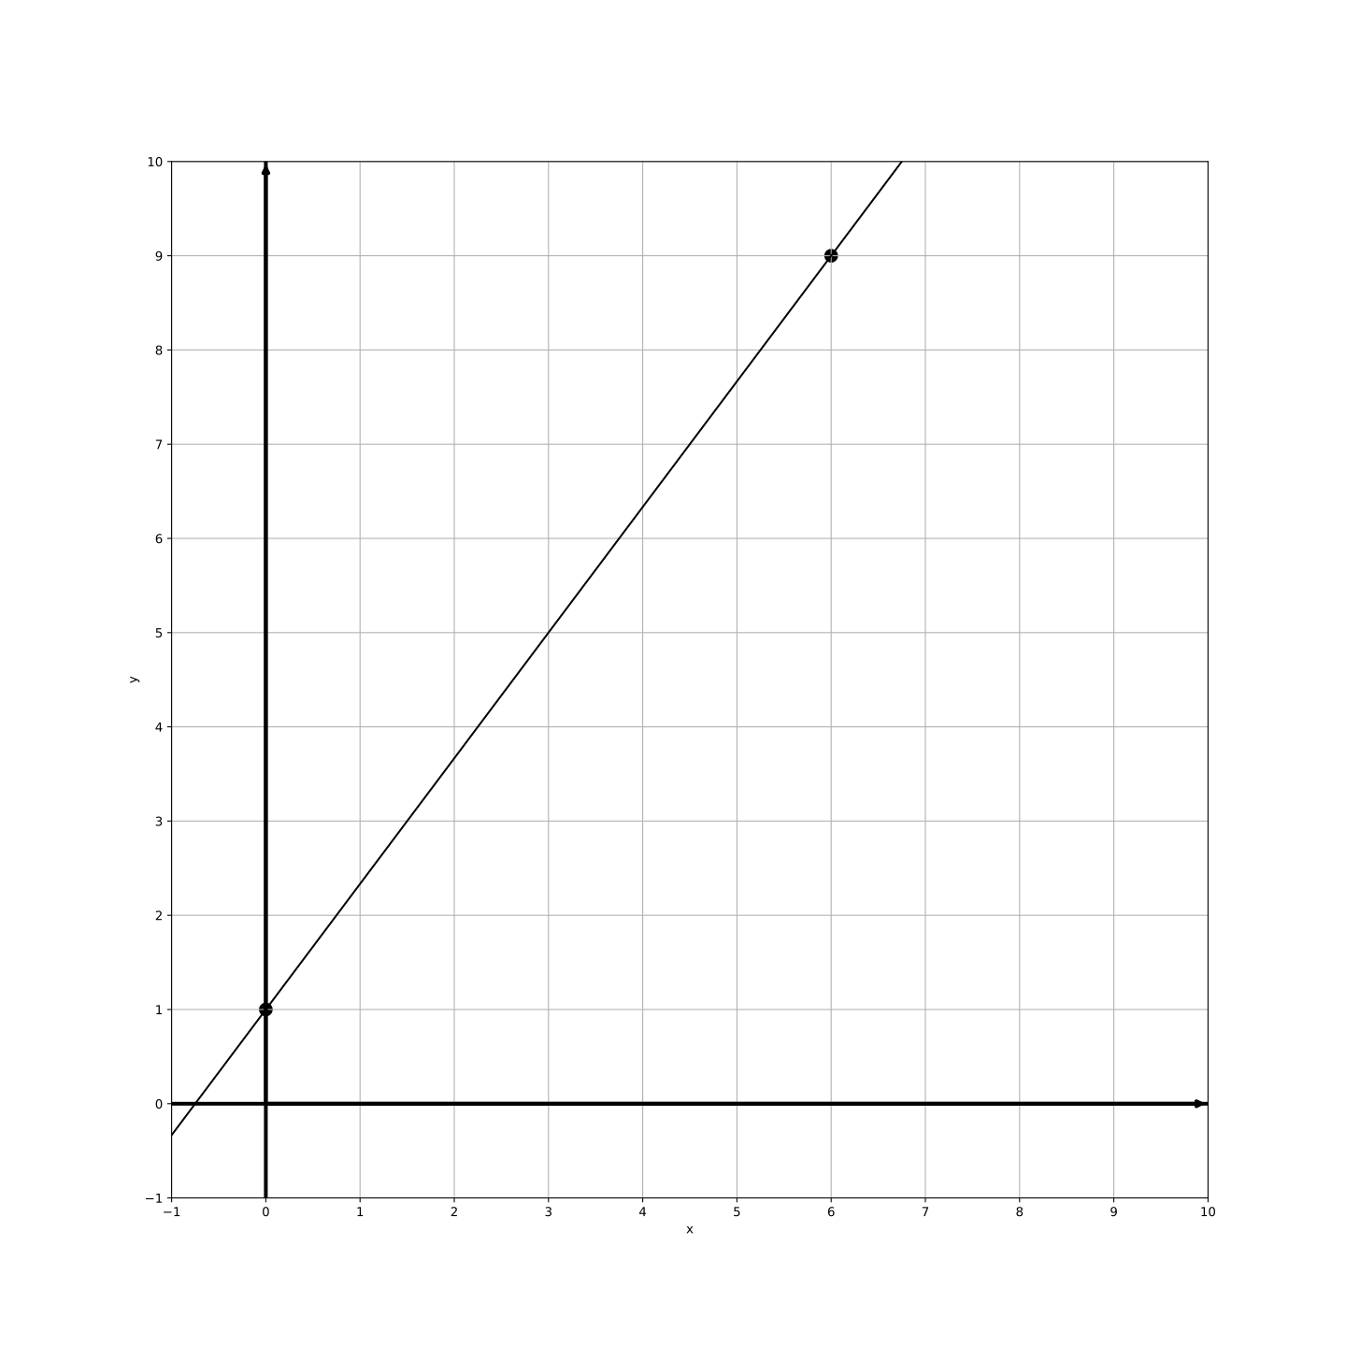

2.  The function f is defined by $f(x)=\frac{1}{m}x−5$, where m is an integer constant and $59≤m≤61$. For the graph of $y=f(x)+8$ in the xy-plane, what is the x-coordinate of a possible x-intercept?

3.  For the linear function p, the slope of the graph of $y=p(x)$ is 8, and it is known that $p(c)=189$ and $p(33)=165$. For the linear function t, it is given that $t(c)=10$ and $t(3)=−89$. What is the slope of the graph of $y=t(x)$ in the xy-plane?

A.   1

B.   2

C.   3

D.   4

4.  A company produces eco-friendly products. The total revenue of the company in the year 2023 is represented by the equation , where x represents the number of years since 2015. If the revenue is expected to reach 831 dollars in 2023, how many years since 2015 has the company been operating?

A.   10 years

B.   15 years

C.   18 years

D.   20 years

5.  If $86(x+9)=36(x+9)+150$, what is the value of $x+9$?

A.   -9

B.   -6

C. 3

D. 6

6.  The function f is defined by $f(x)=\frac{4}{85}x+23$. What is the value of $f(340)$?

7.  The table shows two values of x and their corresponding values of y. The graph of the linear equation representing this relationship passes through the point $(\frac{1}{2},a)$. What is the value of a?

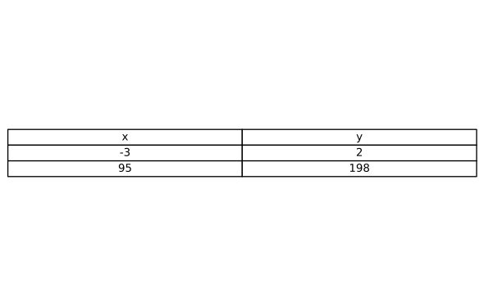

8.  What value of x is the solution to the equation $89x+395=168$?

A. $−\frac{227}{89}$

B. $−\frac{17}{5}$

C. $\frac{5}{4}$

D.    35

9.  For the linear function f, the graph of $y=f(x)$ in the xy-plane has a slope of 5 and passes through the point $(0,−45)$. Which equation defines f?

A. $f(x)=5x−45$

B. $f(x)=5x+45$

C. $f(x)=45x−5$

D. $f(x)=−5x−45$

10.  A researcher is studying a population of bacteria that can grow at specific temperature ranges. The temperature must be at least 81 degrees Fahrenheit and no more than 109 degrees Fahrenheit for optimal growth. Which inequality represents this temperature range, where x is the temperature in degrees Fahrenheit?

A. $x≤190$

B. $81≤x≤109$

C. $x≥81$

D. $x≤109$

SAT Math Algebra Solutions

1.  The graph of line g is shown in the xy-plane. Line k is defined by the equation $40x+py=w$. If line k is graphed in this xy-plane, resulting in the graph of a system of two linear equations, the system of two linear equations will have infinitely many solutions. Given the points $(0,1)$ and $(6,9)$, what is the value of $p+w$ where those points lie on the same line as line k? 

## Answer

-60

## Solution

Concept Check : The question requires students to understand linear equations, specifically how to derive the equation of a line from given points and analyze the relationship between two lines in a graph. It also expects knowledge of how to find solutions for systems of equations and recognize when they have infinitely many solutions, which occurs when the lines are coincident.  
  
Solution Strategy : To approach this problem, students should first rewrite the equation of line k in slope-intercept form ($y=mx+b$) to identify its slope and y-intercept. Next, they need to check if the provided points (0, 1) and (6, 9) can be used to derive a linear equation. This involves calculating the slope between the two points and then finding the equation of the line that passes through both points. Finally, students should compare the derived equation with the equation of line k to determine if they are the same line, which would confirm that the points lie on the same line.  
  
Quick Wins : Start by converting the given equation of line k into slope-intercept form to make it easier to compare with the equation you derive from the two points. Remember to use the slope formula ($m=\frac{y_{2}−y_{1}}{x_{2}−x_{1}}$) to find the slope between the two points. Don’t forget to check that the derived line equation matches line k, which will confirm that the points lie on the same line.  
  
Mistake Alert : Be cautious when calculating the slope to avoid arithmetic errors. Make sure to double-check the conversion of line k into slope-intercept form. When deriving the equation from the points, ensure that you correctly apply the point-slope form of a linear equation. Lastly, remember that for the system to have infinitely many solutions, the two lines must be identical, not just parallel.  
  
SAT Know-How : This problem falls under the category of Algebra, specifically focusing on the graphs of linear equations and functions. It assesses skills in deriving linear equations from points, understanding the concept of systems of equations, and recognizing conditions for overlapping lines. Mastering these concepts is essential for success in SAT math, as they are commonly tested in various forms.  
  
Step 1: Find the equation of line g.  
Calculate the slope of line g: $slope=\frac{9−1}{6−0}=\frac{8}{6}=\frac{4}{3}$.  
Using point (0, 1) and the slope $\frac{4}{3}$, the equation of line g is: $y=\frac{4}{3}x+1$.  
Rewriting in standard form: $4x−3y=−3$.  
Step 2: Equate line g with line k.  
Given equation for line k: $40x+py=w$.  
Since lines are the same, multiply line g’s equation by a factor to match line k’s coefficients.  
Multiply $4x−3y=−3$ by 10 to obtain: $40x+py=w$.  
Step 3: Find p and w.  
Line k’s form: $40x−30y=−30$ => $p=−30$, $w=−30$.  
Therefore, $p+w=−30−30=−60$.

2.  The function f is defined by $f(x)=\frac{1}{m}x−5$, where m is an integer constant and $59≤m≤61$. For the graph of $y=f(x)+8$ in the xy-plane, what is the x-coordinate of a possible x-intercept?

## Answer

-177, -180, -183

## Solution

Concept Check : The student is expected to understand how to manipulate linear functions and determine x-intercepts. Specifically, they need to know how to adjust the function to find the x-intercept after a transformation (in this case, adding 8 to the function). This requires knowledge of how to set the function equal to zero to find the x-intercept.  
  
Solution Strategy : To find the x-coordinate of the x-intercept of the function $y=f(x)+8$, the student should first rewrite the function as $f(x)+8=0$. This will lead to setting up the equation to solve for x. The student should also remember that the x-intercept occurs when $y=0$. After simplifying the equation, the next step involves substituting the values of m (from the given range) to find the corresponding x-intercepts.  
  
Quick Wins : To solve this problem efficiently, first, correctly rewrite the function with the transformation applied. Make sure to carefully simplify and isolate x. Since m is an integer that can take on specific values, consider calculating the x-intercept for each integer value of m within the range 59 to 65. This will give you multiple possible x-intercepts to consider, enhancing your understanding of how changes in m affect the function.  
  
Mistake Alert : Be cautious not to misinterpret the transformation of the function. Adding 8 to the function shifts the graph vertically, so ensure that you correctly calculate the new equation before proceeding to find the x-intercept. Additionally, double-check your arithmetic when substituting values for m, as small mistakes could lead to incorrect x-intercept values.  
  
SAT Know-How : This problem falls under the category of algebra, specifically focusing on the graphs of linear equations and functions. It assesses the student’s ability to manipulate linear equations and understand transformations involving vertical shifts. Mastering this type of problem will enhance problem-solving skills related to functions, a crucial aspect of the SAT math section.  
  
First, substitute the given function into the transformed function: $y=f(x)+8=(\frac{1}{m}x−5)+8$ 
  
Simplify the equation: $y=\frac{1}{m}x−5+8$ $→$ $y=\frac{1}{m}x+3$
  
To find the x-intercept, set $y=0$: $0=\frac{1}{m}x+3$ $→$ $−3=\frac{1}{m}x$ $→x=−3m$
  
Substitute possible values of m within the given range:  
When $m=59$, $x=−3×59=−177$  
When $m=60$, $x=−3×60=−180$  
When $m=61$, $x=−3×61=−183$  
Thus, possible x-intercepts are: -177, -180, -183

3.  For the linear function p, the slope of the graph of $y=p(x)$ is 8, and it is known that $p(c)=189$ and $p(33)=165$. For the linear function t, it is given that $t(c)=10$ and $t(3)=−89$. What is the slope of the graph of $y=t(x)$ in the xy-plane?

A.   1

B.   2

C.   3

D.   4

## Answer

C

## Solution

Concept Check : The question is designed to assess the student’s understanding of linear functions and how to calculate slopes. Students should know that the slope of a linear function can be determined using the formula $\frac{change in y}{change in x}$ and apply this knowledge to the given values.  
  
Solution Strategy : To find the slope of the linear function t, students need to recognize that the slope can be calculated by using the two points provided: $t(c)=10$ and $t(3)=−89$. They should set up the slope formula, substituting the values for y and x from these two points. The thought process involves identifying the coordinates and applying the slope formula correctly.  
  
Quick Wins : When calculating the slope, remember to use the correct order for the points in the slope formula: $\frac{(y_{2}−y_{1})}{(x_{2}−x_{1})}$. It’s also helpful to note that you can label the points as (c, 10) and (3, -89) to keep track of them. Additionally, if you’re unsure about the order, visualize the points on a graph to determine which corresponds to which value.  
  
Mistake Alert : Be careful not to mix up the values of c and 3 when substituting into the slope formula. Additionally, ensure that you are subtracting the y-values correctly and that you are using the x-values that correspond to those y-values. A common mistake is to forget to consider the signs of the changes in y and x.  
  
SAT Know-How : This type of problem falls under the category of Algebra, specifically focusing on the graphs of linear equations and functions. It assesses the student’s ability to compute slopes from given points, a fundamental skill in understanding linear relationships. Mastering such problems is crucial for SAT success, as it enhances problem-solving skills and numerical reasoning.  
  
First, use the conditions for the function p to determine the value of c:  
We know that the slope of p is 8, so we can write: $8=\frac{165−189}{33−c}$.  
Simplify: $8=\frac{−24}{33−c}$.  
Multiply both sides by (33 - c): $8×(33−c)=−24$.  
Expand the left side: $264−8c=−24$.  
Add 24 to both sides: $264=8c−24$.  
Add 24 to both sides: $288=8c$.  
Divide both sides by 8: $c=36$.  
Now, find the slope of the function t using the slope formula with the known points (c, 10) and (3, -89): $t(36)=10$ 
 and $t(3)=−89$, so the slope $m=\frac{10−(−89)}{36−3}$.  
Simplify the numerator: $10−(−89)=99$.  
Subtract in the denominator: $36−3=33$.  
So, $m=\frac{99}{33}=3$.

4.  A company produces eco-friendly products. The total revenue of the company in the year 2023 is represented by the equation , where x represents the number of years since 2015. If the revenue is expected to reach 831 dollars in 2023, how many years since 2015 has the company been operating?

A.   10 years

B.   15 years

C.   18 years

D.   20 years

## Answer

C

## Solution

Concept Check : The intent of the question is to assess the student’s ability to interpret a linear equation in the context of a real-life scenario. Students are expected to understand how to manipulate and solve linear equations, and they should be familiar with the concepts of revenue, time variables, and how to relate them in the context of the problem.  
  
Solution Strategy : To approach this problem, students should first identify what the variable ’x’ represents in the context of the problem, which is the number of years since 2015. Then, they should recognize that the equation given can be rearranged to isolate ’x’. This will require applying algebraic principles, such as distributing terms, combining like terms, and solving for the variable. It’s essential to keep track of the relationships between the years and the revenue stated in the equation.  
  
Quick Wins : A helpful tip is to break down the equation step-by-step. Start by simplifying the right side and isolating ’x’ on one side of the equation. It can also be beneficial to convert the equation into a more familiar linear form. Additionally, double-check your calculations at each step to ensure accuracy. Finally, remember to interpret the final value of ’x’ in the context of the problem to ensure it makes sense.  
  
Mistake Alert : Students should be careful not to make common mistakes such as misreading the equation or mistakenly adding or subtracting terms incorrectly. Additionally, pay attention to the meaning of the variable ’x’ to avoid misinterpreting what the solution represents. It’s also important to check that the context of the problem aligns with the solution you arrive at, ensuring that it is a reasonable answer in terms of the years since the company began operating.  
  
SAT Know-How : This problem falls under the category of Algebra, specifically focusing on linear equation word problems. It assesses the student’s skills in interpreting, manipulating, and solving linear equations in real-world contexts. Mastery of these skills is essential for success on the SAT, as it demonstrates the ability to connect mathematical concepts to practical situations.  
  
1. Begin by simplifying the equation: .  
2. Distribute 76 in the term : .  
3. The equation becomes: .  
4. Combine like terms on the right side: .  
5. The equation now is: .  
6. Add 537 to both sides to isolate the term with x: .  
7. This simplifies to: .  
8. Divide both sides by 76 to solve for x: .  
9. Calculate the division: .  
10. Therefore, the company has been operating for 18 years since 2015.

5.  If $86(x+9)=36(x+9)+150$, what is the value of $x+9$?

A.   -9

B.   -6

C.    3

D.    6

## Answer

C

## Solution

Concept Check : The intent of this question is to assess the student’s ability to solve a linear equation using the substitution method. Students are expected to understand how to isolate variables and perform algebraic operations to find the value of ’x + 9.’  
  
Solution Strategy : To approach this problem, the student should start by recognizing that both sides of the equation contain the term ’(x + 9).’ The first step is to distribute the coefficients (86 and 36) to the term ’(x + 9)’ on both sides. After simplifying both sides, the student should then rearrange the equation to isolate ’x’ or directly solve for ’x + 9’ by manipulating the equation appropriately.  
  
Quick Wins : A helpful tip is to combine like terms after distributing the coefficients. This will make it easier to isolate the variable. Also, consider rewriting the equation in terms of ’x + 9’ directly, which could simplify your calculations. Always double-check your calculations after each step to ensure accuracy.  
  
Mistake Alert : Students should be cautious about making errors in distribution and combining like terms. It’s easy to miscalculate coefficients or to accidentally drop a term when rearranging the equation. Double-check your work to avoid these common mistakes, especially when dealing with negative numbers or when moving terms from one side of the equation to the other.  
  
SAT Know-How : This problem falls under the category of Algebra, specifically focusing on solving linear equations and inequalities through substitution. It assesses the student’s skills in distributing terms, combining like terms, and isolating variables. Mastering these techniques is essential for success in SAT math, as it reinforces the foundational skills needed for more complex algebraic concepts.  
  
Step 1: Simplify both sides by subtracting $36(x+9)$ from both sides of the equation. $86(x+9)−36(x+9)=150$

Step 2: Combine like terms on the left side. $50(x+9)=150$

Step 3: Isolate $(x+9)$ by dividing both sides by 50. $x+9=\frac{150}{50}$ 
  
Step 4: Simplify the fraction. $x+9=3$

6.  The function f is defined by $f(x)=\frac{4}{85}x+23$. What is the value of $f(340)$?

## Answer

39

## Solution

Concept Check : The intent of the question is to assess the student’s understanding of linear functions and their ability to evaluate a function for a specific input. Students should know how to substitute a value for x in the given function and perform basic arithmetic operations.  
  
Solution Strategy : To approach this problem, the student should first identify what f(340) means, which involves substituting 340 in place of x in the function f(x). The next step is to carefully perform the arithmetic operations as defined by the function, ensuring to follow the order of operations correctly.  
  
Quick Wins : When evaluating a function, always start by clearly substituting the value into the function. It may be helpful to break the problem down into smaller steps: first calculate the multiplication, and then add the constant. Keeping track of each step can help prevent mistakes.  
  
Mistake Alert : Be careful with arithmetic operations, especially when dealing with fractions and large numbers. Double-check each step to ensure that you haven’t made any calculation errors, particularly with addition and multiplication. It’s also essential to ensure that you’re substituting the correct value for x.  
  
SAT Know-How : This problem type falls under the category of Algebra, specifically focusing on evaluating linear functions. It assesses the student’s ability to substitute values and perform calculations accurately. Developing a systematic approach to function evaluation will enhance problem-solving efficiency in the SAT exam.  
  
Step 1: Substitute $x=340$ into the function. $f(340)=\frac{4}{85}×340+23$ 
  
Step 2: Calculate the multiplication. $\frac{4}{85}×340=4×\frac{340}{85}$ 
  
Since $\frac{340}{85}=4$, the expression simplifies to $4×4=16$.  
Step 3: Add the constant term 23 to the result. $f(340)=16+23=39$

7.  The table shows two values of x and their corresponding values of y. The graph of the linear equation representing this relationship passes through the point $(\frac{1}{2},a)$. What is the value of a?



## Answer

$−\frac{369}{190}$

## Solution

Concept Check : The intent of this question is to assess the student’s understanding of linear equations, specifically the ability to interpret a data table that relates x and y values. Students are expected to know how to use the slope-intercept form of a linear equation or point-slope form to find the value of y (denoted as ’a’) when a specific x value is provided.  
  
Solution Strategy : To approach this problem, the student should first identify the linear relationship indicated by the two given points in the table. The student should calculate the slope of the line using the formula for slope (change in y over change in x). Once the slope is known, they can use the point-slope form or slope-intercept form to derive the equation of the line. By substituting $x=\frac{1}{2}$ into the equation, the student can solve for the corresponding y value, which is ’a’.  
  
Quick Wins : Make sure to carefully read the values from the table and double-check the calculations for slope. When deriving the equation of the line, remember that the point-slope form can be very helpful: $y−y_{1}=m(x−x_{1})$, where m is the slope and $(x_{1},y_{1})$ is one of the points from the table. If needed, ensure that the resulting equation is simplified before substituting $x=\frac{1}{2}$.  
  
Mistake Alert : A common mistake is miscalculating the slope, which can lead to an incorrect equation. Also, be careful when substituting $x=\frac{1}{2}$ into the equation; it’s easy to make arithmetic errors if not careful. Lastly, ensure that the units are consistent when interpreting the values from the table.  
  
SAT Know-How : This problem is a type of algebra question focusing on the graphs of linear equations. It assesses the student’s ability to interpret data, calculate the slope, and derive the equation of a line. Mastering these skills is crucial for solving similar SAT problems effectively, as it requires not just computational skills but also an understanding of the relationship between variables in linear functions.  
  
First, calculate the slope (m) of the line using the formula for the slope of a line between two points $(x_{1},y_{1})$ and $(x_{2},y_{2})$: $m=\frac{y_{2}−y_{1}}{x_{2}−x_{1}}=\frac{198−(−3)}{95−0}=\frac{201}{95}$ 
  
Simplify the slope: $m=\frac{201}{95}$  
Next, use the point-slope form of a line to find the equation of the line. We can use the point (0, -3): $y−y_{1}=m(x−x_{1})$ $y−(−3)=(\frac{201}{95})(x−0)$ $y+3=\frac{201}{95}x$
  
  
  
Subtract 3 from both sides to solve for y: $y=\frac{201}{95}x−3$ 
  
Now, substitute $x=\frac{1}{2}$ to find the value of a: $a=(\frac{201}{95})(\frac{1}{2})−3$ 
  
Calculate a: $a=\frac{201}{190}−3$ 
  
Convert 3 to a fraction with a denominator of 190: $3=\frac{570}{190}$ $a=\frac{201−570}{190}=−\frac{369}{190}$

8.  What value of x is the solution to the equation $89x+395=168$?

A. $−\frac{227}{89}$

B. $−\frac{17}{5}$

C. $\frac{5}{4}$

D.    35

## Answer

A

## Solution

Concept Check : The intent of this question is to assess the student’s understanding of solving linear equations. Specifically, it tests the ability to isolate the variable x using algebraic manipulation, which typically involves operations such as addition, subtraction, multiplication, and division.  
  
Solution Strategy : To approach this problem, the student should begin by isolating the term containing x. This usually involves subtracting 395 from both sides of the equation to eliminate the constant term on the left side. Following that, the student would divide both sides by 89 to solve for x. Keeping track of the order of operations is crucial throughout this process.  
  
Quick Wins : A helpful tip is to write down each step of your calculation clearly. This will not only help you avoid mistakes but also make it easier to double-check your work. Remember to balance the equation by performing the same operation on both sides. Finally, always recheck your final answer by substituting it back into the original equation to ensure it holds true.  
  
Mistake Alert : Students should be cautious not to make common mistakes such as forgetting to perform the same operation on both sides of the equation or miscalculating arithmetic operations. It’s also important to be careful with negative signs and to ensure that the final value of x is simplified correctly.  
  
SAT Know-How : This problem falls under the category of algebra, specifically focusing on solving linear equations. It assesses the student’s ability to manipulate equations and understand the properties of equality. Mastering these skills is essential for success in algebra and is a common type of question encountered in the SAT exam, emphasizing the importance of clear, logical reasoning and attention to detail.  
  
Step 1: Start with the given equation: $89x+395=168$.  
Step 2: Subtract 395 from both sides to begin isolating x: $89x=168−395$.  
Step 3: Simplify the right-hand side: $168−395=−227$.  
Now we have: $89x=−227$.  
Step 4: Divide both sides by 89 to solve for x: $x=−\frac{227}{89}$.  
Step 5: Ensure the fraction is in its simplest form. Since -227 and 89 have no common factors other than 1, the fraction $−\frac{227}{89}$ is already simplified.

9.  For the linear function f, the graph of $y=f(x)$ in the xy-plane has a slope of 5 and passes through the point $(0,−45)$. Which equation defines f?

A. $f(x)=5x−45$

B. $f(x)=5x+45$

C. $f(x)=45x−5$

D. $f(x)=−5x−45$

## Answer

A

## Solution

Concept Check : The question intends for the student to understand the concept of linear functions, specifically how to use the slope-intercept form of a linear equation ($y=mx+b$) to find the equation of a line. The student is expected to know how to identify the slope and y-intercept of a linear function.  
  
Solution Strategy : To solve this problem, the student should recognize that the slope-intercept form of a line is given by $y=mx+b$, where m represents the slope and b represents the y-intercept. Given the slope of 5 and the point (0, -45), the student should substitute these values into the equation to find the linear function f.  
  
Quick Wins : Remember that the slope-intercept form is very helpful in these types of problems. The slope (m) is the coefficient of x, and the y-intercept (b) is the constant term. If a point is given where x equals 0, it directly gives you the y-intercept. Be sure to correctly substitute the values and simplify the equation properly.  
  
Mistake Alert : Be careful not to confuse the point (0, -45) with the slope. It is easy to mistakenly use the y-coordinate as the slope or vice versa. Additionally, double-check your arithmetic when substituting values into the equation to avoid simple calculation errors.  
  
SAT Know-How : This problem falls under the category of Algebra, specifically focused on linear equations and functions. It assesses the student’s ability to apply the slope-intercept form of a linear equation to find a function. Mastering this skill is crucial for solving various types of algebraic problems on the SAT, showcasing the importance of understanding the relationship between slope, intercepts, and linear functions.  
  
1. Understand the General Form of a Linear Function: The equation of a line in slope-intercept form is $y=mx+b$, where m is the slope and b is the y-intercept.  
2. Identify the Given Slope: The problem states that the slope m is 5.  
3. Determine the Y-Intercept: Since the line passes through the point (0, -45), the y-intercept b is -45.  
4. Express the function $f(x)$: Substitute the values of m and b into the slope-intercept form: $f(x)=5x−45$.

10.  A researcher is studying a population of bacteria that can grow at specific temperature ranges. The temperature must be at least 81 degrees Fahrenheit and no more than 109 degrees Fahrenheit for optimal growth. Which inequality represents this temperature range, where x is the temperature in degrees Fahrenheit?

A. $x≤190$

B. $81≤x≤109$

C. $x≥81$

D. $x≤109$

## Answer

B

## Solution

Concept Check : The question requires students to understand how to express a real-world situation using a linear inequality. Specifically, students need to know how to translate the constraints of a temperature range into mathematical notation, recognizing that ’at least’ corresponds to a greater than or equal to sign (≥) and ’no more than’ corresponds to a less than or equal to sign (≤).  
  
Solution Strategy : Begin by identifying the key phrases in the problem that indicate the boundaries of the temperature range. Note that ’at least 81 degrees’ suggests that the temperature x is greater than or equal to 81, while ’no more than 109 degrees’ indicates that the temperature x is less than or equal to 109. This leads to a compound inequality that can be formulated to represent these constraints.  
  
Quick Wins : When you encounter word problems, highlight or underline the important phrases that indicate constraints or limits. Creating a visual representation, such as a number line, can also help to clarify the range of values. Remember to use appropriate inequality symbols: ≥ for ’at least’ and ≤ for ’no more than’.  
  
Mistake Alert : Be careful not to confuse the terms ’at least’ and ’no more than’ with their opposite meanings. Misinterpreting these phrases can lead to incorrect inequalities. Also, ensure that you are using the variable (x in this case) consistently to represent the temperature throughout your work.  
  
SAT Know-How : This problem falls under the category of algebra, specifically focusing on linear inequalities derived from real-world contexts. It assesses the student’s ability to interpret and translate conditions into mathematical expressions. Mastering this skill is crucial for success in the SAT, as it demonstrates not only comprehension of inequalities but also the ability to apply mathematical reasoning to everyday situations.  
  
1. We need to represent the minimum and maximum temperatures in an inequality.  
2. The temperature must be at least 81 degrees Fahrenheit, which means x is greater than or equal to 81.  
3. The temperature must be no more than 109 degrees Fahrenheit, which means x is less than or equal to 109.  
4. Combining these two conditions, we get the inequality $81≤x≤109$, which represents the temperature range for optimal growth.