SAT Math Problem Solving and Data Analysis

1.  In a survey of 70 individuals regarding their support for international policies, the results indicated that 12 supported Country A, 25 supported Country B, and 33 supported Country C. If one individual is selected at random, what is the probability that the individual supports Country B?

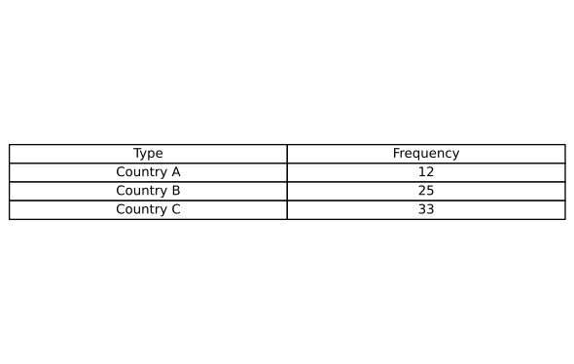

A. $\frac{1}{2}$

B. $\frac{3}{5}$

C. $\frac{5}{14}$

D. $\frac{33}{70}$

2.  What is the median of the data set shown? data set = [4, 50, 8, 23, 15, 42, 16]

3.  How many liters are equivalent to 3.5 gallons? (1 gallon = 3.78541 liters)

4.  A car travels at a constant acceleration of 4.5 meters per second squared. What is this acceleration, in feet per minute squared, rounded to the nearest tenth? (Use 1 foot = 0.3048 meters)

A.    53149.0

B.    53149.2

C.    53150.0

D.    53150.2

5.  Each side of rectangle C has a length of 10 feet and a width of 4 feet. If both dimensions of rectangle C are multiplied by a scale factor of 2 to create rectangle D, what is the length, in feet, of each side of rectangle D?

A.   20 feet

B.    8 feet

C.   16 feet

D.   12 feet

6.  The table shows the distribution of different big data technologies adopted by two technology companies. If a technology represented in the table is selected at random, what is the probability of selecting a technology related to Company A, given that the technology is related to Data Storage? (Express your answer as a decimal or fraction, not as a percent.) 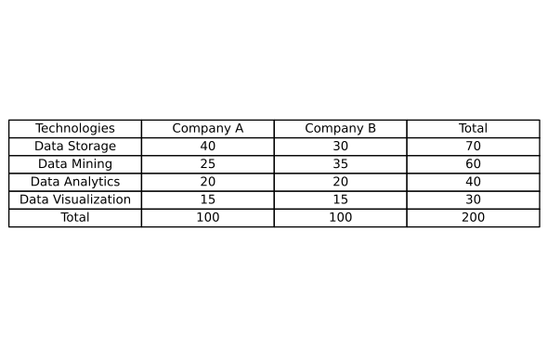A. $\frac{1}{2}$

B. $\frac{2}{3}$

C. $\frac{3}{5}$

D. $\frac{4}{7}$

7.  What is the median of the data set shown? data set = [3, 7, 9, 1, 5, 8, 2]

8.  In a survey of 70 adults regarding their political ideologies, the results were classified as either Conservative, Liberal, or Moderate, as shown in the frequency table. If one adult is selected at random, what is the probability that the selected adult identifies as Liberal?

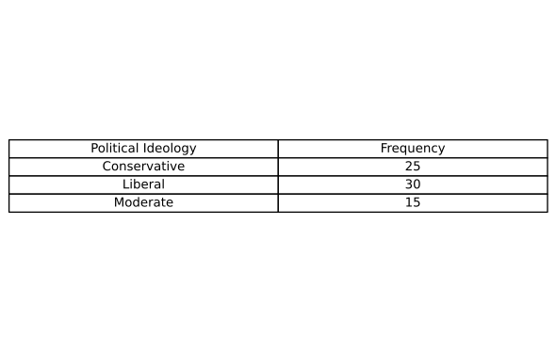

9.  The table shows the energy output in gigawatt-hours (GWh) for two countries with respect to their renewable and traditional energy resources. If an energy output is selected at random, what is the probability that the output is from Country A, given that it is from a renewable resource? (Express your answer as a decimal or fraction, not as a percent.)

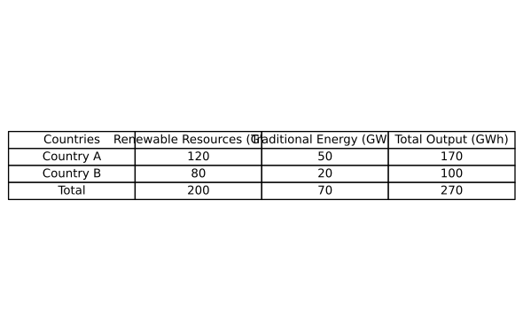

10.  A car travels at a speed of 5.2 meters per second. What is this speed in kilometers per hour, rounded to the nearest tenth? (Use 1 kilometer = 1,000 meters.)

A.   18.5 km/h

B.   18.6 km/h

C.   18.7 km/h

D.   18.8 km/h

SAT Math Problem Solving and Data Analysis Solutions

1.  In a survey of 70 individuals regarding their support for international policies, the results indicated that 12 supported Country A, 25 supported Country B, and 33 supported Country C. If one individual is selected at random, what is the probability that the individual supports Country B?



A. $\frac{1}{2}$

B. $\frac{3}{5}$

C. $\frac{5}{14}$

D. $\frac{33}{70}$

## Answer

C

## Solution

This problem tests the student’s understanding of basic probability concepts and their ability to interpret and use frequency data to calculate probabilities.  
To approach this problem, students need to identify the total number of individuals surveyed, which is 70, and the number of individuals who support Country B, which is 25. The probability that a randomly selected individual supports Country B is the ratio of the number of supporters of Country B to the total number of individuals surveyed.  
Remember that probability is calculated as the number of favorable outcomes divided by the total number of possible outcomes. Always double-check the numbers given in the problem to ensure accuracy.  
A common mistake is to incorrectly sum the frequencies or misinterpret the question, such as finding the probability for the wrong country. Pay close attention to the details provided in the problem.  
This type of problem is straightforward and requires a solid understanding of basic probability concepts. It evaluates the student’s ability to interpret data and apply probability formulas accurately. In SAT exams, being adept at these kinds of problems can lead to quick wins, freeing up time for more complex questions.  
  
To find the probability that an individual supports Country B, we use the formula:, $Probability =\frac{Number of individuals supporting Country B}{Total number of individuals surveyed}$, Substitute the given values into the formula:, $Probability=\frac{25}{70}$, Simplify the fraction:, $Probability=\frac{5}{14}$

2.  What is the median of the data set shown? data set = [4, 50, 8, 23, 15, 42, 16]

## Answer

16

## Solution

The problem is designed to test the student’s understanding of how to find the median in a data set. It assesses the student’s ability to organize data and identify the middle value.  
To solve the problem, the student needs to first ensure the data set is in numerical order, which it already is. Then, since there are seven numbers, the median is the one in the fourth position when the numbers are listed in order.  
Remember that the median is the middle number in a list of numbers. If the list has an odd number of entries, the median is the exact middle number. If it has an even number of entries, you would take the average of the two middle numbers.  
Be careful not to confuse the median with the mean or mode. They are different measures of central tendency. Ensure the data is sorted before attempting to find the median.  
This type of problem is fundamental in understanding statistical data analysis. Finding the median is a basic skill that helps in understanding the distribution of data. On the SAT, this type of problem tests your ability to work with and interpret data accurately, which is essential for data analysis.  
  
Count the numbers in the data set: 7 numbers., Identify the middle position: (7 + 1) / 2 = 4, The median is the fourth number in the list., Looking at the data set: [4, 50, 8, 23, 15, 42, 16], sorting the data set: [4, 8, 15, 16, 23, 42, 50], The fourth number is 16.

3.  How many liters are equivalent to 3.5 gallons? (1 gallon = 3.78541 liters)

## Answer

13.2489

## Solution

This problem aims to test the student’s understanding of unit conversion, specifically converting from gallons to liters using a given conversion factor.  
To solve this problem, students need to multiply the number of gallons by the conversion factor to find the equivalent amount in liters. Thus, they should calculate $3.5gallons×3.78541liters/gallon$.  
Always write down the units and ensure they cancel out correctly in the conversion process. This will help you keep track of the conversion you are performing and avoid errors.  
Make sure to use the exact conversion factor provided in the problem. Also, be careful with multiplication and ensure you are not missing any decimal points which could lead to incorrect answers.  
This type of problem assesses your ability to perform basic unit conversions, a vital skill in the Problem Solving and Data Analysis section. It requires careful attention to detail and precision in calculations. Practicing unit conversions with various units can help improve speed and accuracy on such questions in the SAT.  
  
1. Use the conversion factor: .  
2. Multiply the number of gallons by the conversion factor to find the equivalent number of liters.  
3. Calculation: .  
4. According to the guidelines, round the decimal to the fourth digit: 13.2489.  
5. Therefore, 3.5 gallons is approximately 13.2489 liters.

4.  A car travels at a constant acceleration of 4.5 meters per second squared. What is this acceleration, in feet per minute squared, rounded to the nearest tenth? (Use 1 foot = 0.3048 meters)

A.    53149.0

B.    53149.2

C.    53150.0

D.    53150.2

## Answer

B

## Solution

This problem tests the student’s ability to perform unit conversions, specifically converting from meters per second squared to feet per minute squared. It also evaluates the student’s understanding of unit relationships and their ability to handle multi-step conversions.  
To solve this problem, the student should follow these steps:  
1) Convert meters to feet by using the conversion factor 1 foot = 0.3048 meters.  
2) Convert seconds squared to minutes squared by recognizing that there are 60 seconds in a minute and squaring that conversion factor.  
3) Combine these conversions to find the acceleration in feet per minute squared.  
First, remember to deal with one unit conversion at a time. It might help to write down each step to keep track of your conversions. Additionally, always double-check your conversion factors and ensure that units cancel out correctly.  
Be careful with squaring the time conversion factor. Remember that you need to square the entire conversion factor (60 seconds per minute) to convert seconds squared to minutes squared. Also, ensure you do not round off too early in your calculations, as this can lead to inaccuracies.  
This unit conversion problem is a common type in SAT math, reflecting real-world scenarios where multiple unit conversions are necessary. It tests both basic arithmetic skills and understanding of unit relationships. Mastering these types of problems is crucial for the Problem Solving and Data Analysis section of the SAT.  
  
Given acceleration: 4.5 meters per second squared.  
First, convert meters to feet: $\frac{4.5}{0.3048}$ feet per meter.  
Result: $\frac{4.5}{0.3048}=14.7637795276$ feet per second squared.  
Now convert seconds squared to minutes squared: (14.7637795276 feet / ${\left(second\right)}^{2}$) $×$ (${\left(60\right)}^{2}$) seconds squared per minute squared.  
Calculation: $14.7637795276×3600=53149.2062996$ feet per minute squared.  
Round the result to the nearest tenth: 53149.2

5.  Each side of rectangle C has a length of 10 feet and a width of 4 feet. If both dimensions of rectangle C are multiplied by a scale factor of 2 to create rectangle D, what is the length, in feet, of each side of rectangle D?

A.   20 feet

B.    8 feet

C.   16 feet

D.   12 feet

## Answer

A

## Solution

This problem intends to assess the student’s understanding of how scale factors affect the dimensions of geometric figures, specifically rectangles, and requires knowledge of basic multiplication and properties of rectangles.  
To solve this problem, students should recognize that multiplying each dimension of rectangle C by a given scale factor will yield the dimensions of rectangle D. The length and width of rectangle C are 10 feet and 4 feet, respectively. By multiplying these dimensions by the scale factor of 2, students can find the new dimensions of rectangle D.  
Remember that when you multiply both the length and width by a scale factor, you are essentially enlarging the rectangle proportionally. Make sure to apply the scale factor to both dimensions separately.  
Be careful not to confuse the scale factor with addition. It’s important to multiply each dimension by the scale factor, not add it. Additionally, ensure that you apply the scale factor to both the length and the width.  
This problem is a straightforward application of scaling, a fundamental concept in geometry and proportional reasoning. It tests the student’s ability to apply multiplication to geometric figures and understand the properties of similar shapes. Mastery of this type of problem is essential for success in the SAT’s Problem Solving and Data Analysis category, as it reflects a student’s ability to handle real-world mathematical situations.  
  
Calculate the new length: $10 feet ×2=20 feet$, Calculate the new width: $4 feet ×2=8 feet$, Both sides of rectangle D are calculated.

6.  The table shows the distribution of different big data technologies adopted by two technology companies. If a technology represented in the table is selected at random, what is the probability of selecting a technology related to Company A, given that the technology is related to Data Storage? (Express your answer as a decimal or fraction, not as a percent.) 

A. $\frac{1}{2}$

B. $\frac{2}{3}$

C. $\frac{3}{5}$

D. $\frac{4}{7}$

## Answer

D

## Solution

This problem tests the student’s understanding of conditional probability, particularly how to calculate the probability of an event given a specific condition using a table of data. It checks if the student can interpret data in a tabular format and apply probability formulas correctly.  
To solve this problem, students need to identify the relevant data in the table concerning technologies related to Data Storage and then focus only on those entries. They must then calculate the probability that, given a technology is related to Data Storage, it is related to Company A. This involves using the conditional probability formula: $P(A|B)=\frac{P(A and B)}{P(B)}$.  
First, isolate the rows or columns that pertain to Data Storage. Focus on these entries, ignoring all other technologies. Then count the total number of Data Storage entries, and specifically those associated with Company A. Use these counts to set up your fraction for conditional probability.  
Ensure that you are only considering the technologies related to Data Storage when calculating probabilities. A common mistake is to include unrelated categories, which can lead to incorrect answers. Also, remember to express your final answer as a decimal or fraction as instructed.  
This type of SAT problem is designed to assess the student’s capability in handling conditional probabilities in a real-world context using tables. Mastery of this problem involves attentiveness to detail and the ability to filter relevant data from a larger dataset. It highlights the importance of methodical data handling and precise calculation, critical skills in both academic and professional data analysis contexts.  
  
First, find the total number of technologies related to Data Storage: 70.  
Next, find the number of Data Storage technologies related to Company A: 40.  
Calculate the probability $P(A|B)$ as the ratio of Data Storage technologies related to Company A to the total Data Storage technologies: $P(A|B)=\frac{Number of Data Storage technologies related to Company A}{Total number of Data Storage technologies}=\frac{40}{70}=\frac{4}{7}$

7.  What is the median of the data set shown? data set = [3, 7, 9, 1, 5, 8, 2]

## Answer

5

## Solution

The problem aims to assess the student’s understanding of finding the median from a data set. It checks if the student can correctly identify the middle value of an ordered data set, which is a fundamental concept in statistics.  
To solve this problem, the student should first arrange the data set in ascending order. Once the data is ordered, the student should identify the middle value. Since the data set has an odd number of elements, the median is the middle number of the ordered list.  
Remember, the median is the middle value of a data set arranged in order. For an odd number of data points, it’s simply the middle one. For an even number, it’s the average of the two middle values. Always ensure your data is ordered before searching for the median.  
A common mistake is forgetting to order the data before finding the median. Always double-check that the data is sorted correctly. Also, ensure you correctly count to find the middle position, especially if the data set is long.  
This problem is a classic example of testing basic statistical skills related to identifying central tendencies. Being able to find the median is crucial as it provides insight into the distribution of data. In the SAT, this type of problem tests accuracy and attention to detail, ensuring students understand and apply statistical concepts accurately.  
  
Step 1: Arrange the data set in ascending order.  
The given data set is [3, 7, 9, 1, 5, 8, 2].  
Arranging it in ascending order gives [1, 2, 3, 5, 7, 8, 9].  
Step 2: Determine the number of values in the data set.  
The data set has 7 values, which is an odd number.  
Step 3: Find the middle value.  
Since there are 7 values, the median is the 4th value in the ordered data set.  
The 4th value is 5.  
Therefore, the median of the data set is 5.

8.  In a survey of 70 adults regarding their political ideologies, the results were classified as either Conservative, Liberal, or Moderate, as shown in the frequency table. If one adult is selected at random, what is the probability that the selected adult identifies as Liberal? 

## Answer

$\frac{3}{7}$

## Solution

This problem is designed to assess the student’s understanding of simple probability concepts, specifically how to calculate probability using a frequency table. The goal is to check if students can interpret data presented in a tabular form and apply basic probability principles.  
To solve this problem, students should first identify the total number of adults surveyed, which is given as 70. Then, they need to find the frequency of adults who identify as Liberal from the table. The probability is then calculated by dividing the number of Liberals by the total number of surveyed adults.  
Focus on extracting the correct data from the table. Ensure you correctly identify the number of adults who identify as Liberal. Remember that probability is the ratio of the favorable outcome to the total number of possible outcomes.  
Be cautious about misreading the frequency table. Ensure you are dividing the correct numbers – the number of Liberals should be the numerator, and the total number of adults should be the denominator. Double-check your calculations to avoid simple arithmetic errors.  
This type of problem is fundamental in understanding probability and data interpretation. It tests the ability to read data from tables and apply mathematical concepts to solve real-world problems. Mastering these skills is crucial for success in the SAT math section, as it demonstrates proficiency in problem-solving and analytical reasoning.  
  
1. To find the probability, divide the number of favorable outcomes by the total number of outcomes.  
2. In this context, a favorable outcome is an adult identifying as Liberal.  
3. Therefore, the probability P that the selected adult identifies as Liberal is given by:  
  
4. Substitute the values into the equation:  
  
5. Simplify the fraction:  
  
6. The simplified probability that a randomly selected adult identifies as Liberal is $\frac{3}{7}$.

9.  The table shows the energy output in gigawatt-hours (GWh) for two countries with respect to their renewable and traditional energy resources. If an energy output is selected at random, what is the probability that the output is from Country A, given that it is from a renewable resource? (Express your answer as a decimal or fraction, not as a percent.) 

## Answer

$\frac{3}{5}$

## Solution

This problem assesses the student’s understanding of conditional probability, particularly the ability to use a contingency table to find the probability of one event given another event has occurred.  
To solve this problem, you should first focus on the rows or columns that represent renewable resources. Then, identify all the energy outputs from renewable resources. Next, focus on the subset of these outputs that are from Country A. Use the formula for conditional probability: $P(A|B)=\frac{P(A∩B)}{P(B)}$.  
Carefully read the table to accurately identify the row or column representing renewable resources. Ensure you correctly sum the values associated with Country A and the total for renewable resources. Double-check your calculations when applying the conditional probability formula.  
A common mistake is to misinterpret the table or to mistakenly include values not related to renewable resources. Ensure that you are only considering outputs from renewable resources when calculating the probability.  
This type of question is typical in the SAT’s Problem Solving and Data Analysis section. It tests your understanding of conditional probability and your ability to accurately interpret data from tables. Mastery of these skills is crucial for success in this area, as they are fundamental to data analysis and interpreting real-world data scenarios.  
  
To find the probability that an energy output is from Country A given that it is from a renewable resource, we’ll use the formula for conditional probability: $P(A|B)=\frac{P(A∩B)}{P(B)}$. $P(A∩B)$ 
 is the probability that the output is from Country A and a renewable resource, which is the amount of renewable energy from Country A divided by the total energy output: $P(A∩B)=\frac{120}{270}$.  
P(B) is the probability that an output is from a renewable resource, which is the total renewable energy output divided by the total energy output: $P(B)=\frac{200}{270}$.  
Substitute these into the formula: $P(A|B)=\frac{\frac{120}{270}}{\frac{200}{270}}$.  
Simplify the expression: $P(A|B)=\frac{120}{200}$.  
Further simplify the fraction: $\frac{120}{200}=\frac{3}{5}$.  
Thus, the probability that an energy output is from Country A given that it is from a renewable resource is $\frac{3}{5}$.

10.  A car travels at a speed of 5.2 meters per second. What is this speed in kilometers per hour, rounded to the nearest tenth? (Use 1 kilometer = 1,000 meters.)

A.   18.5 km/h

B.   18.6 km/h

C.   18.7 km/h

D.   18.8 km/h

## Answer

C

## Solution

This problem tests the student’s ability to convert units of speed from meters per second to kilometers per hour. It assesses understanding of unit conversion principles and multiplication skills.  
To solve this problem, students need to first understand the conversion factor between meters and kilometers, and seconds and hours. The speed is given in meters per second, and it needs to be converted to kilometers per hour. This requires multiplying the speed by the conversion factors: 1,000 meters per kilometer and 3,600 seconds per hour.  
Remember that 1 kilometer is 1,000 meters and there are 3,600 seconds in an hour. To convert from meters per second to kilometers per hour, multiply the speed by 3.6 (since $\frac{3,600}{1,000}=3.6$).  
A common mistake is to forget to convert both the meters to kilometers and the seconds to hours. Ensure to multiply by 3.6, not 3,600 or 1,000, as this already accounts for both conversions.  
This type of problem is common in SAT exams as it evaluates the student’s ability to perform unit conversions, which is essential in solving real-world problems. By practicing such questions, students can improve their accuracy and speed in handling unit conversion tasks, which are key skills in the Problem Solving and Data Analysis section.  
  
Start with the speed in meters per second: 5.2 m/s., Convert meters to kilometers by multiplying by 0.001: 5.2 m/s $×$ 0.001 km/m = 0.0052 km/s., Convert seconds to hours by multiplying by 3,600: 0.0052 km/s $×$ 3600 s/h = 18.72 km/h., The speed in kilometers per hour is 18.72 km/h, which is rounded to the nearest tenth as 18.7 km/h.