SAT Math Algebra

1.  The table shows two values of x and their corresponding values of y. The graph of the linear equation representing this relationship passes through the point $(\frac{5}{2},b)$. What is the value of b?

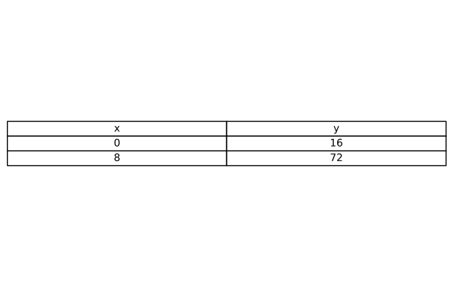

A. $\frac{67}{2}$

B.    34

C. $\frac{69}{2}$

D.    35

2.  For the linear function g, the graph of $y=g(x)$ in the $xy$-plane has a slope of 12 and passes through the point (0, 5). Which equation defines g?

A. $y=12x+5$

B. $y=12x-5$

C. $y=-12x+5$

D. $y=5x+12$

3.  In the xy-plane, line m has a slope of -3 and a y-intercept of (0, 12). What is the x-coordinate of the x-intercept of line m?

4.  The graph of line g is shown in the xy-plane. Line k is defined by the equation $3x+py=w$, where p and w are constants. If line k is graphed in this xy-plane, resulting in the graph of a system of two linear equations, the system of two linear equations will have infinitely many solutions. What is the value of $p+w$?

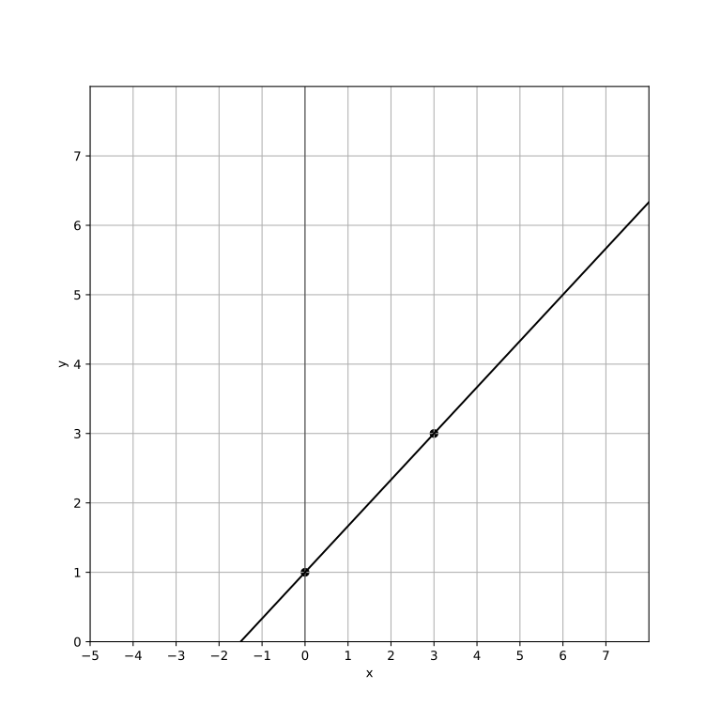

A. $-\frac{9}{2}$

B.    -3

C.    -9

D.    9

5.  The function f is defined by $f(x)=\frac{2}{n}x-10$, where n is an integer constant and $5≤n≤8$. For the graph of $y=f(x)+15$ in the $xy$-plane, what is the x-coordinate of a possible x-intercept?

A.    -13

B.    -15

C.    -17

D.    -19

6.  The function f is defined by $f(x)=\frac{2}{n}x-10$, where $n$ is an integer constant and $8≤n≤11$. For the graph of $y=f(x)+6$ in the $xy$-plane, what is the x-coordinate of a possible x-intercept?

A.    10

B.    12

C.    14

D.    16

7.  The function g is defined by $g(x)=\frac{3}{5}x+45$. What is the value of g (25)?

8.  Line $m$ is defined by the equation $3x-2y=6$. Line $n$ is parallel to line $m$ in the $xy$-plane. What is the slope of line $n$?

A. $\frac{1}{2}$

B. $\frac{3}{2}$

C. $\frac{2}{3}$

D. $-\frac{3}{2}$

9.  A research organization receives a grant of $\$12,000$ for an AI project. The first 5 months costs $\$2,000$ per month. After that, the monthly cost decreases to for each of the following months. If the total budget is exhausted after m months, where $m>5$, which equation represents this situation?

A. $2000×5+1500×(m-5)=12000$

B. $2000×5+1500×(m-5)=9000$

C. $2000×m=12000$

D. $1500×m=10000$

10.  What is the solution (x, y) to the given system of equations? $2x+3y=12$, $y=2$

A.   (3, 2)

B.   (4, 2)

C.   (2, 3)

D.   (2, 2)

SAT Math Algebra Solutions

1.  The table shows two values of x and their corresponding values of y. The graph of the linear equation representing this relationship passes through the point $(\frac{5}{2},b)$. What is the value of b?



A. $\frac{67}{2}$

B.    34

C. $\frac{69}{2}$

D.    35

## Answer

A

## Solution

This problem tests the student’s ability to understand linear equations and their representation on a graph. Specifically, it focuses on recognizing the relationship between variables in a linear equation and using given points to find unknown values.

To approach this problem, first identify the linear equation from the given data table by finding the slope (m) and using one of the points to determine the y-intercept (c). Then, use the linear equation in the form y = mx + c to find the value of b when x is $\frac{5}{2}$. Remember that the slope (m) of a line can be calculated using the formula $m=\frac{(y2-y1)}{(x2-x1)}$.

Once the slope is found, use it with one of the points to find the equation of the line. After that, substitute $x=\frac{5}{2}$ into the equation to solve for b. Be careful with fractions when calculating the slope and substituting values.

It’s easy to make mistakes with negative signs or when simplifying fractions. Make sure to double-check your calculations. This type of problem is common in the SAT and is designed to evaluate your understanding of linear equations and their graphs.

It requires careful calculation and attention to detail, especially with fractions. Mastering this type of question will help you in algebra and function graph questions on the SAT.

1. Calculate the slope (m) of the line using the points (0, 16) and (8, 72):

- Slope formula:   
-

2. Use the slope-point form to find the equation of the line:  
- Point-slope form:   
- Substitute:   
- Simplify:

3. Substitute $x=\frac{5}{2}$ to find b: $y=7⋅\frac{5}{2}+16$ 
, $y=\frac{35}{2}+16$. Convert 16 to a fraction:   
- Combine: $y=\frac{35}{2}+\frac{32}{2}=\frac{67}{2}$

Therefore, the value of b is $\frac{67}{2}$.

2.  For the linear function g, the graph of $y=g(x)$ in the $xy$-plane has a slope of 12 and passes through the point (0, 5). Which equation defines g?

A. $y=12x+5$

B. $y=12x-5$

C. $y=-12x+5$

D. $y=5x+12$

## Answer

A

## Solution

This problem tests the student’s understanding of the equation of a linear function, specifically identifying and using the slope-intercept form. It checks if the student knows how to apply the concept of slope and y-intercept to find the equation of a line.  
To solve this problem, the student should recognize that the slope-intercept form of a linear equation is y = mx + b, where m represents the slope and b represents the y-intercept. Given the slope (m) is 12 and the y-intercept (b) is 5 (since the line passes through (0, 5)), the equation becomes $y=12x+5$.  
Remember that in the slope-intercept form $y=mx+b$, m is the slope and b is the y-intercept, which is the point where the line crosses the y-axis. Substitute the given values directly into this form to find the equation quickly.  
Be careful not to confuse the x-intercept with the y-intercept. Also, ensure that you correctly substitute the slope and y-intercept into the equation form without mixing them up. Double-check that the point given (0, 5) confirms the y-intercept directly.  
This problem is straightforward if you are familiar with the slope-intercept form of linear equations. It assesses your ability to interpret and apply basic algebraic concepts in graphing linear functions. Practicing these types of problems can help reinforce your understanding of linear equations and their graphical representations, which are fundamental in algebra. On the SAT, such questions evaluate your capacity to quickly and accurately apply algebraic principles.  
  
For a linear function with slope m and y-intercept b, the equation can be written as $y=mx+b$.  
Given the slope $m=12$ and the line passes through the point (0, 5)  
the y-intercept (b) is 5.  
Therefore, the equation of the line is $y=12x+5$.

3.  In the xy-plane, line m has a slope of -3 and a y-intercept of (0, 12). What is the x-coordinate of the x-intercept of line m?

## Answer

4

## Solution

This problem tests the student’s understanding of the equation of a line in slope-intercept form $y=mx+b$ and their ability to determine the x-intercept from this equation.  
To find the x-coordinate of the x-intercept, the student must set y = 0 in the equation of the line and solve for x. The equation of the line can be written as $y=-3x+12$. Setting y to 0 gives the equation $0=-3x+12$. Solving for x will yield the x-intercept.  
Remember that the x-intercept is where the line crosses the x-axis, which means y is zero at this point. You can always use the slope-intercept form of the equation to find intercepts quickly.  
Be careful with the signs when solving the equation. It’s easy to make a mistake with negative slopes or intercepts, so double-check your calculations.  
This problem is a classic test of understanding linear equations and their intercepts. It assesses the ability to manipulate algebraic equations and understand the geometric interpretation of a line’s slope and intercepts. Mastery of these concepts is essential for success on the SAT, as they are fundamental to algebra and graph interpretation.  
  
Start with the equation: $0=-3x+12$.  
Subtract 12 from both sides: $-12=-3x$.  
Divide both sides by -3: $x=\frac{-12}{-3}$.  
Simplify the fraction: $x=4$.

4.  The graph of line g is shown in the xy-plane. Line k is defined by the equation $3x+py=w$, where p and w are constants. If line k is graphed in this xy-plane, resulting in the graph of a system of two linear equations, the system of two linear equations will have infinitely many solutions. What is the value of $p+w$?



A. $-\frac{9}{2}$

B.    -3

C.    -9

D.     9

## Answer

C

## Solution

This problem tests the student’s understanding of the conditions under which a system of linear equations has infinitely many solutions. Specifically, it assesses their ability to identify when two lines are identical by comparing their slopes and y-intercepts.

To solve this problem, the student needs to recognize that for the system of equations to have infinitely many solutions, the two lines must be the same. This means that the equation of line k must be a multiple of the equation of line g.

The student should first find the equation of line g from the graph, determine its slope and y-intercept, and then set the coefficients of line k proportional to those of line g. Remember that two lines are identical if they have the same slope and y-intercept.

When given a line equation in the form $Ax+By=C$, converting it to the slope-intercept form $y=mx+b$ can make it easier to compare slopes and y-intercepts. Be careful when aligning the coefficients of the two equations. It’s crucial to ensure that the ratios of the coefficients of x, y, and the constant terms are the same for the two equations.

Also, ensure to simplify the equation of line g correctly from the graph. This type of problem is common in algebra sections of standardized tests, where understanding the graphical representation and algebraic manipulation are key.

It requires not only knowledge of linear equations but also the ability to translate between different forms of these equations. Mastering such problems will enhance a student’s ability to quickly and accurately solve linear equation systems on the SAT.  
  
Equating the slopes: $\frac{-3}{p}=\frac{2}{3}$.  
Solving for p: $-3=\frac{2}{3}p$  
hence $p=-\frac{9}{2}$.  
Equating the y-intercepts: $\frac{w}{p}=1$.  
Substitute $p=-\frac{9}{2}$ into $\frac{w}{p}=1$: $\frac{w}{-\frac{9}{2}}=1$  
therefore, $w=-\frac{9}{2}$.  
Calculate $p+w$: $p+w=(-\frac{9}{2})+(-\frac{9}{2})=-9$.

5.  The function f is defined by $f(x)=\frac{2}{n}x-10$, where n is an integer constant and $5≤n≤8$. For the graph of $y=f(x)+15$ in the $xy$-plane, what is the x-coordinate of a possible x-intercept?

A.    -13

B.    -15

C.    -17

D.    -19

## Answer

B

## Solution

This problem tests the student’s understanding of linear equations and their graphs, specifically focusing on finding the x-intercept of a transformed function. It also checks the student’s ability to manipulate algebraic expressions and understand the effect of constants on the graph of the function.  
To solve this problem, recognize that the x-intercept is the value of x when y equals zero. The function provided is transformed to $y=f(x)+15$. Set y to zero and solve for x: $0=\frac{2}{n}x-10+15$. Simplify the equation to find x in terms of n, then substitute possible integer values for n between 5 and 8 as given in the problem to find the possible x-intercept.  
Remember that the x-intercept occurs when $y=0$. Carefully handle the algebraic manipulation and ensure you substitute each possible value of n to find potential solutions. Check your work by substituting back to see if the value makes the entire expression zero.  
A common mistake is to forget adding or subtracting constants when manipulating the function. Make sure not to overlook the +15 when setting up the equation for finding the x-intercept. Additionally, ensure all integer values of n within the specified range are checked.  
This problem is a good test of basic algebraic manipulation and understanding of linear functions. It requires careful attention to detail, especially in handling transformations of functions. SAT problems like this assess whether students can apply algebraic concepts in slightly more complex contexts, which is a critical skill for success in this section.  
  
Substitute $y=f(x)+15$ into the equation:, $y=(\frac{2}{n}x-10)+15$  
Simplify: $y=\frac{2}{n}x+5$  
To find the x-intercept, set y = 0:, $0=\frac{2}{n}x+5$  
Subtract 5 from both sides: $-\frac{2}{n}x=5$  
Multiply both sides by $-\frac{n}{2}$: $x=-\frac{5n}{2}$  
Considering the integer values of n:  
For n = 5: $x=-\frac{5(5)}{2}=-\frac{25}{2}=-12.5$  
For n = 6: $x=-\frac{5(6)}{2}=-\frac{30}{2}=-15$  
For n = 7: $x=-\frac{5(7)}{2}=-\frac{35}{2}=-17.5$  
For $n=8:x=-\frac{5(8)}{2}=-\frac{40}{2}=-20$  
Possible x-coordinates are -12.5, -15, -17.5, and -20.

6.  The function f is defined by $f(x)=\frac{2}{n}x-10$, where $n$ is an integer constant and $8≤n≤11$. For the graph of $y=f(x)+6$ in the $xy$-plane, what is the x-coordinate of a possible x-intercept?

A.    10

B.    12

C.    14

D.    16

## Answer

D

## Solution

This problem tests the student’s understanding of linear functions, specifically how to find the x-intercept of a transformed function. It also assesses the ability to handle composite functions and apply algebraic manipulation to solve for specific values.

To find the x-intercept of the function $y=f(x)+6$, set y to 0 and solve for x. First, rewrite the function $f(x)=\frac{2}{n}x-10$ and then substitute into the given equation. Set $0=\frac{2}{n}x-10+6$ and solve for x.

Consider each possible value of n within the given range to find the x-intercept. Remember that the x-intercept occurs where $y=0$. By setting y to 0 in the given equation, you simplify your task to solving a straightforward linear equation.

Check each value of n to ensure you cover all possible cases. Be careful with signs when solving the equation. Also, ensure that you properly substitute and simplify for each value of n.

It is easy to make arithmetic errors, so double-check your work. This problem is a good exercise in understanding linear functions and their transformations. It requires the student to apply algebraic techniques and consider multiple scenarios due to the range of values for n.

This type of problem is common in SAT math sections and helps assess a student’s ability to manipulate and solve equations under different conditions.  
  
Substitute $f(x)$ into $y=f(x)+6$ to get $y=\frac{2}{n}x-10+6$.  
Simplify to $y=\frac{2}{n}x-4$.  
Set y = 0 for the x-intercept: $0=\frac{2}{n}x-4$.  
Add 4 to both sides: $\frac{2}{n}x=4$.  
Solve for x by multiplying both sides by $\frac{n}{2}$: $x=2n$.  
Substitute possible integer values of n (8, 9, 10, 11) to find possible x-coordinates:  
If $n=8$, $x=2(8)=16$.  
If $n=9$, $x=2(9)=18$.  
If $n=10$, $x=2(10)=20$.  
If $n=11$, $x=2(11)=22$.

7.  The function g is defined by $g(x)=\frac{3}{5}x+45$. What is the value of g(25)?

## Answer

60

## Solution

This problem assesses the student’s ability to understand function notation and evaluate a function at a given point. It tests their comprehension of linear functions and basic arithmetic operations.  
To solve this problem, substitute the given value into the function. Here, you need to replace ’x’ with 25 in the function $g(x)=\frac{3}{5}x+45$, and then perform the arithmetic operations to find $g(25)$.  
When evaluating a function at a specific point, carefully substitute the given number into the function and perform each step methodically. Double-check your arithmetic to avoid small errors.  
A common mistake is to miscalculate the multiplication or the fraction operation. Ensure that you correctly multiply $\frac{3}{5}$ by 25 and then add 45.  
This type of problem is fundamental in algebra and serves as a basis for understanding more complex functions and graphs. It helps students practice function evaluation, which is a crucial skill in algebra and calculus. In SAT math, being comfortable with function notation and evaluation can save time and avoid mistakes in more complex problems.  
  
Substitute $x=25$ into the function $g(x)$: $g(25)=\frac{3}{5}×25+45$ 
, Calculate $\frac{3}{5}×25$:  
Multiply 3 and 25 to get 75.  
Divide 75 by 5 to get 15., Add 15 to 45, which results in 60.  
Thus, the value of $g(25)$ is 60.

8.  Line $m$ is defined by the equation $3x-2y=6$. Line $n$ is parallel to line $m$ in the $xy$-plane. What is the slope of line $n$?

A. $\frac{1}{2}$

B. $\frac{3}{2}$

C. $\frac{2}{3}$

D. $-\frac{3}{2}$

## Answer

B

## Solution

The problem aims to test the student’s understanding of the concept of slope in linear equations and their ability to identify the slope of a line parallel to a given line. It assesses the student’s knowledge of how to manipulate equations to find the slope and understand the properties of parallel lines.

First, rewrite the equation of line m in the slope-intercept form ($y=mx+b$) to identify its slope. The given equation is $3x-2y=6$.

Solve for y: $3x-2y=6$, $-2y=-3x+6$, $y=\frac{3}{2}x-3$.

The slope of line m is $\frac{3}{2}$. Since line n is parallel to line m, it has the same slope. Therefore, the slope of line n is also $\frac{3}{2}$. Remember that parallel lines have the same slope. To quickly find the slope of a line given in standard form ($Ax+By=C$), rearrange the equation into slope-intercept form ($y=mx+b$) by solving for y.

The coefficient of x will be the slope. Be careful when rearranging the equation. Make sure to correctly isolate y and simplify the equation properly. Avoid common mistakes such as incorrect algebraic manipulations or sign errors.

Double-check your work to ensure accuracy. This type of problem is fundamental in algebra and is common on the SAT. It tests a student’s ability to manipulate equations and understand the properties of linear functions, particularly the concept of parallel lines.

Mastery of this skill is crucial for solving similar problems efficiently and accurately on the SAT. Always practice converting equations to slope-intercept form and recognizing the properties of parallel and perpendicular lines.

Start with the equation $3x-2y=6$.  
Convert to slope-intercept form by isolating y.  
Subtract 3x from both sides: $-2y=-3x+6$.  
Divide every term by -2 to solve for y: $y=\frac{3}{2}x-3$.  
The equation $y=\frac{3}{2}x-3$ is in slope-intercept form $y=mx+b$.  
The slope $m$ of line m is $\frac{3}{2}$.  
Since line $n$ is parallel to line $m$, it has the same slope.  
Thus, the slope of line n is $\frac{3}{2}$.

9.  A research organization receives a grant of $\$12,000$ for an AI project. The first 5 months costs $\$2,000$ per month. After that, the monthly cost decreases to for each of the following months. If the total budget is exhausted after m months, where $m>5$, which equation represents this situation?

A. $2000×5+1500×(m-5)=12000$

B. $2000×5+1500×(m-5)=9000$

C. $2000×m=12000$

D. $1500×m=10000$

## Answer

A

## Solution

This problem aims to test the student’s ability to translate a real-world scenario into a linear equation. It evaluates the understanding of piecewise functions and how to represent changing rates within a single equation.

First, identify the cost for the first 5 months and then for the remaining months. Use this information to formulate a piecewise linear equation that describes the total cost as a function of the number of months, m.

Break down the problem into two parts: the first 5 months and the months after that. Calculate the total cost for the first 5 months and then add the cost for the remaining months. Ensure you correctly apply the conditions: $m>5$.

Also, be cautious about correctly calculating the transition point at 5 months and applying the correct rate for the subsequent months. This type of problem is common on the SAT to test algebraic reasoning and the ability to model real-world situations.

Mastering this will help you handle similar problems efficiently. Always break down the problem into manageable parts and carefully apply the given conditions to avoid errors.  
  
For the first 5 months, the cost is $\$2,000×5=\$10,000.$  
The total budget is $\$12,000$, so the remaining months should not exceed the given budget.  
The equation representing the total cost after m months is: $2000×5+1500×(m-5)=12000$.

10.  What is the solution (x, y) to the given system of equations? $2x+3y=12$, $y=2$

A.   (3, 2)

B.   (4, 2)

C.   (2, 3)

D.   (2, 2)

## Answer

A

## Solution

This problem aims to assess the student’s ability to solve a system of linear equations, which is a fundamental concept in algebra. The student should be able to substitute and solve for the variables to find the solution.

First, identify that the second equation provides a direct value for y. Substitute this value into the first equation to solve for x.

The steps are as follows:   
1. Recognize that $y=2$ from the second equation.   
2. Substitute into the first equation: .   
3. Simplify and solve for x.

When you have one of the variables directly given (like $y=2$), always substitute it into the other equation first. This simplifies the problem and reduces potential errors. Don’t forget to check your solution by substituting both values back into the original equations.

Make sure you substitute the value of y correctly and perform arithmetic operations carefully. Pay attention to signs and coefficients to avoid simple mistakes. This type of problem is straightforward if you follow the correct steps of substitution and solving.

It tests your understanding of basic algebraic manipulation and solving systems of equations. These skills are crucial for more complex algebra problems and are frequently tested in SAT. Practice similar problems to improve your speed and accuracy.  
  
Substitute $y=2$ into the equation $2x+3y=12$.  
This gives us: $2x+3(2)=12$. Simplify the equation: $2x+6=12$.  
Subtract 6 from both sides: $2x=12-6$., $2x=6$. Divide both sides by 2 to solve for x: $x=3$. Therefore, the solution is $(x,y)=(3,2)$.