SAT Math Problem Solving and Data Analysis

1.  In a community consisting of 190 members, the members were surveyed about their ethical views, and their opinions were categorized into three groups as shown in the frequency table: Group A had 40 members, Group B had 70 members, and Group C had 80 members. If one member is selected at random, what is the probability that the selected member belongs to Group A?

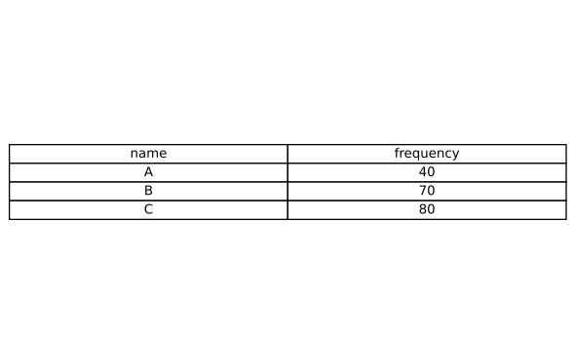

A. $\frac{4}{19}$

B. $\frac{2}{9}$

C. $\frac{1}{4}$

D. $\frac{1}{2}$

2.  The population of Town B increased by $17\%$ from 2020 to 2021. If the population of Town B in 2021 is represented as k times the population in 2020, what is the value of k?

A.   0.17

B.   0.83

C.   1.17

D.   1.34

3.  What is the median of the data set shown? data set = [64, 15, 54, 92, 90, 31]

4.  Which of the following equations best represents the line of best fit shown in the scatter plot? 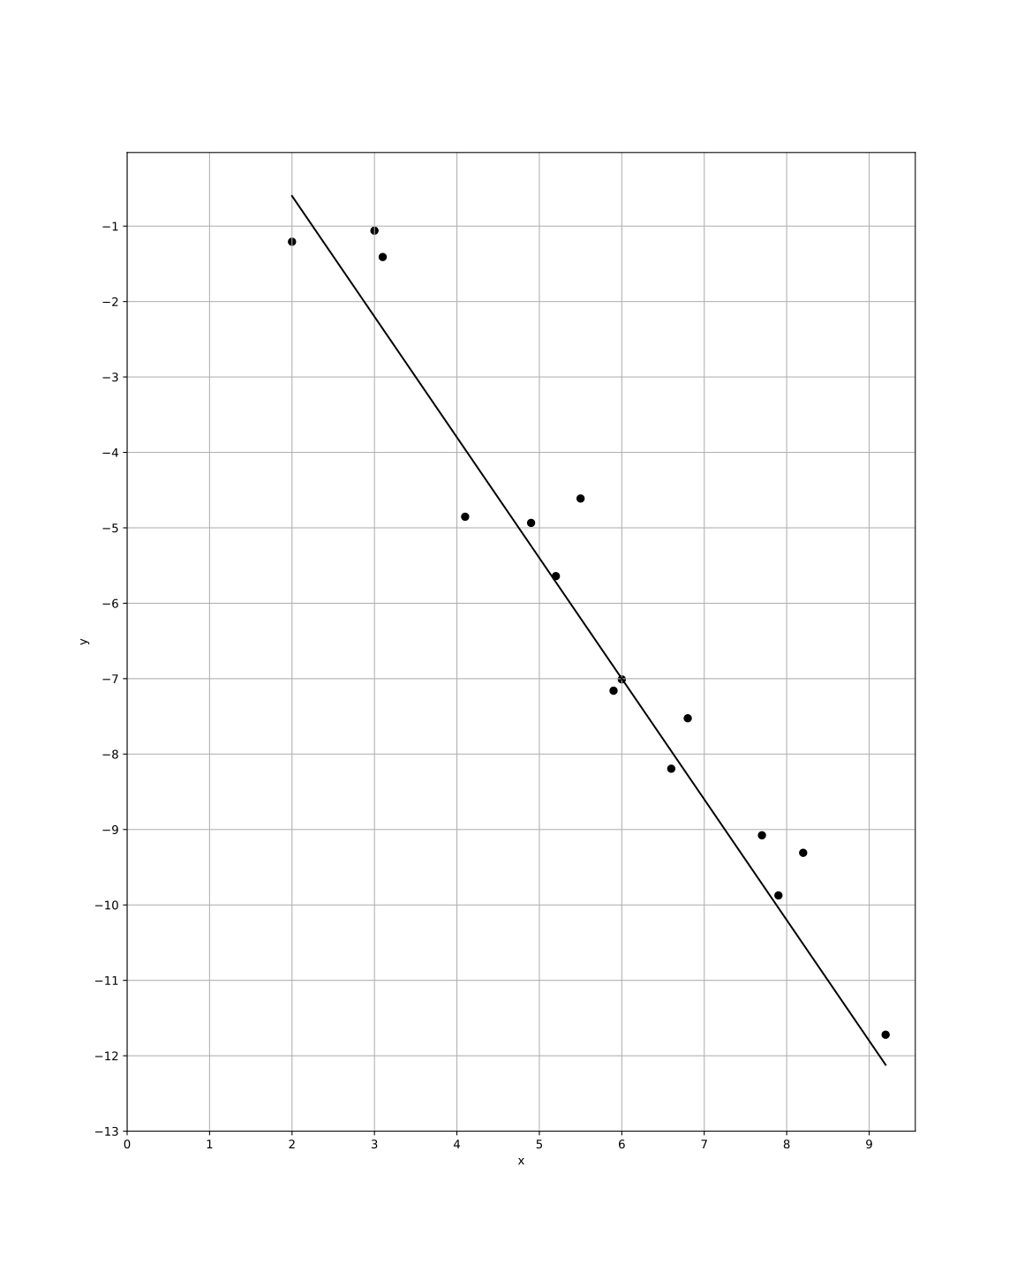

A.   y = 2.6 - 1.6x

B.   y = 2.6 + 1.6x

C.   y = -2.6 + 1.6x

D.   y = -2.6 - 1.6x

5.  The positive number a is $6600\%$ of the number c, and c is $62\%$ of the number b. If a - b = wc where w is a constant, what is the value of w?

6.  The ratio x to y is equivalent to the ratio 5 to 7. If y = 50t, what is the value of x in terms of t?

A. $\frac{1}{10}$   t

B.   25t

C. $\frac{250}{7}$   t

D. $\frac{7}{250}$   t

7.  The table shows the distribution of voters for two candidates, A and B. If a voter is selected at random, what is the probability that the voter supports candidate A, given that the voter is from Type A? (Express your answer as a decimal or fraction, not as a percent.)

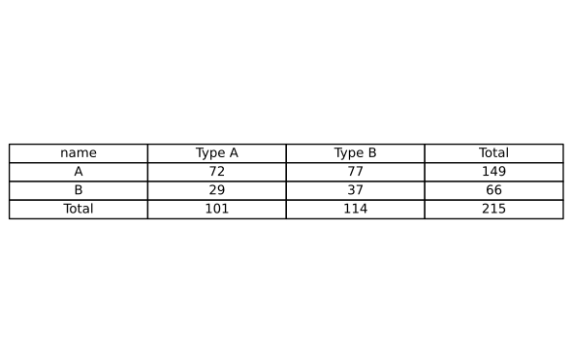

8.  In a smart home system, $45\%$ of the devices are connected to the Internet. If 900 devices are currently connected, what is the total number of devices in the system?

A.   1800

B.   2000

C.   2200

D.   2500

9.  A city has a total wealth of 3,299,940 dollars. After accounting for the wealth of 3,036,600 dollars in the top $10\%$ of earners, the remaining wealth is distributed evenly among the other residents. If there are 63 remaining residents, how much wealth does each of these residents receive on average?

A. $\$4,000$

B. $\$4,180$

C. $\$4,200$

D. $\$4,500$

10.  At a political rally, there are a total of 780 attendees. Each attendee can be categorized as either a voter supporting Candidate X, a voter supporting Candidate Y, or undecided. If the probability of randomly selecting a voter supporting Candidate X is 0.55 and the probability of selecting a voter supporting Candidate Y is 0.25, how many attendees are classified as undecided?

A.   120

B.   135

C.   156

D.   180

SAT Math Problem Solving and Data Analysis Solutions

1.  In a community consisting of 190 members, the members were surveyed about their ethical views, and their opinions were categorized into three groups as shown in the frequency table: Group A had 40 members, Group B had 70 members, and Group C had 80 members. If one member is selected at random, what is the probability that the selected member belongs to Group A?



A. $\frac{4}{19}$

B. $\frac{2}{9}$

C. $\frac{1}{4}$

D. $\frac{1}{2}$

## Answer

A

## Solution

Concept Check : The intent of the question is to assess the student’s understanding of basic probability concepts, specifically how to calculate the probability of an event occurring based on the relative frequency of that event in a given population. Students should know how to use the formula for probability, which is the number of favorable outcomes divided by the total number of outcomes.  
  
Solution Strategy : To approach this problem, the student should first recognize that they need to find the probability of selecting a member from Group A. The key steps involve identifying the number of members in Group A and the total number of members in the community. The student should then set up the probability formula: $P(Group A) =\frac{Number of members in Group A}{Total number of members}$.  
  
Quick Wins : When calculating probability, always ensure that you correctly identify the total number of outcomes. In this case, it’s the total number of community members. Also, make sure to double-check that you have the correct number for Group A. It may help to write down the formula and plug the numbers in step-by-step to avoid confusion.  
  
Mistake Alert : Students should be cautious not to confuse the sizes of the groups. Ensure you do not mistakenly add the numbers of the groups together, as this could lead to an incorrect total. Also, be careful with the arithmetic; double-check your calculations to avoid simple errors that could change the outcome.  
  
SAT Know-How : This problem falls under the category of Problem Solving and Data Analysis, specifically focusing on probability and relative frequency. It assesses the student’s ability to calculate the probability of an event based on given data, which is a fundamental skill in statistics. Mastering such problems is essential for success on the SAT, as it helps students develop critical thinking and analytical skills necessary for interpreting data.  
  
Identify the total number of members in the community, which is 190.  
Determine the number of members in Group A, which is 40.  
The probability of selecting a member from Group A is the ratio of Group A members to the total members.  
Calculate the probability: $Probability =\frac{Number of Group A members}{Total number of members}=\frac{40}{190}$.  
Simplify the fraction $\frac{40}{190}$ by dividing both the numerator and the denominator by their greatest common divisor, which is 10.  
Simplified, $\frac{40}{190}$ becomes $\frac{4}{19}$.

2.  The population of Town B increased by $17\%$ from 2020 to 2021. If the population of Town B in 2021 is represented as k times the population in 2020, what is the value of k?

A.   0.17

B.   0.83

C.   1.17

D.   1.34

## Answer

C

## Solution

Concept Check : The question aims to assess the student’s understanding of exponential growth and percentage increase. Students should know how to express growth as a factor of the original amount and apply the concept of percentages in the context of population growth.  
  
Solution Strategy : To solve the problem, students should start by understanding that a $17\%$ increase can be represented as a multiplication factor. They need to express the relationship between the population in 2020 and 2021 using the percentage increase formula. This will involve converting the percentage to a decimal and applying it to the original population figure.  
  
Quick Wins : Remember that a $17\%$ increase means that the new population is $117\%$ of the original population. To find the factor ’k’, convert $17\%$ to a decimal (0.17) and add it to 1. This will give you the multiplier that represents the population in 2021 relative to 2020. Practice converting percentages to decimal form, as it is a common step in many problems.  
  
Mistake Alert : Be careful with the conversion between percentage and decimal. A common mistake is to forget to add 1 when calculating the total percentage after an increase. Ensure you clearly distinguish between the original population and the increased population to avoid confusion.  
  
SAT Know-How : This problem belongs to the category of Problem Solving and Data Analysis, specifically focusing on linear and exponential growth. It tests the student’s ability to apply knowledge of percentage increases in real-world contexts. Mastering such problems will enhance your skills in interpreting data trends and applying mathematical concepts effectively.  
  
Step 1: Express the percentage increase as a decimal: $17\%$ = 0.17.  
Step 2: Calculate the population in 2021 in terms of the population in 2020:  
Population in 2021 = P + 0.17P = 1.17P.  
Step 3: Express the population in 2021 as k times the population in 2020: $k=\frac{Population in 2021}{Population in 2020}=\frac{1.17P}{P}$ 
.  
Step 4: Simplify the expression:  
k = 1.17.

3.  What is the median of the data set shown? data set = [64, 15, 54, 92, 90, 31]

## Answer

59

## Solution

Concept Check : The intent of this question is to assess the student’s understanding of how to find the median of a given data set. The student is expected to know the concept of median as a measure of central tendency, which requires them to arrange the data in order and identify the middle value(s).  
  
Solution Strategy : To solve this problem, the student should first arrange the data set in ascending order. Once the data is sorted, the student will need to determine the median by identifying the middle value. If there is an odd number of values, the median is the middle number. If there is an even number of values, the median is the average of the two middle numbers.  
  
Quick Wins : 1. Always start by sorting the data in increasing order. This will help you clearly see the middle value(s). 2. Remember that the median is the middle value: for an odd number of data points, it’s the single middle value, and for an even number, it’s the average of the two middle values. 3. Use a pencil and paper or a calculator to avoid mistakes when calculating averages.  
  
Mistake Alert : 1. Be careful to sort the numbers correctly; mixing them up will lead to the wrong median. 2. Don’t forget to check whether the number of data points is odd or even, as this affects how you calculate the median. 3. Ensure that you calculate the average correctly if needed, especially when dealing with two middle values.  
  
SAT Know-How : This problem falls under the category of Problem Solving and Data Analysis, specifically focusing on understanding the center, spread, and shape of distribution. It tests the student’s skills in organizing data and calculating the median, a fundamental concept in statistics. Mastering this skill is essential for effectively analyzing data sets, which is a key component of the SAT math section.  
  
Step 1: Arrange the data set in ascending order: [15, 31, 54, 64, 90, 92].  
Step 2: Identify the middle numbers of the data set since it has an even number of points.  
Step 3: The middle numbers are the 3rd and 4th numbers in the ordered list, which are 54 and 64.  
Step 4: Calculate the median by finding the average of these two middle numbers: $\frac{54+64}{2}=\frac{118}{2}=59$.  
Conclusion: The median of the data set is 59.

4.  Which of the following equations best represents the line of best fit shown in the scatter plot? 

A.   y = 2.6 - 1.6x

B.   y = 2.6 + 1.6x

C.   y = -2.6 + 1.6x

D.   y = -2.6 - 1.6x

## Answer

A

## Solution

Concept Check : The intent of this question is to assess the student’s understanding of linear regression and their ability to interpret scatter plots. Students are expected to recognize the characteristics of a line of best fit and how various linear equations can represent the data points visually displayed in the scatter plot.  
  
Solution Strategy : To approach this problem, students should first analyze the scatter plot for the overall trend of the data points. They should consider whether the points are clustering around a particular line and determine the slope and y-intercept of that line. Additionally, students may want to evaluate each provided equation to see which one aligns most closely with the observed data trend.  
  
Quick Wins : When examining the scatter plot, look for patterns such as positive or negative correlation. Pay attention to how steep the line should be, and note the points where the line crosses the y-axis. Using the coordinates of any two points from the line, students can calculate the slope (rise/run) to help confirm which equation might be correct. If given multiple options, graphing them can also help visualize which best fits the scatter plot.  
  
Mistake Alert : Students should be cautious of misinterpreting the scatter plot, especially by focusing only on outlier points that may not follow the overall trend. Additionally, they should avoid making assumptions about the slope or intercept without checking their calculations against multiple points. Be careful not to rush into selecting an answer without verifying how well it fits with the data points.  
  
SAT Know-How : This problem falls under the ’Problem Solving and Data Analysis’ category, specifically focusing on scatter plots and finding the line of best fit. It assesses skills such as interpreting visual data, understanding linear relationships, and applying concepts of slope and intercept. Mastering this type of question can enhance a student’s ability to analyze data effectively on the SAT.  
  
1. Analyze the line of best fit on the scatter plot and determine its slope.  
- From the provided graph, the plot shows a line that appears to rise from left to right, indicating a positive slope.  
2. Determine the y-intercept where the line crosses the y-axis.  
- Based on the information, the y-intercept is positive as the line crosses above the origin on the graph.  
3. Evaluate each option to see which equation fits the observed characteristics of the line:  
- Option A: y = 2.6 - 1.6x (positive y-intercept, negative slope)  
- Option B: y = 2.6 + 1.6x (positive y-intercept, positive slope)  
- Option C: y = -2.6 + 1.6x (negative y-intercept, positive slope)  
- Option D: y = -2.6 - 1.6x (negative y-intercept, negative slope)  
4. Based on the negative slope and positive y-intercept observed from the graph, Option A is the correct equation.

5.  The positive number a is $6600\%$ of the number c, and c is $62\%$ of the number b. If a - b = wc where w is a constant, what is the value of w?

## Answer

64.3871

## Solution

Concept Check : The intent of this question is to assess the student’s understanding of percentages and their ability to manipulate relationships between different variables. The student is expected to know how to express one quantity as a percentage of another and how to set up equations based on these relationships.  
  
Solution Strategy : To solve this problem, the student should start by converting the percentage statements into equations. For instance, since a is $6600\%$ of c, this can be expressed as a = 66c (because $6600\%$ means 66 times c). Similarly, since c is $62\%$ of b, this can be expressed as c = 0.62b. Once these relationships are established, the student can substitute and rearrange the equations to find the value of w in the equation a - b = wc.  
  
Quick Wins : When working with percentages, remember to convert them into decimal form for calculations. Also, keep track of the relationships between the variables step by step. Writing down each conversion clearly will help you avoid confusion. It may also be helpful to substitute the expressions derived from the percentage relationships into each other to simplify the problem.  
  
Mistake Alert : Be cautious with the conversion of percentages to decimal form; a common mistake is misinterpreting the percentage value (e.g., confusing $6600\%$ with 66.0). Ensure that you apply the percentage correctly and double-check the algebraic manipulations to avoid errors in signs or values.  
  
SAT Know-How : This problem is categorized under Problem Solving and Data Analysis, specifically focusing on basic percentages. It tests the student’s ability to understand and apply relationships among variables through percentages and to manipulate these relationships algebraically. Mastery of such problems requires a good grasp of percentage calculations and algebraic skills, which are essential for success on the SAT.  
  
1. Express the given relationships as equations:  
- Since a is $6600\%$ of c, a = 66c (because ).  
- Since c is $62\%$ of b, c = 0.62b or equivalently, .  
2. Substitute these equations into the equation a - b = wc:  
- Substitute a = 66c and $b=\frac{c}{0.62}$ into a - b = wc.  
- Therefore, 66c - (c/0.62) = wc.  
3. Simplify the equation:  
- To combine terms, express b in terms of c by converting the division to a multiplication: .  
- Replace b in the equation: 66c - 1.6129032258c = wc.  
- Combine like terms: 66c - 1.6129032258c = 64.3870967742c.  
4. Solve for w:  
- Since 64.3870967742c = wc, then w = 64.3870967742.  
5. Round w to four decimal places if necessary:  
- w ≈ 64.3871.

6.  The ratio x to y is equivalent to the ratio 5 to 7. If y = 50t, what is the value of x in terms of t?

A. $\frac{1}{10}$   t

B.   25t

C. $\frac{250}{7}$   t

D. $\frac{7}{250}$   t

## Answer

C

## Solution

Concept Check : The intent of the question is to assess the student’s understanding of ratios and their ability to set up and manipulate equations based on proportional relationships. The student should know how to express one variable in terms of another using given ratios.  
  
Solution Strategy : To approach this problem, the student should first recognize that the statement ’the ratio x to y is equivalent to the ratio 5 to 7’ means that $\frac{x}{y}=\frac{5}{7}$. From there, the student can substitute the given value of y (which is 50t) into the equation. The goal is to solve for x in terms of the variable t.  
  
Quick Wins : When dealing with ratios, it can be helpful to cross-multiply to eliminate the fractions. Remember to maintain the equality of the ratios throughout your calculations. Additionally, breaking down the problem step-by-step can make it easier to follow the logic and avoid mistakes.  
  
Mistake Alert : Be careful not to confuse the ratio components when substituting values. It’s also important to double-check the arithmetic when multiplying or dividing, as small errors can lead to incorrect final answers. Ensure you maintain the correct variable relationships throughout the calculations.  
  
SAT Know-How : This problem falls under the category of Problem Solving and Data Analysis, specifically focusing on ratios, rates, and proportions. It assesses the student’s ability to manipulate equations and express one variable in terms of another. Mastering these skills is crucial for success in the SAT, particularly in the math sections where proportional reasoning is frequently tested.  
  
1. Express the given ratio as an equation: x : y = 5 : 7, which means 7x = 5y.  
2. Substitute the given expression for y (y = 50t) into the equation: 7x = 5(50t).  
3. Perform the multiplication: 7x = 250t.  
4. Solve for x by dividing both sides by 7: x = t.  
5. Therefore, the value of x in terms of t is x = $\frac{250}{7}$ t.

7.  The table shows the distribution of voters for two candidates, A and B. If a voter is selected at random, what is the probability that the voter supports candidate A, given that the voter is from Type A? (Express your answer as a decimal or fraction, not as a percent.) 

## Answer

$\frac{72}{101}$

## Solution

Concept Check : The intent is to assess the student’s understanding of conditional probability and the ability to interpret data from a table. Students should be familiar with the concept of conditional probability, which is the probability of an event occurring given that another event has already occurred.  
  
Solution Strategy : To solve this problem, the student should first identify the relevant values from the table related to candidate A and the voters from Type A. The calculation will involve determining the number of voters that support candidate A among those voters from Type A, and then dividing this number by the total number of voters from Type A to find the conditional probability.  
  
Quick Wins : When dealing with tables, it’s crucial to carefully read the labels and understand what each row and column represents. To find the conditional probability, remember the formula $P(A∣B)=\frac{P(A and B)}{P(B)}$, where P(A|B) is the probability of A given B, P(A and B) is the number of favorable outcomes, and P(B) is the total number of outcomes for B. Make sure to simplify your fraction if necessary.  
  
Mistake Alert : Be careful not to confuse the total number of voters with the number of voters from Type A when calculating the probabilities. Double-check the values you extract from the table to avoid simple arithmetic errors. Ensure that you are using the correct numerator and denominator when applying the conditional probability formula.  
  
SAT Know-How : This problem falls under the category of Problem Solving and Data Analysis, specifically focusing on conditional probability. It assesses the student’s ability to interpret data from a table and apply the concept of conditional probability. Understanding how to extract relevant data and apply the appropriate formulas is essential for success in SAT math problem-solving.  
  
Identify the relevant quantities for the probability calculation. We need the number of voters supporting candidate A from Type A and the total number of Type A voters.  
The probability that a voter supports candidate A, given that the voter is from Type A, is calculated as the ratio of the number of Type A voters supporting candidate A to the total number of Type A voters.  
Number of voters supporting candidate A from Type A = 72  
Total number of Type A voters = 101  
Probability that a voter supports candidate A given $Type A=\frac{72}{101}$  
Since 72 and 101 have no common factors other than 1, the fraction $\frac{72}{101}$ is already in its simplest form.

8.  In a smart home system, $45\%$ of the devices are connected to the Internet. If 900 devices are currently connected, what is the total number of devices in the system?

A.   1800

B.   2000

C.   2200

D.   2500

## Answer

B

## Solution

Concept Check : The question intends to assess the student’s understanding of percentages and their ability to translate a word problem into a mathematical equation. The student is expected to know how to work with percentages and apply the concept to find the total number of devices based on the given percentage and quantity.  
  
Solution Strategy : To solve this problem, the student should first identify the relationship between the percentage of connected devices and the total number of devices. The equation can be formed by utilizing the known percentage ($45\%$) and the number of connected devices (900). The student should think about how to express the total devices in terms of the known quantity and the percentage.  
  
Quick Wins : Start by converting the percentage into a decimal form (for $45\%$, this would be 0.45). Then, set up the equation where 0.45 of the total number of devices equals 900. This can be expressed as: Total Devices × 0.45 = 900. From there, you can solve for the total number of devices by isolating the variable.  
  
Mistake Alert : Be careful not to confuse the percentage with the actual number of devices. It’s important to remember that $45\%$ does not mean 45 devices; it means 45 out of every 100 devices. Additionally, make sure to perform the arithmetic operations correctly when isolating the total number of devices to avoid errors.  
  
SAT Know-How : This problem is a classic example of a percentage word problem, which falls under the category of Problem Solving and Data Analysis in the SAT. It assesses the student’s ability to interpret percentages and apply them in real-world contexts. Mastering this type of problem requires a solid understanding of percentages and the ability to set up and solve equations, which are essential skills for success on the SAT.  
  
Let x represent the total number of devices in the system. $45\%$ 
 of x is equal to 900 devices. This can be expressed as the equation: $0.45×x=900$.  
To find x, divide both sides of the equation by 0.45: $x=\frac{900}{0.45}$.  
Calculate 900 divided by 0.45: $x=\frac{900}{0.45}=2000$ 
.  
Thus, the total number of devices in the system is 2000.

9.  A city has a total wealth of 3,299,940 dollars. After accounting for the wealth of 3,036,600 dollars in the top $10\%$ of earners, the remaining wealth is distributed evenly among the other residents. If there are 63 remaining residents, how much wealth does each of these residents receive on average?

A. $\$4,000$

B. $\$4,180$

C. $\$4,200$

D. $\$4,500$

## Answer

B

## Solution

Concept Check : The intent of the question is to assess the student’s understanding of ratios, rates, and proportions, particularly in the context of distributing a total amount of wealth among a group of individuals. The student should be familiar with basic arithmetic operations, particularly subtraction and division, and understand how to set up a problem involving averages.  
  
Solution Strategy : To solve this problem, the student should first determine the total wealth that is not held by the top $10\%$ of earners by subtracting the wealth of the top earners from the total wealth of the city. Then, the student should divide this remaining wealth by the number of remaining residents to find the average wealth per resident. It is important to keep track of the calculations step by step to avoid confusion.  
  
Quick Wins : Start by clearly identifying the total wealth and the amount held by the top earners. Use clear notation for each step: label the total wealth, the wealth of the top earners, and the remaining wealth. When dividing, ensure you double-check the division for accuracy. If you have a calculator, it can help to quickly verify your results.  
  
Mistake Alert : Be careful with the arithmetic operations, especially when subtracting and dividing numbers. It is easy to make a mistake in the calculations, so double-check each step. Additionally, ensure that you are dividing the remaining wealth by the correct number of residents, as miscounting this can lead to incorrect results.  
  
SAT Know-How : This problem falls under the category of Problem Solving and Data Analysis, specifically focusing on ratios, rates, and proportions. It assesses the student’s ability to perform basic arithmetic operations and apply them to real-world scenarios. By understanding how to break down the problem into manageable steps and checking their work, students can develop their problem-solving skills effectively, which is crucial for success in the SAT.  
  
1. Calculate the remaining wealth after accounting for the top $10\%$.  
Remaining wealth = Total wealth - Wealth of top $10\%$  
Remaining wealth = 3,299,940 - 3,036,600  
Remaining wealth = 263,340 dollars  
2. Determine the average wealth received by each of the 63 remaining residents. $Average wealth per remaining resident=\frac{Remaining wealth}{Number of remaining residents}$ $Average wealth per remaining resident=\frac{263,340}{63}$
  
  
Divide 263,340 by 63 to find the average.  
Average wealth per remaining resident = 4,180 dollars

10.  At a political rally, there are a total of 780 attendees. Each attendee can be categorized as either a voter supporting Candidate X, a voter supporting Candidate Y, or undecided. If the probability of randomly selecting a voter supporting Candidate X is 0.55 and the probability of selecting a voter supporting Candidate Y is 0.25, how many attendees are classified as undecided?

A.   120

B.   135

C.   156

D.   180

## Answer

C

## Solution

Concept Check : The intent of this question is to assess the student’s understanding of basic probability concepts, particularly how to apply probabilities to a total population to find unknown quantities. The student is expected to know how to calculate the proportion of a group based on given probabilities and how to perform simple arithmetic operations.  
  
Solution Strategy : To solve the problem, the student should first identify the total number of attendees and the probabilities given for Candidates X and Y. They will need to calculate the total number of attendees who support each candidate by multiplying the total number of attendees by the respective probabilities. After finding those numbers, the student will subtract the sum of these values from the total number of attendees to determine the number of undecided attendees.  
  
Quick Wins : Start by clearly defining the total number of attendees and the probabilities for each candidate. Remember to convert the probabilities into actual counts by using multiplication. Keep your calculations organized, and double-check your work as you go along. It may help to write down the equation you are using to find the number of undecided voters, as this can clarify your thought process.  
  
Mistake Alert : Be careful with the arithmetic calculations, especially when multiplying the total number of attendees by the probabilities. Also, ensure that you are correctly accounting for all parts of the problem—after finding the number of supporters for both candidates, remember to correctly subtract from the total number of attendees to find the undecided group. Watch out for rounding errors or misinterpretation of the probability values.  
  
SAT Know-How : This problem falls under the category of Problem Solving and Data Analysis, specifically focusing on probability and relative frequency. It tests the student’s ability to apply probability concepts to real-world scenarios and perform basic arithmetic operations. Mastering such problems is essential for developing skills in logical reasoning and quantitative analysis, which are critical for success on the SAT.  
  
First, calculate the probability of selecting an undecided voter. This is given by subtracting the sum of the probabilities of the voters for Candidate X and Candidate Y from 1.  
Probability of undecided = 1 - 0.55 - 0.25 = 0.20  
Now, calculate the number of undecided attendees by multiplying the probability of an undecided voter with the total number of attendees.  
Number of undecided attendees = Probability of undecided × Total attendees  
Number of undecided attendees = 0.20 × 780 = 156