SAT Math Advanced

1.  The graph of y = f(x) is shown where $f(x)=ax^{3}+bx^{2}+cx+d$ and a, b, c and d are constants. For how many distinct values of x does f(x) = 0?

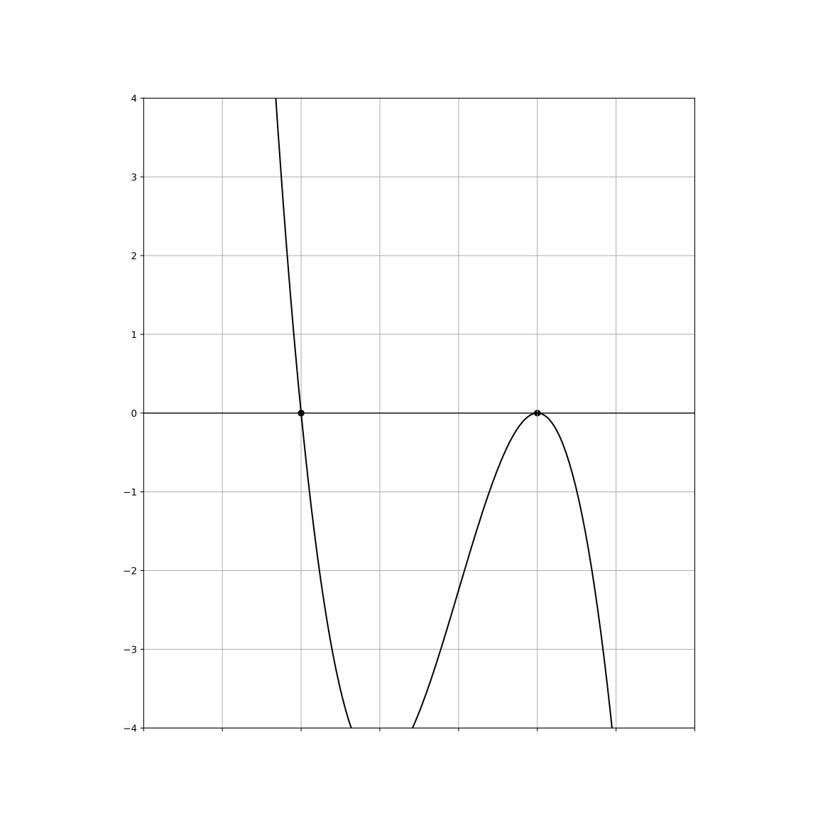

A.   One

B.   Two

C.   Three

D.   Four

2.  In a certain diplomatic negotiation, the population of a small island nation represented by a particular ethnic group is modeled by the function , where is the number of years since 2010. Which of the following best describes the value 8200 in this context?

A.   The estimated population after 10 years f(10) in 2020.

B.   The estimated percentage decline in population each year after 2010.

C.   The initial population of the ethnic group in the year 2010.

D.   The population of the ethnic group at the end of 2010.

3.  The function f is defined by $f(x)=7x^{2}+6x−38$. What is the value of $f(2)$?

4.  The product of a positive number x and the number that is 67 less than x is equal to 1634. What is the value of x?

A.   -19

B.    54

C.    67

D.   86

5.  For the given function f, the graph of $y=f(x)$ in the xy-plane passes through the point (0, b), where b is a constant. What is the value of b? $f(x)=2x^{3}−5x^{2}+9x+81$

6.  The equation $4|x−97|+7=k^{2}+110k+3032$ has exactly one solution for the variable $x$. Which of the following could be the value of $k$?

A.   -55 only

B.    0 only

C.   -55 and 0

D.   -55 and 55

7.  The equation $−5|x−99|−9=k^{2}−100k+2491$ has exactly one solution for the value of $k$. Which of the following could be the value of $k$?

A.    50 only

B.   -50 and 0

C.   -50 only

D.    50 and -50

8.  Given that $n$ and $k$ are numbers greater than 1, and $\sqrt[9]{n^{17}}=\sqrt[15]{k^{7}}$, for what value of $a$ is $n^{3a+2}=k$?

A.    43

B. $\frac{43}{63}$

C. $\frac{85}{63}$

D. $\frac{43}{21}$

9.  Which expression is equivalent to $−36x^{3}+54x^{2}y+8xy^{2}−12y^{3}$?

A. $(12x^{2}−4y^{2})(−3x+5y)$

B. $(6x^{2}+3y^{2})(−6x+4y)$

C. $(9x^{2}−2y^{2})(−4x+6y)$

D. $(3x^{2}+2y^{2})(−12x+2y)$

10.  What is not an x-coordinate of an x-intercept of the graph $y=4(x−7)(x+9)(x−2)$ in the xy-plane?

A.   -9

B.    2

C.    7

D.   10

SAT Math Advanced Solutions

1.  The graph of y = f(x) is shown where $f(x)=ax^{3}+bx^{2}+cx+d$ and a, b, c and d are constants. For how many distinct values of x does f(x) = 0?



A.   One

B.   Two

C.   Three

D.   Four

## Answer

B

## Solution

Concept Check : The intent of this question is to assess the student’s understanding of polynomial functions, specifically cubic polynomials, and their behavior regarding the number of real roots. Students are expected to know how to analyze the graph of a cubic function to determine the number of distinct x-values at which the function equals zero.  
  
Solution Strategy : To approach this problem, students should examine the graph of the polynomial function provided. They will need to identify the points where the graph intersects the x-axis, as these points correspond to the values of x that satisfy f(x) = 0. Students should also consider the shape of the graph, including the number of turning points and the general behavior of cubic functions, which can give clues about the number of real roots.  
  
Quick Wins : When analyzing the graph, pay attention to the following: 1) Each intersection with the x-axis represents a distinct real root. 2) Count the intersections carefully, as a cubic function can have one, two, or three real roots. 3) If the graph is tangent to the x-axis at a point, this counts as a double root (i.e., one distinct solution). 4) Look for any symmetry or other characteristics of the graph that might simplify your analysis.  
  
Mistake Alert : Be cautious not to overlook any intersections with the x-axis, especially in cases where the curve is very close to the x-axis or where it might appear to just touch the axis without crossing it. Double-check to ensure that points of tangency are counted correctly as distinct roots. Additionally, be aware of any potential misinterpretation of the graph’s scale, which can lead to inaccurate counting.  
  
SAT Know-How : This problem falls under the category of Advanced Math and specifically focuses on polynomial functions and their graphs. It assesses the student’s ability to identify the number of distinct real solutions to a polynomial equation by interpreting the graphical representation. The skills tested here include understanding polynomial behavior and root finding, which are crucial for success on the SAT.  
  
To find the number of distinct values of x where f(x) = 0, observe the provided roots and the behavior of the graph.  
The graph is intersecting the x-axis at two distinct points.  
Check for additional roots: The nature of a cubic polynomial implies it can have a third root, which isn’t provided explicitly here.  
The polynomial form and provided graph data suggest the third root might be a repeated one at either of the given intersections or another unexplored intersection point.  
Without more explicit intersections given, the graph might suggest a situation with a triple root or a hidden third root, but given data explicitly shows two distinct real roots.

2.  In a certain diplomatic negotiation, the population of a small island nation represented by a particular ethnic group is modeled by the function , where is the number of years since 2010. Which of the following best describes the value 8200 in this context?

A.   The estimated population after 10 years f(10) in 2020.

B.   The estimated percentage decline in population each year after 2010.

C.   The initial population of the ethnic group in the year 2010.

D.   The population of the ethnic group at the end of 2010.

## Answer

C

## Solution

Concept Check : The question is asking students to understand the context of an exponential function, specifically identifying what the coefficient (8200) represents in relation to the modeled population. Students are expected to know how exponential functions function in real-world scenarios, especially regarding growth or decay over time.  
  
Solution Strategy : To solve this problem, students should first recognize the structure of the exponential function provided. The base of the exponent (0.27) indicates a decay factor, suggesting the population is decreasing. The coefficient (8200) typically represents the initial value or starting population at the beginning of the time frame being considered (in this case, the year 2010). Students should analyze the implications of this coefficient in the context of the population’s behavior over the years.  
  
Quick Wins : When interpreting coefficients in exponential functions, always consider the context of the problem. Identify what the function models and how the parameters relate to real-world quantities. In exponential decay models, the coefficient often represents the initial amount before any decrease occurs. It can be helpful to sketch a quick graph of the function to visualize how the initial value affects the overall trend.  
  
Mistake Alert : Be careful not to confuse the coefficient with the base of the exponent. The base indicates the rate of change (growth or decay), while the coefficient reflects the starting amount. Additionally, ensure you are clear about what ’x’ represents; in this case, it’s the number of years since 2010, not the population itself.  
  
SAT Know-How : This problem falls under the category of Advanced Math, specifically focusing on quadratic and exponential word problems. It assesses students’ ability to interpret parameters in an exponential model within a real-world context. Understanding the meaning of coefficients and their implications in exponential functions is crucial for solving similar problems on the SAT, showcasing the importance of grasping the relationship between mathematical expressions and their practical applications.  
  
To solve this problem, we need to understand the components of the exponential function $f(x)=8200{\left(0.27\right)}^{x}$.  
In general, an exponential function of the form $f(x)=a{\left(b\right)}^{x}$, where a is the initial value or the value when x=0, and b is the base of the exponential function which indicates the growth or decay factor.  
In the given function $f(x)=8200{\left(0.27\right)}^{x}$, the value 8200 is the coefficient of the exponential term, which represents the initial population size.  
When x = 0, which corresponds to the year 2010, $f(0)=8200{\left(0.27\right)}^{0}=8200×1=8200$.  
Thus, 8200 represents the population of the ethnic group at the start of the model, which is the population in the year 2010.

3.  The function f is defined by $f(x)=7x^{2}+6x−38$. What is the value of $f(2)$?

## Answer

2

## Solution

Concept Check : The intent of this question is to assess the student’s understanding of evaluating a quadratic function. Students are expected to know how to substitute a given value into a function and compute the result, demonstrating their proficiency with basic algebraic operations.  
  
Solution Strategy : To solve this problem, the student should start by substituting the given value, which is 2, into the function $f(x)$. This involves replacing x with 2 in the expression $7x^{2}+6x−38$. After substitution, they will need to follow the order of operations (PEMDAS/BODMAS) to simplify the expression step by step.  
  
Quick Wins : When substituting, it’s helpful to write out the function clearly and confirm each step as you go. Break down the calculation into manageable parts, calculating $7(2^{2})$, $6(2)$, and then combining these results along with the constant term -38. This systematic approach can minimize errors.  
  
Mistake Alert : Be careful with arithmetic, especially when squaring numbers and performing addition or subtraction. It’s easy to make mistakes with signs, so double-check your calculations to ensure accuracy. Also, remember to follow the order of operations closely.  
  
SAT Know-How : This problem falls under the category of Advanced Math, focusing on nonlinear functions, particularly quadratics. It assesses the student’s skill in evaluating functions and performing algebraic operations. Mastering such problems enhances problem-solving capabilities and prepares students for the types of questions they may encounter on the SAT.  
  
Start with the function: $f(x)=7x^{2}+6x−38$.  
Substitute $x=2$ into the function: $f(2)=7{\left(2\right)}^{2}+6(2)−38$.  
Calculate $7{\left(2\right)}^{2}$: $2^{2}=4$, so $7(4)=28$.  
Calculate 6(2): $6×2=12$.  
Combine the terms: $28+12−38$.  
Perform the arithmetic: $28+12=40$.  
Subtract 38 from 40: $40−38=2$.  
Thus, the value of $f(2)$ is 2.

4.  The product of a positive number x and the number that is 67 less than x is equal to 1634. What is the value of x?

A.   -19

B.   54

C.    67

D.    86

## Answer

D

## Solution

Concept Check : The intent of this question is to assess the student’s understanding of quadratic equations. The student is expected to recognize how to set up an equation based on a word problem, specifically involving the product of two expressions and a constant. This requires knowledge of forming and solving quadratic equations.  
  
Solution Strategy : To approach the problem, the student should first identify the two expressions mentioned: one is the positive number x, and the other is the number that is 67 less than x, which can be expressed as (x - 67). The next step is to set up the equation by multiplying these two expressions and setting it equal to 1634. This will lead to the formation of a quadratic equation, which can then be rearranged into standard form for solving.  
  
Quick Wins : When forming the equation, be sure to carefully translate the words into mathematical expressions. Remember that ’the product of x and (x - 67)’ means you will multiply these two terms. After setting up the equation, try to simplify it as much as possible before applying methods such as factoring, completing the square, or using the quadratic formula to solve for x. Double-check your arithmetic as you go.  
  
Mistake Alert : One common mistake is misinterpreting the relationship between x and (x - 67). Ensure that you correctly express ’67 less than x’ as (x - 67). Additionally, watch out for errors when expanding the product; it’s easy to miscalculate or forget to combine like terms. Finally, remember that since x is a positive number, you should verify that your solution is a valid positive value after solving the quadratic equation.  
  
SAT Know-How : This problem falls under the category of Advanced Math, specifically within the unit of solving quadratic equations. It requires students to apply their skills in translating verbal expressions into mathematical equations and solving quadratic equations effectively. Overall, this problem assesses the student’s ability to understand relationships and perform algebraic manipulations, which are critical skills for success on the SAT.  
  
1. Set up the equation based on the problem statement:  
x(x - 67) = 1634  
2. Expand the equation:  
x² - 67x = 1634  
3. Rearrange the equation to standard quadratic form (ax² + bx + c = 0):  
x² - 67x - 1634 = 0  
4. Solve the quadratic equation using the quadratic formula: $x=\frac{−b±\sqrt{b^{2}−4ac}}{2a}$ 
  
where a = 1, b = -67, c = -1634  
5. Calculate the discriminant:  
b² - 4ac = (-67)² - 4(1)(-1634)  
b² - 4ac = 4489 + 6536  
b² - 4ac = 11025  
6. Since the discriminant is a perfect square, calculate the roots:  
  
  
7. Calculate x for both cases:  
 =   
 =   
8. Since x must be positive, x = 86.

5.  For the given function f, the graph of $y=f(x)$ in the xy-plane passes through the point (0, b), where b is a constant. What is the value of b? $f(x)=2x^{3}−5x^{2}+9x+81$

## Answer

81

## Solution

Concept Check : The intent of the question is to assess the student’s understanding of polynomial functions and their graphs, specifically the concept of finding the y-intercept of a function. The y-intercept occurs where x = 0, so the student is expected to substitute 0 into the polynomial function to find the corresponding y value, which is represented by the constant b.  
  
Solution Strategy : To approach this problem, the student should recognize that the y-intercept is found by evaluating the function f at x = 0. This involves substituting 0 into the polynomial f(x) = 2x³ - 5x² + 9x + 81 and calculating the resulting value. The thought process should focus on plugging in x = 0 and simplifying the expression to directly find the value of b.  
  
Quick Wins : A useful tip is to remember that the y-intercept is simply the value of the function when x equals 0. For higher-degree polynomials, always start by substituting 0 for x and simplify step by step. Additionally, keep in mind the coefficients of the polynomial; when x is 0, all terms containing x will drop out, leaving only the constant term, which simplifies the calculation.  
  
Mistake Alert : Be careful when substituting x = 0; it’s easy to miscalculate the terms if you’re not careful with the signs or constants. Also, make sure to double-check each term in the polynomial to ensure you haven’t skipped or incorrectly computed any of them. It’s also important to remember that only the constant term remains when substituting x = 0.  
  
SAT Know-How : This problem falls under the category of Advanced Math, specifically involving polynomial functions and their properties. It tests the student’s ability to find the y-intercept of a polynomial function by evaluating it at x = 0. Mastering this concept is crucial for success in the SAT, as it helps in understanding how polynomial graphs behave and provides a foundation for solving more complex equations.  
  
To find b, evaluate the function at x = 0.  
Substitute x = 0 into f(x): f(0) = 2(0)³ - 5(0)² + 9(0) + 81.  
Perform each operation: 2(0)³ = 0, -5(0)² = 0, 9(0) = 0, and the constant 81 remains.  
Therefore, f(0) = 0 + 0 + 0 + 81 = 81.  
Thus, the value of b is 81.

6.  The equation $4|x−97|+7=k^{2}+110k+3032$ has exactly one solution for the variable $x$. Which of the following could be the value of $k$?

A.   -55 only

B.    0 only

C.   -55 and 0

D.   -55 and 55

## Answer

A

## Solution

Concept Check : The intent of this question is to assess the student’s understanding of absolute value equations and how the number of solutions can be determined based on the properties of the equations involved. Students should be familiar with the concept of absolute values and the conditions under which an equation has one solution, particularly in relation to quadratic functions.  
  
Solution Strategy : To solve this problem, students should start by isolating the absolute value expression on one side of the equation. They will need to recognize that for the equation to have exactly one solution, the expression inside the absolute value must equal zero at that solution, and the quadratic expression on the right side must also take a specific form. This typically involves finding the vertex of the quadratic function and ensuring it touches the x-axis at exactly one point. Students should think about how to manipulate the equation to find values of k that meet these conditions.  
  
Quick Wins : Consider rewriting the equation in a form that allows you to analyze the absolute value term. Remember that an absolute value equation has one solution when the expression inside the absolute value is zero, or when the graph of the quadratic touches the line represented by the absolute value. You may want to identify the vertex of the quadratic equation on the right side and find values of k that make it equal to the expression represented by the absolute value. Calculating the discriminant of the quadratic can also provide insight into the number of solutions.  
  
Mistake Alert : Be careful not to overlook the conditions for the absolute value to yield exactly one solution. It’s crucial to ensure that the quadratic’s vertex aligns correctly for it to touch the axis at just one point. Additionally, pay attention to any algebraic manipulations and signs when isolating the absolute value term, as mistakes in these steps can lead to incorrect conclusions about the number of solutions.  
  
SAT Know-How : This problem falls under the category of Advanced Math, specifically focusing on radical, rational, and absolute value equations. It assesses skills related to manipulating and analyzing equations to determine the number of solutions. The key takeaway is to understand how absolute values interact with quadratic functions and to use properties of both to solve for possible values of k. Mastering these concepts is essential for effective problem-solving in SAT math.  
  
Step 1: Start with the absolute value equation: $4|x−97|+7=k^{2}+110k+3032$.  
Step 2: Isolate the absolute value term: $4|x−97|=k^{2}+110k+3025$.  
Step 3: Divide both sides by 4: $|x−97|=\frac{k^{2}+110k+3025}{4}$.  
Step 4: For |x - 97| to have exactly one solution, the expression $\frac{k^{2}+110k+3025}{4}$ must be 0.  
Step 5: Solve the equation: $k^{2}+110k+3025$ = 0.  
Step 6: Factor the quadratic equation: $k^{2}+110k+3025={\left(k+55\right)}^{2}$.  
Step 7: Set the factored expression to 0: ${\left(k+55\right)}^{2}=0$.  
Step 8: Solve for k: k + 55 = 0, so k = -55.

7.  The equation $−5|x−99|−9=k^{2}−100k+2491$ has exactly one solution for the value of $k$. Which of the following could be the value of $k$?

A.    50 only

B.   -50 and 0

C.   -50 only

D.    50 and -50

## Answer

A

## Solution

Concept Check : The question aims to assess the student’s understanding of absolute value equations and their properties. Students are expected to know how to manipulate and analyze equations, particularly how to set conditions for the number of solutions an equation can have, especially when dealing with absolute values.  
  
Solution Strategy : To approach this problem, students should recognize that the absolute value equation can be rewritten to isolate the absolute value expression. They need to analyze the right side of the equation, which is a quadratic expression in k, and determine under what conditions this entire equation will yield exactly one solution. This involves understanding the characteristics of quadratic functions and how they relate to the number of solutions of the equation.  
  
Quick Wins : A helpful strategy is to first simplify the equation to isolate the absolute value. Then, consider the implications of having exactly one solution: this typically occurs when the expression inside the absolute value equals zero, or when the quadratic has one real solution (the vertex lies on the x-axis). Checking the discriminant of the quadratic (b² - 4ac) can also be useful; for one solution, the discriminant should equal zero.  
  
Mistake Alert : Students should be careful with the manipulation of the quadratic equation, ensuring they do not overlook the conditions under which it provides one solution. Additionally, they should be mindful of the absolute value properties, as mistakes may arise in interpreting the outcomes of the absolute value equation. Be cautious about sign changes when isolating the variable and setting up the equations for both cases of the absolute value.  
  
SAT Know-How : This problem falls under the category of Advanced Math, focusing on radical, rational, and absolute value equations. It evaluates the student’s ability to analyze absolute value equations and quadratic expressions, testing their understanding of solution conditions. Mastery of these skills is essential for effective problem-solving on the SAT, particularly in recognizing how to derive conditions for specific numbers of solutions.  
  
Rearrange the given equation: -5|x - 99| - 9 = k² - 100k + 2491  
Add 9 to both sides: -5|x - 99| = k² - 100k + 2500  
Divide by -5: $|x−99|=−\frac{k^{2}−100k+2500}{5}$  
For the equation to have exactly one solution, |x - 99| must be zero.  
Set the quadratic expression to zero: $−\frac{k^{2}−100k+2500}{5}=0$  
Solve for k: k² - 100k + 2500 = 0  
This is a quadratic equation. Solve using the completing square method or quadratic formula:  
Quadratic formula: $k=\frac{100±\sqrt{{\left(100\right)}^{2}−4×1×2500}}{2}$ $k=\frac{100±\sqrt{10000−10000}}{2}$ 
  
k = 50  
Thus, the equation has exactly one solution when k = 50.

8.  Given that $n$ and $k$ are numbers greater than 1, and $\sqrt[9]{n^{17}}=\sqrt[15]{k^{7}}$, for what value of $a$ is $n^{3a+2}=k$?

A.    43

B. $\frac{43}{63}$

C. $\frac{85}{63}$

D. $\frac{43}{21}$

## Answer

B

## Solution

Concept Check : The intent of this question is to test the student’s understanding of radical and rational exponents, specifically how to manipulate and equate expressions involving roots and powers. Students are expected to know how to express radicals as exponents and how to solve equations involving these expressions.  
  
Solution Strategy : To approach this problem, the student should start by rewriting the radical expressions as fractional exponents. For the equation $\sqrt[9]{n^{17}}$, this becomes $n^{\frac{17}{9}}$, and for $\sqrt[15]{k^{7}}$, it becomes $k^{\frac{7}{15}}$. After rewriting, the student can set the two expressions equal to each other, giving $n^{\frac{17}{9}}$ = $k^{\frac{7}{15}}$. Then, the next step would be to express k in terms of n using the relationship given by $n^{3a+2}=k$, which will lead to an equation involving a single variable, making it easier to solve for ’a’.  
  
Quick Wins : When converting radicals to exponents, remember that the root indicates the denominator of the exponent. Keep track of your fractional exponents and ensure you simplify them correctly. Also, when working with equations that involve powers, it can be helpful to express both sides in terms of a common base if possible. This will often make it easier to isolate the variable you’re solving for.  
  
Mistake Alert : Be careful with the laws of exponents when you manipulate the equations. It’s easy to mix up multiplication and addition of exponents. Additionally, remember that when you raise an exponent to another power, you multiply the exponents. Double-check your calculations, especially when dealing with fractional values, as these can lead to mistakes if not handled carefully.  
  
SAT Know-How : This problem falls under the category of Advanced Math, specifically focusing on radical and rational exponents. It assesses the student’s ability to manipulate and solve equations involving exponents and roots. By practicing problems like this, students can develop a stronger grasp of exponent rules and improve their problem-solving skills, which is vital for success on the SAT.  
  
Step 1: Express the roots as exponents: $\sqrt[9]{n^{17}}=n^{\frac{17}{9}}$ $\sqrt[15]{k^{7}}=k^{\frac{7}{15}}$
  
  
Now equate these two expressions: $n^{\frac{17}{9}}=k^{\frac{7}{15}}$ 
  
Step 2: Solve for $k$ in terms of $n$:  
Raise both sides to the power of $\frac{15}{7}$: ${\left(n^{\frac{17}{9}}\right)}^{\frac{15}{7}}={\left(k^{\frac{7}{15}}\right)}^{\frac{15}{7}}$ $n^{\frac{17}{9}⋅\frac{15}{7}}=k^{1}=k$
  
  
Calculate $\frac{17}{9}⋅\frac{15}{7}$: $\frac{17×15}{9×7}=\frac{255}{63}=\frac{85}{21}$ 
  
Thus, $k=n^{\frac{85}{21}}$.  
Step 3: Equate the exponents of $n$:  
Given $n^{\frac{85}{21}}=n^{3a+2}$, equate the exponents: $\frac{85}{21}=3a+2$ 
  
Solve for $a$: $3a+2=\frac{85}{21}$ 
  
Subtract 2 from both sides: $3a=\frac{85}{21}−\frac{42}{21}$ $3a=\frac{43}{21}$
  
  
Divide both sides by 3: $a=\frac{43}{63}$

9.  Which expression is equivalent to $−36x^{3}+54x^{2}y+8xy^{2}−12y^{3}$?

A. $(12x^{2}−4y^{2})(−3x+5y)$

B. $(6x^{2}+3y^{2})(−6x+4y)$

C. $(9x^{2}−2y^{2})(−4x+6y)$

D. $(3x^{2}+2y^{2})(−12x+2y)$

## Answer

C

## Solution

Concept Check : The intent of the question is to assess the student’s ability to factor a polynomial expression. Students should understand the concepts of factoring, including recognizing common factors and applying methods such as grouping or using the distributive property.  
  
Solution Strategy : To solve this problem, students should first look for a common factor among all the terms in the polynomial. After factoring out any common factors, they might consider grouping terms that share a variable or structure. This might involve rearranging the terms or looking for patterns such as differences of cubes or other recognizable forms.  
  
Quick Wins : One useful approach is to first identify the greatest common factor (GCF) of all terms. After factoring out the GCF, examine the remaining expression for further factoring possibilities. If the polynomial has four terms, consider grouping them in pairs to see if a common factor can be factored out from each pair.  
  
Mistake Alert : Be careful not to overlook any common factors, especially if they are negative or involve different variables. Additionally, double-check your factored expression by expanding it back to ensure it matches the original polynomial. It’s also easy to misgroup terms, so take your time to ensure that your groupings make sense.  
  
SAT Know-How : This problem falls under the category of Advanced Math, specifically focusing on factoring polynomial expressions. It assesses skills in identifying common factors and applying factoring techniques effectively. Mastering these skills is crucial for SAT problem-solving, as they often appear in various forms on the exam.  
  
Step 1: Group the polynomial terms: ($−36x^{3}+54x^{2}y$) + ($8xy^{2}−12y^{3}$).  
Step 2: Factor out the greatest common factor from each group:  
From the first group ($−36x^{3}+54x^{2}y$), factor out $−18x^{2}$: $−18x^{2}(2x−3y)$ 
.  
From the second group ($8xy^{2}−12y^{3}$), factor out $4y^{2}$: $4y^{2}(2x−3y)$ 
.  
Step 3: The expression can be rewritten using the common factor (2x - 3y): $(−18x^{2}+4y^{2})(2x−3y)$ 
.  
Step 4: Check each option to find a match:  
Option A: $(12x^{2}−4y^{2})(−3x+5y)$, does not match.  
Option B: $(6x^{2}+3y^{2})(−6x+4y)$, does not match.  
Option C: $(9x^{2}−2y^{2})(−4x+6y)=(−18x^{2}+4y^{2})(2x−3y)$, match.  
Option D: $(3x^{2}+2y^{2})(−12x+2y)$, does not match. So, answer is Option C

10.  What is not an x-coordinate of an x-intercept of the graph $y=4(x−7)(x+9)(x−2)$ in the xy-plane?

A.   -9

B.    2

C.    7

D.   10

## Answer

D

## Solution

Concept Check : The intent of this question is to assess the student’s understanding of polynomial functions and their x-intercepts. Students should know that x-intercepts occur where the output of the function (y) is equal to zero and how to derive the x-coordinate by solving the equation for x.  
  
Solution Strategy : To find the x-intercept, the student should set the polynomial function equal to zero: 4(x - 7)(x + 9)(x - 2) = 0. Then, the student should think about the roots of the polynomial, recognizing that the x-intercepts correspond to the values of x that make any of the factors equal to zero. This means solving the equations (x - 7) = 0, (x + 9) = 0, and (x - 2) = 0.  
  
Quick Wins : Remember that when a product of factors is equal to zero, at least one of the factors must be zero. This principle is known as the Zero Product Property. You can quickly find each x-intercept by simply solving each factor for x, which will give you three potential x-intercepts. Make sure to check each factor carefully.  
  
Mistake Alert : A common mistake is to forget to consider all factors of the polynomial when identifying potential x-intercepts. Double-check that you have accounted for each factor and solved it correctly. Additionally, be careful with your signs when solving equations, especially with negative numbers.  
  
SAT Know-How : This problem is a classic example of finding x-intercepts of a polynomial function, which falls under the category of Advanced Math. It tests the student’s ability to apply the Zero Product Property and solve polynomial equations. Mastering these concepts is essential for success on the SAT, as they often appear in various forms throughout the exam.  
  
Set the equation equal to zero: 0 = 4(x - 7)(x + 9)(x - 2).  
Divide both sides by 4 (since 4 is not equal to 0, this does not affect the solutions): 0 = (x - 7)(x + 9)(x - 2).  
Solve each factor for x:  
x - 7 = 0 $→$ x = 7  
x + 9 = 0 $→$ x = -9  
x - 2 = 0 $→$ x = 2  
Therefore, the x-coordinates of the x-intercepts are 7, -9, and 2.