SAT Math Problem Solving and Data Analysis

1.  The graph shows the estimated number of users (y, in thousands) of a cryptocurrency platform x years after launch, where x ranges from 0 to 5. which of the following best describes the increase in the estimated number of users from x = 1 to x = 3?

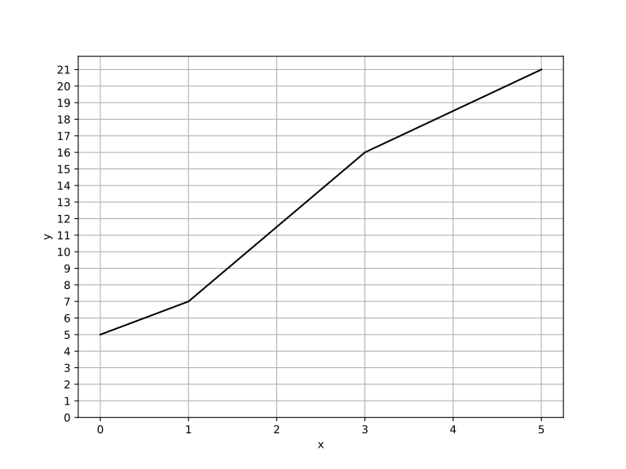

A.  Approximately 1.5 times

B.   Approximately 2 times

C.   Approximately 2.3 times

D. Approximately 3 times

2.  The scatterplot shows the relationship between two variables, x and y. If each y-coordinate in the dataset is increased by 11, which of the following is closest to the new y-coordinate of the y-intercept for the line of best fit?

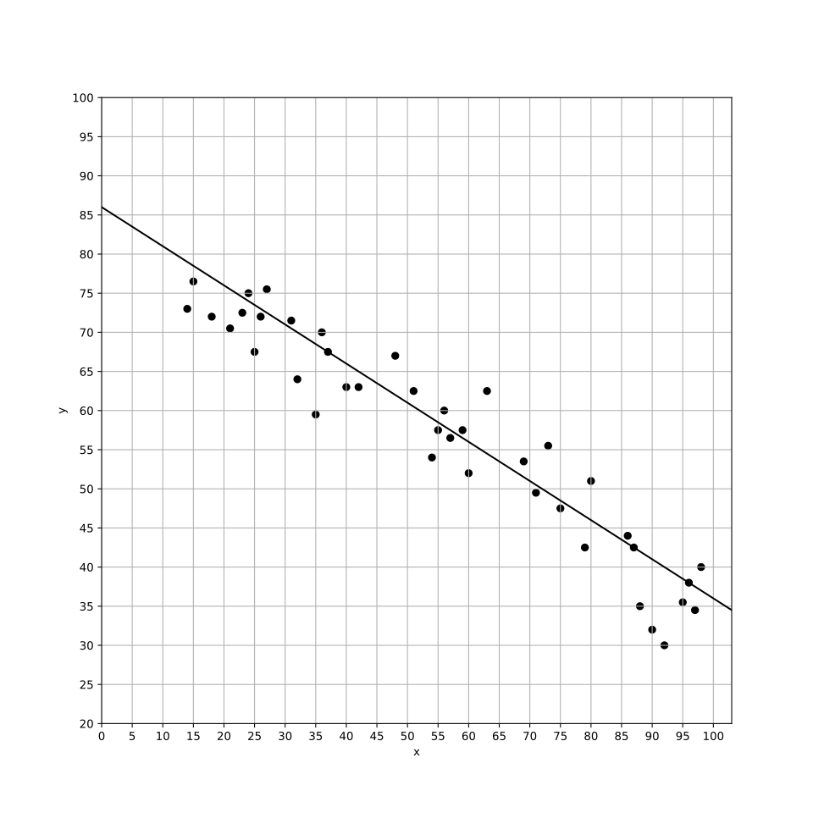

A.   64

B.   75

C.   86

D.   97

3.  A car is traveling at a speed of 21 meters per second. Convert this speed to miles per hour, rounding to the nearest tenth. (Use 1 mile = 1,609 meters.)

A.   18.1

B.   32.4

C.   47.0

D.   62.5

4.  The positive number a is 2000 $\%$ of the number c, and c is 10 $\%$ of the number b. If a - b = wc where w is a constant, what is the value of w?

5.  In a city, the number of students enrolled in public schools increased from 2,068,500 to 2,147,166 over a period of 21 years. On average, how many students were added to the enrollment each year?

A.    3,420

B.    3,576

C.    3,746

D.    3,933

6.  A certain organization had a membership of 2,000 members in the year 2020. If the membership grows at a steady rate of $5\%$ each year, how many members will the organization have in the year 2025?

A.    2100

B.    2431

C.    2553

D.    2680

7.  Which of the following equations best represents the line of best fit shown for the given scatter plot? 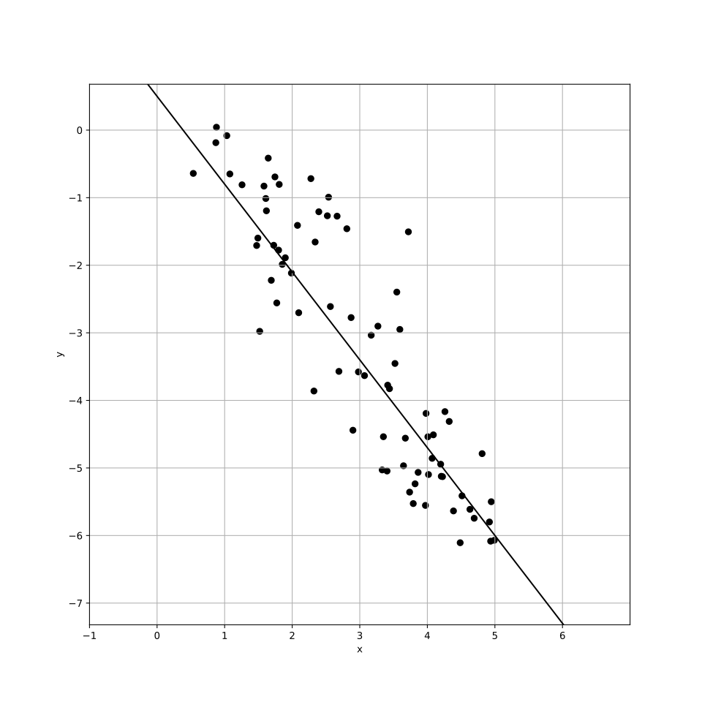

A.   y = -1.3x - 0.5

B.   y = 1.3x + 0.5

C.   y = -1.3x + 0.5

D.   y = 1.3x - 0.5

8.  A cybersecurity team has recorded the lengths of various incidents over time, represented by the original dataset. After adding a new incident that lasted 303 days, how does the mean and median of the new dataset compare to those of the original dataset? 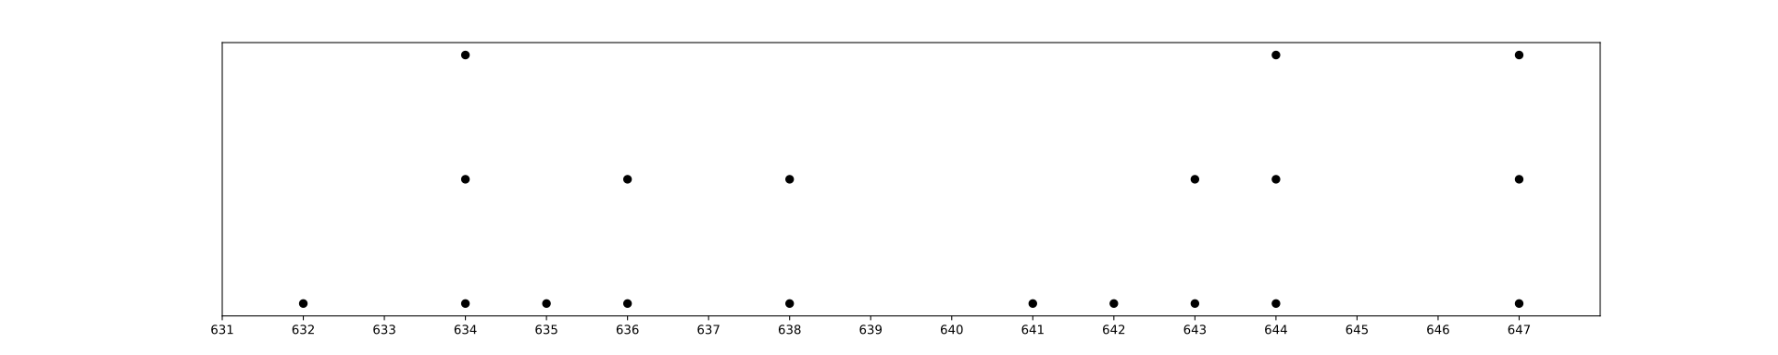

A.   The mean of the new dataset is less than the mean of the original dataset, and the median of the new dataset is less than the median of the original dataset.

B.   The mean of the new dataset is greater than the mean of the original dataset, and the median of the new dataset is greater than the median of the original dataset.

C.   The mean of the new dataset is equal to the mean of the original dataset, and the median of the new dataset is less than the median of the original dataset.

D.   The mean of the new dataset is less than the mean of the original dataset, while the median of the new dataset is greater than the median of the original dataset.

9.  What is the median of the data set shown? data set = [56, 44, 90, 95, 41, 22, 69, 19, 4, 43, 28]

10.  A company has a total of 750 robotic arms in its production line. If $25\%$ of the robotic arms are being used for assembly, how many robotic arms are currently in use for assembly?

A.    185

B.    186

C.    187

D.    188

SAT Math Problem Solving and Data Analysis Solutions

1.  The graph shows the estimated number of users (y, in thousands) of a cryptocurrency platform x years after launch, where x ranges from 0 to 5. which of the following best describes the increase in the estimated number of users from x = 1 to x = 3?



A.   Approximately 1.5 times

B.   Approximately 2 times

C.   Approximately 2.3 times

D.   Approximately 3 times

## Answer

C

## Solution

Concept Check : The question expects the student to analyze a line graph and understand linear growth. The focus is on interpreting the data points provided and calculating the increase in users over a specific interval (from x = 1 to x = 3). Students should know how to read graphs and understand the concept of change or increase over time.  
  
Solution Strategy : To solve this problem, students should first identify the values of users at x = 1 and x = 3 from the given data points. Then, they need to calculate the difference in the number of users between these two points. This requires basic subtraction and an understanding of how to interpret the y-axis values in thousands.  
  
Quick Wins : When analyzing the graph, carefully note the coordinates provided. Always double-check that you are using the correct x-values corresponding to the y-values. It can be helpful to visualize the change by plotting the points on a separate graph if necessary. Also, remember that the y-values are in thousands, so be mindful of the scale when interpreting the numbers.  
  
Mistake Alert : Students may easily make mistakes when reading the graph, especially if they confuse the x and y coordinates. Additionally, be cautious with the units; ensure that you are accounting for the ’thousands’ when reporting the final answer. Double-check your arithmetic when calculating the increase to avoid simple calculation errors.  
  
SAT Know-How : This problem falls under the category of Problem Solving and Data Analysis, focusing on linear growth through graph interpretation. It assesses skills in reading and analyzing data points, understanding changes in values, and performing basic arithmetic operations. Mastering these concepts is crucial for success in the SAT, as they frequently appear in various forms in the exam.  
  
First, identify the number of users at x = 1 and x = 3.  
At x = 1, the number of users is 7,000 (since y is in thousands).  
At x = 3, the number of users is 16,000.  
To find how many times the number of users at x = 3 is compared to x = 1, divide the number of users at x = 3 by the number of users at x = 1.  
Calculate: 16,000 ÷ 7,000 = 16 ÷ 7  
Simplify the fraction $\frac{16}{7}$.  
16 ÷ 7 is approximately 2.2857, which suggests to check if it fits one of the option criteria given in the problem.

2.  The scatterplot shows the relationship between two variables, x and y. If each y-coordinate in the dataset is increased by 11, which of the following is closest to the new y-coordinate of the y-intercept for the line of best fit?



A.   64

B.   75

C.   86

D.   97

## Answer

D

## Solution

Concept Check : The intent of the question is to test the student’s understanding of the concepts of slope and y-intercept in the context of linear equations, particularly how changes to the data affect the y-intercept of the line of best fit. Students should know how to apply the formula for a linear equation, y = mx + b, where m is the slope and b is the y-intercept, and understand the implications of modifying the y-values in a dataset.  
  
Solution Strategy : To approach this problem, the student should start by recalling that the y-intercept (b) of the line of best fit represents the value of y when x is 0. Initially, the y-intercept is given as 86. The problem states that each y-coordinate is increased by 11, which means you need to add 11 to the original y-intercept to find the new y-intercept. This is a straightforward application of the concept that shifting all y-values upward will also shift the y-intercept upward by the same amount.  
  
Quick Wins : Remember that when all y-values are increased by a constant value, the y-intercept will also increase by that same constant. To avoid confusion, write down the original y-intercept, perform the addition clearly, and check your math carefully. Also, be mindful that the slope of the line does not change when only the y-values are adjusted.  
  
Mistake Alert : Be cautious not to confuse the slope with the y-intercept. The slope is not affected by the increase in y-values, so ensure that you are only altering the y-intercept. Double-check your addition to avoid simple arithmetic mistakes, and remember to maintain clarity in distinguishing between the original and new values.  
  
SAT Know-How : This problem falls under the category of Problem Solving and Data Analysis, specifically focusing on scatter plots and linear relationships. It assesses the student’s ability to manipulate and understand linear equations and the effects of changing data values on the line of best fit. Mastering such concepts is crucial for solving similar SAT problems efficiently and accurately.  
  
The equation for the original line of best fit is y = -0.5x + 86.  
Increasing each y-coordinate by 11 affects the entire line, including the y-intercept.  
The new y-intercept can be found by adding 11 to the original y-intercept.  
New y-intercept = 86 + 11 = 97.

3.  A car is traveling at a speed of 21 meters per second. Convert this speed to miles per hour, rounding to the nearest tenth. (Use 1 mile = 1,609 meters.)

A.   18.1

B.   32.4

C.   47.0

D.   62.5

## Answer

C

## Solution

Concept Check : The intent of this question is to assess the student’s understanding of unit conversion, specifically converting speed from meters per second to miles per hour. The student is expected to know the relationship between meters and miles and the process of converting units using multiplication or division.  
  
Solution Strategy : To solve this problem, the student should first identify the conversion factor needed to convert meters to miles. Then, they should calculate the speed in miles per hour by multiplying the speed in meters per second by the appropriate conversion factor to account for both the distance (meters to miles) and the time (seconds to hours). This involves recognizing that there are 3600 seconds in an hour, which will play a crucial role in the conversion process.  
  
Quick Wins : Start by writing down the conversion factors clearly: 1 mile = 1,609 meters and 1 hour = 3600 seconds. This will help in setting up the conversion correctly. Remember that you need to multiply the speed in meters per second by the number of seconds in an hour (3600) to get the speed in miles per hour. It might be helpful to do the calculations step by step to avoid confusion.  
  
Mistake Alert : Be careful not to confuse the conversion factors. It’s easy to misplace the values when multiplying or dividing. Additionally, remember to round the final result to the nearest tenth, as specified in the problem. Double-check your calculations to ensure you haven’t made any arithmetic errors during the conversion process.  
  
SAT Know-How : This problem is an example of a unit conversion question within the Problem Solving and Data Analysis category of the SAT. It assesses the student’s ability to apply conversion factors accurately and perform calculations involving different units of measurement. Mastering this type of problem enhances your problem-solving skills and helps you manage time effectively during the exam.  
  
To convert from meters per second to miles per hour, use the conversion factors given.  
First, convert meters to miles: 21 m/s $×$ (1 mile / 1,609 meters) = $\frac{21}{1,609}$ miles/second.  
Now, convert seconds to hours: $\frac{21}{1,609}$ miles/second $×$ (3,600 seconds / 1 hour) = $\frac{21×3,600}{1.609}$ miles/hour.  
Calculate the above expression: $\frac{21×3,600}{1.609}$ = $\frac{75,600}{1,609}$ ≈ 46.9857 miles/hour.  
Round 46.9857 to the nearest tenth: 47.0 miles/hour.

4.  The positive number a is 2000 $\%$ of the number c, and c is 10 $\%$ of the number b. If a - b = wc where w is a constant, what is the value of w?

## Answer

10

## Solution

Concept Check : The intent of the question is to assess the student’s understanding of percentages and their ability to translate percentage relationships into algebraic equations. The student is expected to know how to express one quantity as a percentage of another and manipulate these relationships to find a constant value.  
  
Solution Strategy : To approach the problem, the student should first convert the percentage statements into equations. For instance, since a is 2000 $\%$ of c, this can be expressed as a = 20c. Next, since c is 10 $\%$ of b, it can be rewritten as c = 0.1b or b = 10c. After establishing these relationships, the student can substitute these expressions into the equation a - b = wc and solve for w while keeping track of the relationships between a, b, and c.  
  
Quick Wins : A helpful tip is to clearly define each variable and write down each relationship step-by-step. This will help in avoiding confusion. It can also be useful to create a visual representation or chart of the relationships between a, b, and c. Remember to keep track of the units and ensure that when you substitute values, they align correctly with the equations. Lastly, double-check each percentage conversion to ensure accuracy.  
  
Mistake Alert : Be careful with the percentage conversions; it’s easy to miscalculate when changing percentages to decimal or whole numbers. Ensure that when you express a as a function of c and b as a function of c, the values are consistent. Additionally, when manipulating the equation a - b = wc, watch for signs (positive/negative) and double-check your substitutions to avoid algebraic errors.  
  
SAT Know-How : This problem is a classic example of problem-solving and data analysis involving percentages. It assesses skills in translating word problems into algebraic equations and manipulating those equations to solve for an unknown constant. Mastering this type of problem enhances one’s ability to handle real-world mathematical scenarios, reflecting a critical skill needed for success on the SAT.  
  
Step 1: Replace a with 20c in the equation a - b = wc.  
Step 2: Replace b with 10c in the equation.  
Step 3: The equation becomes 20c - 10c = wc.  
Step 4: Simplify the left side: 10c = wc.  
Step 5: Divide both sides by c (assuming c ≠ 0): 10 = w.

5.  In a city, the number of students enrolled in public schools increased from 2,068,500 to 2,147,166 over a period of 21 years. On average, how many students were added to the enrollment each year?

A.    3,420

B.    3,576

C.    3,746

D.    3,933

## Answer

C

## Solution

Concept Check : The intent of the question is to assess the student’s understanding of rates and proportions, specifically how to calculate the average rate of change over a specified period. Students should be familiar with the concept of finding the difference between two values and dividing that by the number of years to find the average increase per year.  
  
Solution Strategy : To approach this problem, students should first find the total increase in the number of students by subtracting the initial enrollment from the final enrollment. Then, they will divide that total increase by the number of years (21 years) to determine the average number of students added each year. This involves basic arithmetic operations and an understanding of averages.  
  
Quick Wins : When calculating the average increase, remember the formula: Average Increase = (Final Value - Initial Value) / Number of Years. Make sure to clearly perform each arithmetic step to avoid confusion. It can also be helpful to write down the numbers involved before performing calculations to keep track of your work.  
  
Mistake Alert : Be cautious with your subtraction; ensure you accurately calculate the total increase. Also, remember to divide by the correct number of years (21) and not to confuse this with the total number of students. Double-check your arithmetic to avoid simple errors.  
  
SAT Know-How : This problem falls under the category of Problem Solving and Data Analysis, focusing on ratios, rates, and proportions. It assesses skills in calculating average rates of change, a fundamental concept in analyzing data over time. Mastering this type of problem helps students build confidence in handling real-world data and prepares them for similar questions on the SAT.  
  
Calculate the total increase in the number of students: Final number - Initial number.  
Increase in students = 2,147,166 - 2,068,500 = 78,666.  
Now, find the average annual increase by dividing the total increase by the number of years.  
Average annual increase = $\frac{78666}{21}$.  
Perform the division to find the average: 78,666 ÷ 21 = 3,746.  
Therefore, the average number of students added to the enrollment each year is 3,746.

6.  A certain organization had a membership of 2,000 members in the year 2020. If the membership grows at a steady rate of $5\%$ each year, how many members will the organization have in the year 2025?

A.    2100

B.    2431

C.   2553

D.    2680

## Answer

C

## Solution

Concept Check : The question intends to assess the student’s understanding of exponential growth, specifically how to apply the formula for exponential growth to determine the future value based on a given growth rate. The student should recognize that a constant percentage growth leads to exponential growth, which involves the concept of compounding over time.  
  
Solution Strategy : To approach this problem, the student should first identify the initial value (the number of members in 2020) and the growth rate. They need to understand that the formula for exponential growth can be expressed as A = P(1 + r)ⁿ, where A is the amount after n years, P is the initial amount, r is the growth rate, and n is the number of years. The student should calculate how many years pass from 2020 to 2025 and input the values into the formula to find the total membership in 2025.  
  
Quick Wins : Remember that the growth rate needs to be converted into decimal form when using it in the formula; for a $5\%$ growth rate, use 0.05. Also, be careful to count the correct number of years from 2020 to 2025, which is 5 years. Make sure to perform the operations in the correct order, using parentheses to ensure accurate calculations.  
  
Mistake Alert : Students often confuse the number of years when calculating growth, so double-check the time span. Also, ensure the growth rate is used in decimal form instead of percentage form. Lastly, pay attention to rounding; depending on the context, you may need to round the final answer to the nearest whole number, as you cannot have a fraction of a member.  
  
SAT Know-How : This problem is a typical example of the ’Problem Solving and Data Analysis’ category, specifically focusing on linear and exponential growth. It assesses skills in applying mathematical formulas related to growth rates and understanding how to manipulate exponential equations. Mastering these types of problems is crucial for success on the SAT, as they test both conceptual understanding and practical application of mathematical principles.  
  
The formula for exponential growth is: Final Amount = Initial Amount × (1 + Growth Rate)ⁿ  
In this problem, Initial Amount = 2000, Growth Rate = 0.05, and n = 5 years.  
Calculate the growth factor for one year: 1 + 0.05 = 1.05  
Raise the growth factor to the power of 5 years: 1.05⁵  
Calculate 1.05⁵: 1.05 × 1.05 × 1.05 × 1.05 × 1.05 = 1.2762815625  
Multiply this factor by the initial membership: 2000 × 1.2762815625 = 2552.563125  
Round the result to the nearest whole number since the number of members must be a whole number: 2553

7.  Which of the following equations best represents the line of best fit shown for the given scatter plot? 

A.   y = -1.3x - 0.5

B.   y = 1.3x + 0.5

C.   y = -1.3x + 0.5

D.   y = 1.3x - 0.5

## Answer

C

## Solution

Concept Check : The intent of the question is to assess the student’s ability to interpret scatter plots and determine the equation of the line of best fit. Students are expected to understand concepts related to linear relationships and how to analyze data visually represented in a scatter plot.  
  
Solution Strategy : To approach this problem, students should first look at the scatter plot to observe the overall trend of the data points. They need to identify whether the relationship appears to be positive, negative, or possibly nonlinear. Then, they should recall how to derive the equation of a line in slope-intercept form (y = mx + b), where m is the slope and b is the y-intercept. If the graph provides specific data points, they could use those to calculate the slope and y-intercept, or they could estimate these values visually based on the distribution of the points.  
  
Quick Wins : When analyzing the scatter plot, pay attention to the direction of the data points and any clusters. Estimate the slope by selecting two points on the line of best fit, and use the formula (change in y)/(change in x) to find it. Remember to consider the y-intercept as the point where the line crosses the y-axis. If multiple equations are provided, evaluate each one by substituting a few x-values to see which one gives outputs that align with the visual trend of the scatter plot.  
  
Mistake Alert : Be cautious with visual estimation; it can be easy to misjudge the precise location of data points or the line of best fit. Also, don’t forget to check for outliers that might skew your perception of the overall trend. When calculating the slope, ensure that you are using the correct coordinates for your chosen points, and double-check your arithmetic to avoid simple calculation errors.  
  
SAT Know-How : This problem falls under the category of Problem Solving and Data Analysis and specifically focuses on interpreting scatter plots to find the line of best fit. It assesses skills in understanding linear relationships, applying knowledge of slope and intercept, and making estimations based on visual data. Developing proficiency in these areas can significantly enhance your problem-solving abilities on the SAT.  
  
The slope of the line of best fit is -1.3, which means that the line decreases as x increases.  
The y-intercept of the line of best fit is 0.5, which means that the line crosses the y-axis at the point (0, 0.5).  
We need to find an equation in the format y = mx + b, where m is the slope and b is the y-intercept.  
Now, let’s compare each option:  
A) y = -1.3x - 0.5: This equation has a slope of -1.3 and a y-intercept of -0.5.  
B) y = 1.3x + 0.5: This equation has a slope of 1.3 and a y-intercept of 0.5.  
C) y = -1.3x + 0.5: This equation has a slope of -1.3 and a y-intercept of 0.5, which matches the given conditions.  
D) y = 1.3x - 0.5: This equation has a slope of 1.3 and a y-intercept of -0.5.  
The correct equation is C) y = -1.3x + 0.5 because it matches both the given slope and y-intercept.

8.  A cybersecurity team has recorded the lengths of various incidents over time, represented by the original dataset. After adding a new incident that lasted 303 days, how does the mean and median of the new dataset compare to those of the original dataset? 

A.   The mean of the new dataset is less than the mean of the original dataset, and the median of the new dataset is less than the median of the original dataset.

B.   The mean of the new dataset is greater than the mean of the original dataset, and the median of the new dataset is greater than the median of the original dataset.

C.   The mean of the new dataset is equal to the mean of the original dataset, and the median of the new dataset is less than the median of the original dataset.

D.   The mean of the new dataset is less than the mean of the original dataset, while the median of the new dataset is greater than the median of the original dataset.

## Answer

A

## Solution

Concept Check : The question aims to assess the student’s understanding of measures of central tendency, specifically mean and median, and how they are affected by the inclusion of new data points. The student should know how to calculate these values and the implications of adding an outlier or extreme value to a dataset.  
  
Solution Strategy : To approach this problem, the student should first recall the definitions and calculation methods for both the mean and median. They should consider how the addition of a new incident (303 days) compares to the original dataset’s values. They should analyze whether 303 days is significantly higher or lower than the previous incidents to predict how it will affect the mean and median. Additionally, they should think about how to recalculate these statistics after including the new data point.  
  
Quick Wins : When calculating the mean, remember that it is the sum of all values divided by the number of values. For the median, ensure you understand that it is the middle value when the data is ordered. If the new data is an outlier, it could significantly affect the mean while having a smaller impact on the median. It can be helpful to sketch a simple number line to visualize where the new data point falls in relation to the existing data.  
  
Mistake Alert : Be cautious about jumping to conclusions based solely on intuition. Always perform the calculations to verify your predictions regarding the mean and median. Additionally, be aware that the mean can be skewed by extreme values, while the median remains more stable. Double-check the ordering of data when finding the median, and ensure you account for the correct number of data points after adding the new incident.  
  
SAT Know-How : This problem falls under Problem Solving and Data Analysis, focusing on understanding the center, spread, and shape of distributions. It assesses the student’s ability to analyze how a new data point influences the mean and median of a dataset. Mastery of these concepts is crucial for effective data interpretation, a key skill tested in the SAT.  
  
1. Calculate the original dataset’s mean.  
- Multiply each data point by its frequency: (632 $×$ 1) + (634 $×$ 3) + (635 $×$ 1) + (636 $×$ 2) + (638 $×$ 2) + (641 $×$ 1) + (642 $×$ 1) + (643 $×$ 2) + (644 $×$ 3) + (647 $×$ 3) = 12159.  
- Total Frequency is 30.  
- Original mean = $\frac{12159}{19}$ = 639.9473  
2. Calculate the new dataset’s mean by adding 303.  
- New dataset total sum = 12159 + 303 = 12462.  
- New total frequency = 19 + 1 = 20.  
- New mean = = 623.1  
3. Calculate the median for the original dataset.  
- Arrange the data points in order, identify the median position: At position 10 (for 19 items) ->641.  
4. Calculate the median for the new dataset.  
- New dataset: [303, 632, 634, 634, 634, 635, 636, 636, 638, 638, 641, 642, 643, 643, 644, 644, 644, 647, 647, 647].  
- With 20 items, the median is the mean of 10th and 11th items ->639.5.  
5. Compare means and medians.  
- Original mean 639.9473 becomes 623.1, which is less.  
- Original median 641 becomes 639.5, which is less.

9.  What is the median of the data set shown? data set = [56, 44, 90, 95, 41, 22, 69, 19, 4, 43, 28]

## Answer

43

## Solution

Concept Check : The intent of this question is to assess the student’s understanding of how to find the median in a data set. It requires knowledge of basic statistics, specifically the concept of median, which is the middle value of a sorted data set. The student should be familiar with the steps of ordering the data and determining the median based on whether the number of data points is odd or even.  
  
Solution Strategy : To approach this problem, the student should first sort the data set in ascending order. This is crucial because the median is determined by the position of the numbers in a sorted list. Once the data is sorted, the student will identify the middle number(s) to find the median. If there is an odd number of values, the median is the middle number; if there is an even number of values, the median is the average of the two middle numbers.  
  
Quick Wins : 1. Always sort the data set first; this is essential for accurately finding the median. 2. Count the total number of data points to determine if it’s odd or even. 3. If the count is odd, the median is the value at the $\frac{n+1}{2}$ position in the sorted list. If it’s even, the median will be the average of the values at the $\frac{n}{2}$ and ( $\frac{n}{2}$ + 1) positions. 4. Use a calculator for averaging if needed, to ensure accuracy.  
  
Mistake Alert : Be careful not to skip the sorting step; finding the median without sorting will lead to an incorrect answer. Additionally, double-check the count of data points to ensure you are applying the correct method (odd vs. even). When calculating the average of two numbers, make sure to add them correctly and divide by 2 accurately.  
  
SAT Know-How : This problem falls under the category of ’Problem Solving and Data Analysis’, specifically focusing on the center of distribution by finding the median. It assesses the student’s ability to organize data, understand statistical concepts, and perform basic arithmetic operations. Mastering how to find the median is a critical skill in data analysis, and practicing such problems enhances overall proficiency in handling statistical data on the SAT.  
  
Step 1: Arrange the data set in ascending order: [4, 19, 22, 28, 41, 43, 44, 56, 69, 90, 95]  
Step 2: Identify the middle number. Since the data set contains 11 numbers, the 6th number in the ordered list is the median.  
Step 3: The 6th number in the ordered list is 43.

10.  A company has a total of 750 robotic arms in its production line. If $25\%$ of the robotic arms are being used for assembly, how many robotic arms are currently in use for assembly?

A.    185

B.    186

C.    187

D.    188

## Answer

C

## Solution

Concept Check : The intent of this question is to assess the student’s understanding of percentages and their ability to apply this concept in a real-world context. The student is expected to know how to calculate a percentage of a total amount, which is a fundamental skill in problem-solving and data analysis.  
  
Solution Strategy : To solve this problem, the student should first recognize that they need to find $25\%$ of the total number of robotic arms, which is 750. This can be done by converting the percentage into a decimal or fraction and then multiplying it by the total amount. The thought process should include understanding that ’percent’ means ’per hundred’ and how to apply this concept in multiplication to find the portion in use.  
  
Quick Wins : A helpful way to calculate percentages is to convert the percentage into a fraction or decimal. For example, $25\%$ can be expressed as 0.25 or 25/100. After conversion, multiplying this by the total number of robotic arms (750) will yield the answer. Breaking down the calculation step-by-step can help ensure accuracy. Additionally, think of percentages in terms of parts of a whole to visualize the problem better.  
  
Mistake Alert : Students should be careful not to confuse the percentage with the actual number of robotic arms. It’s easy to miscalculate if you forget to convert percentages properly or make arithmetic errors during multiplication. Also, ensure that you are applying the percentage to the correct total amount, and double-check your calculations to avoid simple mistakes.  
  
SAT Know-How : This problem falls under the category of ’Problem Solving and Data Analysis’ and specifically focuses on the concept of percentages. It assesses the student’s ability to apply basic arithmetic operations and understand percentages in a practical scenario. Mastering such calculations is essential for the SAT, as they often involve real-life applications that require accurate interpretation and computation.  
  
Step 1: Understand the problem.  
We have 750 robotic arms, and $25\%$ of them are used for assembly.  
Step 2: Calculate $25\%$ of 750.  
Step 3: Convert $25\%$ to a decimal. $25\%=\frac{25}{100}=0.25$.  
Step 4: Multiply the total number of robotic arms by this decimal to find how many are used for assembly. $750×0.25=187.5$ 
.