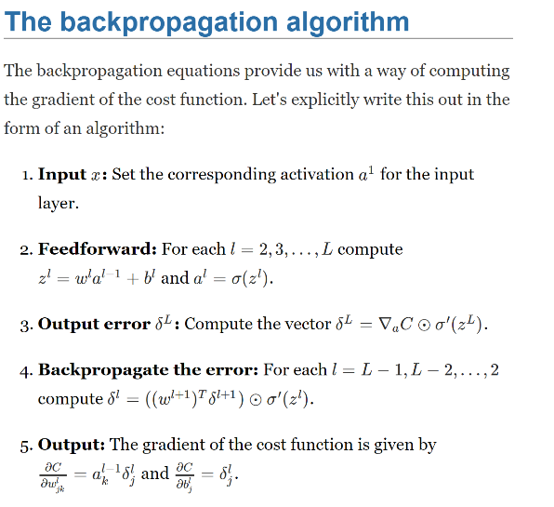 All pictures come from: <http://neuralnetworksanddeeplearning.com/chap2.html>

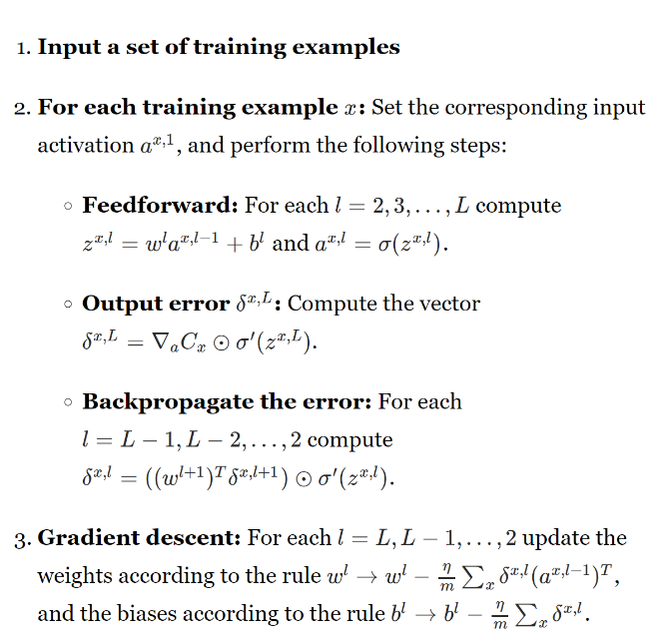 Full algorithm:

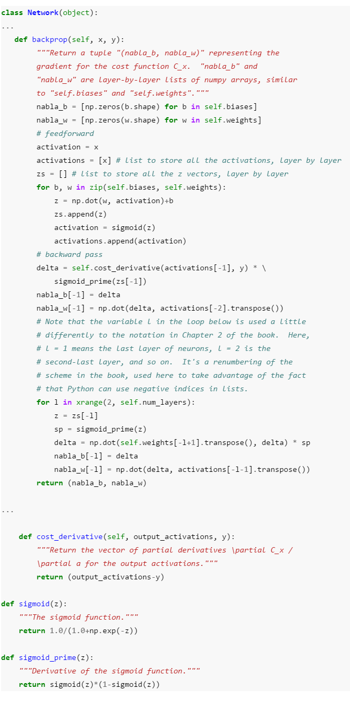Backpropagation alg. (python):

Update weights and biases using gradient descent alg. (python):

